**Anton Slizh’s**

**U2M1.LW.Core SQL**

*GitHub: https://github.com/drapejny/DataCamp2022*

## 2.1. Task 01: CREATE Storage Objects

Creating all tables using prepared scripts:

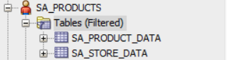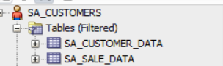

## 2.2. Task 02: Generate Test Data in Storage Layers

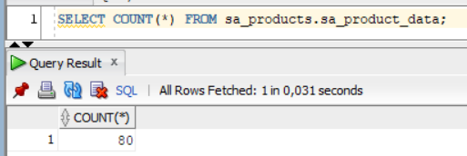

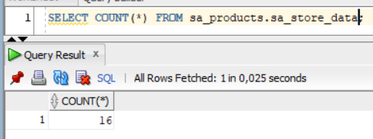

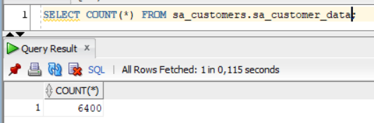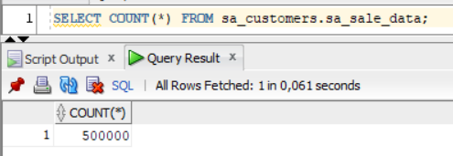

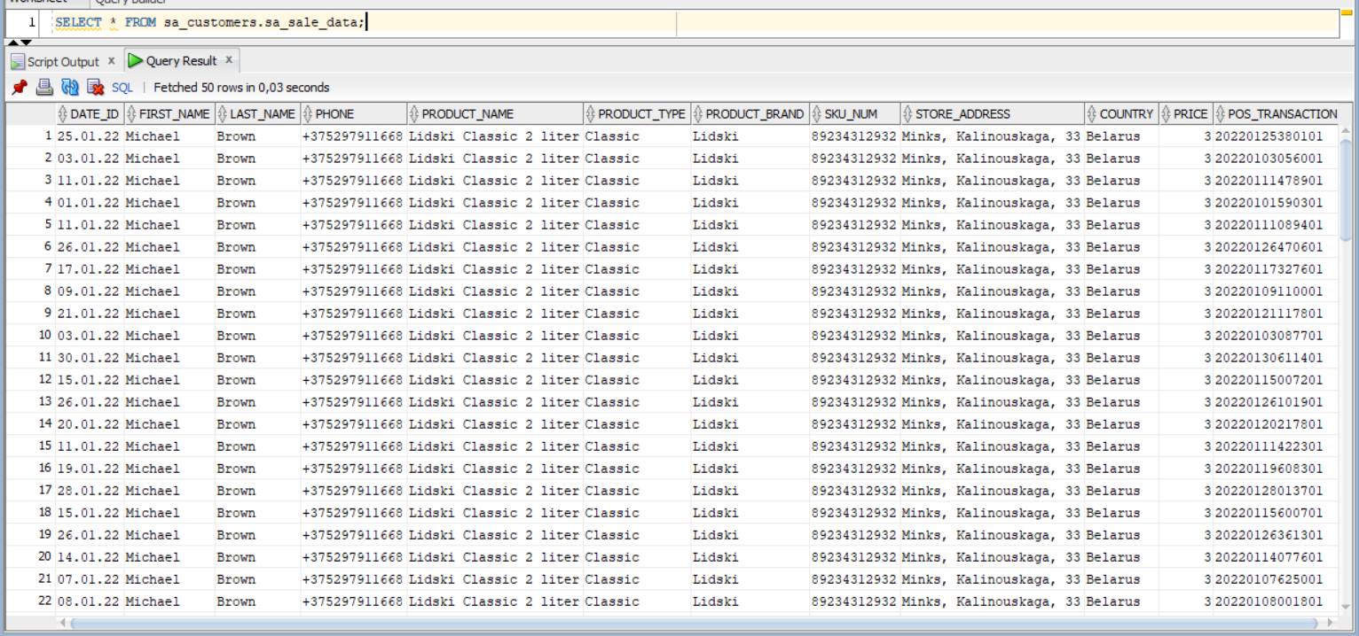

## 2.3. Task 03: Create Group by Plan

Selecting most popular brands by counties:

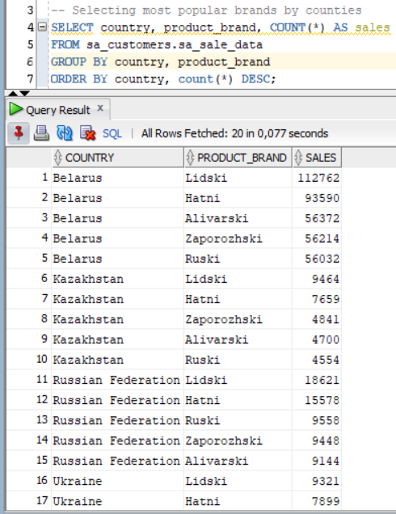

Selecting most popular stores:

