**Anton Slizh’s**

**U2M11.LW.ETL Overview - Advanced Refresh Scenarios**

**Task 1**

## 2.1. Task 01: Loading to SAL Layer Data

**Task 1 is the same as Task 2 at Lab 10. Check previous lab.**

**Task 2**

## 3.1. Task 02: Prepare Report Layout

**The Main Task** is to create Ad Hoc SQL for Report Layout Monthly that was developed on LabWork 2 (Use STAR schema objects for source of Data).

**Task Results:**

Create required objects:

* Put objects script to Git.
* Prepare Document with Screenshot of Data

First report represents the monthly sales and revenue for each store

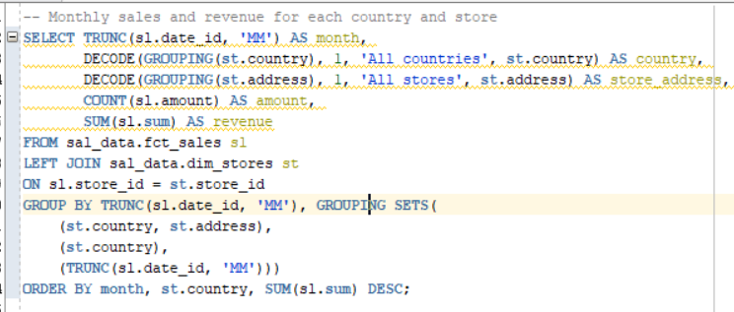

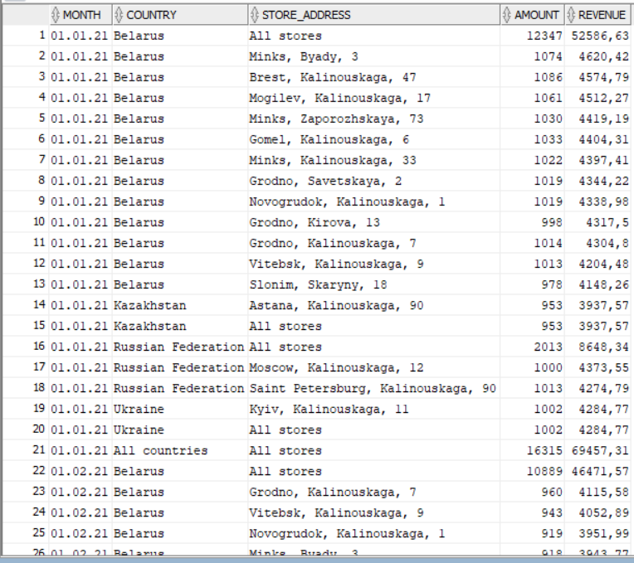

Second report represents the most popular product brands

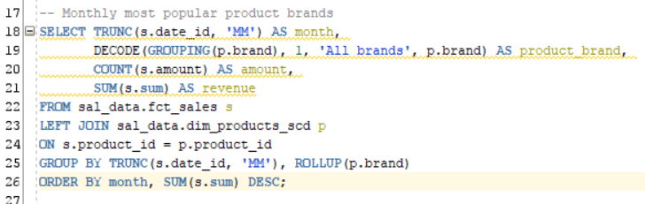

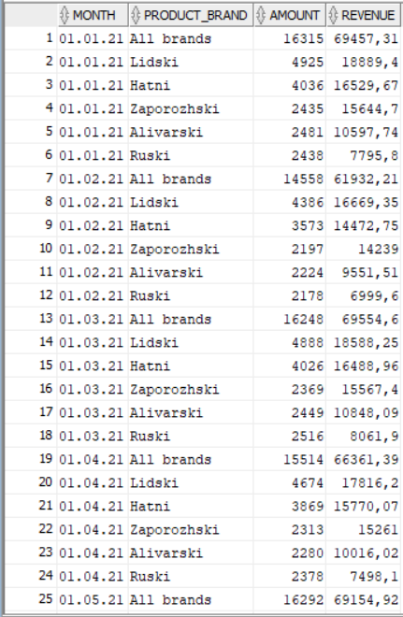

The third report represents the most popular products

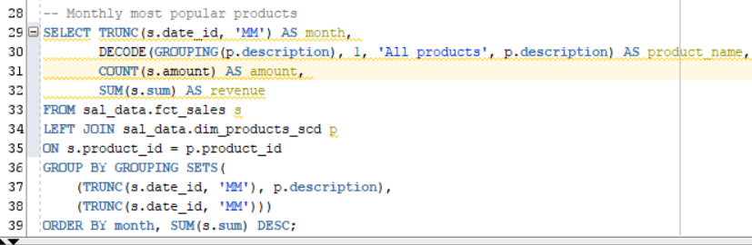

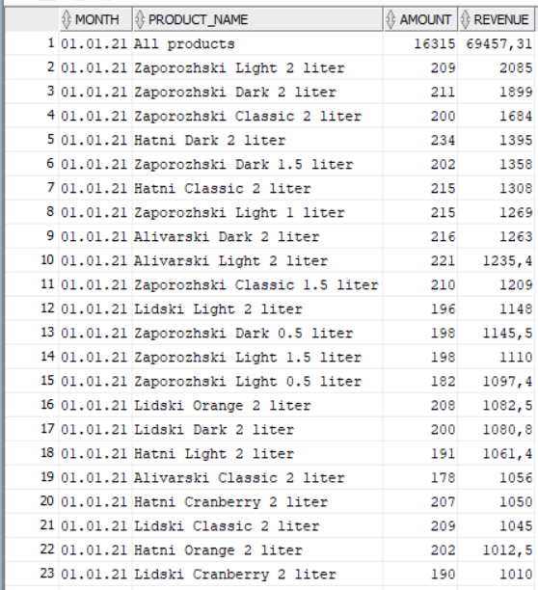

**Task 3**

## 3.2. Task 03: Compare Report Layout Performance

**The Main Task** is to create summarize table with comparison Performance of next Report Layout:

* Advancing Grouping (GROUP BY GROUPING SETs – LabWork 02)
* Model Clause (LabWork 05)
* Star Schema (LabWork 11)

1. **Advancing Grouping (0.157 s)**

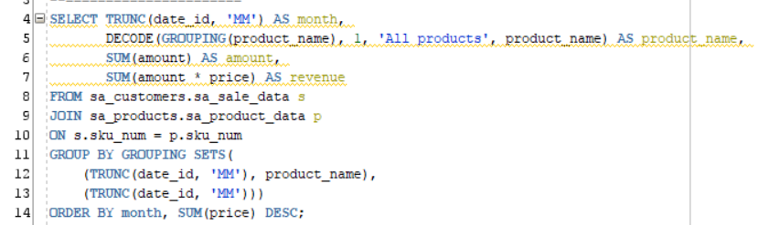

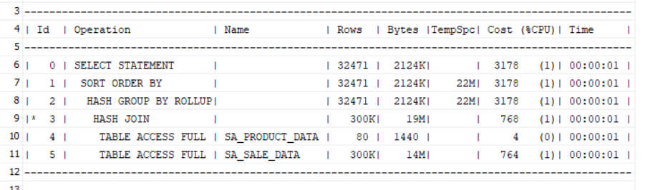

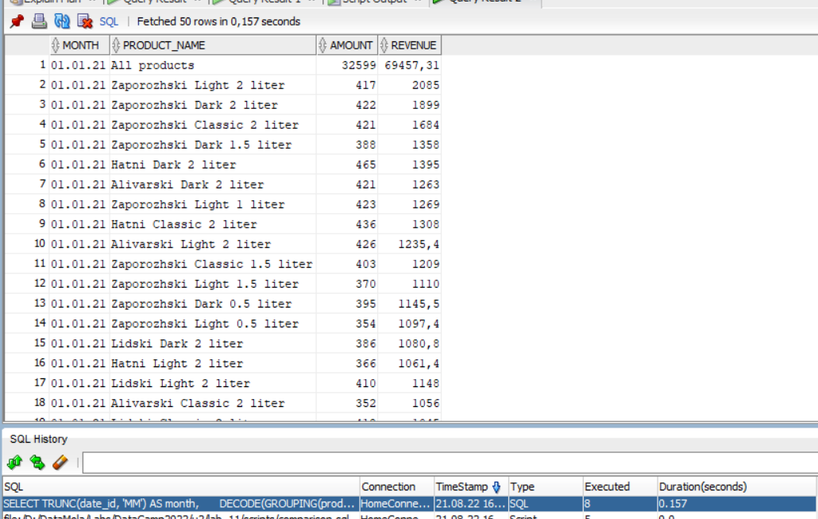

1. **Model Clause (0.143 s)**

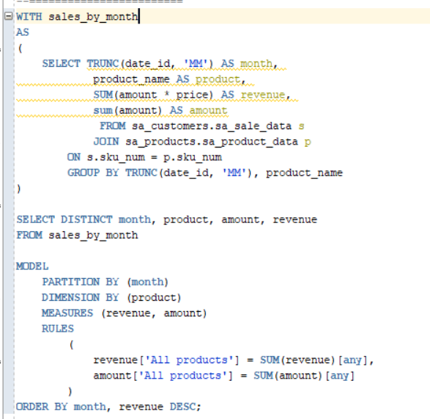

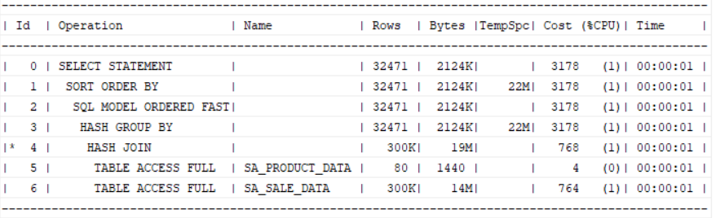

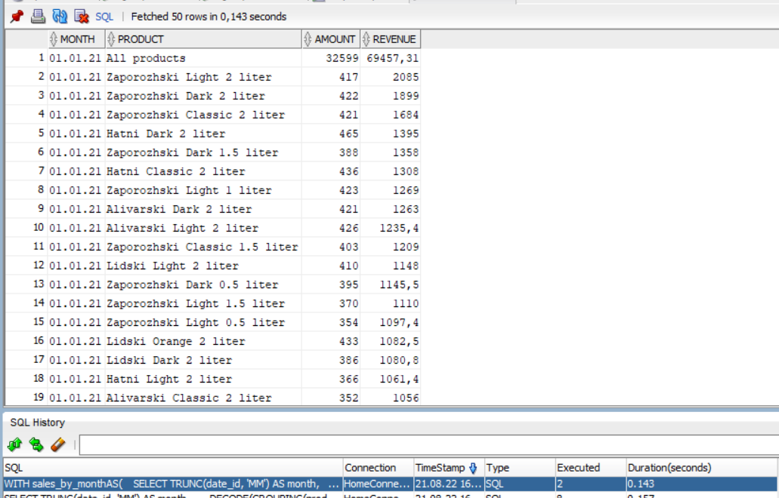

1. **Using Star Scheme (0.110 s)**

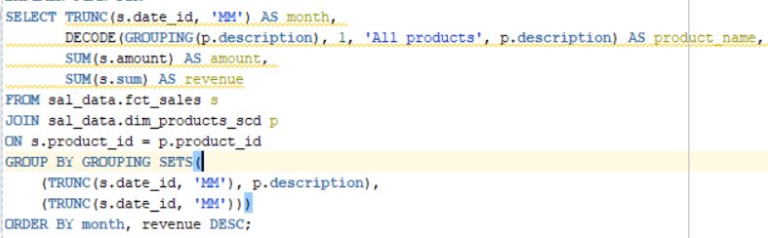

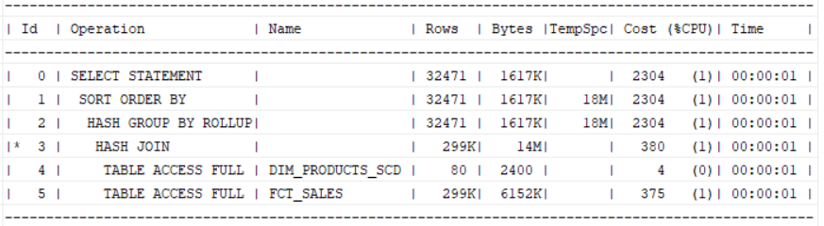

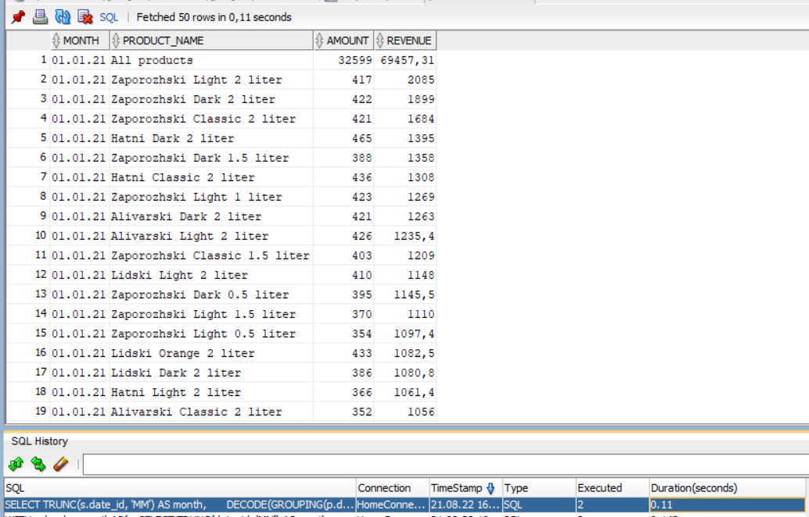

|  |  |  |  |
| --- | --- | --- | --- |
| № | Source Type | Explain Plan - Statistics | Time, Sec. |
| 1 | Advancing Grouping | Cost: 3178 | 0.157 |
| 2 | Model Clause | Cost: 3178 | 0.143 |
| 3 | Star Schema | Cost: 2304 | 0.110 |

In my case, using the Star Scheme objects to prepare business reports is more useful than selecting data on source data tables. The benefit of selecting on Star Scheme object is slight decrease of time and cost needed for query execution.