**Anton Slizh’s**

**U2M2.LW.Advanced Grouping**

## 2.1. Task 01: CREATE Daily Reports Layouts

Daily sales by stores:

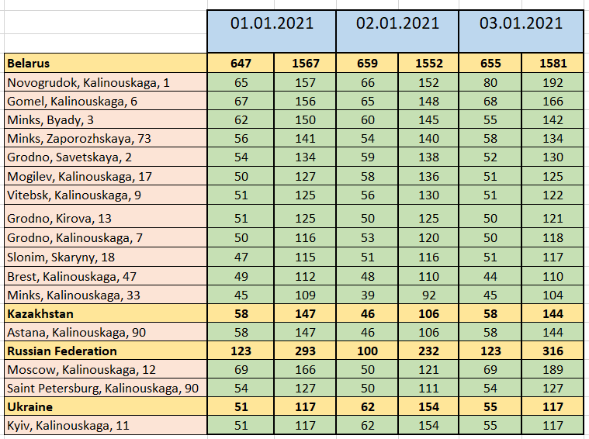

Daily top brands:

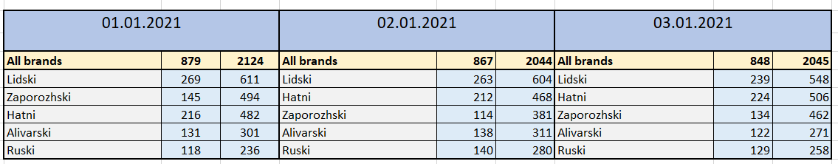Daily top products:

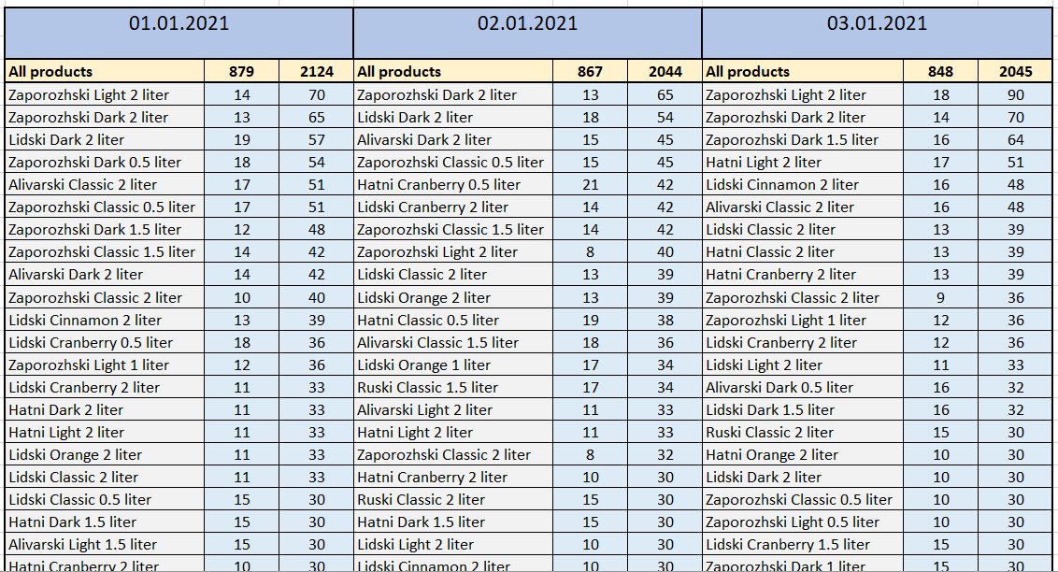

## 2.2. Task 02: CREATE Monthly Reports Layouts

Monthly sales by stores:

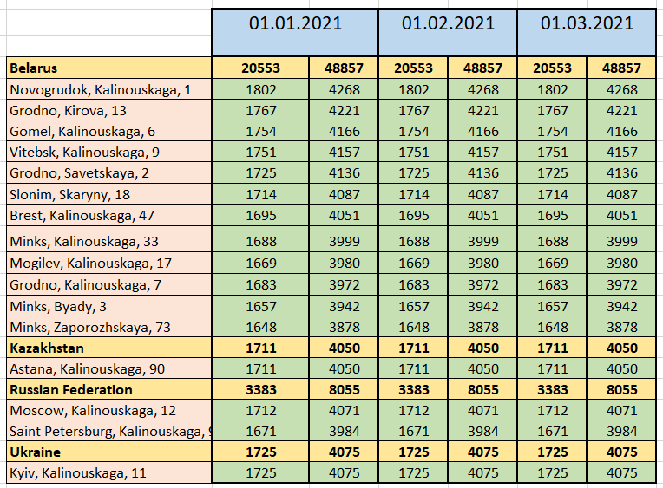

Monthly top brands:

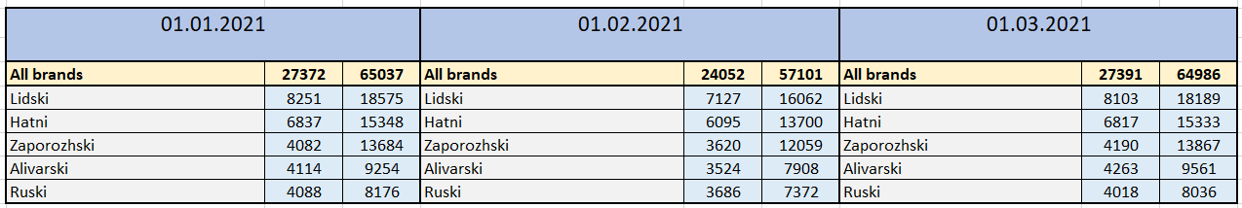

Monthly top products:

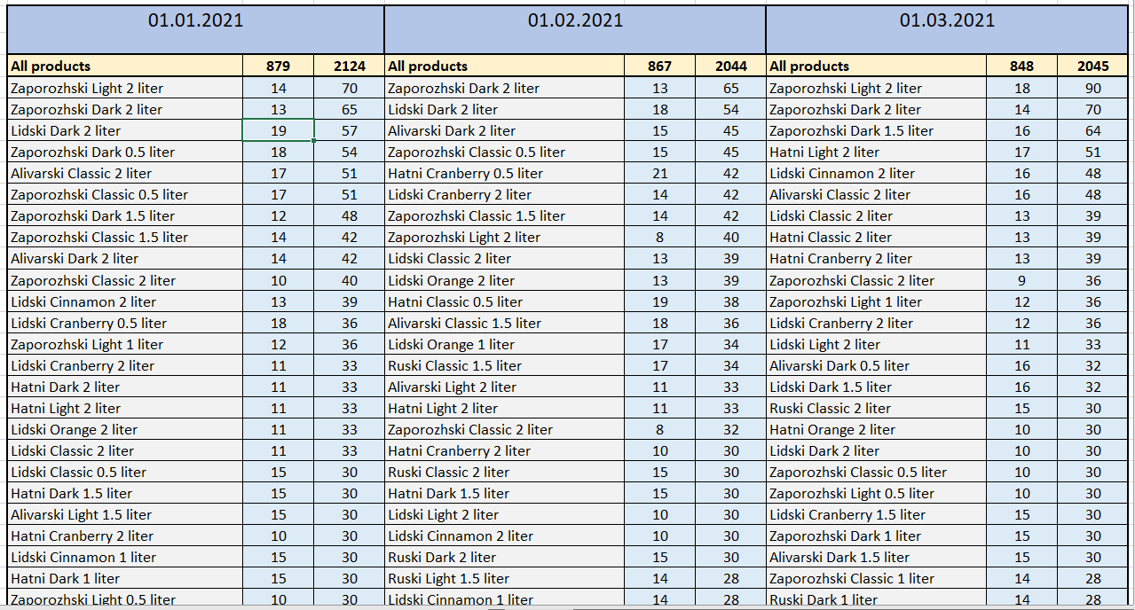

## 3.1. Task 03: CREATE Test AdHoc SQL - Daily Reports (CUBE)

1. Daily sales and revenue for each country and store

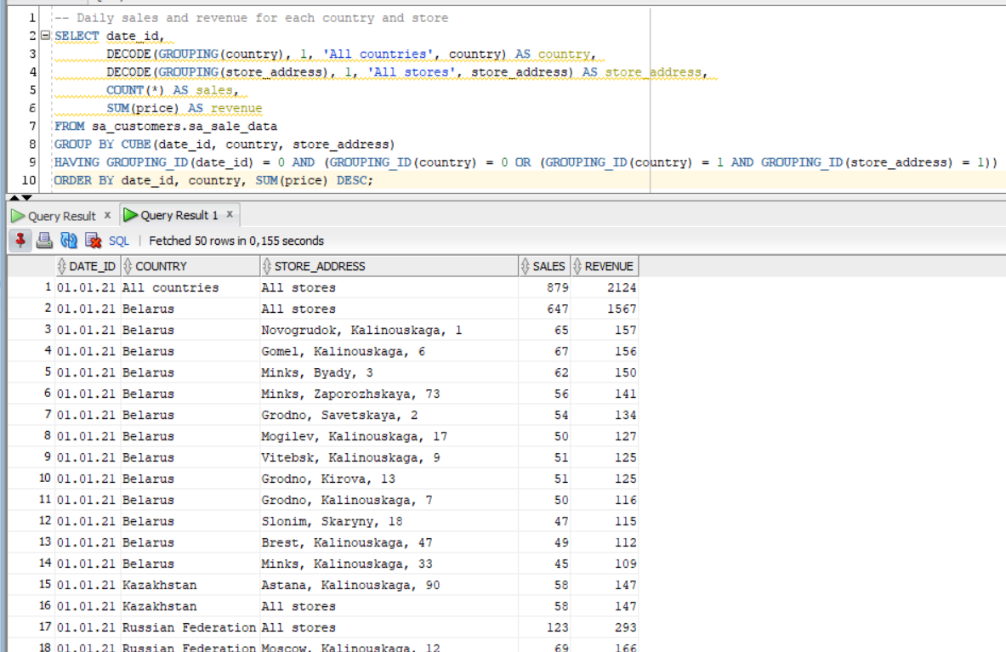

2. Daily most popular product brands

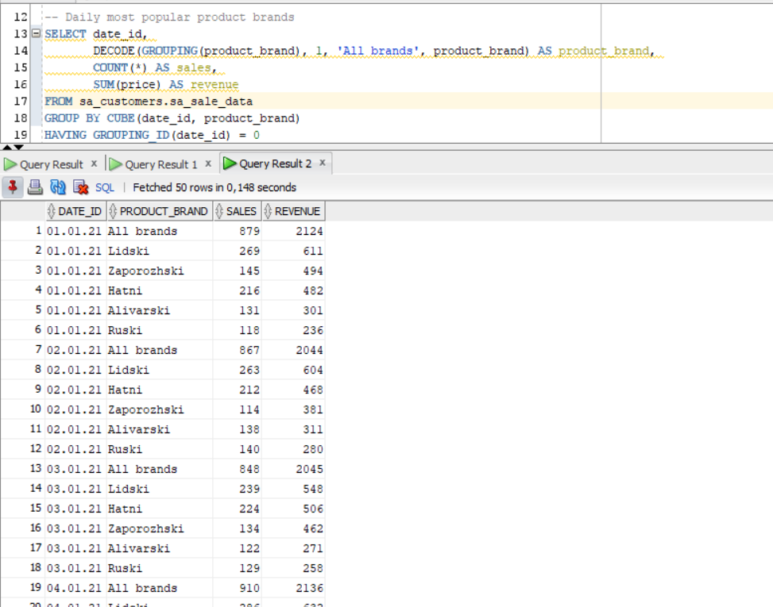

3. Daily most popular products

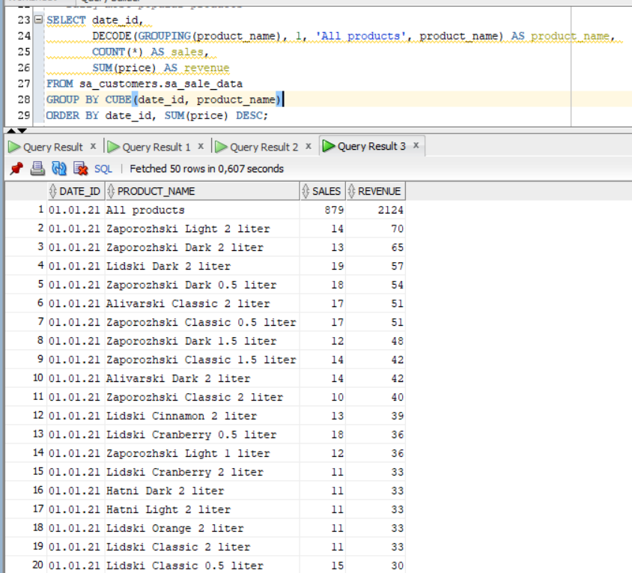

## 3.2. Task 04: CREATE Test AdHoc SQL - Monthly Reports (ROLLUP & GROUPING SETS)

1. Monthly sales and revenue for each country and store

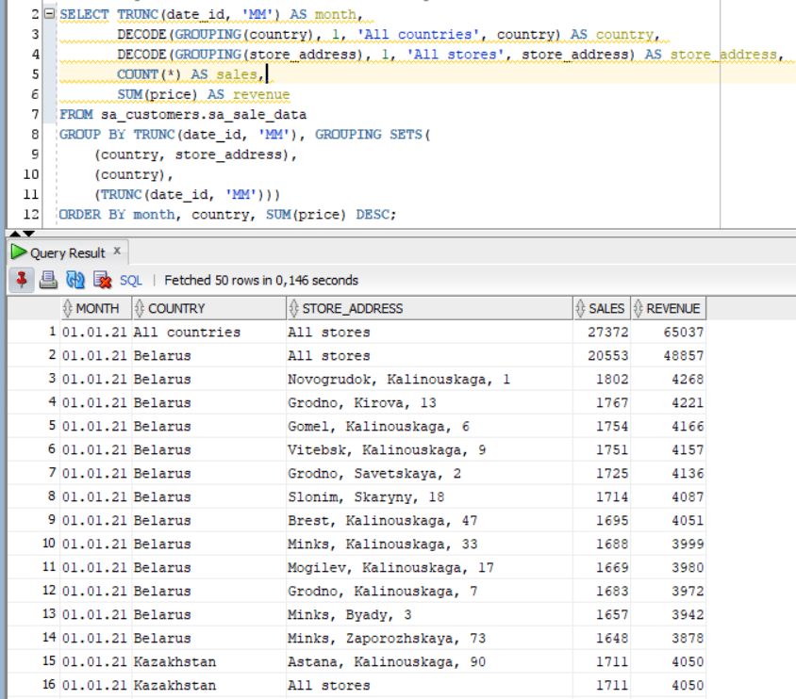

2. Monthly most popular product brands

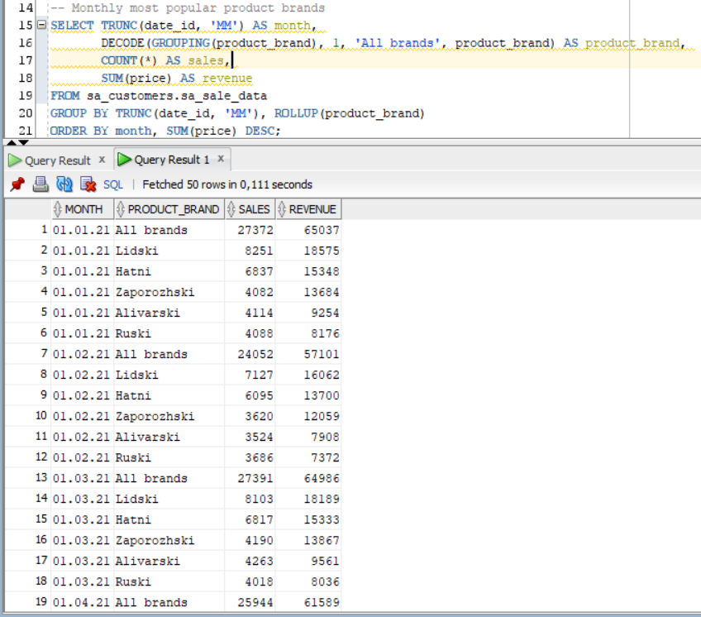

3. Monthly most popular products

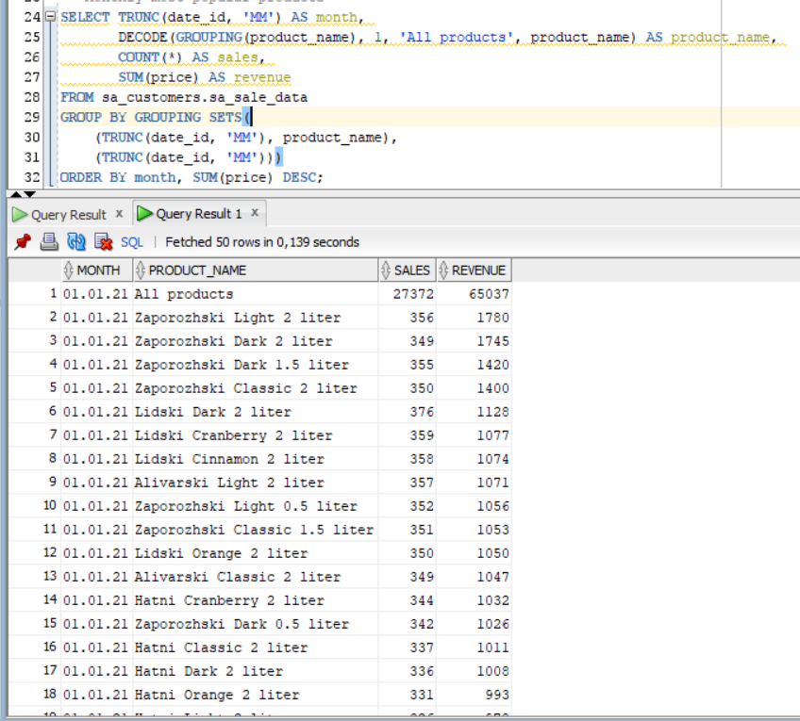

## 3.3. Task 05: CREATE Test AdHoc SQL – ROLLUP by Time

