**Anton Slizh’s**

**U2M3.LW.Subqueries**

**Task 1**

## 2.1. Task 01: Export Geo Location Reference

Creating tablespace and user:

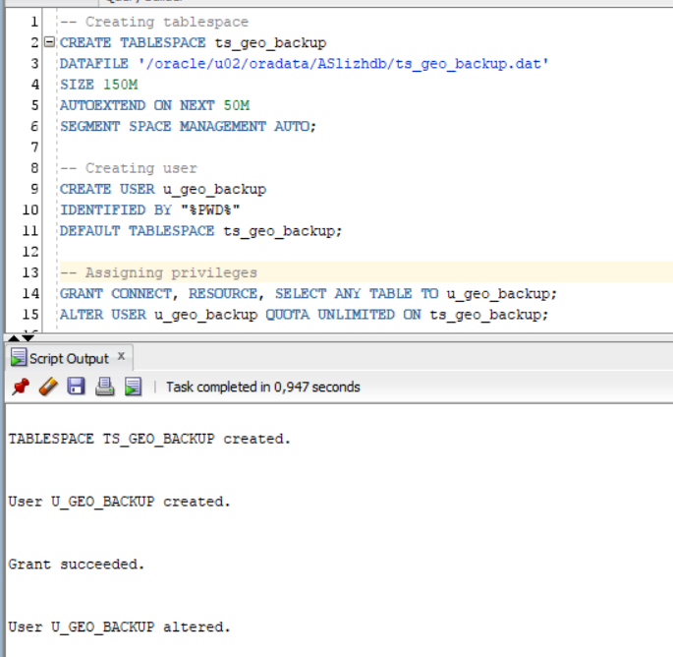

Creating denormalized table with additional columns and hierarchy GEO_SYSTEM > GEO_PART > GEO_REGION > GEO_COUNTRY:

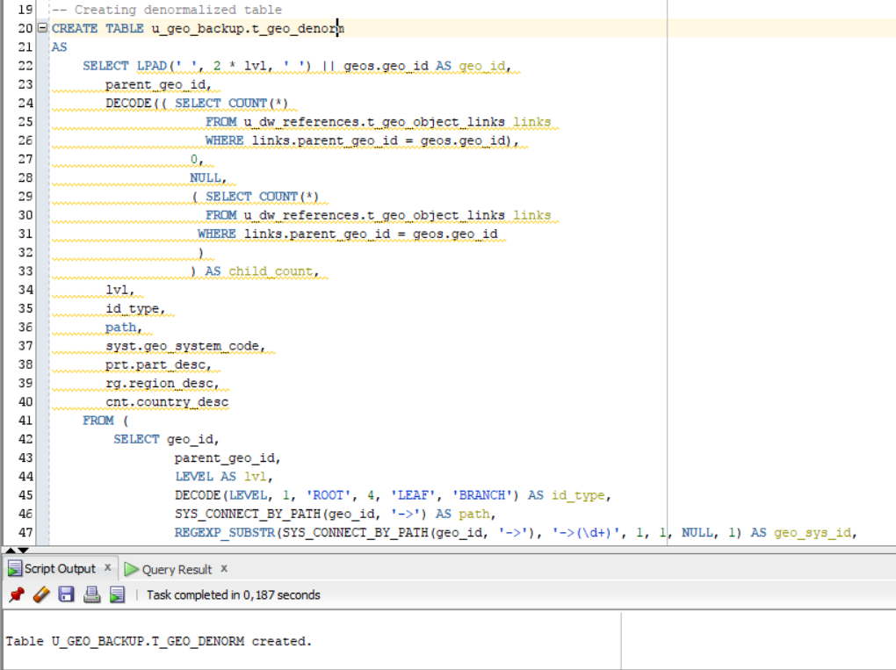

Select results:

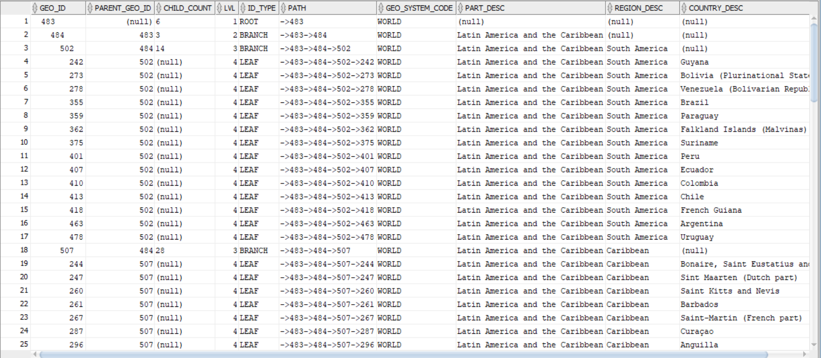

**Task 2**

## 2.2. Task 02: Analyze Business hierarch Reference Analyses