**Anton Slizh’s**

**U2M5.LW.Advanced SQL, PL/SQL**

*GitHub: https://github.com/drapejny/DataCamp2022*

**Task 1**

## 2.1. Task 01: Create Packages for Reload Dimension from SA_*

The main task was to refactor packages from previous task using EXECUTE IMMEDIATE, TO_REFCURSOR and TO_CURSOR_NUMBER function.

I have added some additional procedures into loading store package:

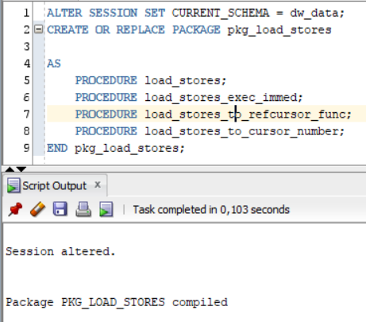

All scripts are located at *pkg_load_stores_impl.sql*

1. **Using EXECUTE IMMEDIATE with Bind Params**

PROCEDURE load_stores_exec_immed

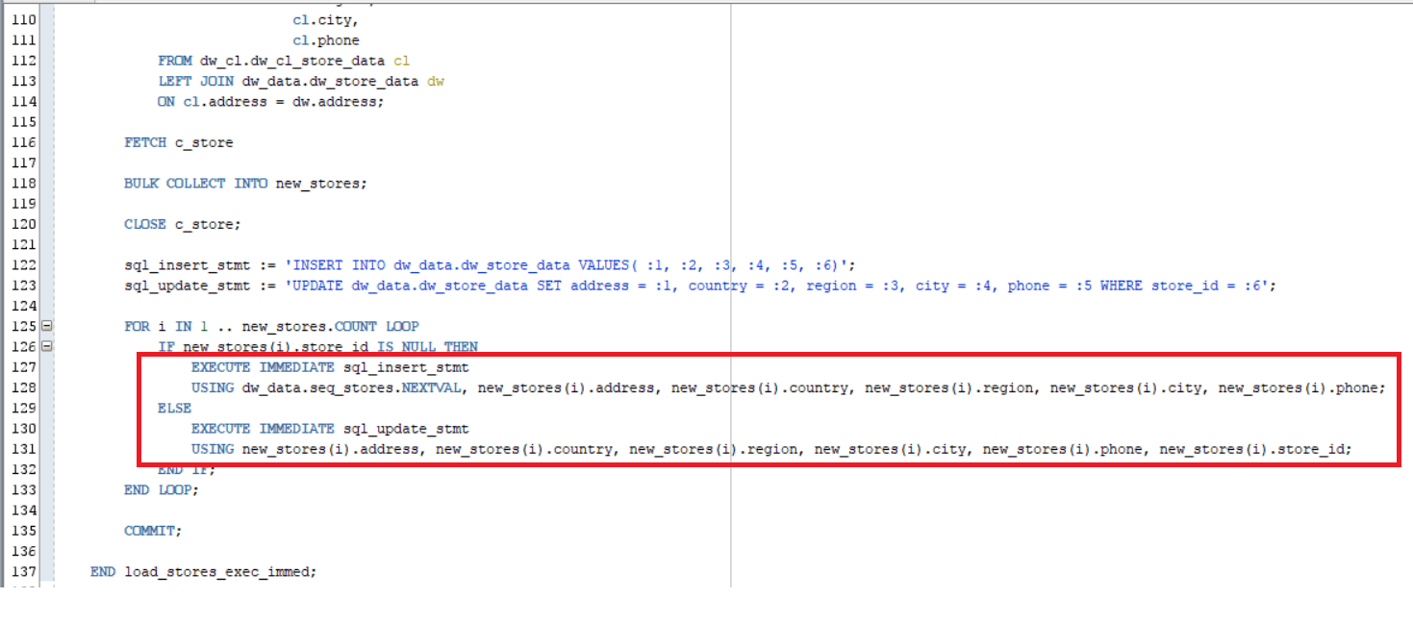

Executing:

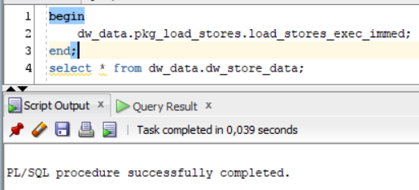

Result:

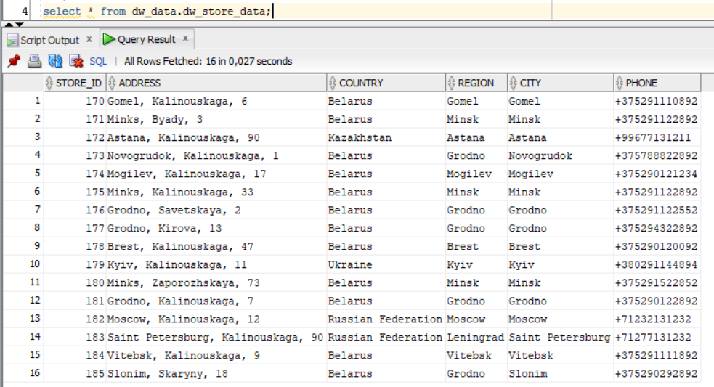

1. **Using DBMS_SQL.TO_REFCURSOR Function**

PROCEDURE load_stores_to_refcursor_func

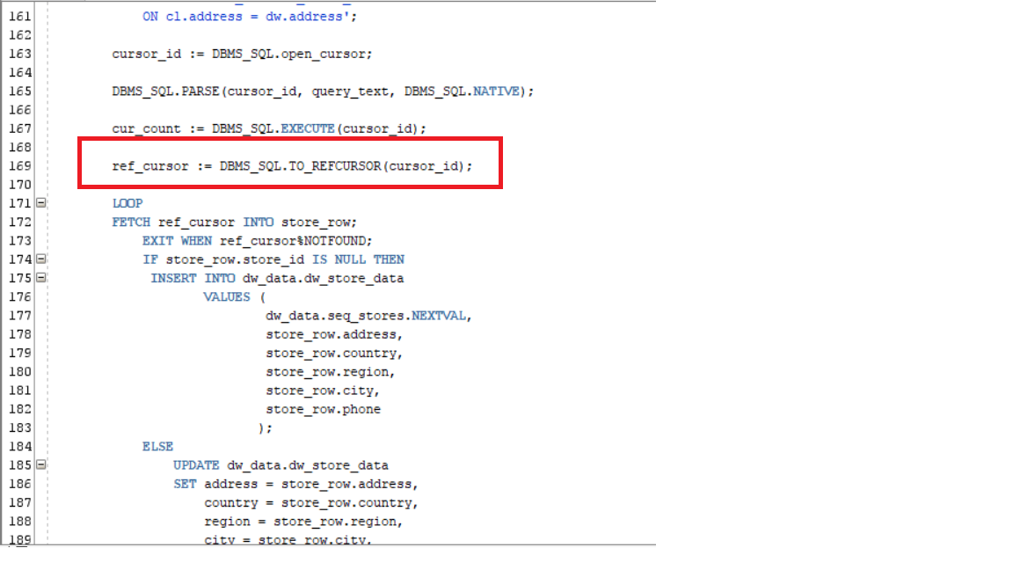

Executing:

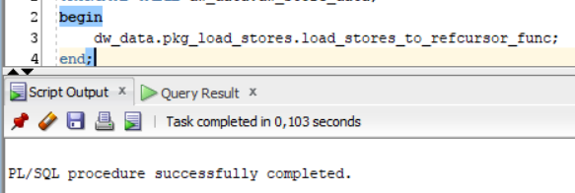

Result:

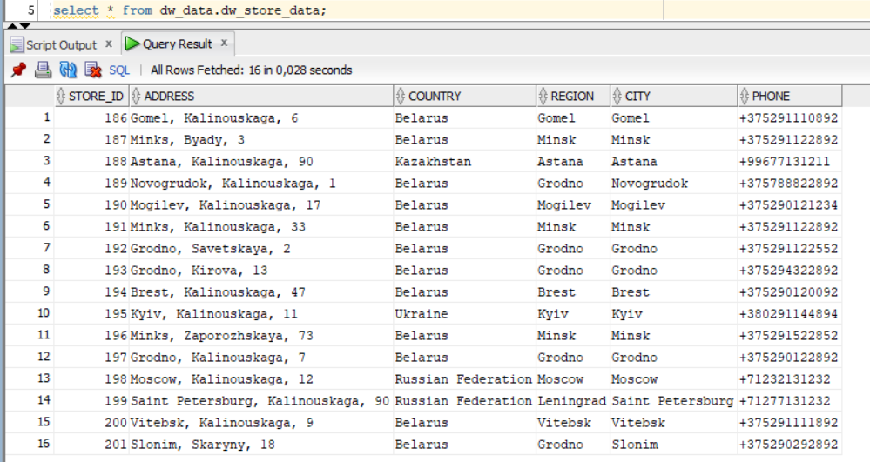

1. **Using DBMS_SQL.TO_CURSOR_NUMBER Function**

PROCEDURE load_stores_to_cursor_number

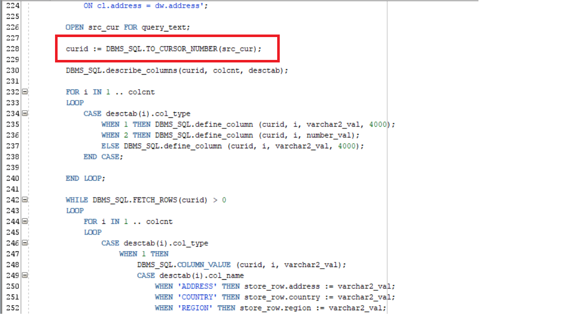

Executing:

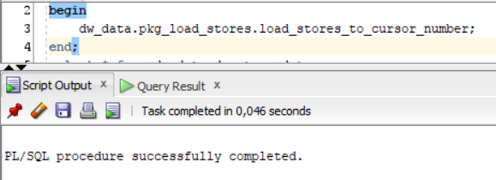

Result:

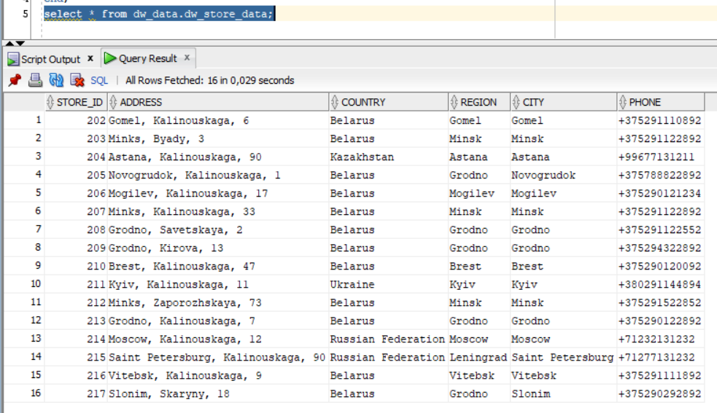

## 3.1. Task 02: CREATE Monthly Reports Layouts

Let’s calculate monthly sales report using Model Clause

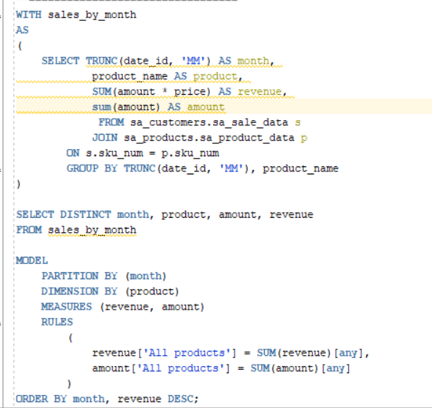

Result:

