**Anton Slizh’s**

**U2M6.LW.Analytic Functions**

*GitHub:* [*https://github.com/drapejny/DataCamp2022*](https://github.com/drapejny/DataCamp2022)

*Note: When I was doing this lab someone allocated too much memory and I couldn’t load my data to DW layer.*

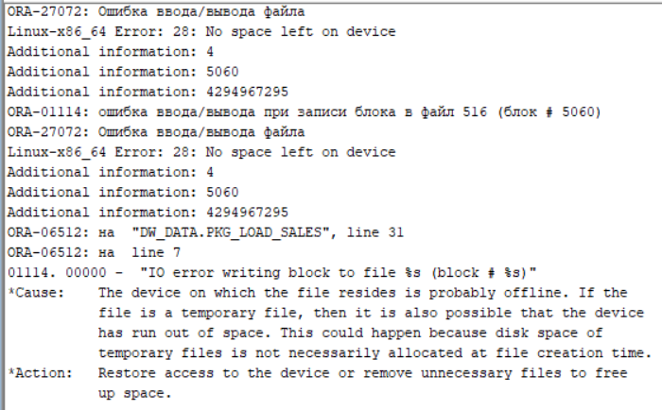

*So, in the task below I will be used my DW_CL layer data, which was available when I performing this task.*

## 2.1. Task 01: Create Ad Hoc SQL FIRST_VALUE, LAST_VALUE

Selecting revenue for stores and showing the store with highest and lowest revenue for each country.

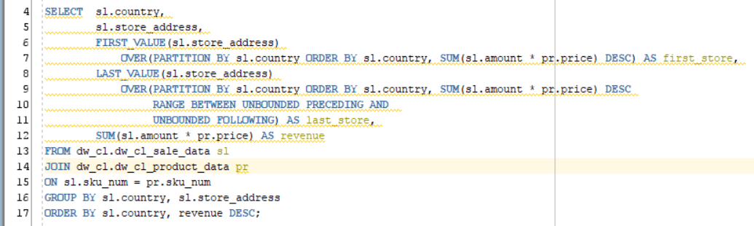

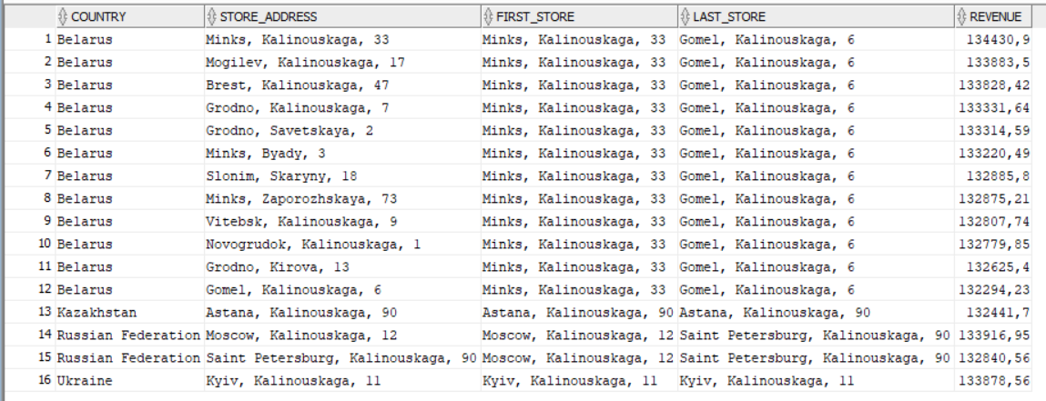

## 2.2. Task 02: Create Ad Hoc SQL RANK, DENSE_RANK, ROWNUM

Showing the difference between RANK, DENSE_RANK and ROW_NUMBER functions by selecting products for each day, store and product brand:

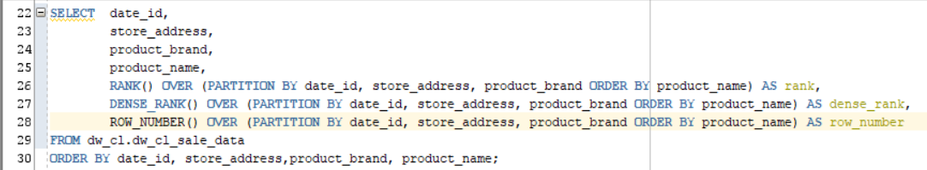

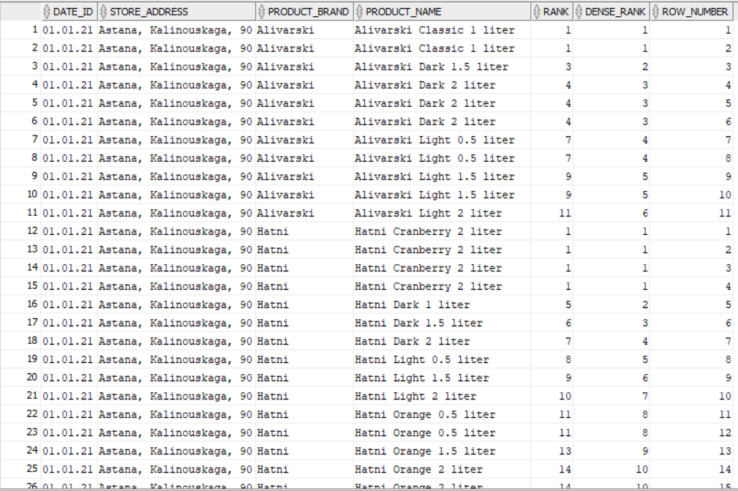

## 2.3. Task 03: Create Ad Hoc SQL AGGREAGATE FUNCS

Selecting daily revenue for each store. Also showing maximum, minimum and average daily revenue:

