**Anton Slizh’s**

**U2M7.LW.Materialized Views**

*GitHub: https://github.com/drapejny/DataCamp2022*

Granting user privileges:

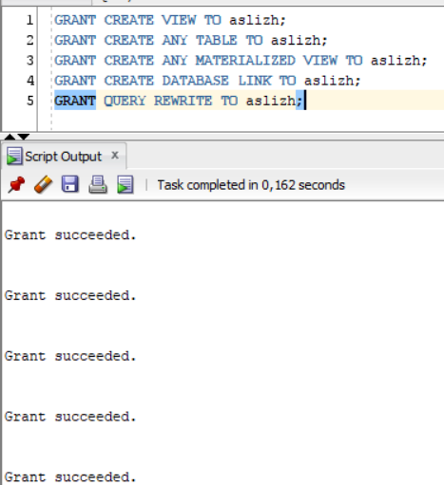

## 2.1. Task 01: Create Materialized Views - ON DEMAND

Creating materialized view with monthly revenue report:

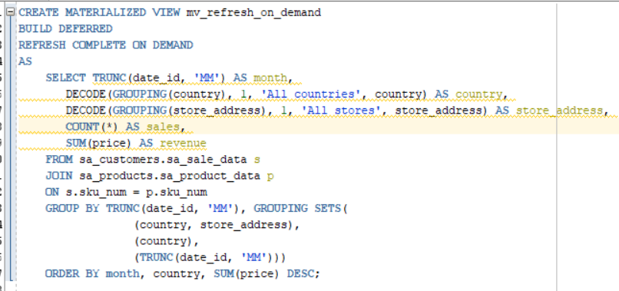

Refreshing data:



Selecting data:

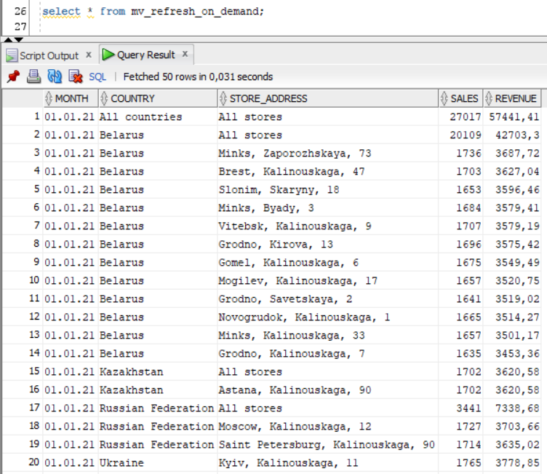

## 2.2. Task 02: Create Materialized Views - ON COMMIT

Creating materialized view

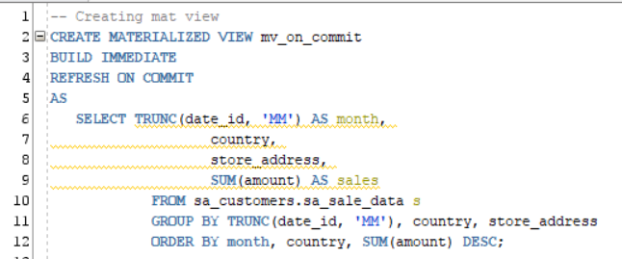

Selecting data:

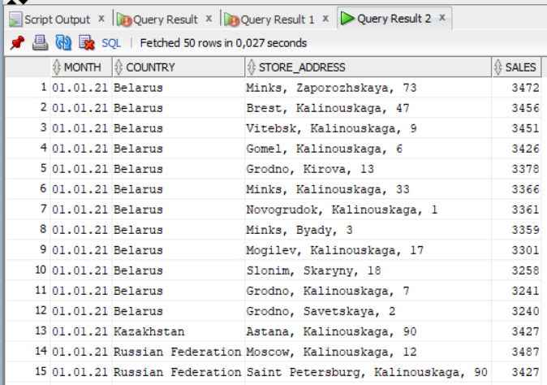

Deleting rows with *date_id = 01.01.2021* from *sa_customers.sa_sale_data*

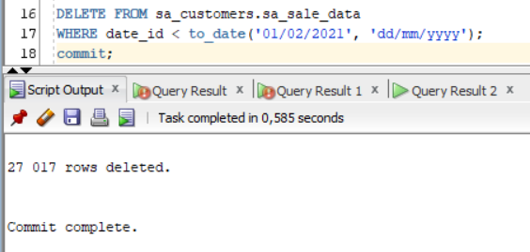

Selecting refreshed data in materialized view:

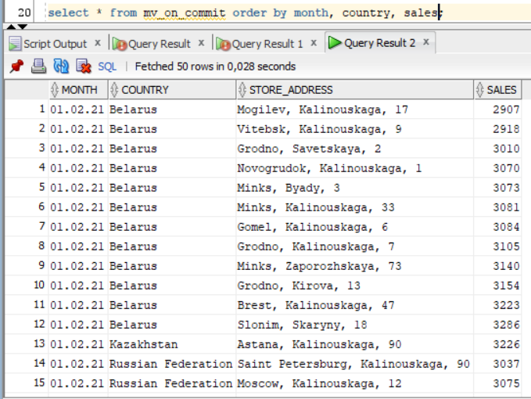

As we see the materialized view was refreshed after commit

## 3.1. Task 03: Create Materialized Views - Refreshing at definitive Time moment

Creating materialized view:

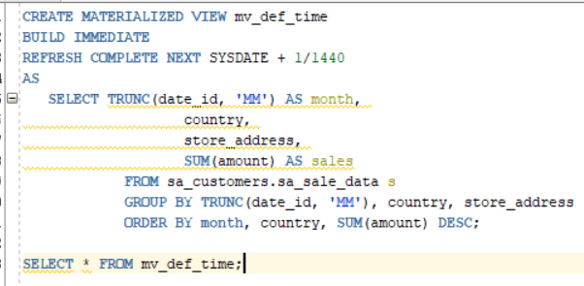

Selecting data (you can see the system time at the corner of screenshot):

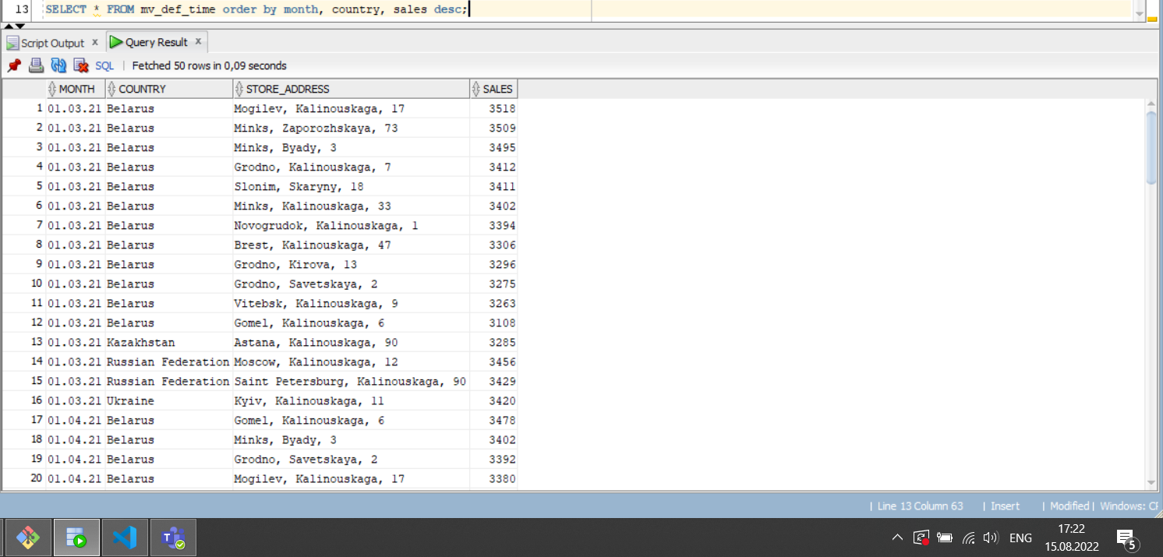

We have defined the update time to one minute. So, let’s make some changes and select data again.

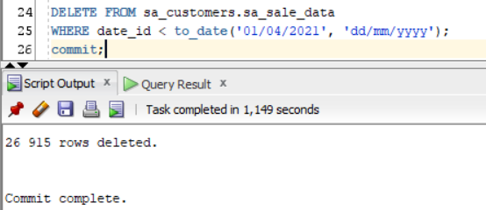

After small period of time let’s select data again (you can see the system time at the corner of screenshot):

