**Anton Slizh’s**

**U2M9.LW.ETL Overview - Transportation**

*GitHub: https://github.com/drapejny/DataCamp2022*

**Task 1**

## 2.1. Task 01: Transportation Description

The transportation method is highly depends on the source system being used. The most common and efficient way to transfer data is to use flat files and mechanism such FTP or other remote files system access protocols. Data is unloaded or exported from the source system into flat files and then transporting to the target platform using FTP or similar mechanism.

Because source systems and data warehouses often use different operating systems and database systems, using flat files is often the simplest way to exchange data between heterogeneous systems with minimal transformations. However, even when transporting data between homogeneous systems, flat files are often the most efficient and most easy-to-manage mechanism for data transfer.

**Task 2**

## 3.1. Task 02: Prepare Table of Facts to DW Layer

I have already created the package for load my fact table in Lab 4. Let’s look at the loading fact table *(fct_sales)* again.

Defining procedure and variables:

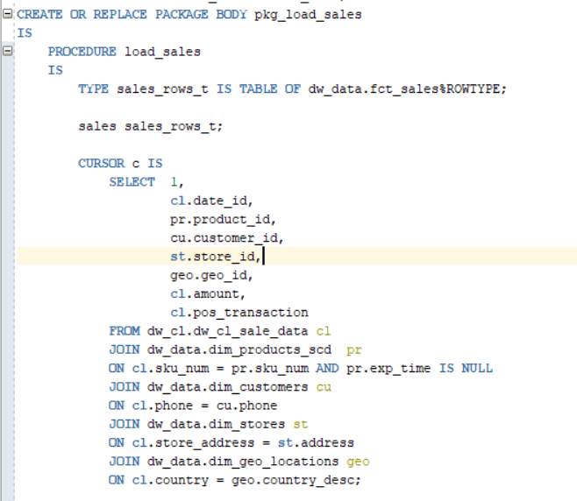

I have used the cursor to iterate throw the data. The cursor was created as select statement on the sales data from cleansing layer and joined data from dimensions (just to convert natural keys to surrogate).

The procedure body contains bulk collecting to the sales variable and further bulk insertion into fact table.

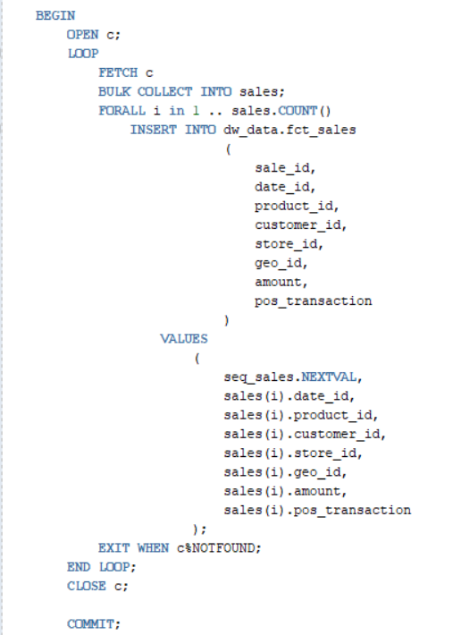

The load sales procedure executing after updating data in the dimensions:

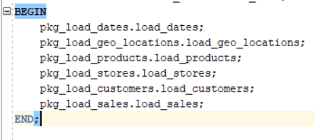

Result data:

