**Anton Slizh’s**

**U3M2.LW.Developing Integration Services Solutions**

**Task 1**

## 1.1. Exercise 1: Creating an Integration Services Project and implementing a package

Creating package scope variable, which will contain the number of exported rows.

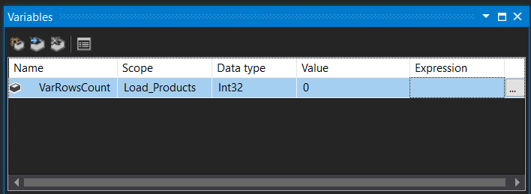

Creating the Data Flow Task to export data about products from Database into the Flat File.

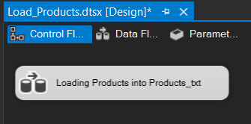

Creating Source OLE DB.

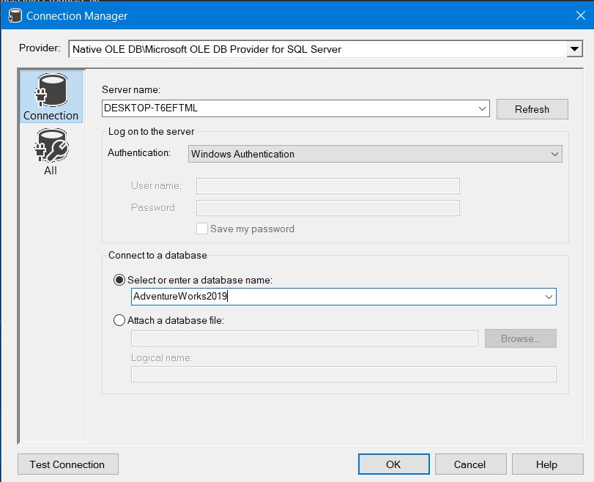

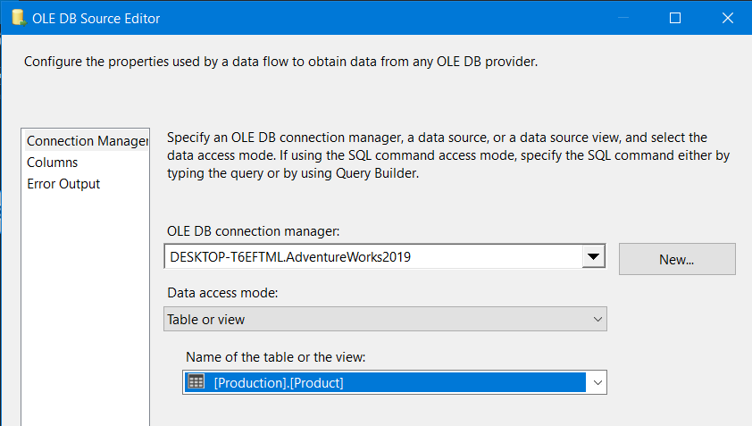

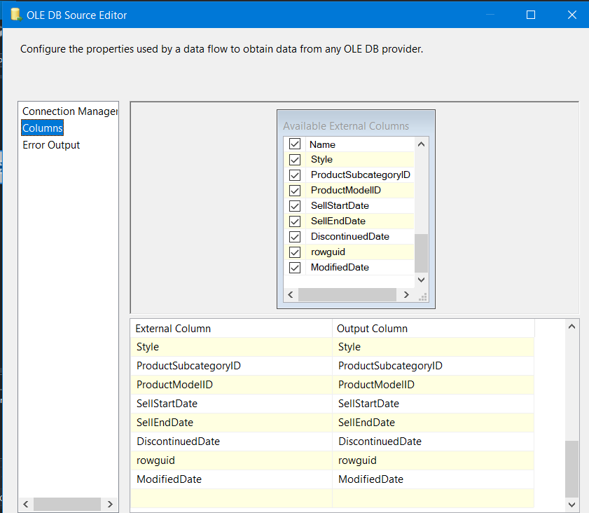

Creating Destination Flat File:

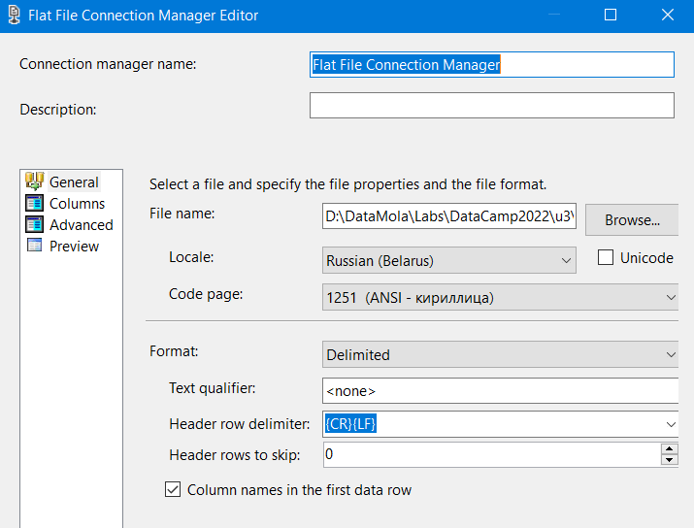

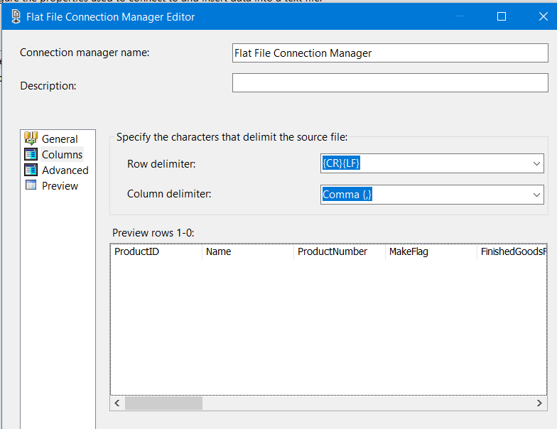

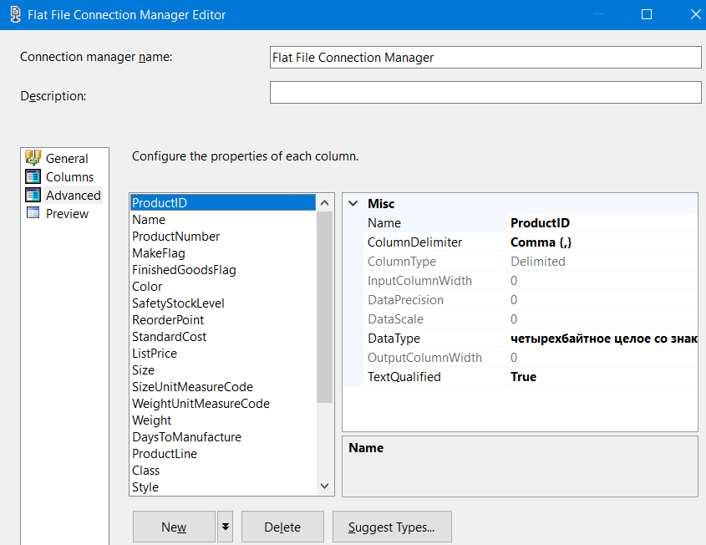

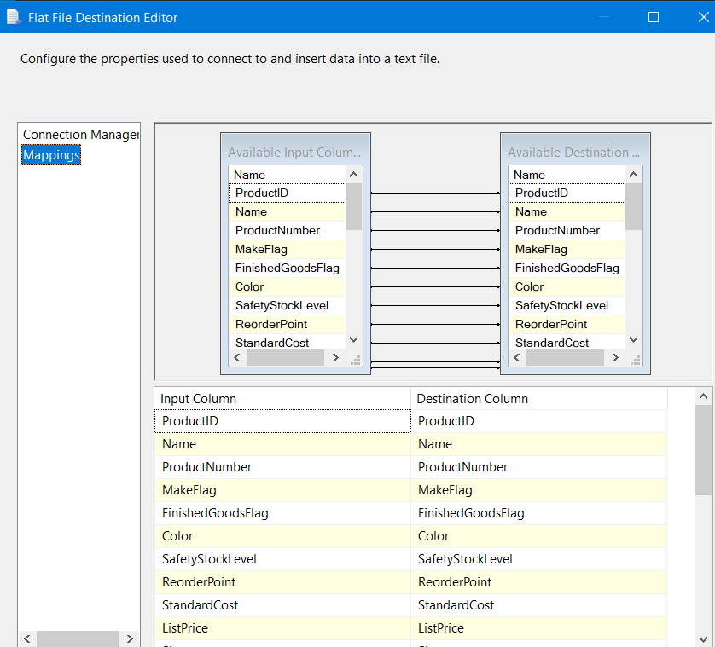

Now let’s create additional task between the Source and Destination which will count all inserted rows. The rows number will be written into recently created *VarRowsCount* variable.

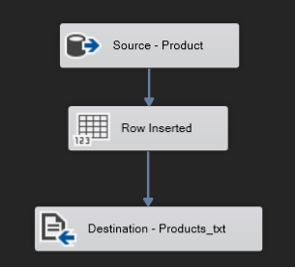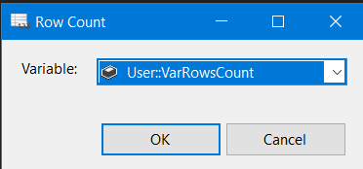

Let’s make sure that all working fine. Create Script Task and print the variable value.

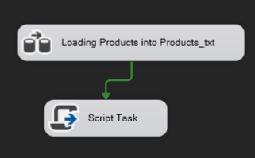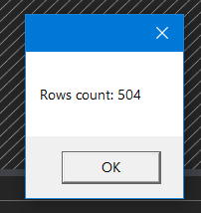

Now let’s create the Event Handler which will send the email after loading data into *Products.txt* file.

As the Send Mail Task doesn’t work with server which needs the credentials, we will write our own script to send messages.

Before writing a script we should create variables which contain our credentials and other email information.

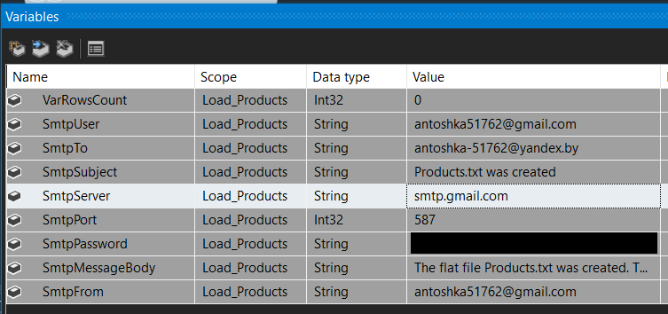

Creating the *OnPostExecute* Handler on *Loading Products into Products_txt* executable. 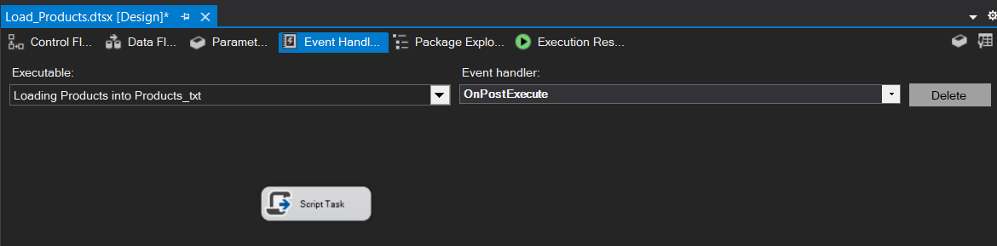

Selecting our variables to use them in the script

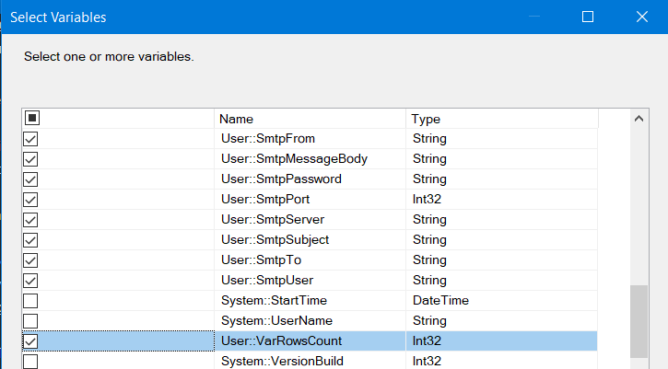

Writing the script code

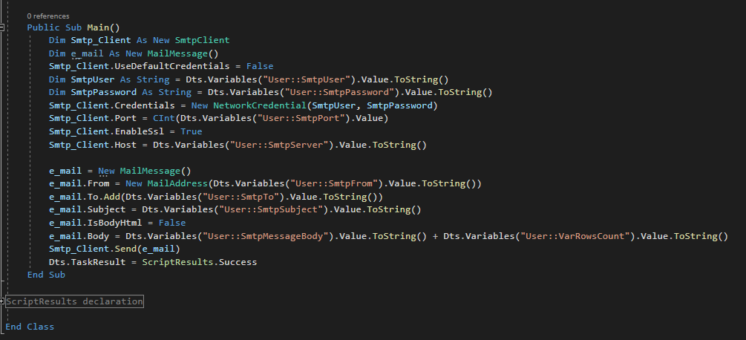

So, the task is completed.

Executing the package:

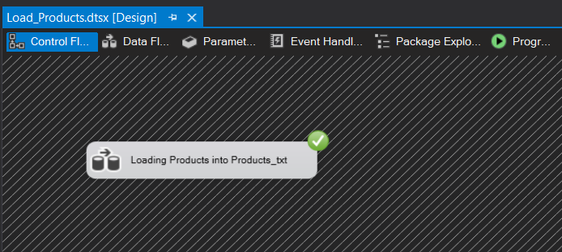

Looking at the data in the *Products.txt*

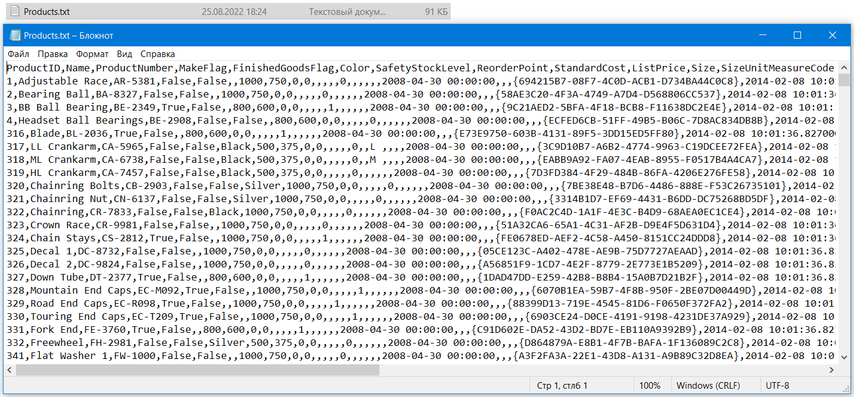

Looking at the E-Mail

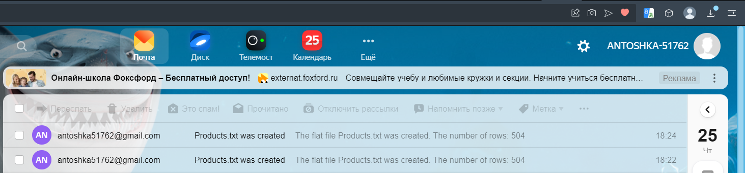

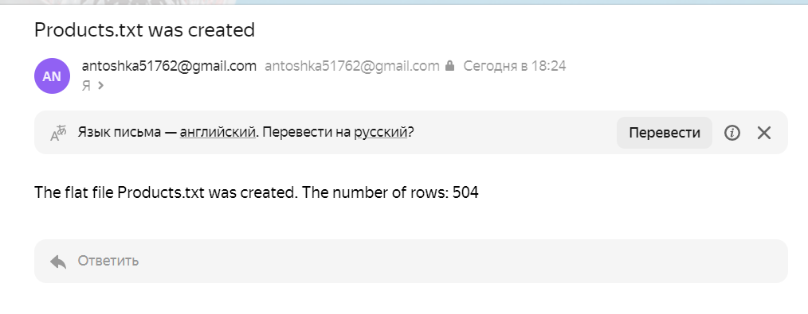

**Task 2**

## 1.2. Exercise 2: Creating a package to keep list of files from a directory