**Task 1**

Create resource group for storage account

>az group create --name storage-rg --location westeurope

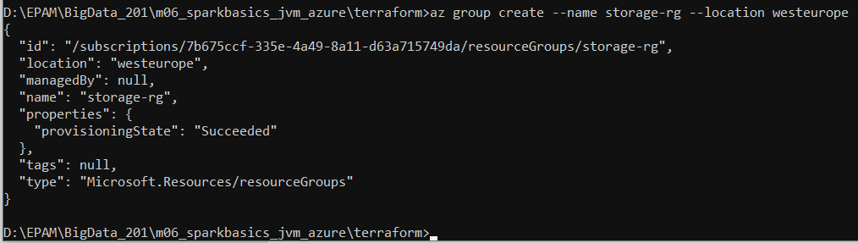

Create storage account

>az storage account create -n slizh --resource-group storage-rg --location westeurope --sku Standard_RAGRS --kind StorageV2

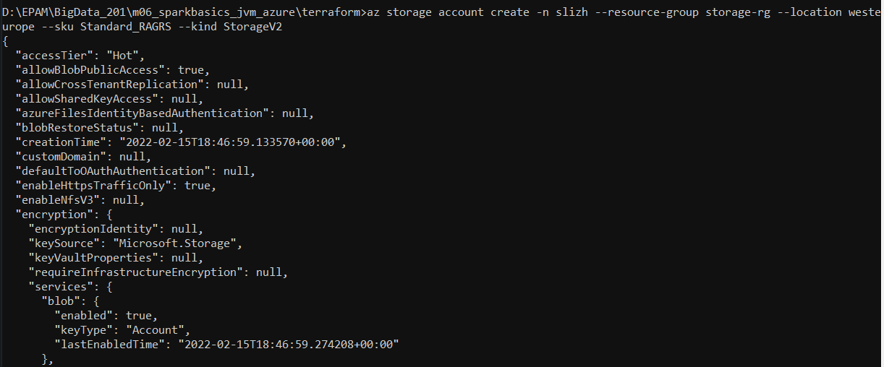

Create container

>az storage container create -n backends --account-name slizh --auth-mode login



Initialize terraform

>terraform init –reconfigure

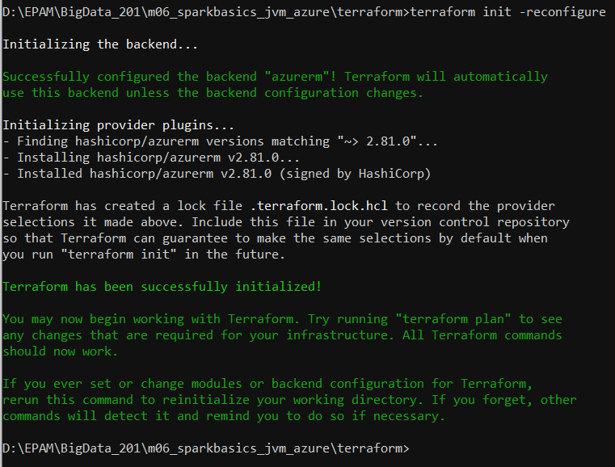

Create cluster resources

>terraform apply



Manually creating app, creating client secret. Managing roles and access permissions for storage account. Look at screenshots 1-6

Create Azure Container Registry

>az acr create --resource-group rg-slizh-westeurope --name slizhcr --sku Basic

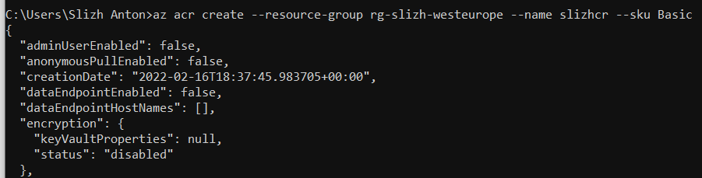

Manually managing roles for ACR. Look at screenshots 7-8

Configuring **kubectl** to connect to AKS using **az aks get-credentials**

>az aks get-credentials --resource-group rg-slizh-westeurope --name aks-slizh-westeurope



Checking cluster information

>kubectl cluster-info

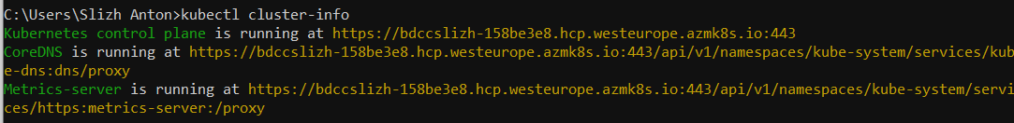

Integrate ACR with AKS

>az aks update -n aks-slizh-westeurope -g rg-slizh-westeurope --attach-acr slizhcr

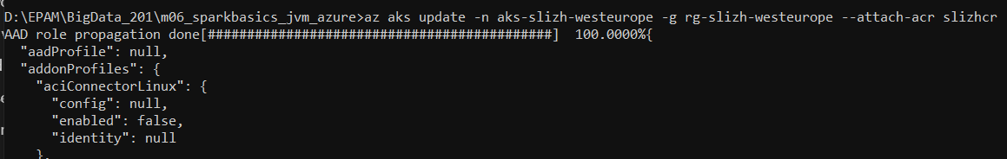

Dowload Spark from [**https://dlcdn.apache.org/spark/spark-3.2.1/spark-3.2.1-bin-hadoop3.2.tgz**](https://dlcdn.apache.org/spark/spark-3.2.1/spark-3.2.1-bin-hadoop3.2.tgz) and extract to D:\Programs\spark-3.2.1-bin-hadoop3.2

Сreate System Variable SPARK_HOME

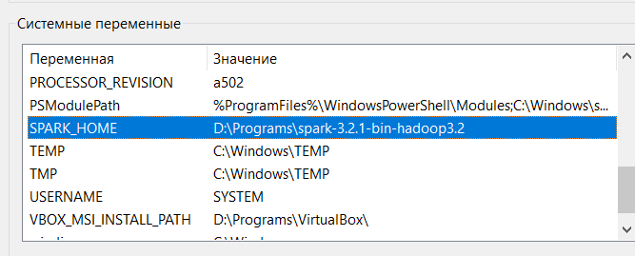

Deploy spark app manually:

>mvn clean package

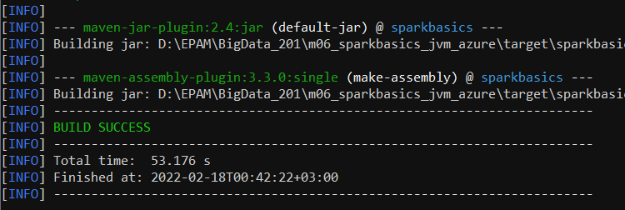

>docker build --no-cache -f docker\Dockerfile -t spark-image .

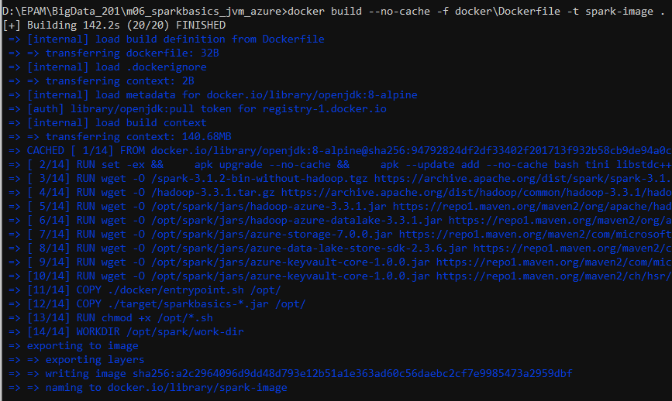

>docker tag spark-image slizhcr.azurecr.io/spark-basics

>docker push slizhcr.azurecr.io/spark-basics

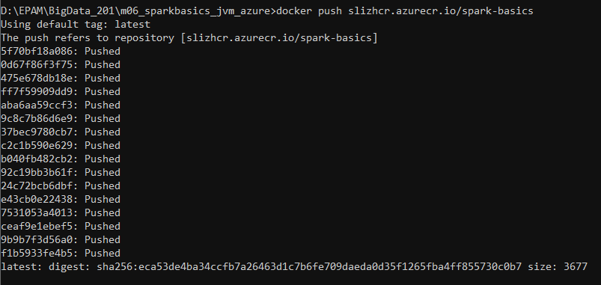

>%SPARK_HOME%\bin\spark-submit --master k8s://https://bdccslizh-158be3e8.hcp.westeurope.azmk8s.io:443 --deploy-mode cluster --name spark-pi --class by.slizh.sparkbasics.Main --conf spark.executor.instances=5 --conf spark.kubernetes.container.image=slizhcr.azurecr.io/spark-basics --conf spark.kubernetes.container.image.pullPolicy=Always local:///opt/sparkbasics-1.0.0-jar-with-dependencies.jar

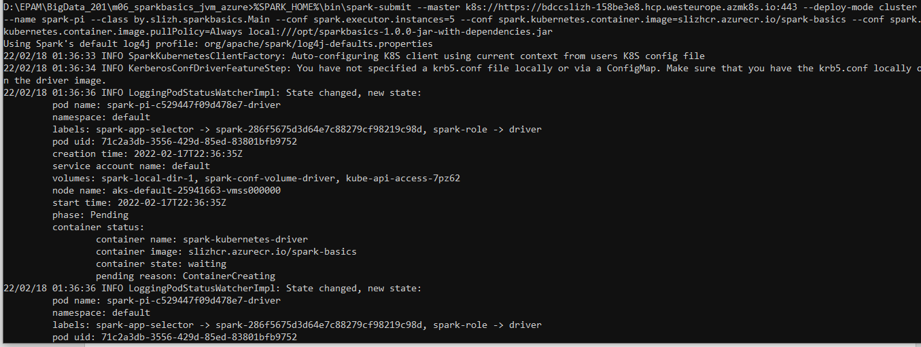

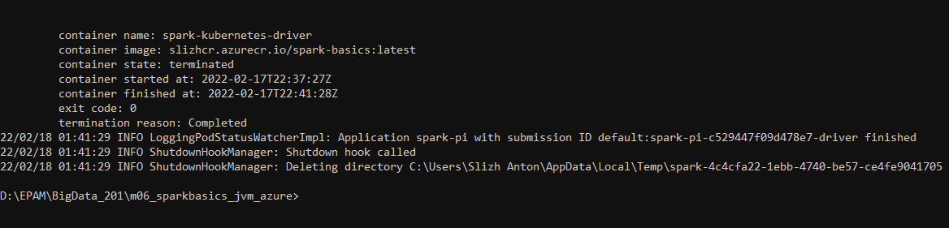

Final result

