**Preface**

**GEN 0**

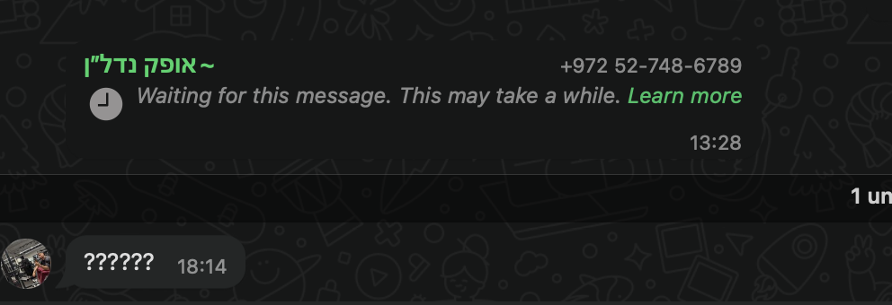

test