Do you also want to transform your ....

Youre at the right place

Balancing Energies, Enriching Lives

Your Gateway to Positive Energy

Harmonizing Spaces, Energizing Lives: Your Path to Vaastu Solutions

Building Balance, Transforming Spaces

Balanced Spaces, Blissful Living

Feel Good, Live Better

Feel better, live the best

Simple Steps, Rich Rewards

Radiant Homes, Radiant Lives

Story about how vastu evolved

1. "Elevate Your Lifestyle with Vaastu Elegance"
2. "Luxury Living Redefined through Vaastu Wisdom"
3. "Crafting Opulent Spaces with Vaastu Mastery"
4. "Indulge in Luxurious Vaastu Living"
5. "Experience the Essence of Luxury with Vaastu Harmony"
6. "Vaastu Splendor for Your Luxe Lifestyle"
7. "Embrace Luxurious Living, Embrace Vaastu Brilliance"
8. "Vaastu: Where Luxury Meets Harmony"
9. "Luxury Living, Perfected by Vaastu Design"
10. "Vaastu Elegance for the Discerning Lifestyle"

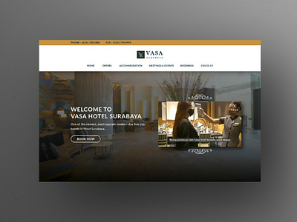

https://advancegeovastu.com/