- Create a table listing 3 types of printers, 2 types of scanners, and 2 types of webcams, and for each, write one real-life use case (for example: 'Inkjet printer – printing college assignments').
ANS:

Device Type | Type | Real-Life Use Case
Printer | Inkjet Printer | Printing college assignments.
Printer | Laser Printer | Printing office documents.
Printer | Dot Matrix Printer | Printing bills and invoices.
Scanner | Flatbed Scanner | Scanning photos and documents.
Scanner | Handheld Scanner | Scanning barcodes and small documents.
Webcam | USB Webcam | Online classes and video meetings.
Webcam | Built-in Webcam | Video calls on a laptop.
- Draw a labeled diagram showing how a typical home printer connects to a laptop or PC, including the connection interface used (USB, Wi-Fi, or Bluetooth).
ANS:
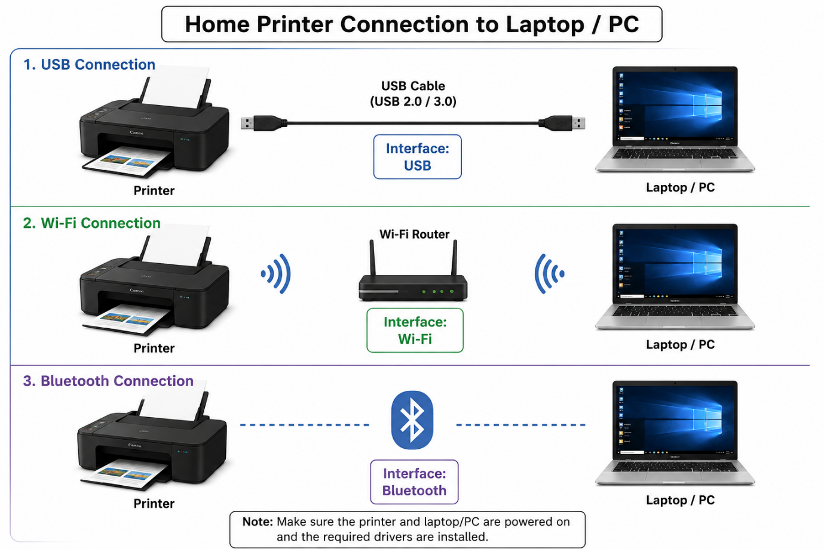
- List three different connection interfaces (such as USB, Wi-Fi, Bluetooth) used by peripherals like printers, scanners, and webcams, and for each, name one advantage and one disadvantage.<br><br><em><strong>Hint:</strong> Think about speed, convenience, and compatibility.</em>
ANS:
Connection Interfaces
Interface | Advantage | Disadvantage
USB | Fast and stable connection. | Limited by cable length.
Wi-Fi | Wireless and convenient. | Depends on network signal.
Bluetooth | No cables required. | Slower than USB and short range.
- Pick any one device you use at home or college (printer, scanner, or webcam). Write step-by-step instructions for how you would connect it to your computer, including what cable or wireless method you would use and any setup steps required.
ANS:

- Turn on the printer.
- Connect the USB cable to the printer and computer.
- Wait for the computer to detect the printer.
- Install the printer driver if required.
- Open Settings > Printers & Scanners and add the printer.
- Print a test page to check that it is working.

