- Draw a labelled diagram of a typical home WiFi router and a network switch, clearly marking at least 3 different ports (such as WAN, LAN, Console) and the location of status LEDs.
ANS:
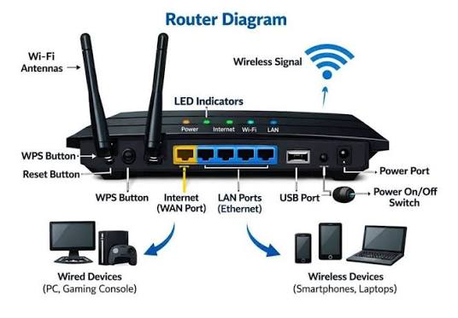

- ist 3 key differences between routers and switches in terms of their main functions and how they handle network traffic.<br><br><em><strong>Hint:</strong> Think about how each device deals with IP addresses, MAC addresses, and the types of networks they connect.</em>
ANS:
- Function: A router connects different networks, while a switch connects devices within the same network (LAN).
- Address Used: A router mainly uses IP addresses, while a switch uses MAC addresses to forward data.
- Traffic Handling: A router directs packets between different networks, while a switch forwards frames to the correct device within a local network.
- Take a real or virtual image of a router and a switch (from your home, lab, or Google Images), and identify the following on each: Power port, at least 2 Ethernet ports, and any LED indicators. Annotate the image or describe their position and purpose.
ANS:
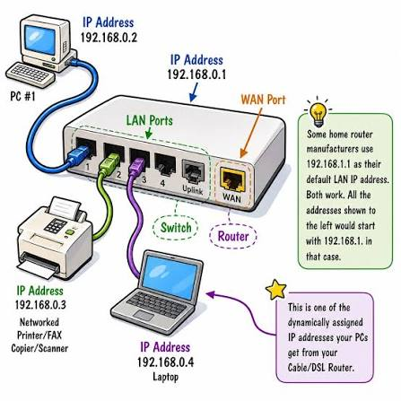

- Imagine you are setting up a small gaming café network for IPL streaming and multiplayer matches. Write a short scenario explaining which device (router or switch) you would connect first to the ISP line, and how you would connect 8 gaming PCs to the network. Justify your choices.
ANS:
I would first connect the router to the ISP line because it provides Internet access to the cafe. Then, I would connect the router to a switch.
Network: ISP → Router → Switch → 8 Gaming PCs

