- Draw a labeled diagram of a typical home Wi-Fi setup showing a modem, router, switch, access point, and at least two devices (like a laptop and smartphone) connected to the network.
ANS:
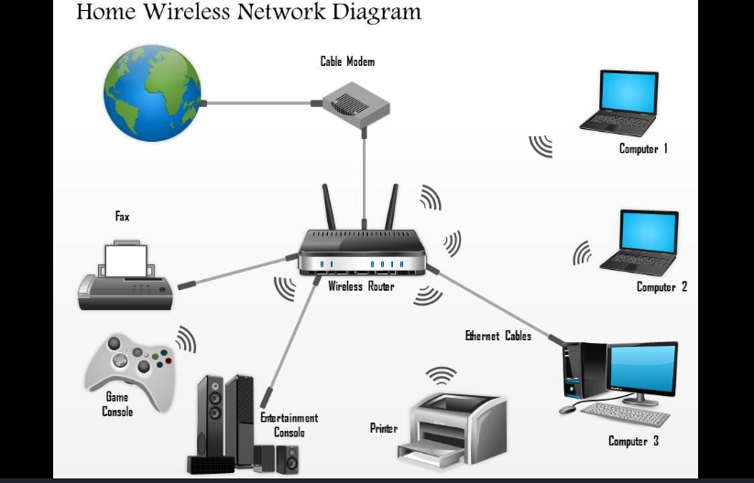
- List the main function of each networking hardware device: modem, router, switch, access point, and network cable. For each, give a real-life example of where you might see or use it (for example, 'router: at home to share internet').
ANS:
1.Modem: Connects the home network to the Internet.
2.Router: Connects different networks and shares the Internet.
3.Switch: Connects multiple devices in the same local network.
4.Access Point: Provides wireless network/Wi-Fi connectivity.
5.Network Cable: Transfers data between wired network devices.
3. Take photos or find images online (with source links) of at least three types of network cables (such as Ethernet, coaxial, fiber optic) and write one line describing where each is commonly used.
ANS:
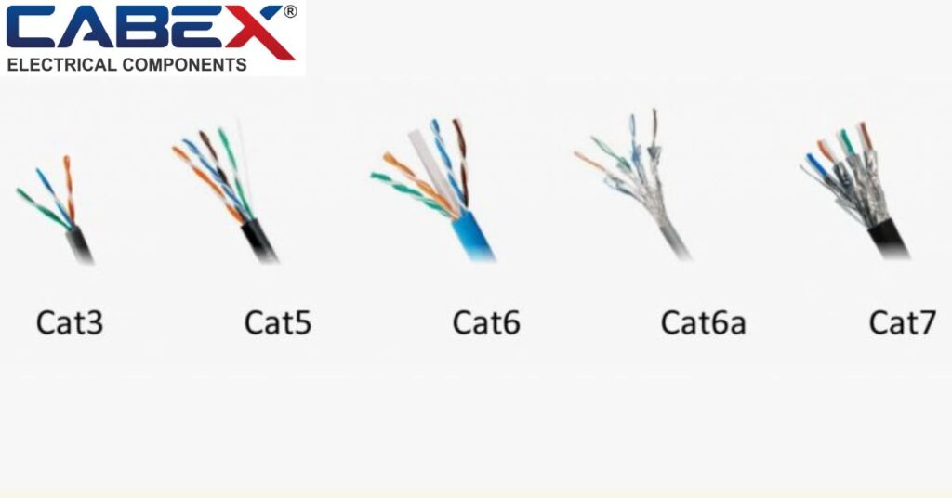
1. Ethernet Cable (RJ45):
Used to connect computers, routers, and switches in a LAN.
2. Coaxial Cable:
Commonly used for cable TV and broadband Internet connections.
3. Fiber Optic Cable:
Used for high-speed and long-distance Internet and telecommunications networks.
4. Create a comparison table listing at least four differences between a router and a switch, including their main use, typical location, and how they handle data.
ANS:

Point | Router | Switch
Main Use | Connects different networks and shares Internet. | Connects devices within the same network.
Typical Location | Used at home, office, or network edge. | Used inside LANs, offices, and computer labs.
Data Handling | Forwards packets using IP addresses. | Forwards frames using MAC addresses.
Internet Connection | Usually connects the local network to the Internet. | Usually connects devices to the local network.
Example | Home Wi-Fi router. | Switch connecting PCs in a computer lab.

