

**Dharmsinh Desai University, Nadiad**

**Faculty of Technology**

**Department of Computer Engineering**

B.Tech.(CE) Semester - VI

Subject : **System Design Practice (CE-621)**

Project Title: **Income Tax Return**

By: **Dhwani Popat (CE-100)(17CEUOS089)**

**Drashti Tandel (CE-133)(17CEUBS083)**

Guided by:

**Prof. Hariom A. Pandya**

**DHARMSINH DESAI UNIVERSITY**

College Road, NADIAD-387001 (GUJARAT)



**CERTIFICATE**

This is to certify that the term work carried out in the subject of **System Design Project** and recorded in this report is bonafide work of **Miss. Dhwani Popat (Roll No.:CE-100, Identity Number: 17CEUOS089), Miss. Drashti Tandel (Roll No.:CE-133, Identity Number: 17CEUBS083)** Of **B.Tech. Semester-VI** in the branch of Computer Engineering during the academic year 2019-20.

Prof. Hariom A. Pandya Dr. C. K. Bhensdadia

(Project Guide and Assistant Professor) Head Of CE Dept.,

Faculty of Technology, Faculty of Technology,

Dharmsinh Desai University, Dharmsinh Desai University,

Nadiad. Nadiad.

**TABLE OF CONTENTS**

Abstract…...……………………….……………………………………………4

1.Intoduction……………….……………………………………..…….………5

1.1Project Details: Brief Specifications………………………………………………5

1.2 Technology Used……………………………………………..…………………...5

2.Software Requirement Specifications………….………………...…………...6

2.1 Functional Requirements………………………………………………………….6

2.2NonFunctionalRequirements…………………………………...………………….8 3.Design……………….………...………………………………………..……..9

3.1 Use Case Diagram………...……………………………………………………….9

3.2 Class Diagram……………………………………………………...........................9

3.3 Sequence Diagram..…………………………………………………......................11

3.4 Activity Diagram…..……………………………………………….………………11

3.5 State Diagram.…………………………………………………………………...…12

3.6 E-R Diagram……………………………..………………………..………………..14

3.7 Data Dictionary …………………………………………………………………….16

4.Implementation Details…………….....……………………………………...…17

4.1Implementation Environment……………………………………………………….17

4.2 Description Of Modules……………………………………………...…………..….17

4.3Function Prototype…………………………..……………………………………….17 5.Testing……………………………………………………...…………………...19

6.Screenshots………………………………………………………………..….....21

7.Conclusion………………………………………..………………………..……25

8.Limitations and Future Extensions of the System……………….…...................26

8.1 Limitations……………………………………………………………………….….26

8.2Future Extensions………………………………………………………...….………26 9.Bibliography………………………………..……………………………...……27

**Abstract**

To run this world and the economy of any country, there is requirement of money and it is essential to pay tax to the country to be developed.

In a world where everything is governed by technology and for the generation that wants everything immediately without giving more time, the ‘Income-Tax Calculator in Gujarati’ aims at providing the users efficient platform for Calculating Income-tax by filling the forms which are in Gujarati.

**1.INTRODUCTION**

* 1. **Project Details : Broad Specifications**

Income-Tax calculator will provide the forms in Guajarati so that one can understand easily, and for taking feedbacks we are giving facility to generate forms dynamically for admin. Here User can also calculate income-tax according to new tax rules.

* 1. **Technology Used**

**Back End:** Python ( Django )

**Front End:** HTML, CSS, BOOTSTRAP, JavaScript, jQuery

**Database:** MySql

**2. SOFTWARE REQUIREMENT SPECIFICATIONS**

**2.1 Functional Requirements**

1. End-User

R.1 Login and Registration for Application

R.1.1 Registration for Application

Description: This function creates account.

Input: Person's Details

Output: Appropriate Response

Exception: Error Message

R.1.2 Login for Application

Description: Logging In

Input: User Details

Output: Appropriate Response

Exception: Error Message

R.2 Manage Profile

Description: User can Manage Profile

R.2.1 Add Profile Details

Input: User Information

Output: Success Message

R.2.2 Update Profile

Input: Update Design for T-Shirt

Output: Success Message

R.2.3 View Profile

Input: User Selection

Output: Success Message

R.3 Manage Tax

Description: User can calculate Tax

R 3.1 Calculate Tax

Input: Income Details

Output: Appropriate answer

R 3.2 View Tax

Input: User Selection

Output: Tax Details

R 3.1 Delete Tax

Input: User Selection

Output: Success Message

R.4 Give Feed-Back

Description: User can give the feed-back

Input: Appropriate Answers

Output: Success message

2. Admin

R.1 Login for the admin

R.1.1 Login for Application

Description: Logging In

Input: User Details

Output: Appropriate Response

Exception: Error Message

R.2 Create Feed-Back Form

Description: Admin can create and View Feed Back Forms

R.2.2 Generate Forms

Input: Form Details

Output: Success Message

R.2.2 View Form

Input: User Selection

Output: Appropriate Output

**2.2 Non-Functional Requirements**

**2.2.1 Software Quality Attributes**

1. **Flexibility:**

The system should be developed in such a way that, that is easily customized. If new functions are required, there will be little effort required to update the system to support new transactions.

1. **Reliability:**

As the system provides the right tools for discussion, it must be made sure that the system is reliable in its operations and for securing the sensitive details.

**3.DESIGN**

**3.1 Use Case Diagram**

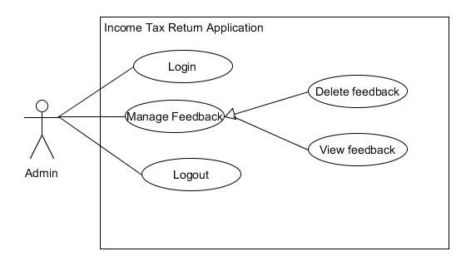

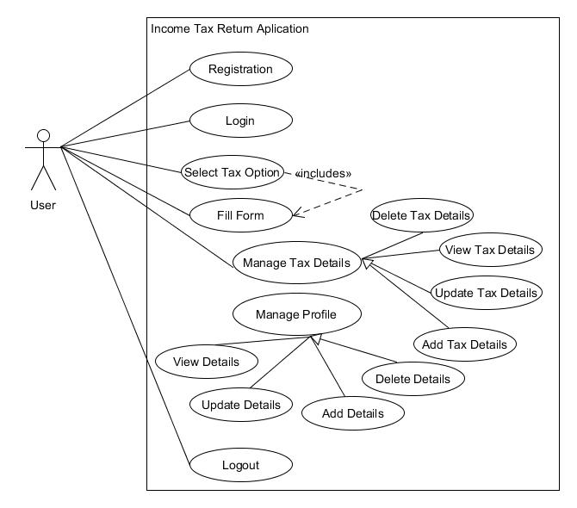

**3.2 Class Diagram**

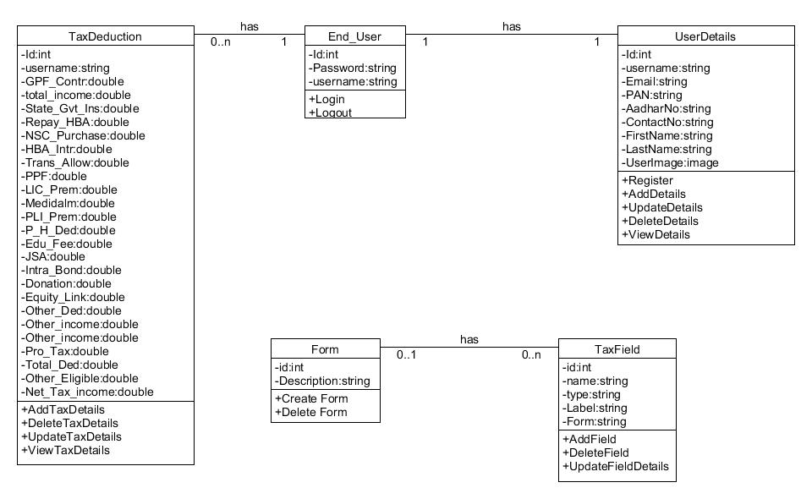

**3.3 Sequence Diagram**

* View Tax Details

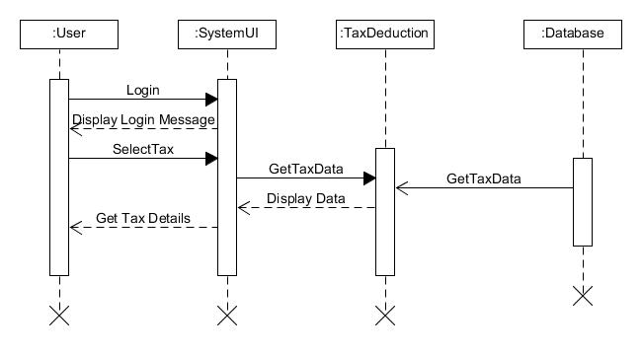

* Add New Entry

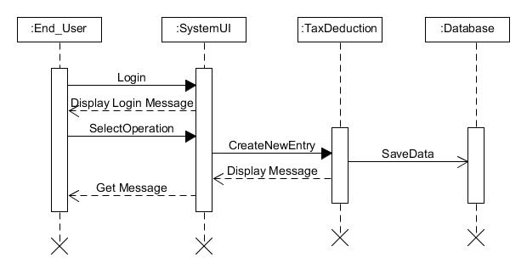

**3.4 Activity Diagram**

* Manage Tax Details

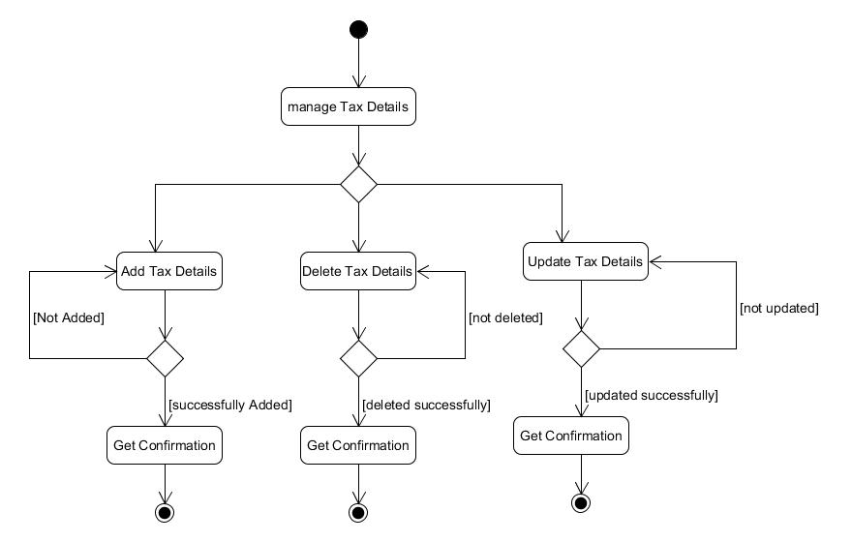

* Fill Form

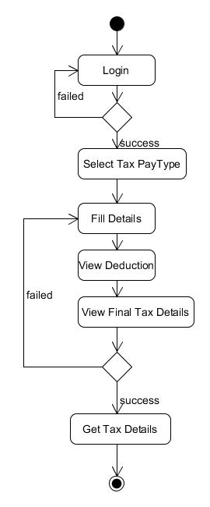

**3.6 ER Diagram**

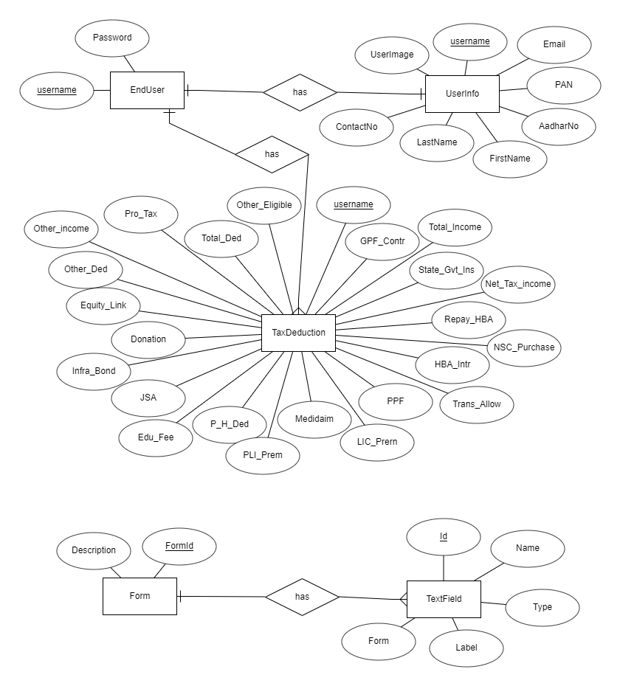

**3.7 Data Dictionary**

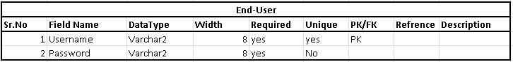

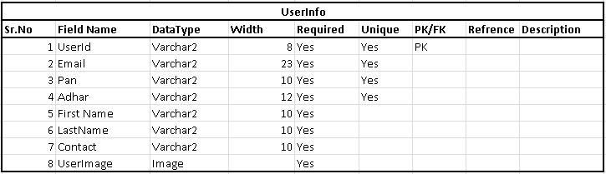

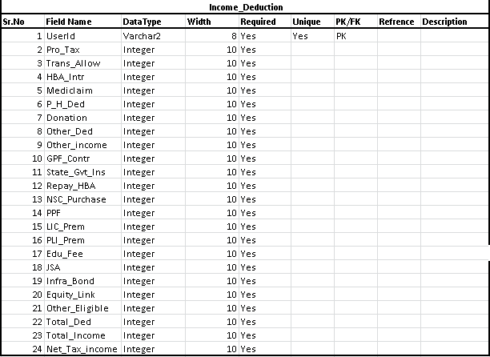

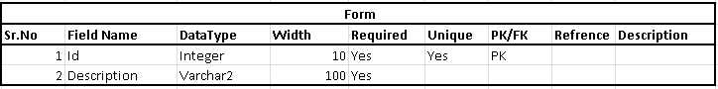

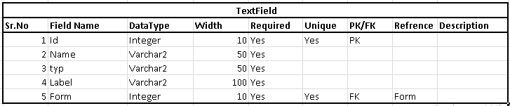

**4.IMPLEMENTATION DETAILS**

**4.1 Implementation Environment**

Visual Code in Windows 10

**4.2 Description of Modules**

1. **Register Module:**

This module is used to create the account on website. All fields are contain some types of validations. Then user can login to our website using his/her credentials.

1. **Login Activity :**

This module takes users credentials and then verifies it with registered users, If user have entered incorrect credentials then alert with “Incorrect credentials. Try Again letter”, otherwise user will be redirected to the home page with welcome message.

1. **Main Module :**

This module contains the main homepage of the system which provides basic information about the website. It contains inline navigation to go to different parts of the pages. This module does not needs authentication. It contains buttons for sign in and login.

1. **User Home Module :**

This module is accessed by only logged in user, User can search different tax pay options according to his requirement, he/she can fill details, applicable to see his/her personal information. User can also logout if he/she wants, so, he/she will be redirected to main home page of website.

1. **Admin Home Module :**

This module is accessed by only admin user, Admin Can generate dynamic feedback forms to take different reviews every time. Admin can manage different categories, subcategories different types of tax deduction, manage tax paying rules Admin can see reviews of the application, too.

1. **Give Feed-Back Activity :**

This module is accessed by only logged in user, User can give feedback as per his/her reviews about the application.

**4.3 Function Prototype**

* User Login:

def login(request)

def auth_view(request)

def loggedin(request)

def invalidlogin(request)

def logout(request)

* User Register:

def registration(request)

def new_registration(request)

* View Profile:

def profile2(request)

def useinfo1(request)

* Fill Form:

def itr1form(request)

def itr1dform1(request)

def itr1dform(request)

* **View Tax:**

def show(request)

* **Delete Tax-Details:**

def delete(request)

**5.TESTING**

In this system we have used Black Box testing. The main focus of black box testing is on the validation of your functional requirements.

Here are the generic steps followed to carry out any type of Black Box Testing.

✓ Initially, the requirements and specifications of the system are examined.

✓ Tester chooses valid inputs (positive test scenario) to check whether SUT processes them correctly. Also, some invalid inputs (negative test scenario) are chosen to verify that the SUT is able to detect them.

✓ Tester determines expected outputs for all those inputs.

✓ Software tester constructs test cases with the selected inputs.

✓ The test cases are executed.

✓ Software tester compares the actual outputs with the expected outputs.

✓ Defects if any are fixed and re-tested.

**Different Test Cases:**

For Login:

If user enters correct username and password then system shows the home page of the application. If user enters incorrect details than system will show the message “Something is wrong, check username or password”.

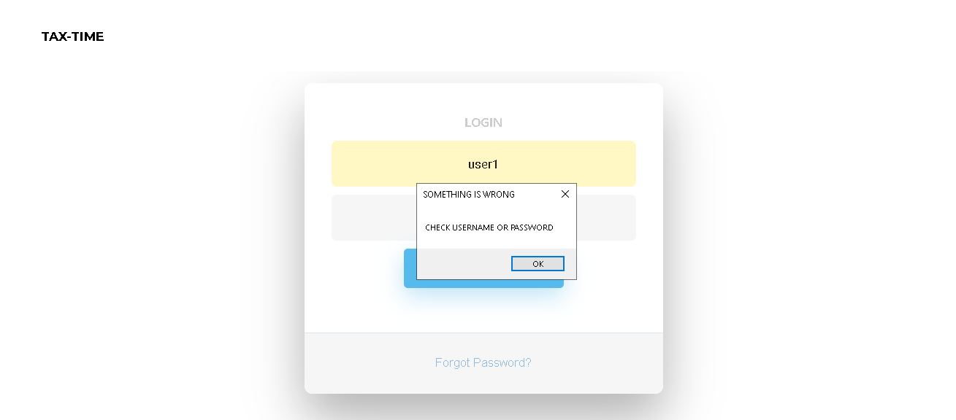

For User Register:

If user enters incorrect confirmation password then system will show “Password do not match” message. And if user enters correct data than he will be redirected to user details page.

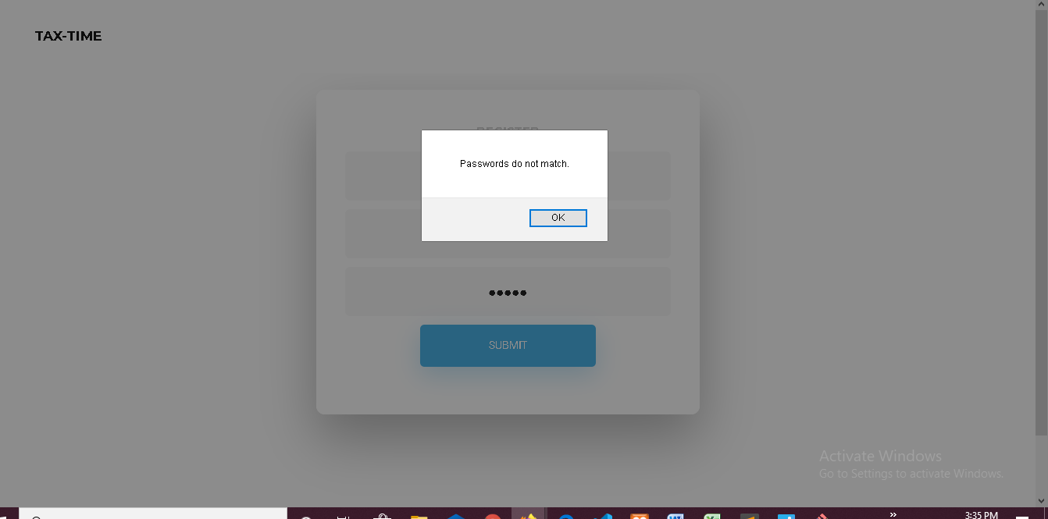

**6.SCREEN-SHOTS**

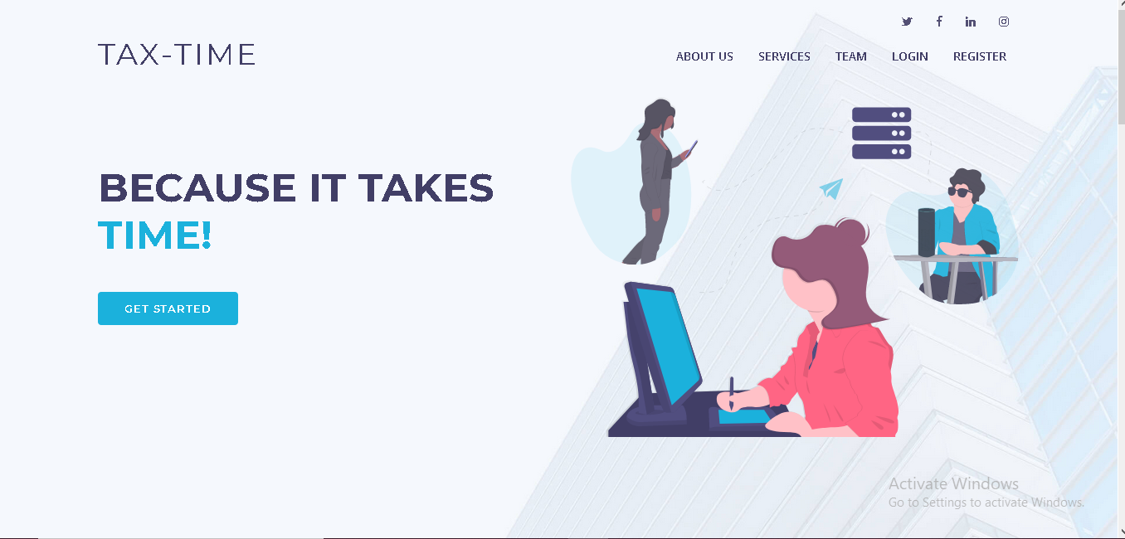

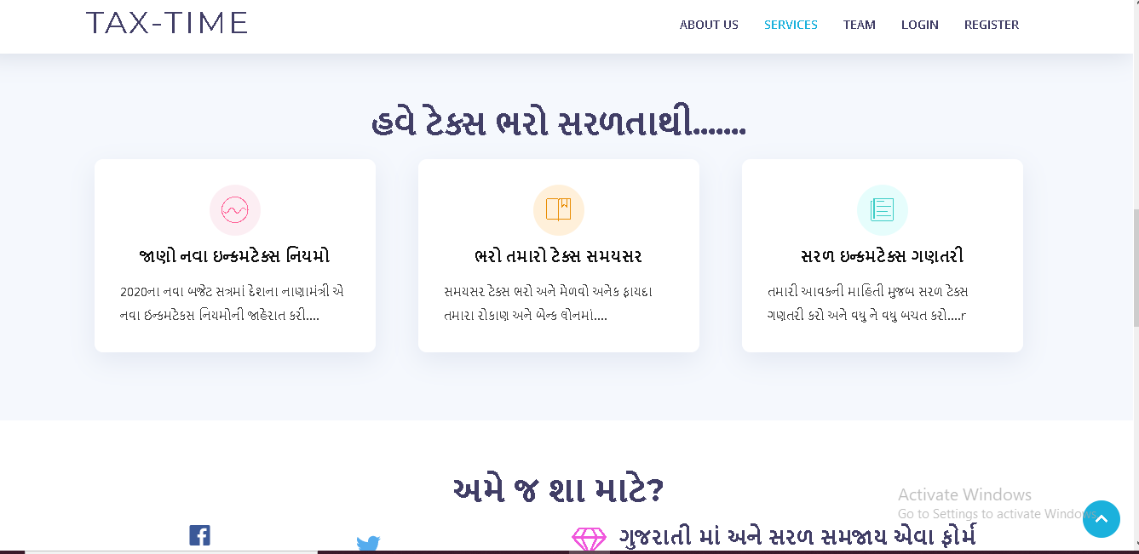

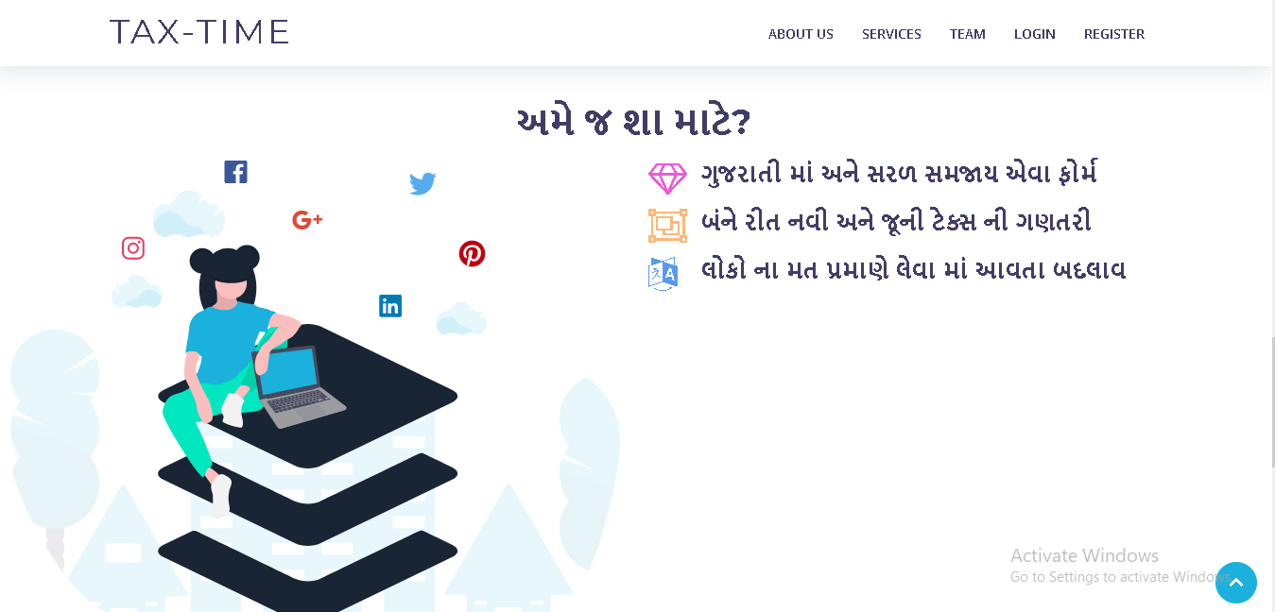

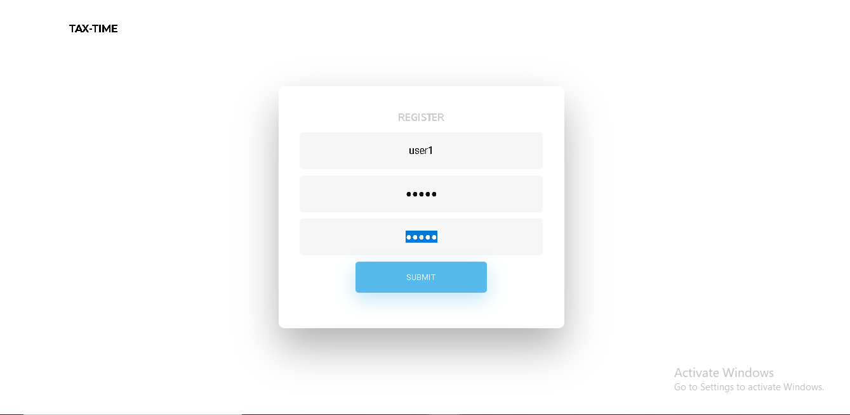

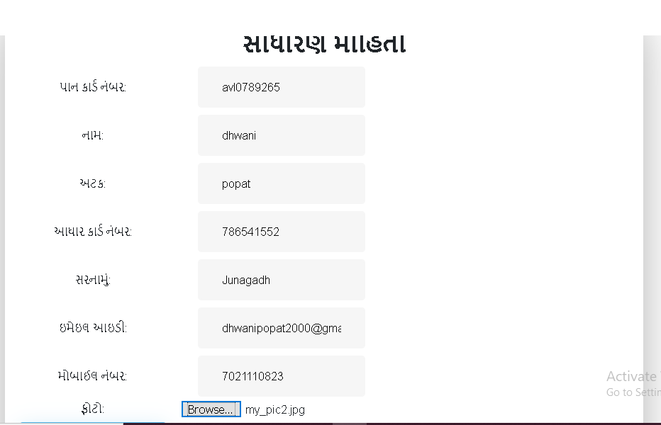

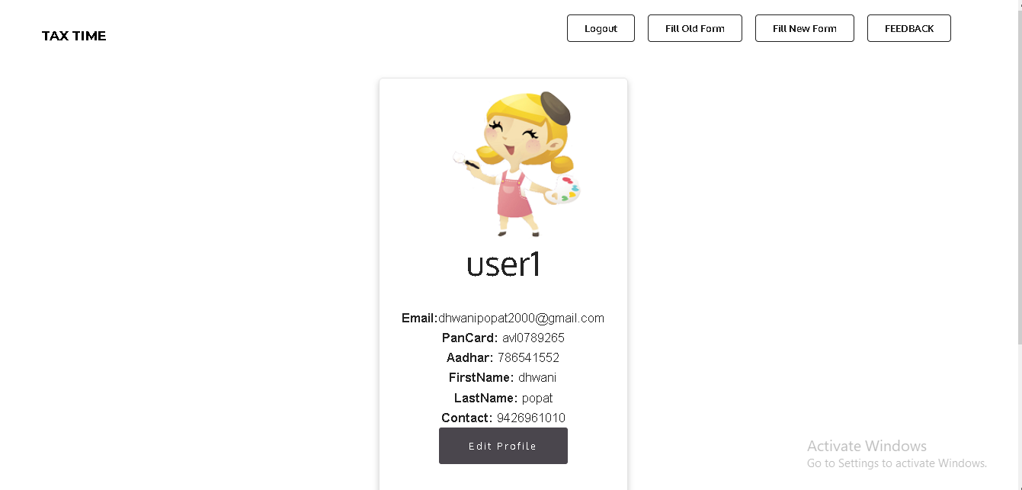

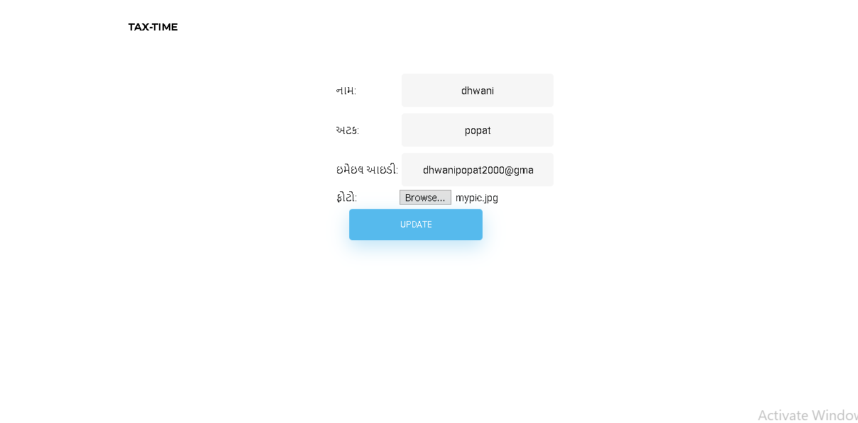

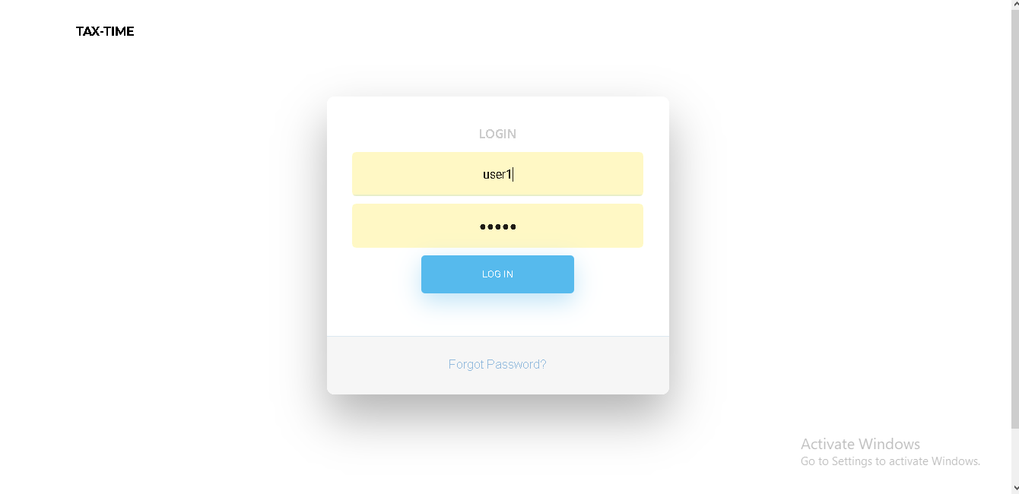

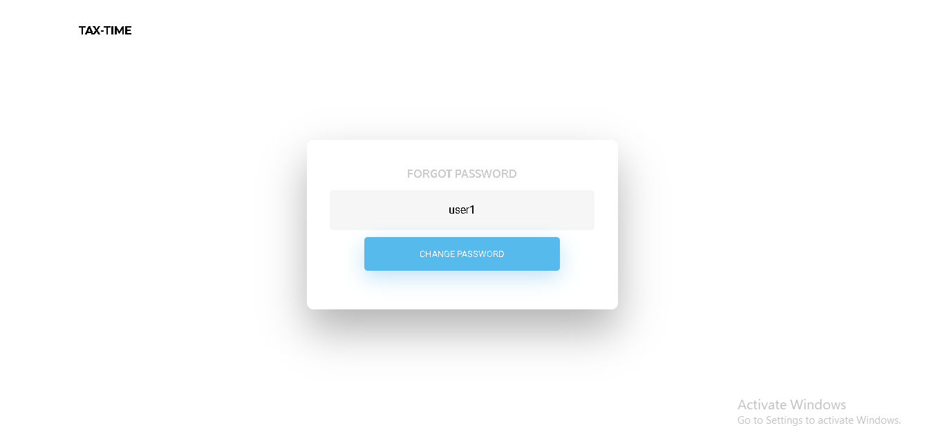

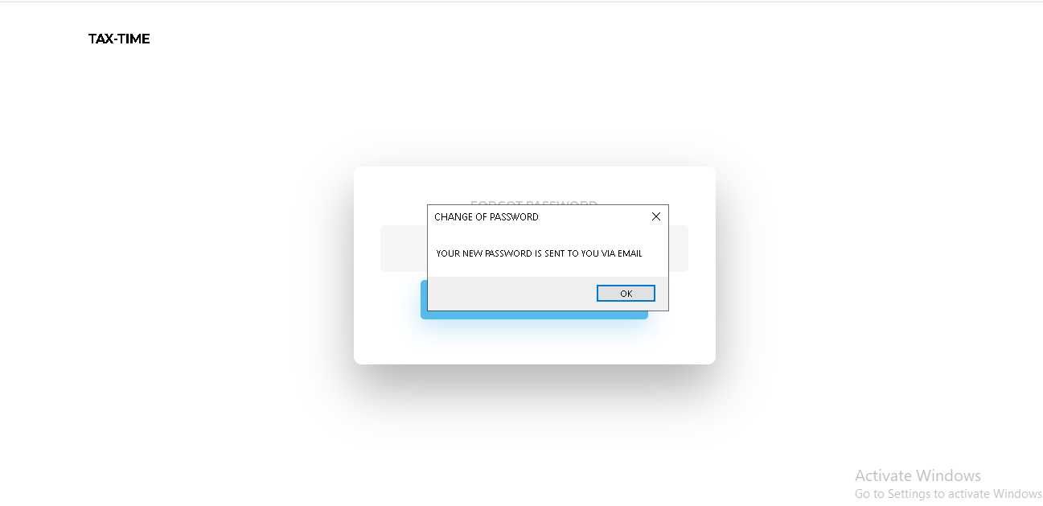



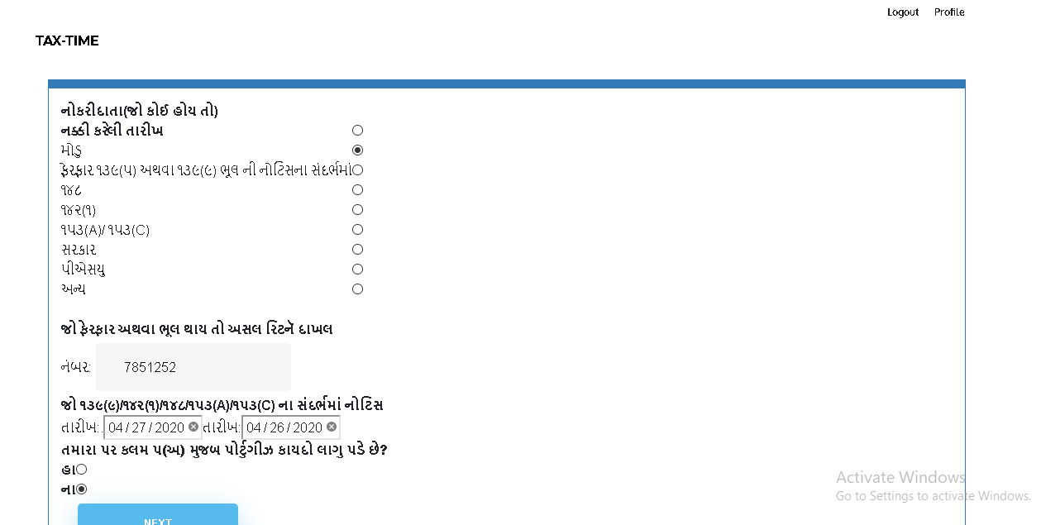

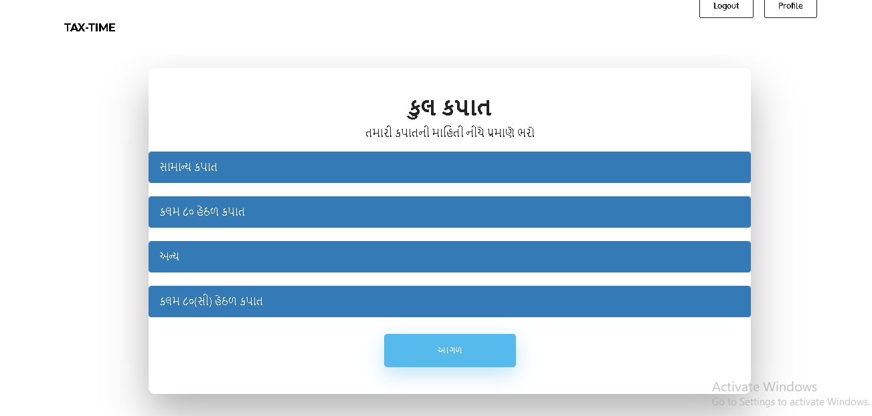

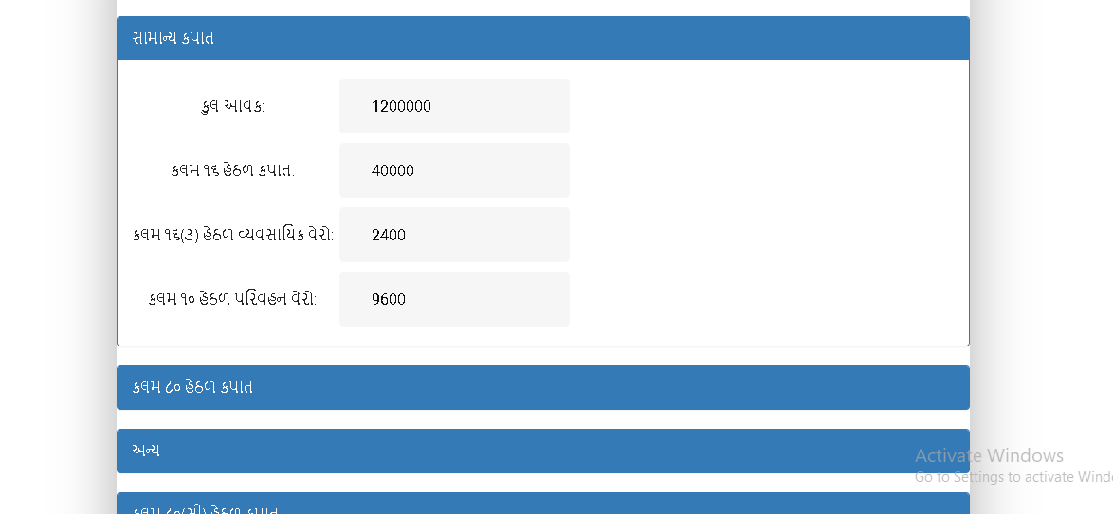

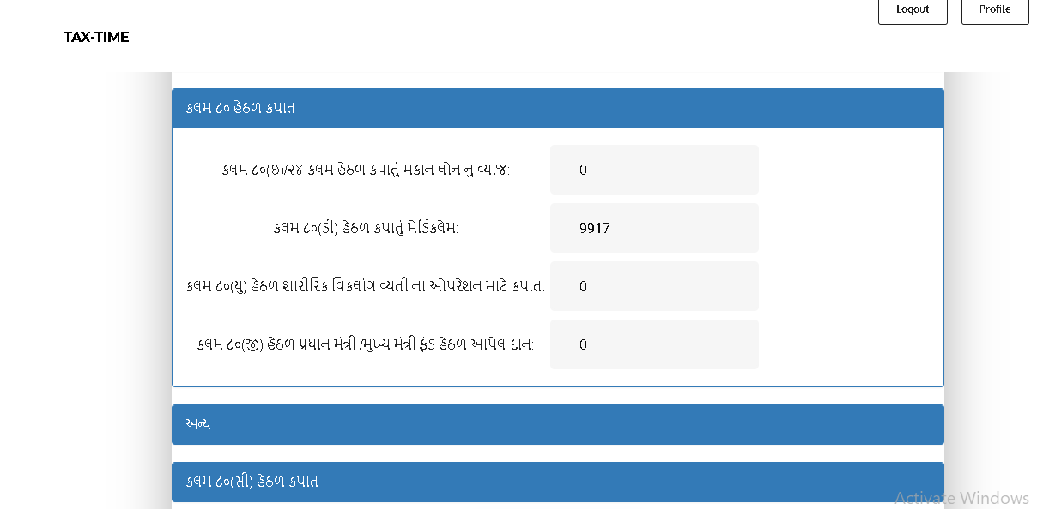

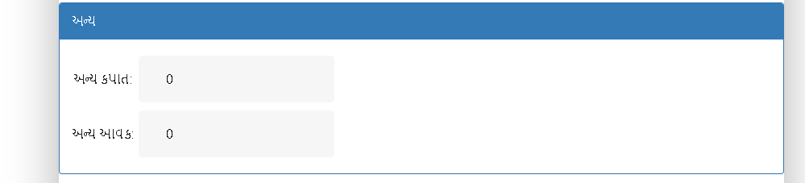

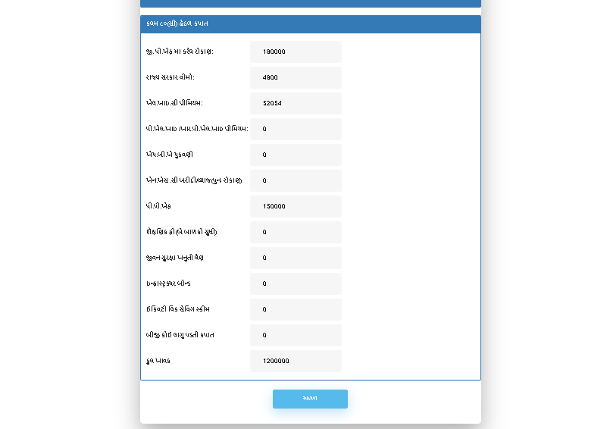

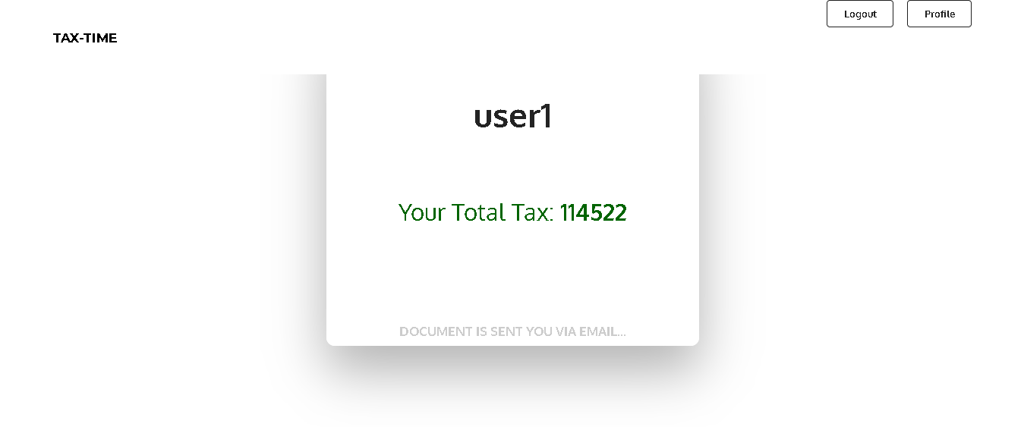

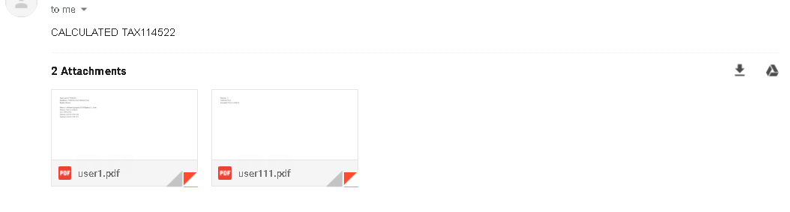

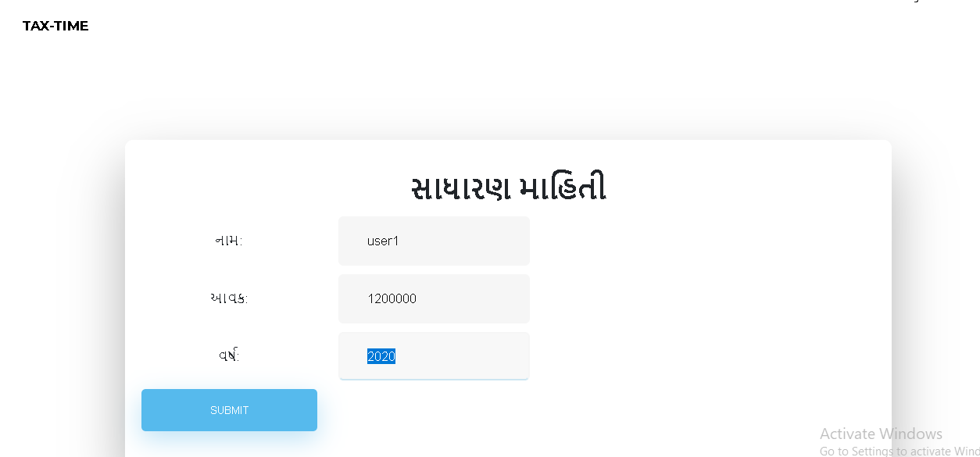

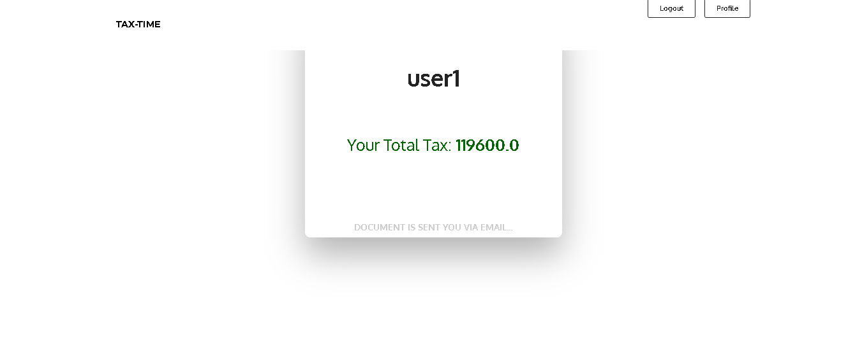

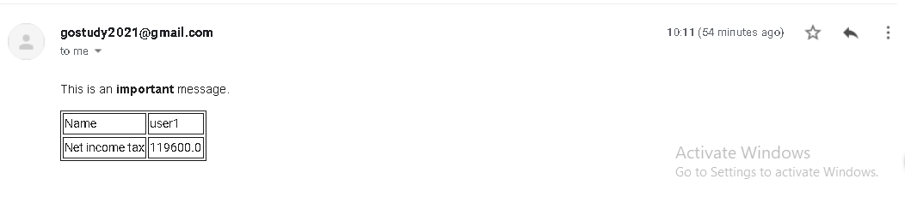

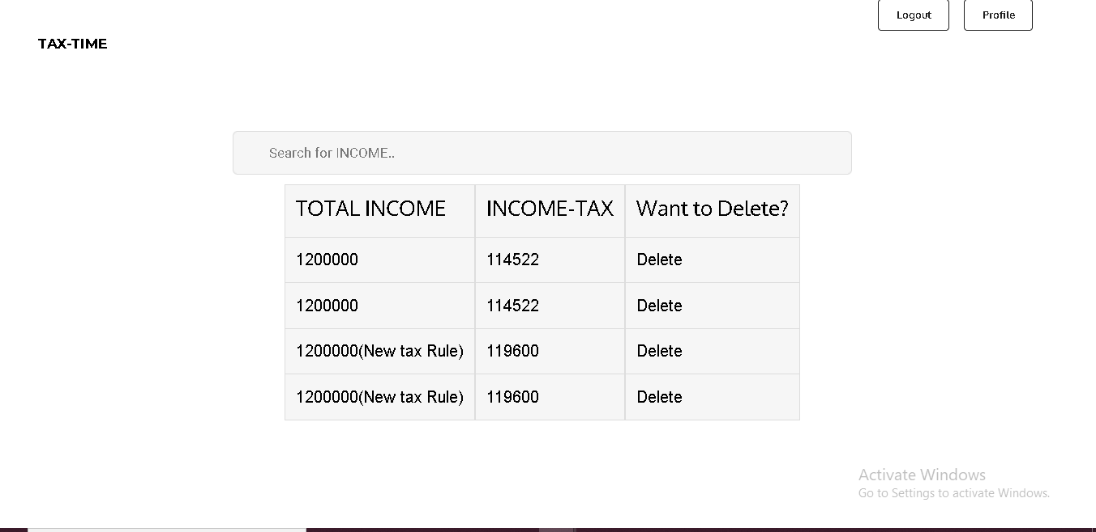



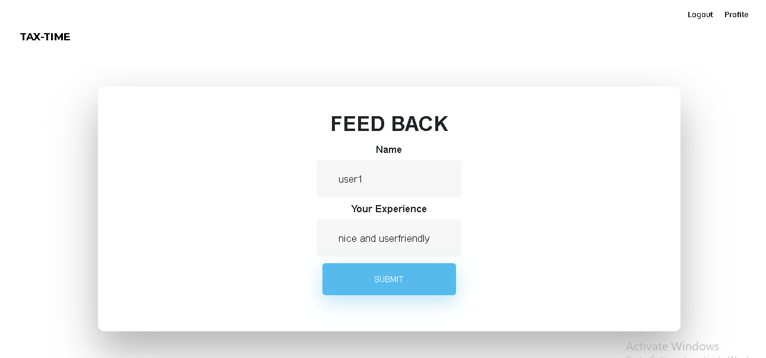

**ADMIN SIDE:**

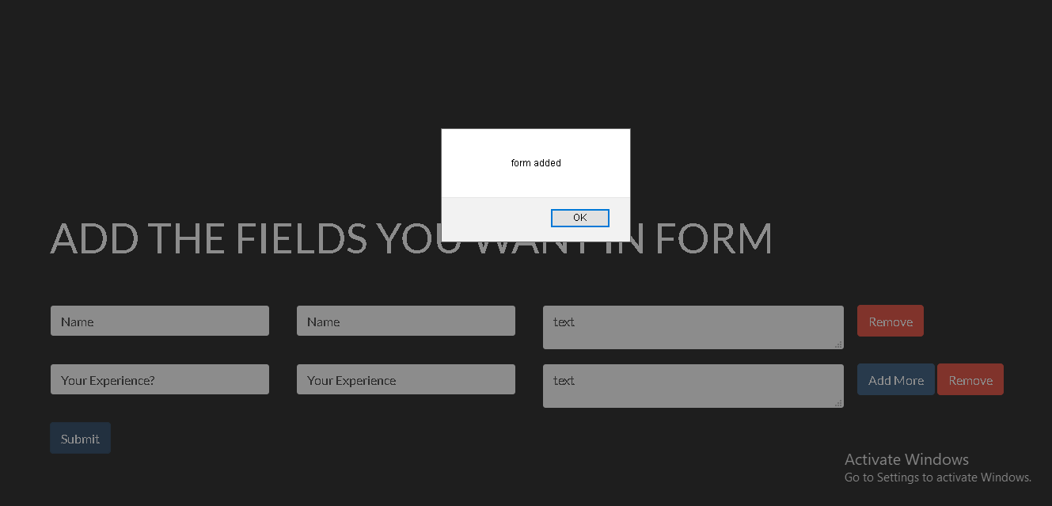

**7.CONCLUSION**

Hereby, we conclude that the functionalities implemented in Online T-shirt Designing System was performed by understanding all the modules according to requirements which are as given below:

* User Registration
* Login
* Calculate income tax by 2 methods.
* Dynamic Form Generation for admin.
* View Forms
* View Previous Record
* Give Feedback

After implementation of coding, comprehensive testing was performed and the result were provided in the report.

**8.LIMITATIONS AND FUTURE EXTENSIONS**

* 1. **Limitations**
* Currently the website is for itr1.
* Currently the project is on local server.
* Our system does not provide facility to change previous data entered for tax paying.
  1. **Future Extensions**

We will implement all the income tax forms.

**9.BIBLIOGRAPHY**

Following links and websites were referred during the development of this project.

* <https://www.google.co.in>
* <https://www.wikipedia.org>
* <https://www.tutorialspoint.com>
* <https://www.stackoverflow.com>
* <https://www.w3schools.com>