**ARTIFICIAL INTELLIGENCE**

**LAB 1**

**AIM:** Study of Facts, Objects, Predicates and Variables.

**Sample Program:**

Code:

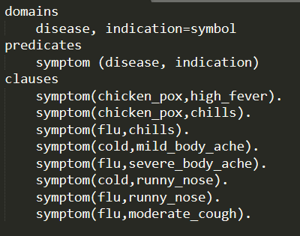

Questions:

1. Goal: symptom(cold,runny_nose)

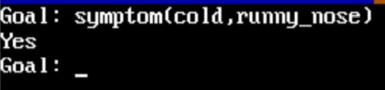

1. Goal: symptom(_,chills)

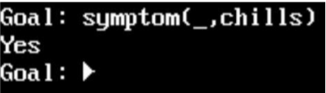

1. Goal: symptom(Disease,runny_nose)

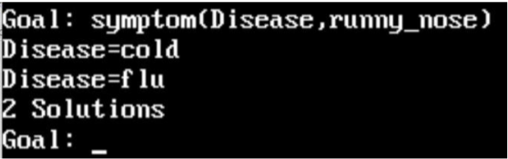

1. Goal: symptom(Disease, mild_body_ache) and symptom(Disease, runny_nose)

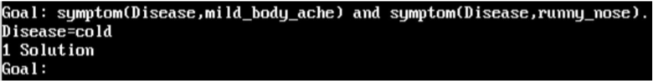

1. Add symptom(flu, mild_body_ache) in existing database 7 run following goal

Goal: symptom(Disease,mild_body_ache), symptom(Disease, runny_nose)

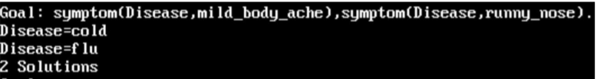

**EXERCISE:**

1. Write a prolog program for the following facts.
2. Colour of b1 is red
3. Colour of b2 is blue
4. Colour of b3 is yellow
5. Shape of b1 is square
6. Shape of b2 is circle
7. Shape of b3 is square
8. Size of b1 is small
9. Size of b2 is small
10. Size of b3 is large

Code:

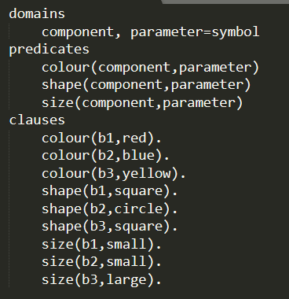

Questions:

1. What is the shape of b3?

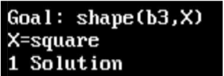

1. Which component is having large size and yellow color?

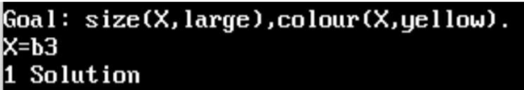

1. Give answer from the given clauses.

Code:

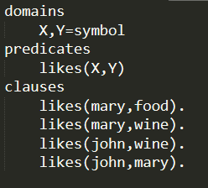

1. likes(mary,food)



1. likes(john,wine)

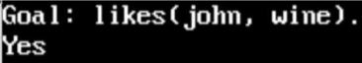

1. likes(john,food)

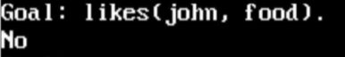

1. John likes anything that Mary likes

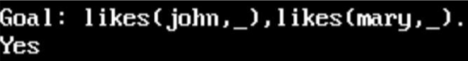

1. John likes anyone who likes wine

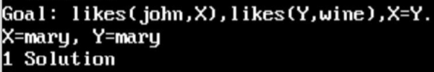

1. Give answers from the given clauses.

Code:

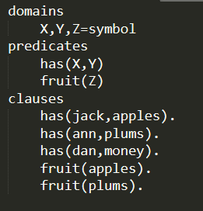

1. what Jack has?

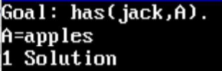

1. Does Jack have something?

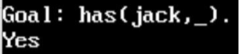

1. Who has apples and Who has plums?

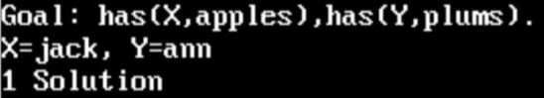

1. Does someone have apples and plums?

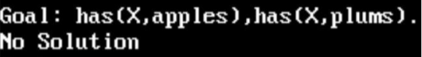

1. Has Dan fruits?

