ARTIFICIAL INTELLIGENCE

LAB 2

**AIM:** Study of RULES & UNIFICATION

**EXERSICE:**

**1. Write a prolog program for the following facts and rules and answer the given question**

1. Parva has symptom fever
2. Parva has symptom rash
3. Parva has symptom headache
4. Parva has symptom runny nose
5. Vidhi has symptom chills
6. Vidhi has symptom fever
7. Vidhi has symptom headache
8. Vivan has symptom runny nose
9. Vivan has symptom rash
10. Vivan has symptom flu

Rule 1: Patient has Disease measles if Patient has symptoms fever, cough, conjunctivitis and rash.

Rule 2: Patient has Disease german measles if Patient has symptoms fever, headache, runny nose and rash.

Rule 3: Patient has Disease flu if Patient has symptoms fever, headache, body-ache and chills.

Rule 4: Patient has Disease common cold if Patient has symptoms headache, sneezing, sore throat, chills and runny nose.

Rule 5: Patient has Disease mumps if Patient has symptoms fever and swollen glands.

Rules 6: Patient has Disease chicken pox if Patient has symptoms fever, rash, body-ache and chills.

**Question: Identify patient with any particular disease based on rules and facts given above.**

**Solution:**

Code:

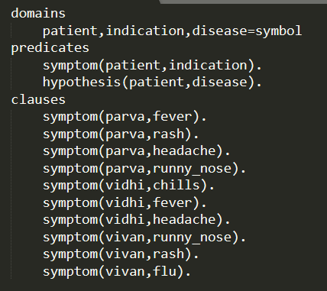

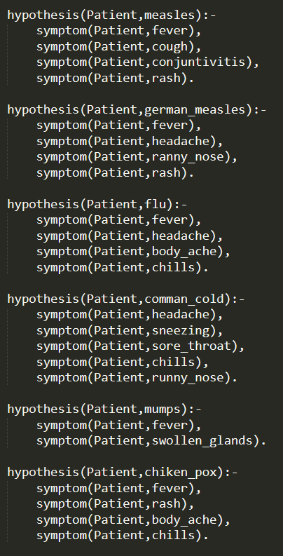



Output:

Goal: hypothesis(X,measles)

No Solution

Goal: hypothesis(X,german_measles)

X=parva

1 Solution

Goal: hypothesis(X,flu)

No Solution

Goal: hypothesis(X,cold)

No Solution

Goal: hypothesis(X,mumps)

No Solution

Goal: hypothesis(X,chicken_pox)

No Solution

**2. Write a program for family tree given below which contains three predicates: male, female, parent. Make rules for family relations: father, mother, grandfather, grandmother, brother, sister, uncle, aunt, nephew and niece.**

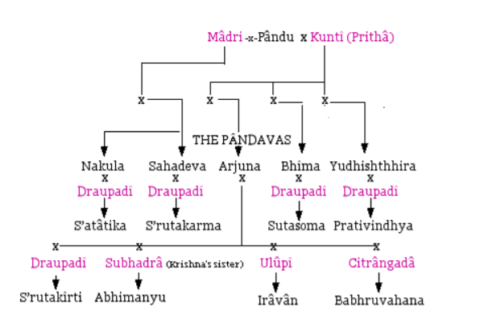

**Solution:**

Code:

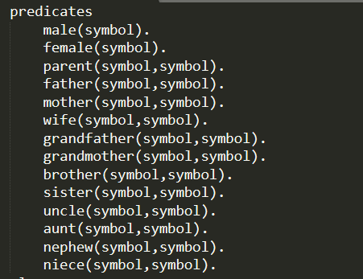

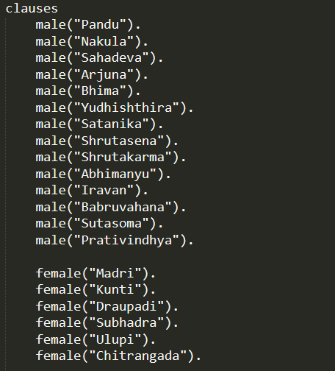

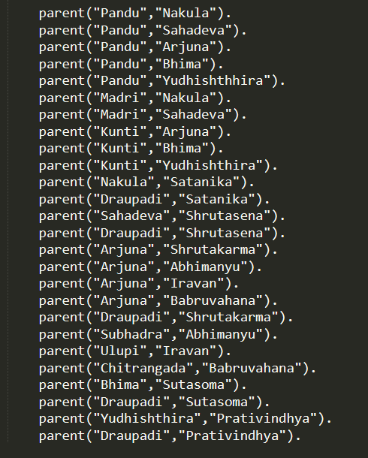

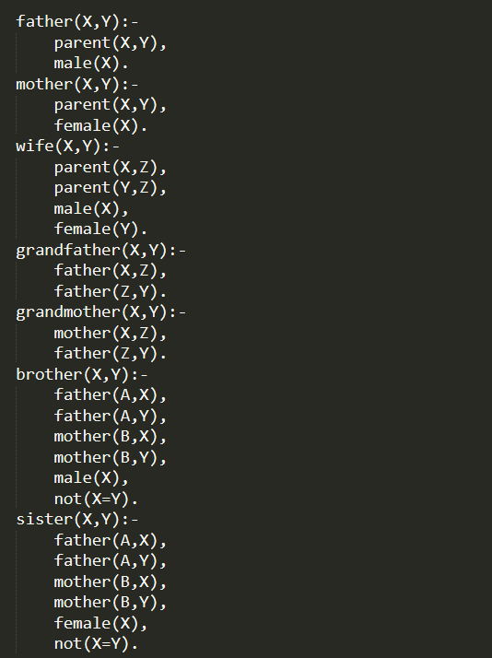

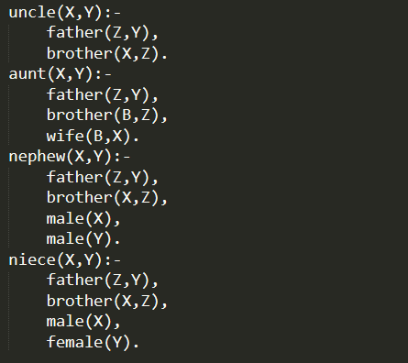

Output:

Goal: father(X,arjuna)

X= pandu 1 Solution

Goal: grandfather(X,abhimanyu)

X=pandu

1 Solution

Goal: uncle(X,babhruvahana)

X=nakula

X=sahadev

X=bhima

X=yudhishthhira

4 Solutions

Goal: parent(X,satatika)

X=nakula

X=draupadi

Goal: aunt(X,iravan)

No Solution

Goal: mother(X,abhimanyu)

X=subhadra

1 Solution

**3. Write a prolog program for the following facts and rules, and trace the given goals:**

* 1. hardware is easy course
  2. Books for hardware are available
  3. logic is not easy course
  4. graphics is easy course
  5. graphics has 8 credits
  6. graphics has lab component
  7. Books for database are available
  8. Mary takes compilers

Rule1: X takes Y, if Y is easy course and books for Y are available.

Rule2: X takes Y, if Y has 8 credits and Y has lab component.

**Solution:**

Code:

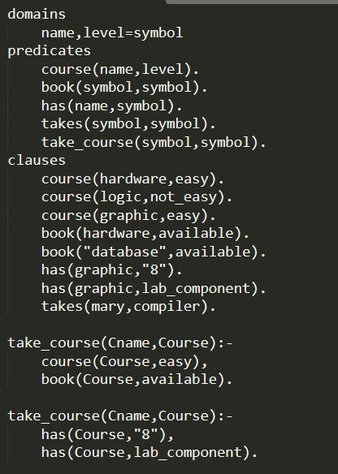

Goals:

a) Does Mary take a graphics course?

take_course(mary,graphics)

No

b) Which course Mary takes?

take_course(mary,X)

X=hardware

X=graphic

2 Solutions

c) Who takes graphics courses?

take_course(X,graphic)

No Solution