ARTIFICIAL INTELLIGENCE

LAB 3

**AIM:** To learn simple input and output predicates in prolog and to build rule-based consultation program.

**1. Medical Diagnosis**

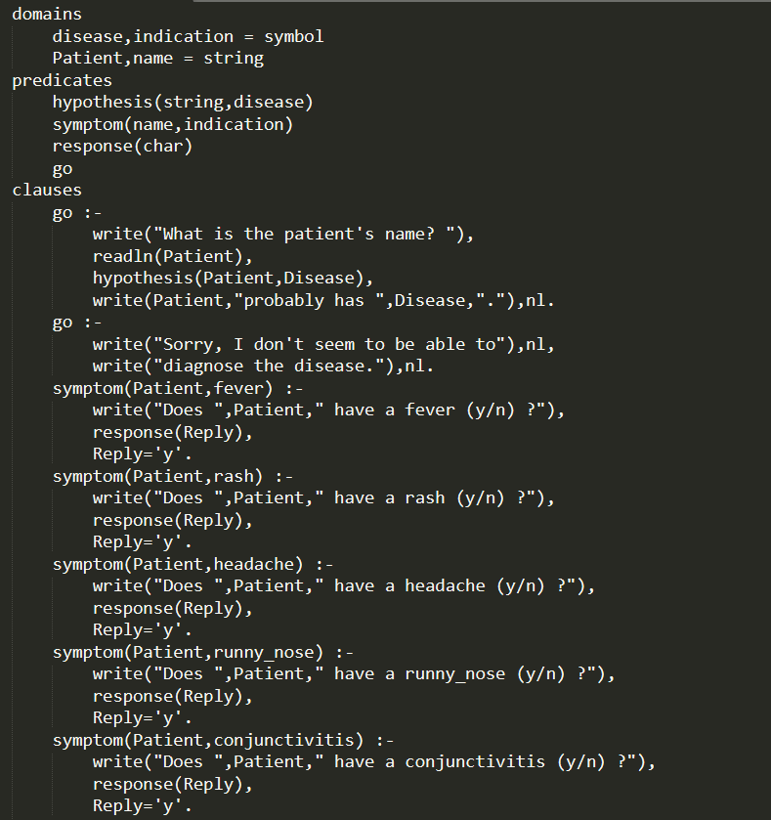

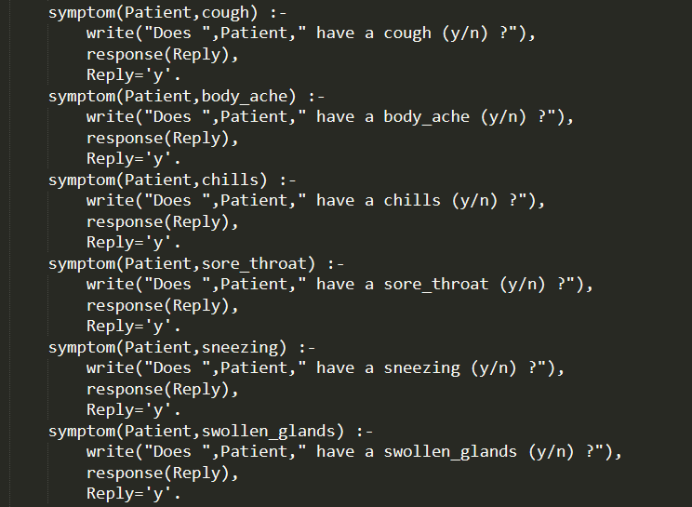

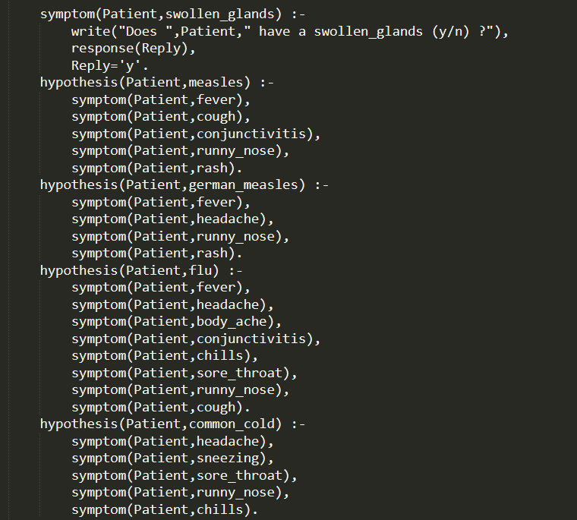

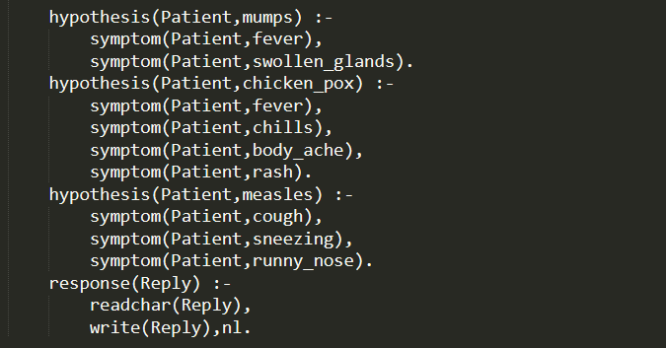

Output:

1. Unsuccessful to identify the disease.

Goal: go

What is patient’s name? Drashti

Does Drashti have a fever (y/n)? y

Does Drashti have a cough (y/n)? n

Does Drashti have a headache (y/n)? n

Does Drashti have a body_ache (y/n)? y

Does Drashti have a conjunctivitis (y/n)? n

Does Drashti have a runny_nose (y/n)? y

Does Drashti have a chills (y/n)? n

Does Drashti have a sneezing (y/n)? n

Sorry, I don’t seem to be able to

diagnose the disease.

Yes

1. Successfully able to identify the disease.

Goal: go

What is patient’s name? Drashti

Does Drashti have a fever (y/n)? y

Does Drashti have a swollen_glands (y/n)? y

Drashti probably has mumps.

**2. Predict user’s nature based on color user likes.**

**Solution:**

Code:

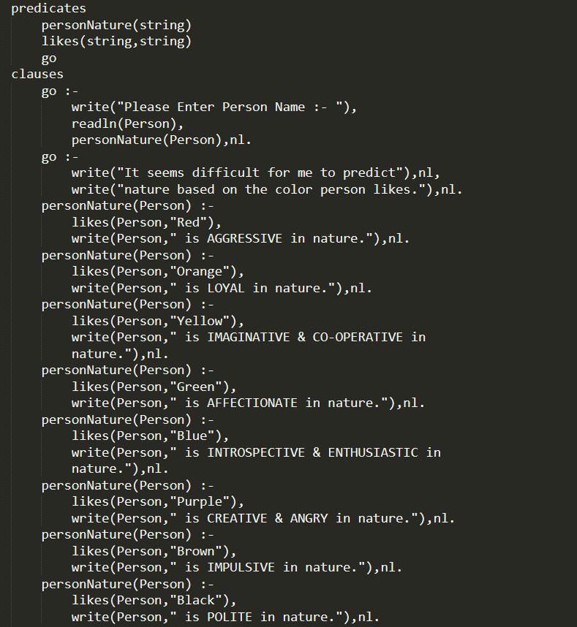

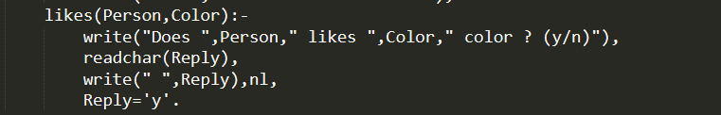

Output:

1. A person who doesn’t like any color.

Please Enter Person Name:- Drashti

Does Drashti likes Orange color?(y/n) n

Does Drashti likes Red color?(y/n) n

Does Drashti likes Brown color?(y/n) n

Does Drashti likes Blue color?(y/n) n

Does Drashti likes Black color?(y/n) n

Does Drashti likes Green color?(y/n) n

Does Drashti likes Yellow color?(y/n) n

It seems difficult for me to predict

nature based on the color person likes.

1. A person who likes Red color.

Please Enter Person Name:- Drashti

Does Drashti likes Orange color?(y/n) n

Does Drashti likes Red color?(y/n) y

Does Drashti likes Brown color?(y/n) n

Does Drashti likes Blue color?(y/n) n

Drashti is AGGRESSIVE in nature

**3.** **Predict user’s health based on habits user practices.**

**Solution:**

Code:

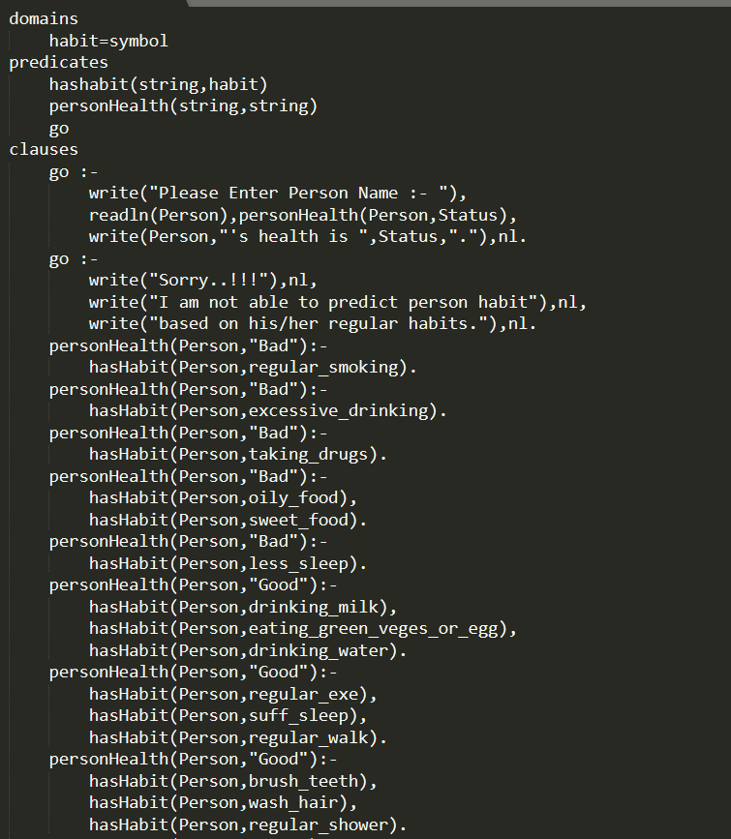

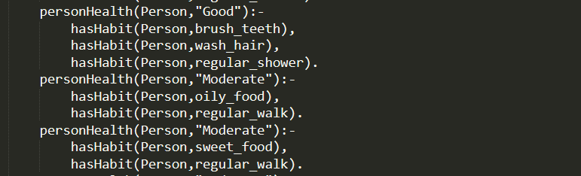



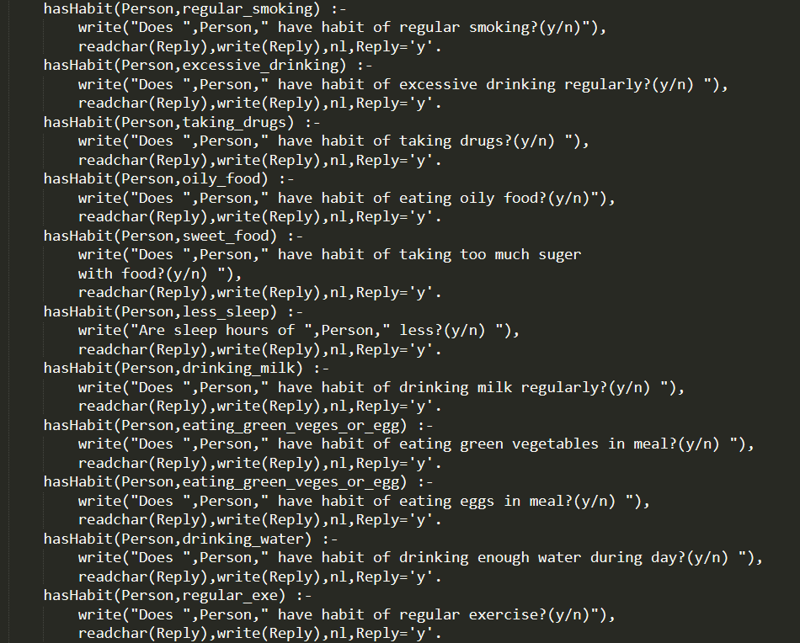

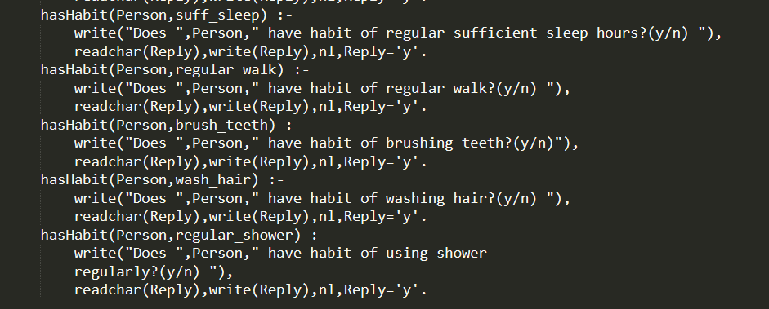

Output:

Please Enter Person Name:- Drashti

Does Drashti have habit of regular smocking?(y/n) n

Does Drashti have habit of excessive drinking regularly?(y/n) n

Does Drashti have habit of taking drugs?(y/n) n

Does Drashti have habit of eating oily food?(y/n) y

Does Drashti have habit of taking too much sugar with food?(y/n) y

Drashti’s health is Bad.

Yes