**IMAGE PROCESSING LAB 3**

**AIM:** Implement following image enhancement techniques using Octave

1) Contrast Stretching

2) Intensity Level Slicing

3) Bit Plane Slicing

* **Contrast Stretching:**

Contrast stretching is a process that expands the range of intensity levels in an image so that it spans the available full intensity range.

* **Intensity Level Slicing:**

Intensity level slicing means highlighting a specific range of intensities in an image. In other words, we segment certain gray level regions from the rest of the image.

* **Bit Plan Slicing:**

Bit plane slicing is a method of representing an image with one or more bits of the byte used for each pixel. One can use only MSB to represent the pixel, which reduces the original gray level to a binary image.

**Exercise:**

1. **Do contrast stretching For the Image given in Figure 3.10 of the Textbook. Obtain Contrast stretched Image from Low contrast Image as given in Figure 3.**

**Code: -**

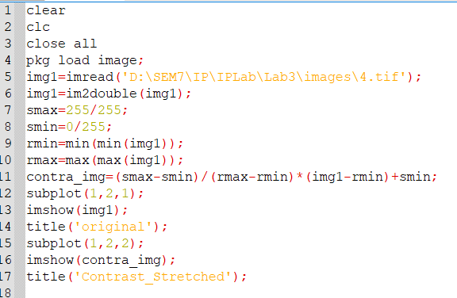

**Output: -**

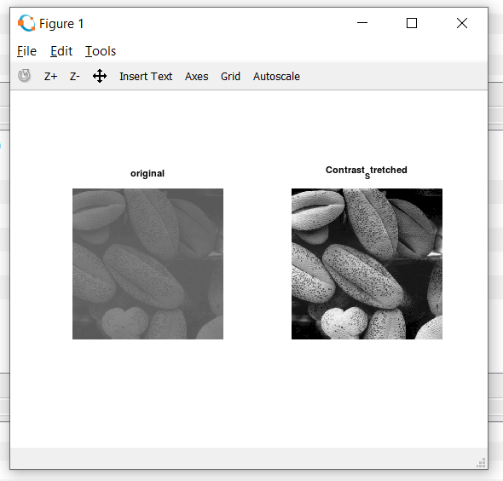

1. **Take any family photo of yours – convert it into grayscale- reduce its contrast by using the function that was defined during the lab session. Enhance the contrast of that image using piecewise linear operation for contrast stretching.**

**Code: -**

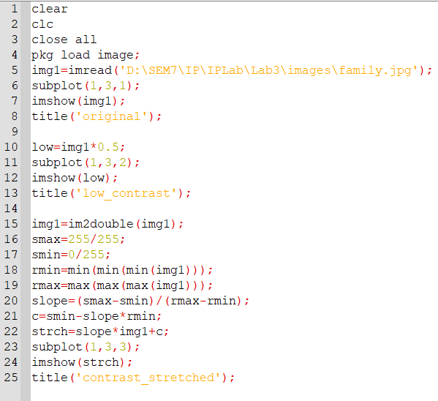

**Output: -**

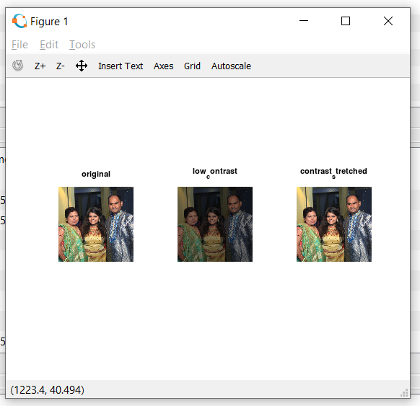

1. **Apply thresholding to any of your grayscale photos.**

**Code: -**

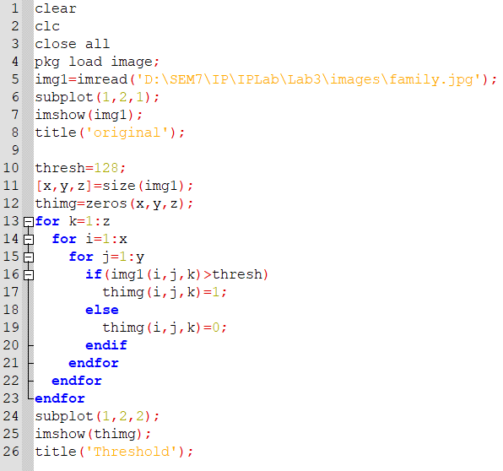

**Output: -**

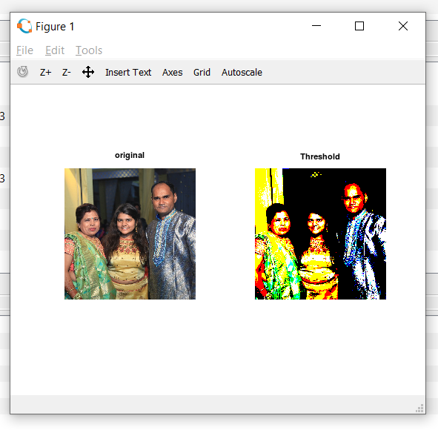

1. **Take your photo and separate out its bit plains. Reconstruct the given image using higher order 2-bit planes. Reconstruct the given image using higher order 4-bit planes. Experiment with the bit planes and derive your conclusions**

**Code: -**

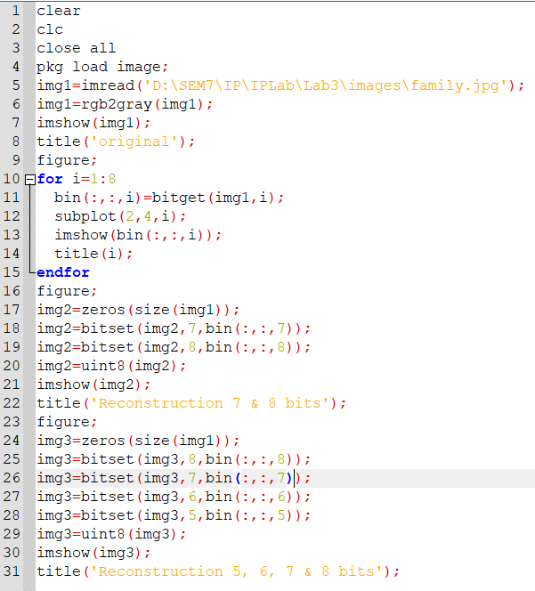

**Output: -**

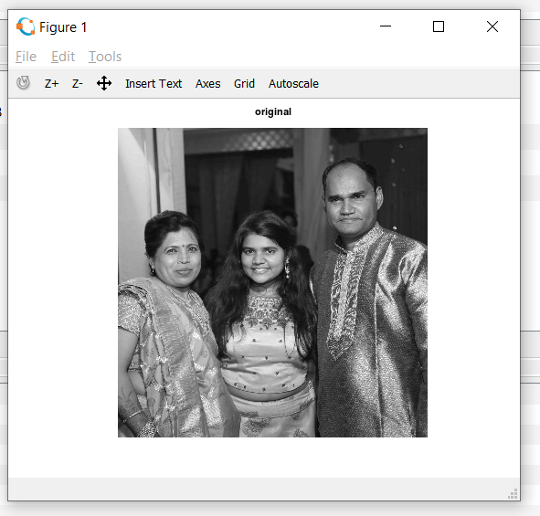

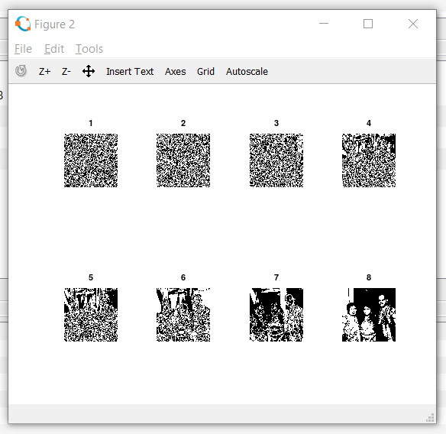

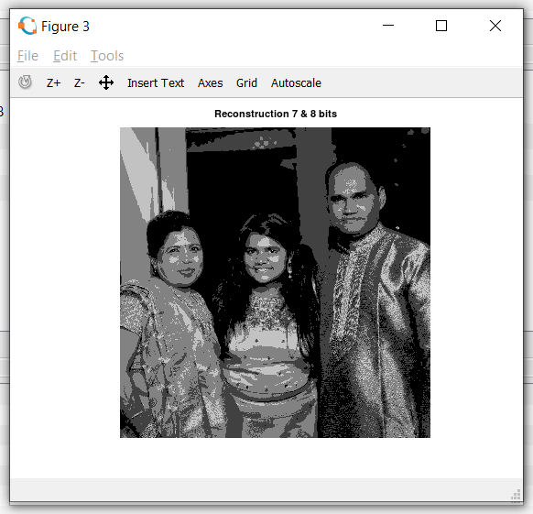

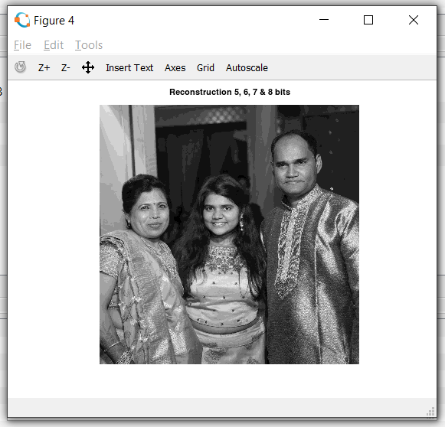

1. **Perform intensity slicing to separate out red green balloons from the image 1(check: lab3 images) given.**

**Code: -**

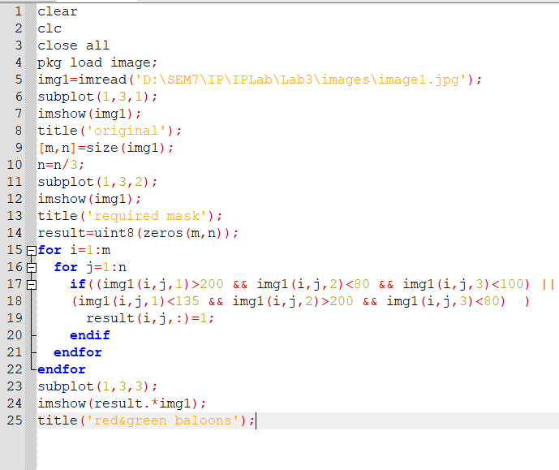

**Output: -**

