**LAB-3 - 6211**

Q1.

A1.

1. COUNT(*) from gene;
2. SELECT DISTINCT chromosome from gene
3. SELECT DISTINCT gene_type from gene
4. SELECT COUNT(*) FROM gene where modification_date BETWEEN DATE('2015-01-01') AND DATE('2021-12-31')

Q2.

A2.

1. SELECT gene.name,synonym.name from gene JOIN synonym ON gene.gene_id = synonym.gene_id;
2. SELECT DISTINCT COUNT(*) name from synonym;
3. SELECT DISTINCT gene.chromosome, external_identifier.identifier from gene JOIN external_identifier ON gene.gene_id = external_identifier.gene_id WHERE gene.chromosome = 1;
4. SELECT DISTINCT gene.gene_type, synonym.name from gene JOIN synonym ON gene.gene_id = synonym.gene_id WHERE gene.gene_type = "unknown";

Q3.

A3.

1)

1. select name,count(*) from gene where species in ('homo sapiens','mus musculus') group by name order by count(*) DESC, name ASC ;

2)

1. select name from gene where species in ('homo sapiens','mus musculus') group by name order by name DESC ;
2. SELECT gene.name,synonym.name from gene JOIN synonym ON gene.gene_id = synonym.gene_id;
3. SELECT DISTINCT gene.name, external_identifier.identifier from gene JOIN external_identifier ON gene.gene_id = external_identifier.gene_id;

Q4.

A4.

1) Count for Part 1 Q4 is **95813**

2)

1. Do they come from different species? Find an example.

YES. These genes come from both humans and mice and thus they have the same names.

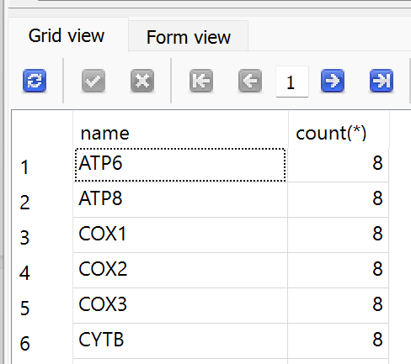

Fig 1: Multiple genes having same name as species are different

1. Do they have different synonyms? Find an example.

YES. The gene A1BG has 4 synonyms as shown in the figure proving multiple genes having the same name.

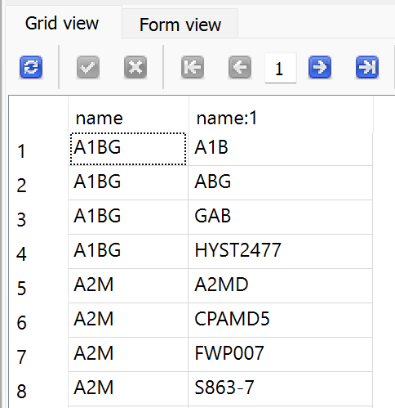

Fig 2: Multiple genes having same name as synonyms are different

1. Do they have different identifiers? Find an example.

YES. A1BG gene has 3 identifiers as shown in the figure below

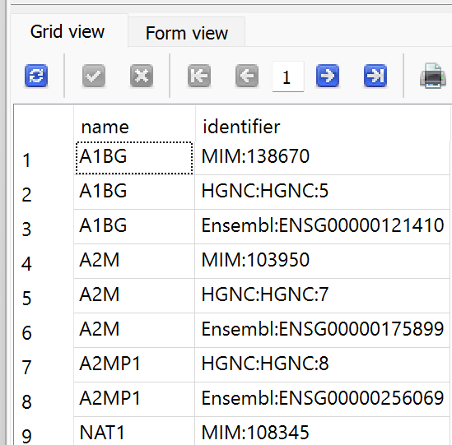

Fig 3: Multiple genes having same name as identifiers are different