MICROGOAL

TEAM MEMBERS
TEAM LEADER: RASIKA D
TEAM MEMBER: RATHISREE P
TEAM MEMBER: MYTHILI J
TEAM MEMBER: NISHA M

MicroGoals – Secure Goal Management Backend API

Abstract
MicroGoals is a secure backend RESTful API designed to manage personal goals efficiently. The system is developed using Node.js, Express.js, and MongoDB, enabling users to register, authenticate, and perform CRUD (Create, Read, Update, Delete) operations on their goals.
The application implements JWT-based authentication, ensuring that only authenticated users can access protected routes. Each goal is securely linked to its respective user, preventing unauthorized access to other users' data.
The main objective of this project is to demonstrate the implementation of secure API development, database management, and authentication mechanisms in a scalable backend architecture.

Introduction
Modern applications require secure backend systems to manage user data efficiently. Goal management systems help individuals track tasks and progress toward personal objectives.
The MicroGoals API provides a backend solution for managing goals securely using RESTful APIs. The system allows users to register, log in, and manage their goals through a protected environment.
By using JWT authentication and middleware-based security, the application ensures safe data access and user-specific goal management.

Objectives
The main objectives of this project are:
- To design and develop a secure backend API.
- To implement user authentication using JWT tokens.
- To create a system where users can manage their personal goals.
- To ensure secure database operations using MongoDB.
- To implement middleware-based authentication and error handling.

System Architecture
The system follows the MVC (Model–View–Controller) architecture pattern, which separates application logic into different layers.
Model:
Handles database structure and schema definitions.
Router (Controller):
Handles API routes and request-response logic.
Middleware:
Handles authentication and centralized error management.
Utility:
Handles token generation and helper functions.

Technical Architecture
Component | Technology Used
Runtime Environment | Node.js
Backend Framework | Express.js
Database | MongoDB
ODM | Mongoose
Authentication | JWT (JSON Web Token)
Password Security | bcryptjs
Validation | Joi
API Testing | Thunder Client

Entity Relationship Diagram
Entity 1 – User
Attribute | Description
_id | Unique user identifier
name | Name of the user
email | Unique user email
password | Hashed password
Entity 2 – Goal
Attribute | Description
_id | Unique goal identifier
title | Goal description
completed | Goal completion status
user | Reference to user ID

Relationship
One User → Many Goals
A single user can create multiple goals, but each goal belongs to only one user.

System Features
- User Registration
- Secure Login System
- JWT Token Authentication
- Goal Creation
- Goal Retrieval
- Goal Update
- Goal Deletion
- Protected API Routes
- Centralized Error Handling

Project Setup
Step 1 – Initialize Node Project
npm init -y
Step 2 – Install Dependencies
npm install express mongoose bcryptjs jsonwebtoken dotenv cors joi
Step 3 – Start Server
npm start
Server runs on:
http://localhost:8000

Folder Structure
Backend/
│
├── Middlewares/
│ ├── authMiddleware.js
│ └── errormiddleware.js
│
├── Model/
│ ├── UserModel.js
│ └── GoalModel.js
│
├── Router/
│ ├── AuthRouter.js
│ └── GoalRouter.js
│
├── Schema/
│ ├── User.js
│ └── GoalSchema.js
│
├── utils/
│ └── generatetoken.js
│
├── validation/
│ └── userValidation.js
│
├── .env
├── .gitignore
├── Index.js
├── package.json
└── package-lock.json
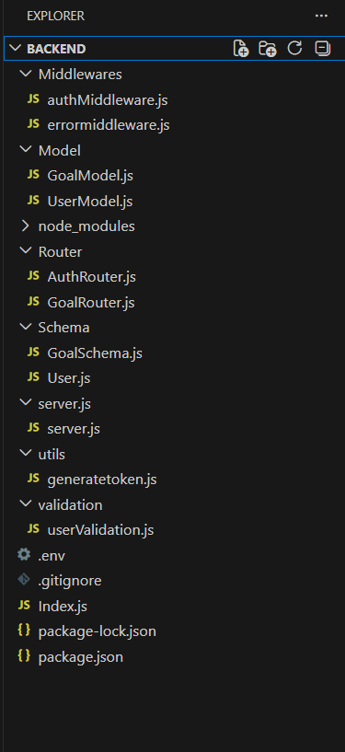

API Endpoints
Authentication APIs
Method | Endpoint | Description
POST | /api/auth/signup | Register new user
POST | /api/auth/login | Login user

Goal APIs
Method | Endpoint | Description
POST | /api/goals/create | Create new goal
GET | /api/goals/:id | Get goal
PUT | /api/goals/:id | Update goal
DELETE | /api/goals/:id | Delete goal

JWT Authentication
After successful login or registration, the backend generates a JWT token.
Example header:
Authorization: Bearer <token>
The token is verified using authentication middleware before accessing protected routes.

Authentication Middleware
The authMiddleware performs the following steps:
- Reads Authorization header
- Extracts the JWT token
- Verifies token using secret key
- Retrieves user ID
- Grants access to protected routes
If the token is missing or invalid:
401 Unauthorized

Error Handling Middleware
A centralized error middleware captures errors across the application.
Example response:
{
"success": false,
"message": "Internal Server Error"
}
This ensures consistent error responses across APIs.

Database Development
MongoDB is used to store user and goal data.
User Schema
Stores user information with encrypted passwords.
Goal Schema
Stores goals and references the user who created them.
Each goal is associated with the authenticated user ID, ensuring secure data isolation.

Project Execution Steps
- Start MongoDB database
- Run backend server
- Open Thunder Client
- Register user using signup API
- Login to receive JWT token
- Add token in Authorization header
- Perform CRUD operations on goals

Project Output
Successful User Registration
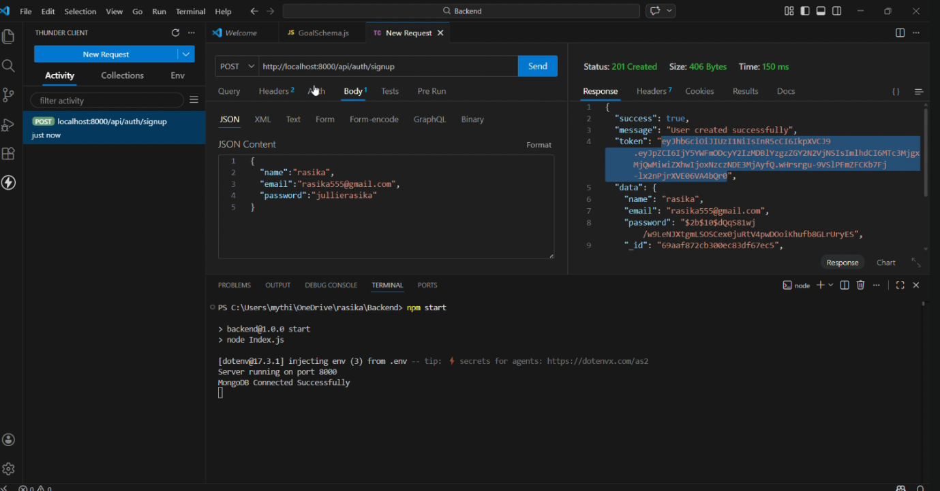
User registers successfully and receives authentication token.

JWT Token Generated
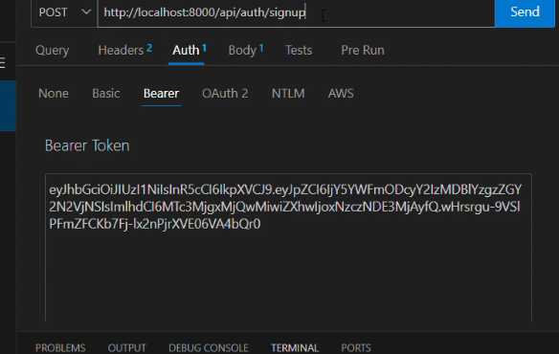
The token is used to access protected routes.

Goal Created Successfully
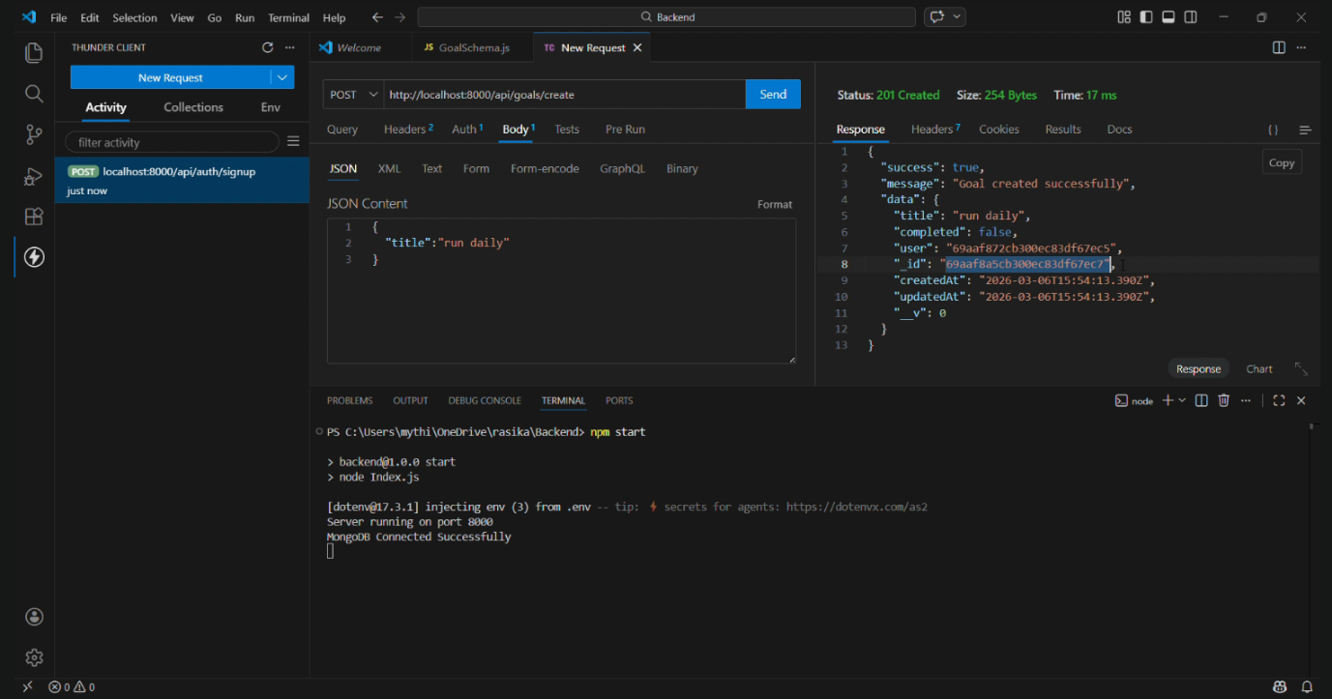
User creates goals stored in MongoDB database.

Goal Deleted Successfully
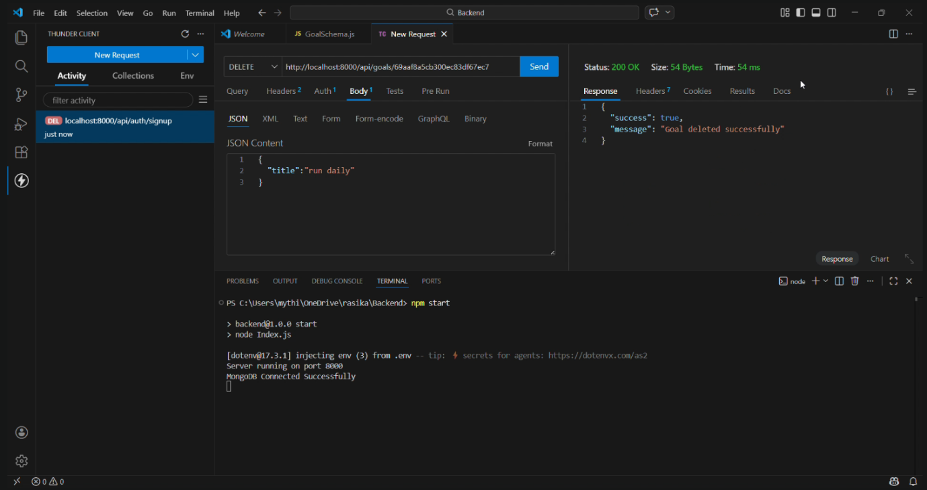
User deletes goals using goal ID.

Conclusion
The MicroGoals backend API successfully demonstrates the development of a secure and scalable RESTful backend system.
The implementation of JWT authentication, middleware protection, and MongoDB integration ensures secure user management and data isolation.
This project highlights the practical use of Node.js, Express.js, and MongoDB in building real-world backend applications.

THANK YOU!

