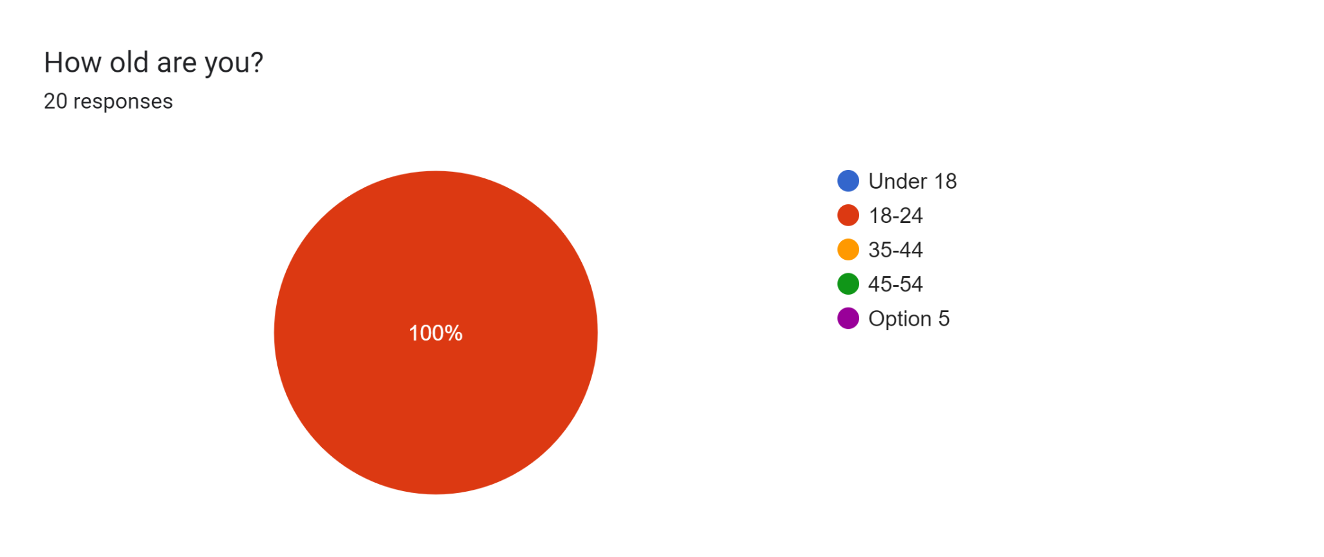

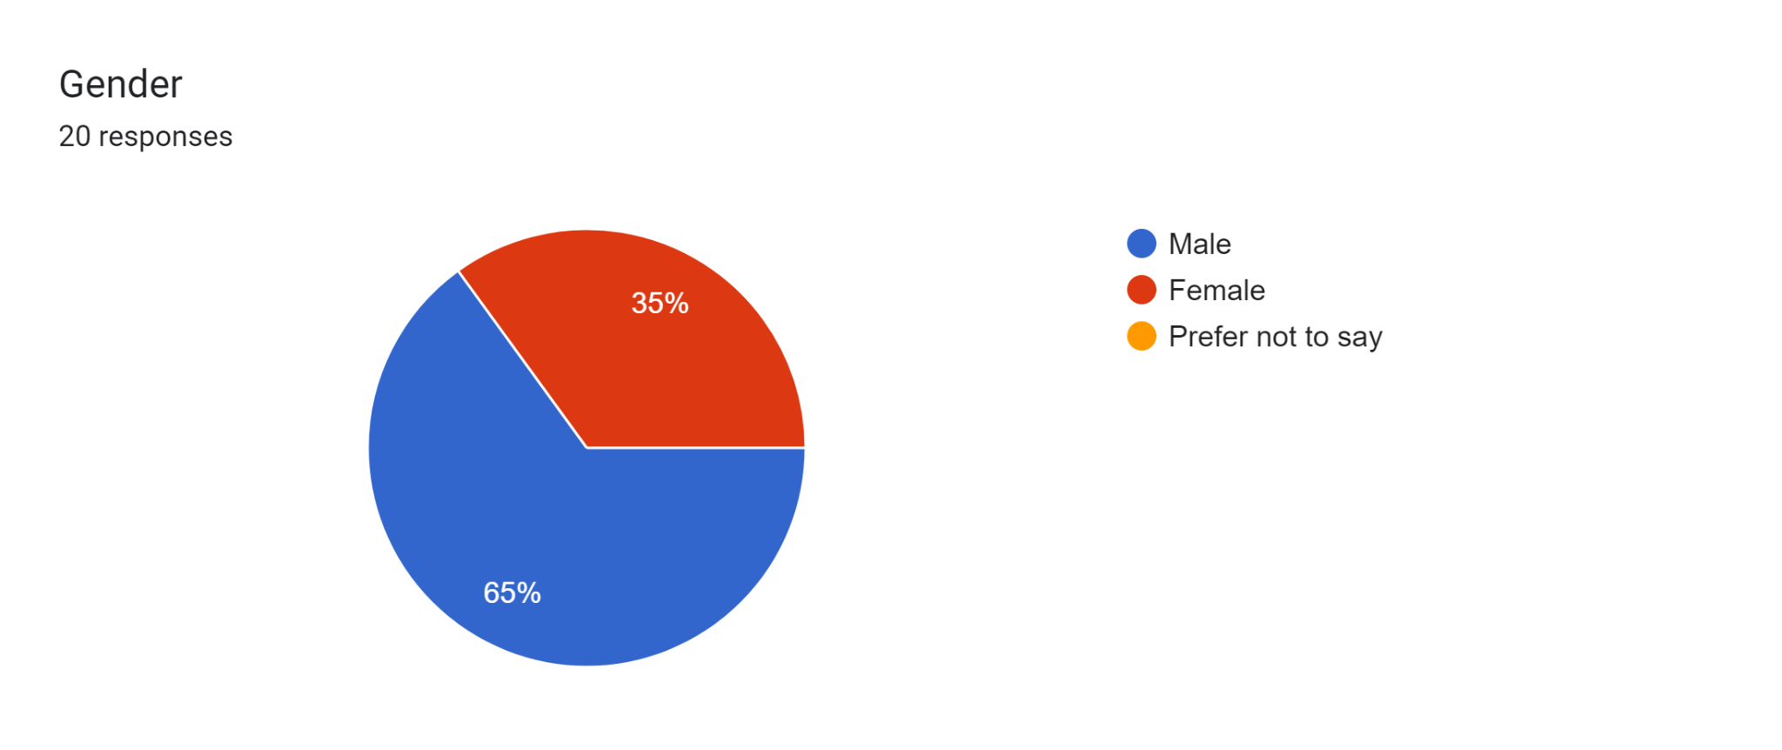

Forms response chart. Question title:   Professional Background:  
. Number of responses: 20 responses.

Forms response chart. Question title:   How intuitive do you find the user interface of the file verification system?  
. Number of responses: 20 responses.

Forms response chart. Question title:   How easy is it to navigate through the system?  
. Number of responses: 20 responses.

Forms response chart. Question title:   How would you rate the speed of the file verification process?  
. Number of responses: 20 responses.

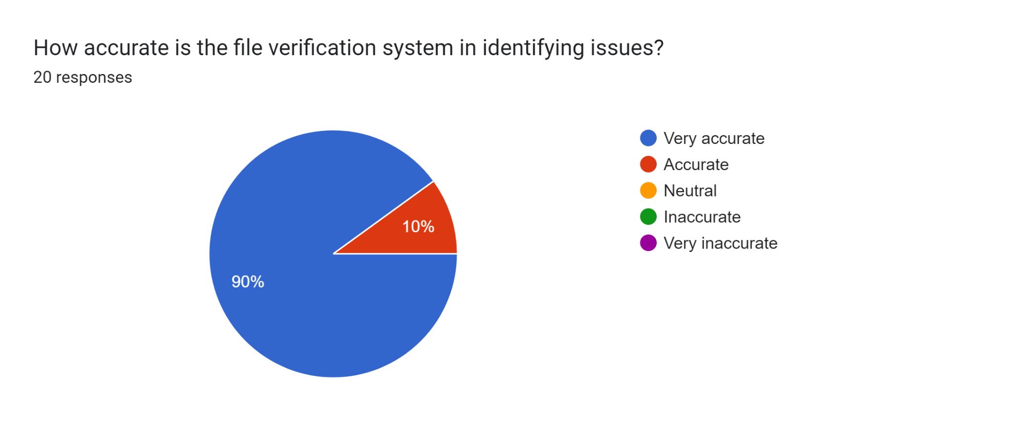

Forms response chart. Question title: How reliable is the system in terms of uptime and performance?
. Number of responses: 20 responses.

Forms response chart. Question title:   Overall, how satisfied are you with the file verification system?  
. Number of responses: 20 responses.