Dravid,Francinaldo,Jinuk,Richard

EECS 448

Prof. John Gibbons

11 May 2016

User Manual for Rock Chalk Jaymovies

**Getting to the Page**

You can reach Rock Chalk Jaymovies at the following address:

<http://eecs448.f5tech.com.br/>

Once there, you should see the following landing page: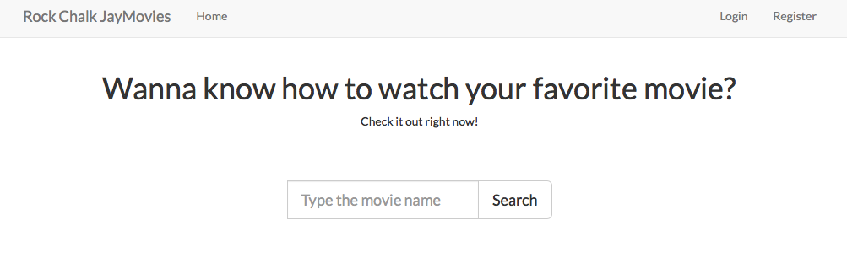

This page gives you the following options:

1) Direct search: Search for the movie or TV show you wish to find right away, no login required. (Bottom center part of the page)

2) Register: Register for an account with us! It’s free. (Top Right of the page)

3) Login: If you’ve already registered for an account with us, feel free to use your credentials to use your profile. (Top Right of the page, left of the register button).

**Direct Search**

Rock Chalk Jaymovies’ primary function is to allow users to see which service they can use to view their content, whether it be movies or TV. To that end, if you want to search for movies or TV without a user account, more power to you. Here’s how you do it:

1) Go the Direct search bar on the bottom of the page:

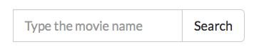

2) Say you’re a Coppola fan and you want to watch The Godfather. Just type it in!

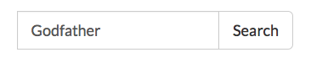

Rock Chalk Jaymovies does keyword search, so you don’t need to specify which Godfather movie-they’ll all show up.

3) You’ll be directed to the following landing page:

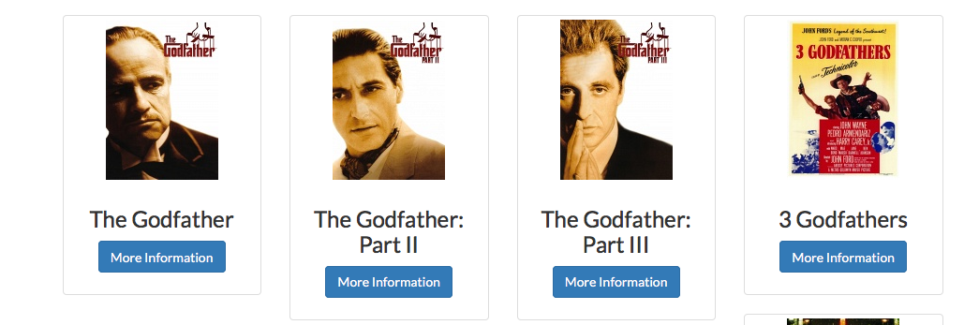

at which, point you can pick the one you want (preferably one of the first two results). We recommend The Godfather: Part II. Click on “More Information” to see where you can get your movie.

4) The left side of the screen should show a poster of the movie, as well as a brief synopsis. The right side of the screen should show you all of your movie options. Since the Godfather is not on any streaming service, you’re only options are to purchase. Fortunately, there are quite a few services offering downloads of this classic:

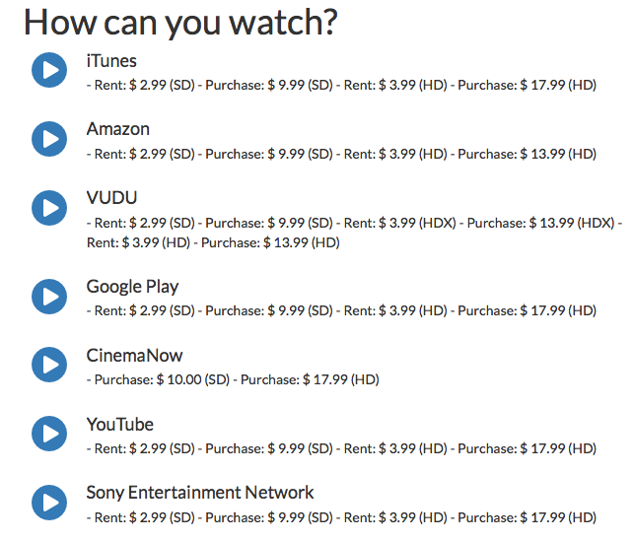

As you can see, you have plenty of options-you can rent or purchase the movie, and get it in standard definition (SD) or high definition (HD). We recommend HD if you have a strong Internet connection, especially for a movie as beautiful as this one.

5) To select on of these services, just click on the arrow button next to them. Say you wanted to use Amazon’s service, seeing as it has the cheapest streaming option. Clicking on the button takes you to the Amazon page. If you’re already logged into Amazon, just follow their directions:

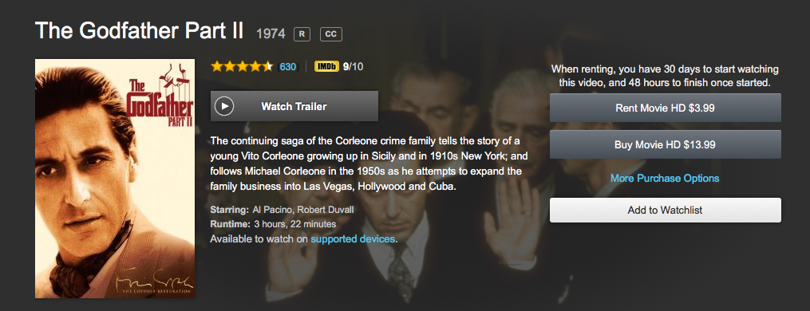

And you’re all set! That’s all you need to do in order to use the service to watch your movie. No more blindly searching around the Internet again!

**LICENSE**

Copyright (c) 2016 Rock Chalk Jaymovies

All rights reserved.

Redistribution and use in source and binary forms, with or without modification, are permitted provided that the following conditions are met:

1. Redistributions of source code must retain the above copyright notice, this list of conditions and the following disclaimer.

2. Redistributions in binary form must reproduce the above copyright notice, this list of conditions and the following disclaimer in the documentation and/or other materials provided with the distribution.

3. Neither the name of the copyright holder nor the names of its contributors may be used to endorse or promote products derived from this software without specific prior written permission.

THIS SOFTWARE IS PROVIDED BY THE COPYRIGHT HOLDERS AND CONTRIBUTORS "AS IS" AND ANY EXPRESS OR IMPLIED WARRANTIES, INCLUDING, BUT NOT LIMITED TO, THE IMPLIED WARRANTIES OF MERCHANTABILITY AND FITNESS FOR A PARTICULAR PURPOSE ARE DISCLAIMED. IN NO EVENT SHALL THE COPYRIGHT HOLDER OR CONTRIBUTORS BE LIABLE FOR ANY DIRECT, INDIRECT, INCIDENTAL, SPECIAL, EXEMPLARY, OR CONSEQUENTIAL DAMAGES (INCLUDING, BUT NOT LIMITED TO, PROCUREMENT OF SUBSTITUTE GOODS OR SERVICES; LOSS OF USE, DATA, OR PROFITS; OR BUSINESS INTERRUPTION) HOWEVER CAUSED AND ON ANY THEORY OF LIABILITY, WHETHER IN CONTRACT, STRICT LIABILITY, OR TORT (INCLUDING NEGLIGENCE OR OTHERWISE) ARISING IN ANY WAY OUT OF THE USE OF THIS SOFTWARE, EVEN IF ADVISED OF THE POSSIBILITY OF SUCH DAMAGE.