
Spotify

Product Dissection for Spotify
Company Overview:
Spotify, founded in 2006 by Daniel Ek and Martin Lorentzon, is a leading music streaming platform offering millions of songs, podcasts, and personalized playlists like Discover Weekly. With over 500 million users worldwide, including 220 million Premium subscribers, it allows users to create, share, and follow playlists while discovering music tailored to their tastes. Spotify has transformed the music industry by connecting artists with global audiences and delivering personalized listening experiences.

Product Dissection and Real-World Problems Solved by Spotify:
User Accounts and Streaming:
Spotify provides flexible user accounts with both free and Premium tiers. Premium subscribers enjoy ad-free, high-quality streaming and offline listening, while free users can still access music with occasional ads. This solves the problem of uninterrupted listening for serious users and provides casual access for everyone.
Music Library and Discovery:
With a vast music library of millions of songs and albums across genres and languages, Spotify allows users to search, browse, and stream music instantly. This eliminates the need to purchase individual tracks and makes discovering new music easy and convenient.

Playlists and Personalization:
Spotify’s playlist and recommendation features, including Discover Weekly and Daily Mix, help users discover new music based on their listening habits. Users can also create, follow, and share playlists, organizing their favourite songs efficiently and enhancing their music experience.
Social and Collaborative Feature:
Spotify enables social interaction by allowing users to follow friends and artists, share playlists, and collaborate on shared playlists. This fosters engagement and makes music discovery a collaborative, social activity.
Analytics and Insights:
Spotify tracks listening habits and provides analytics, such as top songs, favourite artists, and listening trends. These insights help users understand their preferences and make informed decisions about which music to explore next.
Cross-Platform Access and Podcasts:
Spotify is accessible on multiple platforms including desktop, mobile, web, and smart devices. Combined with its growing library of podcasts and non-music content, this ensures users can enjoy entertainment anytime, anywhere, solving the problem of limited access to diverse audio content.

Case Study: Real-World Problems and Spotify's Innovative Solutions
Problem 1: Difficulty Discovering New Music
Many music listeners struggle to find songs that match their personal tastes and often end up listening to the same tracks repeatedly. This makes music discovery monotonous and limits exposure to new artists and genres.
Spotify’s Solution:
Spotify addresses this challenge through its personalized recommendation engine. Playlists like Discover Weekly, Daily Mix, and Release Radar are tailored to users’ listening habits, introducing them to new songs and artists they might enjoy. This keeps the listening experience fresh, engaging, and continuously evolving.
Problem 2: Managing and Organizing Music Libraries
With thousands of songs available, users often find it difficult to organize their music, maintain playlists, or quickly access their favourite tracks. Without proper organization, users may feel overwhelmed by the sheer volume of content.
Spotify’s Solution:
Spotify allows users to create, organize, and share playlists, as well as use the “Liked Songs” feature to save favourite tracks. Collaborative playlists also enable shared curation among friends, making it easier to manage music while encouraging social interaction and discovery.

Problem 3: Limited Social Music Interaction
Traditional music platforms lack social features, making it challenging for users to share music with friends, follow others’ tastes, or explore content through social networks.
Spotify’s Solution:
Spotify provides social features, allowing users to follow friends and artists, share playlists, and collaborate on music collections. These features foster community engagement and enhance the music discovery experience by leveraging social connections.

Problem 4: Understanding Personal Listening Habits
Many users are unaware of their own music preferences or trends in their listening behaviour, limiting their ability to explore new genres or discover overlooked favourites.
Spotify’s Solution:
Spotify provides listening analytics, including insights such as top songs, favorite artists, and genre preferences. These insights help users understand their listening habits, refine playlists, and make informed decisions about music exploration.

Problem 5: Access Across Devices
Users expect seamless music streaming across multiple devices, but inconsistent support can interrupt their listening experience, especially when switching between smartphones, desktops, or smart speakers.
Spotify’s Solution:
Spotify offers cross-platform accessibility, allowing users to stream music and podcasts across smartphones, desktops, web browsers, and smart devices. Premium users also benefit from offline listening, ensuring uninterrupted access and convenience anywhere.

Conclusion:
Spotify effectively addresses real-world challenges in music discovery, library management, social interaction, analytics, and cross-device access. Its innovative features create a seamless, personalized, and social music experience that keeps users engaged and supports artist exposure globally.

Top Features of Spotify
- Vast Music Library
Access to millions of songs, albums, and artists across genres and languages, allowing users to stream almost any track instantly.
- Personalized Recommendations
Playlists like Discover Weekly, Daily Mix, and Release Radar suggest music based on individual listening habits and preferences.
- Playlists and Library Management
Users can create, save, organize, and share playlists. “Liked Songs” allows easy access to favourite tracks.
- Social and Collaborative Features
Follow friends and artists, share playlists, and collaborate on playlists for shared music experiences.
- Podcasts and Non-Music Content
Offers millions of podcasts and audio shows covering entertainment, education, news, and more.
- Cross-Platform Accessibility
Available on mobile, desktop, web, smart speakers, and other devices, with seamless syncing across platforms.
- Offline Listening (Premium)
Allows users to download songs and playlists for listening without internet access.
- Search and Browse Features
Advanced search and genre/mood-based browsing help users quickly find new music, artists, or playlists
- Listening Analytics and Insights
Provides data on top songs, favourite artists, and listening habits to help users discover trends in their music preferences.
Schema Description
The schema for Spotify involves multiple entities that represent different aspects of the platform. These entities include Users, Artists, Albums, Songs, Playlists, Likes, Follows, Listening History, and Recommendations. Each entity has specific attributes that describe its properties and relationships with other entities.

User Entity:
Users are at the core of Spotify. The user entity contains information about each user:
- UserID (Primary Key): A unique identifier for each user.
- Name: The user’s full name.
- Email: The user’s email address for account communication.
- Subscription_Type: Indicates whether the user is Free or Premium.
- Registration_Date: The date when the user joined Spotify.

Artist Entity:
Artists represent music creators on Spotify.
- ArtistID (Primary Key): A unique identifier for each artist.
- Name: The name of the artist.
- Genre: The primary genre associated with the artist.

Album Entity:
Albums are collections of songs released by artists.
- AlbumID (Primary Key): A unique identifier for each album.
- Title: The name of the album.
- Release_Date: The release date of the album.
- ArtistID (Foreign Key): The artist who created the album.

Song Entity:
Songs represent individual tracks on Spotify.
- SongID (Primary Key): A unique identifier for each song.
- Title: The name of the song.
- Duration: Length of the song.
- AlbumID (Foreign Key): The album the song belongs to.
- ArtistID (Foreign Key): The artist who performed the song.
- Genre: The genre of the song.

Playlist Entity:
Playlists allow users to organize songs into collections.
- PlaylistID (Primary Key): A unique identifier for each playlist.
- Name: The playlist’s name.
- UserID (Foreign Key): The user who created the playlist.
- Creation_Date: The date when the playlist was created.
- Privacy_Status: Indicates whether the playlist is Public or Private.

PlaylistSong Entity:
Associate songs with playlists.
- PlaylistSongID (Primary Key): A unique identifier for each association.
- PlaylistID (Foreign Key): The playlist containing the song.
- SongID (Foreign Key): The song included in the playlist.

Like Entity:
Tracks songs that users like.
- LikeID (Primary Key): A unique identifier for each like.
- UserID (Foreign Key): The user who liked the song.
- SongID (Foreign Key): The song that was liked.
- Like_Date: The date the like was registered.

Follow Entity:
Represents social connections between users.
- FollowID (Primary Key): A unique identifier for each follow relationship.
- FollowerUserID (Foreign Key): The user who is following.
- FollowingUserID (Foreign Key): The user being followed.
- Follow_Date: The date the following relationship was initiated.

Listening History Entity:
Records every song a user listens to.
- HistoryID (Primary Key): A unique identifier for each listening event.
- UserID (Foreign Key): The user who listened to the song.
- SongID (Foreign Key): The song that was listened to.
- Timestamp: The date and time of the listening event.

Recommendation Log Entity:
Tracks song recommendations given to users.
- RecID (Primary Key): A unique identifier for each recommendation.
- UserID (Foreign Key): The user who received the recommendation.
- SongID (Foreign Key): The recommended song.
- Rec_Date: The date the recommendation was made.
- Rec_Type: The type of recommendation (e.g., Discover Weekly, Daily Mix).

Relationships:
- Users create Playlists – Each user can create multiple playlists.
- Playlists contain Songs – Each playlist can have multiple songs, and each song can be in multiple playlists.
- Users like Songs – Users can like multiple songs, and each song can be liked by multiple users.
- Users follow other Users – Users can follow multiple users and be followed by multiple users.
- Artists create Albums – Artists can release multiple albums.
- Albums contain Songs – Each album can have multiple songs.
- Users listen to Songs – Listening History records every song listened to by users.
- Recommendations are logged – Recommendation Log tracks which songs are recommended to which users.

ER Diagram:
Let's construct an ER diagram that vividly portrays the relationships and attributes of the entities within the Instagram schema. This ER diagram will serve as a visual representation, shedding light on the pivotal components of Instagram's data model. By employing this diagram, you'll gain a clearer grasp of the intricate interactions and connections that define the platform's dynamics.
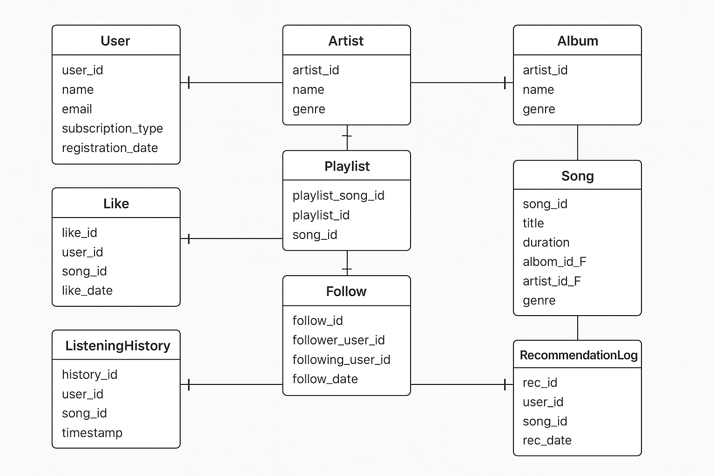
Conclusion:
Spotify has revolutionized the way people discover, consume, and interact with music and audio content. By addressing real-world problems such as limited music discovery, difficulty in organizing large music libraries, lack of social interaction, and understanding personal listening habits, Spotify provides innovative solutions that enhance the overall user experience. Its personalized recommendation engine, curated playlists, and analytics allow users to explore new songs and genres effortlessly, while features like playlist creation, sharing, and collaborative playlists foster social engagement and community building. Additionally, Spotify’s cross-platform accessibility and offline listening options ensure uninterrupted, seamless access to content anytime, anywhere. These combined features not only keep users engaged but also support artists by connecting them with a global audience. Overall, Spotify exemplifies how technology can solve practical challenges in entertainment, creating a personalized, convenient, and socially interactive platform that continues to shape the future of music streaming.

