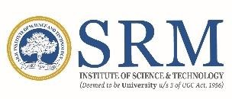

# SRM INSTITUTE OF SCIENCE AND TECHNOLOGY KATTANKULATHUR – 603 203

## **BONAFIDE CERTIFICATE**

Certified that 18CSP107L - Minor Project report titled “**SCHOLAR CONNECT: A PLATFORM TO CONNECT SCHOLARS USING FULLSTACK**” is the bonafide work of “**DRAWESH KUMAR YADAV [RA2111003010757], SHLOK GOEL [RA2111003010807]”** who carried out the project work[internship] under my supervision. Certified further, that to the best of my knowledge the work reported herein does not form any other project report or dissertation on the basis of which a degree or award was conferred on an earlier occasion on this or any other candidate.

|  |  |  |
| --- | --- | --- |
| **Dr. JAGADEESH M**  **SUPERVISOR**  Assistant Professor  Department of Computing Technologies |  | **DR. G. NIRANJANA**  **HEAD OF DEPARTMENT**  Department of Computing  Technologies |