**Connecting Minds: An Adaptive Algorithmic**

**Approach for Scholarly Engagement**

|  |  |  |
| --- | --- | --- |
| M.Jagadeesh1 | Drawesh Kumar Yadav 2 | Shlok Goel3 |
| *Assistant Professor,*  *Department of Computing Technologies,* | *UG Student,*  *Department of Computing Technologies,* | *UG Student,*  *Department of Computing Technologies,* |
| *SRM Institute of Science & Technology*, | *SRM Institute of Science & Technology*, | *SRM Institute of Science & Technology*, |
| Kattankulathur, Chennai-603203,  Tamil Nadu, India, | Kattankulathur, Chennai603203,  Tamil Nadu, India, | Kattankulathur, Chenna603203,  Tamil Nadu, India, |
| jagadeeshdevika@gmail.com | dm1399@srmist.edu.in | sr4385@srmist.edu.in |

***Abstract—*** **In today’s digital era, the demand for a unified platform that integrates software development with academic research dissemination is increasing. Existing systems like GitHub and Google Scholar function independently, leading to fragmented workflows for researchers and developers. This paper presents *Connecting Minds*, a hybrid platform that merges version control and scholarly communication to streamline knowledge sharing. The platform integrates core functionalities such as code management, academic profile maintenance, and publication sharing within a single ecosystem. A structured framework incorporating API-based interoperability, cross-linking mechanisms, and automated version control ensures seamless collaboration. Initial testing demonstrates enhanced research traceability, improved accessibility to academic contributions, and greater efficiency in interdisciplinary collaboration. The results highlight the platform’s potential to transform knowledge management by bridging the gap between software development and scholarly communication. Future enhancements will focus on scalability, security, and advanced analytics to further optimize the research and development experience.**

***Keywords— Scholarly Engagement, platform collaboration, Research Repositories, API Access, Cross-Linking Mechanism, Tagging and Annotation Tools***

1. INTRODUCTION

The increasing digitization of academic research and the growing reliance on software development in scientific advancements necessitate platforms that facilitate seamless collaboration, resource management, and communication. Traditional academic repositories, such as Google Scholar, ResearchGate, and institutional archives, primarily focus on disseminating scholarly publications and tracking citations. However, they lack interactive and collaborative features essential for modern research workflows. On the other hand, platforms like GitHub and GitLab have revolutionized software development by providing version control, issue tracking, and real-time collaboration tools**.** Despite these advancements, there remains a significant gap between the scholarly communication infrastructure used by researchers and the technical frameworks required for collaborative software development. Managing research output and software code separately creates inefficiencies in interdisciplinary fields such as computational science, bioinformatics, and artificial intelligence. This fragmentation hinders reproducibility, traceability, and the acceleration of innovation, which are critical to advancing modern science and engineering.

Several studies have explored the role of digital platforms in facilitating collaboration among researchers and developers. However, existing solutions primarily focus on either academic publication management or software development workflows rather than an integrated approach. Rasheed et al. (2020) examined the influence of social media on research engagement, highlighting challenges such as cyberbullying and the absence of structured academic contributions. Wattanakriengkrai et al. (2022) analysed the linkage between academic papers and GitHub repositories, revealing issues with traceability and limited accessibility to research-driven code. While platforms like Zenodo offer partial integration by allowing researchers to link GitHub repositories with DOI-registered datasets, they do not provide a fully unified environment where research papers and software projects coexist with comprehensive version control and scholarly metadata. These challenges indicate the necessity of a dedicated platform that facilitates seamless collaboration between researchers and developers while ensuring transparency, accessibility, and interdisciplinary knowledge sharing.

To address these issues, this paper presents Connecting Minds, a unified platform designed to integrate academic research dissemination with software development workflows **Figure 1**. The platform combines the functionalities of academic repositories, such as profile management and research sharing, with the collaborative and version control features of GitHub. By enabling users to manage both academic publications and software code within a single ecosystem, Connecting Minds promotes interdisciplinary collaboration, enhances research transparency, and accelerates the pace of scientific discovery. A core feature of the platform is its personalized dashboard, allowing researchers to maintain professional profiles, upload academic papers, and share software projects with peers. This integration ensures that academic findings and their corresponding codebases are accessible for review, reuse, and further development, ultimately improving reproducibility and innovation. Additionally, the platform aligns with Sustainable Development Goals (SDGs) by fostering inclusive education and promoting the free exchange of knowledge, particularly benefiting under-resourced regions.

The primary contributions of this research are as follows: (1) Development of a hybrid knowledge-sharing platform that integrates scholarly communication with collaborative software development (2) Implementation of a unified ecosystem that enhances research traceability, transparency, and

Inter-disciplinary collaboration (3) Introduction of an adaptive algorithm for linking research publications with software code, improving citation and impact tracking and (4) Proposal of a scalable model that can be expanded to support diverse academic and technical disciplines. The organization of this paper follows a structured approach, beginning with a detailed review of related literature, followed by the methodology and system architecture of Connecting Minds, an evaluation of the platform’s effectiveness through testing and validation, and a discussion of results, implications, and potential enhancements. The study concludes by summarizing key findings and suggesting future research directions.

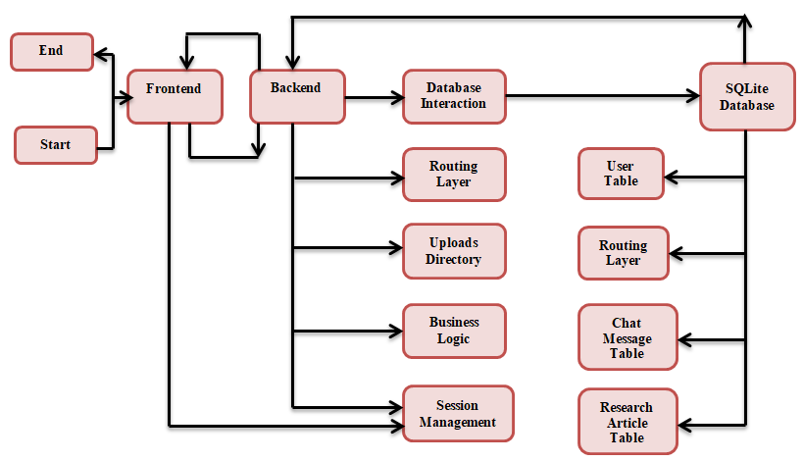

Fig.1. Visualizing the Integration of GitHub and Google Scholar

# PREVIOUS WORKS

Rasheed et al. **[1]** (2020) provided valuable insights into the dual effects of social media on graduate research students, highlighting both its benefits and challenges. The focus on knowledge sharing as a mediator was particularly relevant for understanding positive outcomes. However, further exploration of the impact of cyber bullying and strategies to mitigate its effects would enhance the discussion.

Maeda et al. **[2]** (2022) addressed an important challenge in programming education, offering a practical solution to tailor learning experiences to individual needs. The inclusion of code quality indicators adds depth to the platform’s functionality, aiding in personalized learning. However, elaborating on how the indicators are defined and evaluated would strengthen the proposal.

Ziegler et al. **[3]** (2022) examines the effectiveness of neural code completion tools like GitHub Copilot in improving developer productivity through more intelligent and context-aware suggestions. It assesses how well these tools perform under various scenarios and whether they reduce time spent on repetitive coding tasks.

Wattanakriengkrai et al. **[4]** (2022) offered valuable insights into the alignment between scientific breakthroughs and their implementation in open-source software. Its large-scale analysis and mixed-methods approach provide a robust foundation for understanding traceability and access dynamics. Highlighting trends such as the academic affiliation of repositories and the programming diversity of referenced papers adds depth to the findings.

Imai et al. **[5]** (2022) explores how GitHub Copilot can replace or complement human pair-programming. It investigates its potential to enhance productivity while reducing dependency on a human collaborator.

Vaithilingam et al. **[6]** (2022) examined user expectations and actual experiences while using AIbased code generation tools. It discussed discrepancies in the perceived usefulness of these tools versus their actual performance in real-world tasks.

Oliveira al**. [7]** (2023) examines GitHub developers' collaborations using a heterogeneous network model based on social interactions, repository collaboration time, and technical features. It analyzes the network's size, relevance, and applications, revealing that the metrics are uncorrelated, offering novel insights. The findings demonstrate the utility of this information for tasks like social developer ranking, team formation, community detection, and pair programming.

Singh et al. **[8]** (2024) presented an insightful analysis of Campus Connect, an online platform designed to enrich the college experience by integrating social networking, knowledge sharing, and financial transaction features. The study assessed its influence on student engagement, knowledge exchange, and community development through a mixed-methods approach.

Wang et al. **[9]** (2024) provides a clear and practical comparison of the two IaC tools, offering valuable insights into their strengths and use cases. The emphasis on real-world performance metrics, such as resource destruction times, strengthens the analysis. However, further elaboration on the testing methodology and inclusion of additional metrics, like resource creation times or error handling, could provide a more comprehensive evaluation.

Eswaran et al. **[10]** (2025) offered a succinct and insightful analysis of how blockchain can enhance knowledge sharing systems through secure, transparent, and decentralized collaboration.

The theme of these discussions as given in **table 1** is centred on the intersection of technology with learning, collaboration, and productivity. Topics such as the role of social media in academic engagement, personalized programming learning solutions, the use of AI tools for development, and the integration of blockchain for knowledge sharing are addressed.

Table 1.Summary of Recent Studies on Collaborative Technologies in Knowledge Sharing Systems

|  |  |  |  |
| --- | --- | --- | --- |
| ***Author(s)*** | ***Year*** | ***Highlights*** | ***Limitations*** |
| Rasheed et al. [**1]** | 2020 | Knowledge sharing links social media use to student engagement. | Cyberbullying. |
| Maeda et al. [**2**] | 2022 | A platform for sharing, assessing, and ranking code. | Predefining model code for every learner's proficiency may be impractical. |
| Ziegler et al. **[3]** | 2022 | GitHub Copilot boosts developer productivity with smart, context-aware suggestions. | Specificity and repetition shape how conversation quality is perceived. |
| Wattanakriengkrai et al. **[4]** | 2022 | A study of 20,278 links to assess academic paper references in GitHub repositories. | Focuses solely on GitHub repositories and README.md files |
| Imai et al. **[5]** | 2022 | The effectiveness of pair programming with GitHub Copilot versus human pair-programming. | Code quality is lower |
| Vaithilingam et al. **[6]** | 2022 | LLM-powered code generation tool. | Did not consistently reduce task time or improve task success in real-world scenarios. |
| Oliveira et al. **[7]** | 2023 | Social interaction, time spent collaborating in a repository, and technical attributes. | Relies on GitHub as the sole platform |
| Singh et al. **[8]** | 2024 | Highlight the platform's positive effects on peer knowledge exchange, academic success, and school community belonging. | Evolving needs of college students in the digital era. |
| Wang et al. **[9]** | 2024 | Infrastructure as Code (IaC) tools - Google Cloud Deployment Manager and Terraform | Different cloud setups & different configurations |
| Eswaran et al. **[10]** | 2025 | The convergence of blockchain technology and knowledge-sharing systems. | Data isolation, trust issues, and poor information flow. |

1. PROPOSED MODEL

**This research proposes a unified platform combining GitHub's core functionalities with academic repositories like Google Scholar. This approach is innovative because this unification fosters enhanced collaboration, promotes reproducibility of research, and streamlines access to both scholarly insights and technical implementations, creating a comprehensive knowledge-sharing ecosystem. Figure 2 reflects the essential components of the Connecting Minds platform architecture [11].**

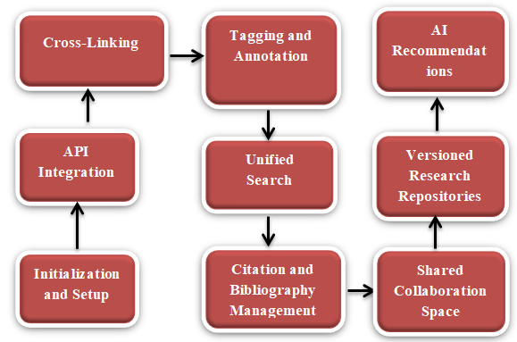

Fig.2. Data Flow Architecture of Connecting Minds Platform

1. **User Profile Management**

**Users can create and manage their academic profiles, including personal information, research interests, and uploaded publications. The profile management system allows for real-time updates to ensure data accuracy. Resource sharing this platform supports the uploading and sharing of academic papers and code repositories [12]. A user-friendly interface facilitates the organization of shared resources through tags and categories, enhancing discoverability [13].**

1. **Collaborative Features**

Real-time communication tools, including a built-in chat feature, are implemented to encourage discussions among users **[14].** WebSocket technology is utilized to enable real-time messaging without page refreshes. Version Control Scholar Connect incorporates version control functionalities similar to GitHub **[15],** allowing users to track changes to codebases, manage contributions, and revert to previous versions if necessary **[16].**

1. **Testing Evaluation**

The system undergoes rigorous testing to ensure functionality, usability, and security.

1. **Functional Testing**

Each feature is tested individually to verify that it operates according to the specified requirements. Automated testing frameworks (e.g., Selenium for frontend testing) are utilized to streamline this process.

1. **User Acceptance Testing (UAT)**

Feedback from a sample group of users is collected to evaluate the platform's usability and functionality. Modifications are made based on user input to improve overall experience **[17].**

1. **Security Testing**

Penetration testing is performed to identify vulnerabilities in the system. This includes testing for SQL injection, cross-site scripting (XSS), and other common security threats.

1. **Deployment**

Scholar Connect may be deployed on cloud-based platforms (e.g., AWS, Google Cloud Platform) to ensure high availability and scalability. Continuous integration and continuous deployment (CI/CD) practices are employed to facilitate regular updates and maintenance **[18].**

1. System Architecture

Scholar Connect employs a layered architecture as shown in **Figure 3** to ensure scalability, modularity, and maintainability. The architecture consists of three primary layers: the Presentation Layer, which encompasses the user interface (UI) and user experience (UX) components, focusing on providing an intuitive and user-friendly experience; the Application Layer, which contains the business logic and handles interactions between the UI and the data layer, ensuring efficient processing of user requests and data flow management; and the Data Layer, which includes the database and data management systems, designed to securely store user profiles, research publications, software projects, and related metadata.

The frontend components are built using modern Python frameworks, such as React.js, ensuring a responsive and accessible UI. Key elements include a Dashboard, which offers personalized spaces for users to view notifications, access projects, and engage in discussions; Profile Management, allowing users to create and update their research profiles, including research interests and uploaded resources; and Resource Uploading, which provides a streamlined interface for submitting academic papers and code repositories. Additionally, a built-in Real-time Chat feature facilitates instant communication among users, enhancing collaboration.

The backend components incorporate RESTful API Services that handle CRUD (Create, Read, Update, and Delete) operations for user profiles, resources, and projects. The Authentication Module implements OAuth 2.0 for secure login, allowing users to access the platform using institutional credentials or social media accounts. A Notification System is integrated to alert users about relevant activities, such as new messages or updates to shared resources.

The database design consists of multiple structured tables. The User Table stores user credentials, including usernames, hashed passwords, and assigned roles (e.g., researcher, developer). The Resource Table maintains metadata for uploaded academic papers and code projects, such as titles, abstracts, file types, and upload dates. The Collaboration Table manages user interactions, including chat logs and collaborative contributions.

The user interface design is structured through initial wireframes that outline the layout of major components. The Login Page is designed for straightforward authentication, while the Dashboard acts as a central hub featuring quick access to projects, notifications, and user statistics. The Profile Page allows users to edit their profiles and view their contributions. The Navigation System is designed to be intuitive, ensuring seamless accessibility across various sections. The interface is responsive, adapting efficiently to desktops, tablets, and mobile devices to enhance usability.

The interaction flow follows a structured approach. During User Registration and Authentication, users register using their email, set a password, and complete a verification process before gaining platform access. Resource Uploading involves users filling out metadata fields and attaching files, which the system validates and securely stores in the database. Collaboration and Communication features enable users to initiate real-time chats with peers and engage in quick exchanges of ideas. The Version Control Management system allows users to manage code versions through an interface similar to GitHub, facilitating efficient tracking of changes and contributions.

To ensure security, the platform incorporates Data Encryption using industry-standard techniques to protect sensitive user information. Access Control is enforced through role-based access control (RBAC), ensuring that users can only access functionalities relevant to their roles. Additionally, Regular Security Audits are conducted to identify and mitigate vulnerabilities, ensuring the system remains secure and resilient against potential threats.

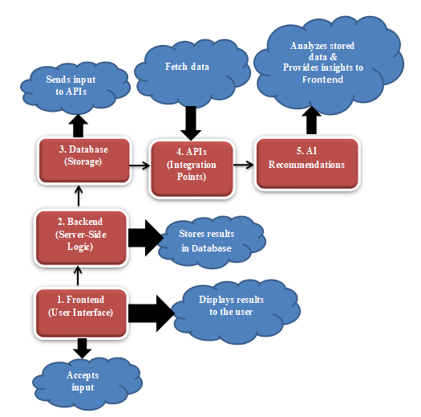

Fig.3. System Architecture Overview

# Conclusions And Future enhancements

The integration of GitHub and Google Scholar into a unified platform offers a novel solution to bridging the gap between academic research and software development. By leveraging APIs, intelligent linking algorithms, and AI-powered recommendations, the platform fosters enhanced collaboration, seamless knowledge sharing, and efficient resource accessibility. This system not only improves traceability between research and implementation but also supports multidisciplinary innovation by providing a shared space for researchers and developers. With its potential to drive advancements in reproducibility, citation tracking, and software quality, the platform represents a significant step toward creating a more interconnected ecosystem for academia and technology. Despite its advantages, the platform has certain limitations that must be addressed for broader adoption. One of the primary challenges is designing a scalable database architecture that accommodates both code files (with version history) and academic publications (with metadata and citations). Ensuring interoperability with multiple research repositories and version control platforms while maintaining performance efficiency is another challenge. Additionally, implementing a secure, role-based authentication system for different user types (e.g., researchers, collaborators, and administrators) adds complexity to access management. The integration of real-time collaboration features, such as live editing and dynamic discussions, demands substantial backend resources and synchronization, which may impact performance if not optimized effectively. Furthermore, ensuring the long-term sustainability and adoption of the platform across diverse research communities requires extensive user engagement and institutional support. For future enhancements, the platform can incorporate advanced analytics to provide citation impact tracking, automated research recommendations, and AI-driven code-review mechanisms. Real-time collaboration features, such as interactive research forums and live coding sessions, could further enhance usability.

Additionally, extending support for diverse academic and development tools, including LaTeX integration, Jupyter Notebook compatibility, and blockchain-based authentication for research integrity, can significantly improve functionality. To ensure seamless integration across institutions, the development of open APIs and interoperability standards will be essential. Lastly, exploring decentralized and federated architectures could enhance data security, privacy, and accessibility, making the platform more resilient and scalable for global research collaboration. By addressing these challenges and expanding its capabilities, the proposed platform has the potential to redefine how researchers and developers collaborate, ultimately accelerating scientific progress and technological innovation.

##### References

1. Rasheed, Muhammad Imran, Muhammad Jawad Malik, Abdul Hameed Pitafi, Jawad Iqbal, Muhammad Khalid Anser, and Mazhar Abbas. "Usage of social media, student engagement, and creativity: The role of knowledge sharing behavior and cyberbullying." Computers & Education 159 (2020): 104002.
2. Maeda, Shintaro, Kento Koike, and Takahito Tomoto. "A knowledge sharing platform for learning from others’ code." In International Conference on Human-Computer Interaction, pp. 489-504. Cham: Springer International Publishing, 2022.
3. Ziegler, A., Kalliamvakou, E., Li, X.A., Rice, A., Rifkin, D., Simister, S., Sittampalam, G. and Aftandilian, E., 2022, June. Productivity assessment of neural code completion. In Proceedings of the 6th ACM SIGPLAN International Symposium on Machine Programming (pp. 21-29).
4. Wattanakriengkrai, Supatsara, Bodin Chinthanet, Hideaki Hata, Raula Gaikovina Kula, Christoph Treude, Jin Guo, and Kenichi Matsumoto. "GitHub repositories with links to academic papers: Public access, traceability, and evolution." Journal of Systems and Software 183 (2022): 111117.
5. Imai, Saki. "Is github copilot a substitute for human pair-programming? an empirical study." In Proceedings of the ACM/IEEE 44th International Conference on Software Engineering: Companion Proceedings, pp. 319-321. 2022.
6. Vaithilingam, Priyan, Tianyi Zhang, and Elena L. Glassman. "Expectation vs. experience: Evaluating the usability of code generation tools powered by large language models." In Chi conference on human factors in computing systems extended abstracts, pp. 1-7. 2022.
7. Oliveira, Gabriel P., Ana Flávia C. Moura, Natércia A. Batista, Michele A. Brandão, Andre Hora, and Mirella M. Moro. "How do developers collaborate? Investigating GitHub heterogeneous networks." Software Quality Journal 31, no. 1 (2023): 211-241.
8. Singh, Nongmeikapam Thoiba, Jyoti Rani, Pardeep Kaur, and Richa Grover. "CampusConnect: A Collaborative College Hub for Reselling and Sharing Knowledge." In 2024 2nd International Conference on Self Sustainable Artificial Intelligence Systems (ICSSAS), pp. 1308-1311. IEEE, 2024.
9. Wang, Hongyu, Brian Kishiyama, David Lopez, and Jeong Yang. "An Overview of Infrastructure as Code (IaC) with Performance and Availability Assessment on Google Cloud Platform." In International Conference on Advances in Computing Research, pp. 497-514. Cham: Springer Nature Switzerland, 2024.
10. Eswaran, Ushaa, Vivek Eswaran, Keerthna Murali, and Vishal Eswaran. "Blockchain-Based Knowledge Sharing and Collaboration." Blockchain Technology Applications in Knowledge Management (2025): 71-114.
11. Saroar, SK Golam, Waseefa Ahmed, Elmira Onagh, and Maleknaz Nayebi. "GitHub marketplace for automation and innovation in software production." Information and Software Technology 175 (2024): 107522.
12. Wang, Tianlei, Shaowei Wang, and Tse-Hsun Peter Chen. "Study the correlation between the readme file of GitHub projects and their popularity." Journal of Systems and Software 205 (2023): 111806.
13. Di Rocco, Juri, Davide Di Ruscio, Claudio Di Sipio, Phuong T. Nguyen, and Riccardo Rubei. "Hybridrec: A recommender system for tagging github repositories." Applied Intelligence 53, no. 8 (2023): 9708-9730.
14. Delgado‐Quirós, Lorena, Isidro F. Aguillo, Alberto Martín‐Martín, Emilio Delgado López‐Cózar, Enrique Orduña‐Malea, and José Luis Ortega. "Why are these publications missing? Uncovering the reasons behind the exclusion of documents in free‐access scholarly databases." Journal of the Association for Information Science and Technology 75, no. 1 (2024): 43-58.
15. Da Silveira, Marcos, Louis Deladiennee, Emmanuel Scolan, and Cedric Pruski. "A knowledge-sharing platform for space resources." Data & Knowledge Engineering 151 (2024): 102286.
16. Singh, Vinay. GIT: A Beginner's Guide to Version Control System Excellence'by Vinay Singh and Rakshit Singh. Dorrance Publishing, 2023.
17. Di Rocco, Juri, Davide Di Ruscio, Claudio Di Sipio, Phuong T. Nguyen, and Riccardo Rubei. "Hybridrec: A recommender system for tagging github repositories." Applied Intelligence 53, no. 8 (2023): 9708-9730.
18. Kleminski, Rajmund, Przemysiaw Kazienko, and Tomasz Kajdanowicz. "Analysis of direct citation, co-citation and bibliographic coupling in scientific topic identification." Journal of Information Science 48, no. 3 (2022): 349-373.
19. Chigbu, Uchendu Eugene, Sulaiman Olusegun Atiku, and Cherley C. Du Plessis. "The science of literature reviews: Searching, identifying, selecting, and synthesising." Publications 11, no. 1 (2023): 2.
20. Gill, Sukhpal Singh, Huaming Wu, Panos Patros, Carlo Ottaviani, Priyansh Arora, Victor Casamayor Pujol, David Haunschild et al. "Modern computing: Vision and challenges." Telematics and Informatics Reports (2024): 100116.