**Connecting Minds: An Adaptive Algorithmic**

**Approach for Scholarly Engagement**

|  |  |  |
| --- | --- | --- |
| M.Jagadeesh1 | Drawesh Kumar Yadav 2 | Shlok Goel3 |
| *Assistant Professor,*  *Department of Computing Technologies,* | *UG Student,*  *Department of Computing Technologies,* | *UG Student,*  *Department of Computing Technologies,* |
| *SRM Institute of Science & Technology*, | *SRM Institute of Science & Technology*, | *SRM Institute of Science & Technology*, |
| Kattankulathur, Chennai-603203,  Tamil Nadu, India, | Kattankulathur, Chennai603203,  Tamil Nadu, India, | Kattankulathur, Chenna603203,  Tamil Nadu, India, |
| jagadeeshdevika@gmail.com | dm1399@srmist.edu.in | sr4385@srmist.edu.in |

***Abstract—*In today’s fast-evolving digital world, the demand for a unified knowledge-sharing platform that integrates collaborative software development with academic research dissemination is growing exponentially. This paper presents the idea and design of a hybrid platform that merges the core functionalities of GitHub, a widely-used environment for software development and version control, with the scholarly communication features of academic repositories like Google Scholar. The proposed platform streamlines workflows for researchers and developers, providing a unified space where both code and academic contributions coexist and evolve within a collaborative ecosystem. By integrating these traditionally separate domains, the platform fosters interdisciplinary collaboration, enabling users to manage code development, maintain version histories, and share academic publications seamlessly. This fusion enhances productivity and promotes innovation, offering a transformative approach to bridging the gap between software development and scholarly communication. The platform is poised to become a cornerstone for scientific and engineering communities, driving advancements at the intersection of technology and research.**

***Keywords— Scholarly Engagement, platform collaboration, Research Repositories, API Access, Cross-Linking Mechanism, Tagging and Annotation Tools***

1. INTRODUCTION

The increasing digitization of academic research and the integration of software development into modern scientific practices demand platforms that streamline collaboration, resource management, and communication. While traditional academic repositories such as Google Scholar and institutional archives focus on disseminating scholarly publications, platforms like GitHub have transformed software development through features such as version control and collaborative coding. However, a significant gap persists between the scholarly communication systems used by researchers and the technical infrastructure required for collaborative software development.

Managing research output and code in separate environments often creates complexities that can hinder interdisciplinary work, particularly in fields where research and software development intersect. Computational science, bioinformatics, and data-driven engineering are just a few examples of disciplines that necessitate seamless integration between academic and technical workflows.

This separation not only limits productivity but also constrains the potential for innovation and reproducibility, both of which are vital to advancing modern science and engineering.

To address this gap, we present Connecting Minds, a unified platform designed to enhance collaboration between researchers and developers. The platform aims to improve both academic productivity and software development workflows by integrating the core functionalities of academic repositories such as user profile management and research dissemination with the collaborative features of version control platforms like GitHub. By enabling users to manage both code and research output within a single seamless environment, Connecting Minds fosters interdisciplinary collaboration, promotes transparency, and accelerates the pace of discovery in various research fields.

At the heart of Connecting Minds lies its personalized dashboard, which empowers users to maintain professional profiles, upload academic papers, and share resources with peers. A standout feature of the platform is its capacity to manage software development projects, including version history and collaborative coding, directly alongside academic publications. This unique integration not only facilitates the sharing of research but also allows associated codebases to be made accessible for review, reuse, and further development by the scholarly community. By enhancing transparency and reproducibility, Connecting Minds addresses key challenges in modern scientific practice, paving the way for a transformative approach to interdisciplinary collaboration.

The Connecting Minds platform is closely aligned with several Sustainable Development Goals (SDGs), which focus on fostering sustainable and inclusive growth in areas such as education, innovation, and collaboration. This research idea aligns with Sustainable Development Goal of Quality Education by advancing knowledge accessibility and learning opportunities through the integration of academic research and software development within a unified platform. By facilitating the free exchange of knowledge, it promotes inclusive, high-quality education, providing educators, students, and researchers with access to the latest academic publications and open-source software projects, thus fostering continuous learning and skill development. Additionally, the platform empowers researchers to widely share their findings; ensuring educational resources are freely available.

This open access benefits learners globally, particularly in under-resourced regions, by bridging knowledge gaps and supporting educational equity. The Proposed platform for combining GitHub and Google Scholar, showcasing their integration for knowledge sharing and collaboration is shown in **Figure 1**.

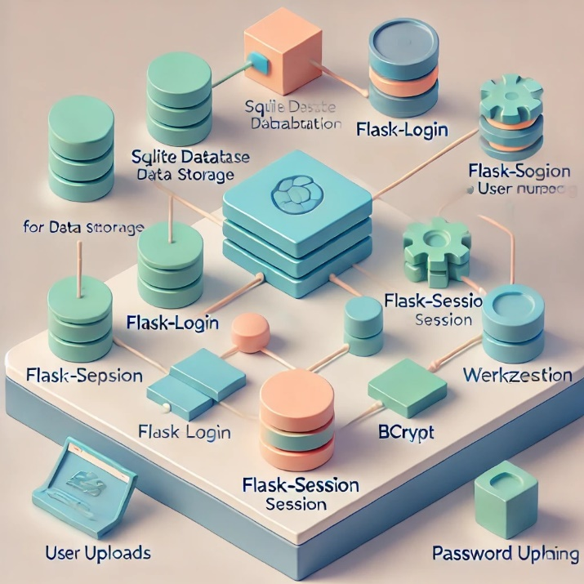

Fig.1. Visualizing the Integration of GitHub and Google Scholar

# PREVIOUS WORKS

Rasheed et al. **[1]** (2020) provided valuable insights into the dual effects of social media on graduate research students, highlighting both its benefits and challenges. The focus on knowledge sharing as a mediator was particularly relevant for understanding positive outcomes. However, further exploration of the impact of cyber bullying and strategies to mitigate its effects would enhance the discussion.

Maeda et al. **[2]** (2022) addressed an important challenge in programming education, offering a practical solution to tailor learning experiences to individual needs. The inclusion of code quality indicators adds depth to the platform’s functionality, aiding in personalized learning. However, elaborating on how the indicators are defined and evaluated would strengthen the proposal.

Ziegler et al. **[3]** (2022) examines the effectiveness of neural code completion tools like GitHub Copilot in improving developer productivity through more intelligent and context-aware suggestions. It assesses how well these tools perform under various scenarios and whether they reduce time spent on repetitive coding tasks.

Wattanakriengkrai et al. **[4]** (2022) offered valuable insights into the alignment between scientific breakthroughs and their implementation in open-source software. Its large-scale analysis and mixed-methods approach provide a robust foundation for understanding traceability and access dynamics. Highlighting trends such as the academic affiliation of repositories and the programming diversity of referenced papers adds depth to the findings.

Imai et al. **[5]** (2022) explores how GitHub Copilot can replace or complement human pair-programming. It investigates its potential to enhance productivity while reducing dependency on a human collaborator.

Vaithilingam et al. **[6]** (2022) examined user expectations and actual experiences while using AIbased code generation tools. It discussed discrepancies in the perceived usefulness of these tools versus their actual performance in real-world tasks.

Oliveira al**. [7]** (2023) examines GitHub developers' collaborations using a heterogeneous network model based on social interactions, repository collaboration time, and technical features.

It analyzes the network's size, relevance, and applications, revealing that the metrics are uncorrelated, offering novel insights. The findings demonstrate the utility of this information for tasks like social developer ranking, team formation, community detection, and pair programming.

Singh et al. **[8]** (2024) presented an insightful analysis of CampusConnect, an online platform designed to enrich the college experience by integrating social networking, knowledge sharing, and financial transaction features. The study assessed its influence on student engagement, knowledge exchange, and community development through a mixed-methods approach.

Wang et al. **[9]** (2024) provides a clear and practical comparison of the two IaC tools, offering valuable insights into their strengths and use cases. The emphasis on real-world performance metrics, such as resource destruction times, strengthens the analysis. However, further elaboration on the testing methodology and inclusion of additional metrics, like resource creation times or error handling, could provide a more comprehensive evaluation.

Eswaran et al. **[10]** (2025) offered a succinct and insightful analysis of how blockchain can enhance knowledge sharing systems through secure, transparent, and decentralized collaboration.

The theme of these discussions as given in **table 1** is centred on the intersection of technology with learning, collaboration, and productivity. Topics such as the role of social media in academic engagement, personalized programming learning solutions, the use of AI tools for development, and the integration of blockchain for knowledge sharing are addressed.

Table 1. Summary of Recent Studies on Collaborative Technologies in Knowledge Sharing Systems

|  |  |  |  |
| --- | --- | --- | --- |
| ***Author(s)*** | ***Year*** | ***Highlights*** | ***Limitations*** |
| Rasheed et al. [**1]** | 2020 | Knowledge sharing links social media use to student engagement. | Cyberbullying. |
| Maeda et al. [**2**] | 2022 | A platform for sharing, assessing, and ranking code. | Predefining model code for every learner's proficiency may be impractical. |
| Ziegler et al. **[3]** | 2022 | GitHub Copilot boosts developer productivity with smart, context-aware suggestions. | Specificity and repetition shape how conversation quality is perceived. |
| Wattanakriengkrai et al. **[4]** | 2022 | A study of 20,278 links to assess academic paper references in GitHub repositories. | Focuses solely on GitHub repositories and README.md files |
| Imai et al. **[5]** | 2022 | The effectiveness of pair programming with GitHub Copilot versus human pair-programming. | Code quality is lower |
| Vaithilingam et al. **[6]** | 2022 | LLM-powered code generation tool. | Did not consistently reduce task time or improve task success in real-world scenarios. |
| Oliveira et al. **[7]** | 2023 | Social interaction, time spent collaborating in a repository, and technical attributes. | Relies on GitHub as the sole platform |
| Singh et al. **[8]** | 2024 | Highlight the platform's positive effects on peer knowledge exchange, academic success, and school community belonging. | Evolving needs of college students in the digital era. |
| Wang et al. **[9]** | 2024 | Infrastructure as Code (IaC) tools - Google Cloud Deployment Manager and Terraform | Different cloud setups & different configurations |
| Eswaran et al. **[10]** | 2025 | The convergence of blockchain technology and knowledge-sharing systems. | Data isolation, trust issues, and poor information flow. |

1. PROPOSED MODEL

**This research proposes a unified platform combining GitHub's core functionalities with academic repositories like Google Scholar. This approach is innovative because this unification fosters enhanced collaboration, promotes reproducibility of research, and streamlines access to both scholarly insights and technical implementations, creating a comprehensive knowledge-sharing ecosystem. Figure 2 reflects the essential components of the Connecting Minds platform architecture.**

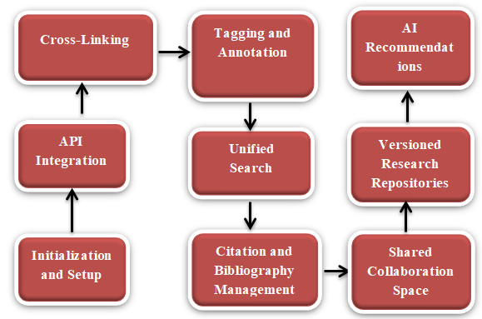

Fig.2. Data Flow Architecture of Connecting Minds Platform

## Core Functionalities

***User Profile Management:*** Users can create and manage their academic profiles, including personal information, research interests, and uploaded publications. The profile management system allows for real-time updates to ensure data accuracy.

*Resource Sharing:* The platform supports the uploading and sharing of academic papers and code repositories. A user-friendly interface facilitates the organization of shared resources through tags and categories, enhancing discoverability.

***Collaborative Features:*** Real-time communication tools, including a built-in chat feature, are implemented to encourage discussions among users. WebSocket technology is utilized to enable real-time messaging without page refreshes.

***Version Control for Software Projects:*** Scholar Connect incorporates version control functionalities similar to GitHub, allowing users to track changes to codebases, manage contributions, and revert to previous versions when necessary.

## Testing Evaluation

The system undergoes rigorous testing to ensure functionality, usability, and security:

**Functional Testing**: Each feature is tested individually to verify that it operates according to the specified requirements. Automated testing frameworks (e.g., Selenium for frontend testing) are utilized to streamline this process.

**User Acceptance Testing (UAT):** Feedback from a sample group of users is collected to evaluate the platform's usability and functionality. Modifications are made based on user input to improve overall experience.

**Security Testing**: Penetration testing is performed to identify vulnerabilities in the system. This includes testing for SQL injection, cross-site scripting (XSS), and other common security threats.

## Deployment

Scholar Connect may be deployed on cloud-based platforms (e.g., AWS, Google Cloud Platform) to ensure high availability and scalability. Continuous integration and continuous deployment (CI/CD) practices are employed to facilitate regular updates and maintenance.

# System Architecture

## Architectural Overview

Scholar Connect employs a layered architecture to ensure scalability, modularity, and maintainability. The architecture consists of the following layers:

**Presentation Layer:** This layer encompasses the user interface (UI) and user experience (UX) components. The design focuses on providing an intuitive and user-friendly experience.

**Application Layer:** This layer contains the business logic and handles interactions between the UI and the data layer. It is responsible for processing user requests and managing data flow.

**Data Layer:** The data layer includes the database and data management systems. It is designed to securely store user profiles, research publications, software projects, and related metadata.

## Component Design

**Frontend Components:**

**User Interface:** Built using modern Python frameworks (e.g., React.js), the UI is designed to be responsive and accessible. Key components include:

**Dashboard:** A personalized space for users to view notifications, access their projects, and engage in discussions.

**Profile Management:** Allows users to create and update their profiles, including research interests and uploaded resources.

**Resource Uploading:** A streamlined interface for submitting academic papers and code repositories.

*Real-time Chat:* A built-in chat feature facilitating instant communication among users.

**Backend Components:**

**API Services:** RESTful APIs are developed to handle CRUD (Create, Read, Update, Delete) operations for user profiles, resources, and projects.

**Authentication Module:** Implements OAuth 2.0 for secure user authentication, allowing users to log in using institutional credentials or social media accounts.

**Notification System:** A service that alerts users to relevant activities, such as new messages or updates to shared resources.

**Database Design:**

**User Table:** Stores user information, including usernames, passwords (hashed), and roles (researcher, developer).

*Resource Table:* Contains metadata for uploaded academic papers and code projects, including titles, abstracts, file types, and upload dates.

**Collaboration Table:** Manages interactions between users, including chat logs and collaborative contributions.

## User Interface Design

Wireframes:

Initial wireframes illustrate the layout and organization of the main components. Key screens include:

**Login Page:** Simple and straightforward, focusing on user authentication.

**Dashboard:** Central hub featuring quick access to projects, notifications, and user statistics.

**Profile Page:** Allows users to edit their profiles and view contributions.

User Experience Considerations:

**Navigation:** Intuitive navigation menus to enhance accessibility.

**Responsiveness:** The design adapts to various devices, ensuring usability on desktops, tablets, and mobile devices.

## Interaction Flow

**User Registration and Authentication:**

Users register by submitting their email and creating a password. Verification is sent to the provided email address.

Upon successful verification, users can log in and access the platform.

**Resource Uploading:**

Users navigate to the resource uploading section, fill out the required metadata fields, and attach the file.

Upon submission, the system validates the input and stores the resource in the database.

**Collaboration and Communication**:

Users can initiate chats with peers by selecting contacts from their connection list.

The chat interface supports real-time messaging, enabling quick exchanges of ideas and collaboration on projects.

**Version Control Management:**

When users upload code projects, they can manage versions through an integrated interface similar to GitHub, tracking changes and contributions effectively.

## Security Measures

**Data Encryption:** All sensitive user data is encrypted using industry-standard encryption techniques.

**Access Control:** Role-based access control (RBAC) ensures that users can only access functionalities relevant to their roles.

**Regular Audits:** The platform undergoes regular security audits to identify and mitigate vulnerabilities.

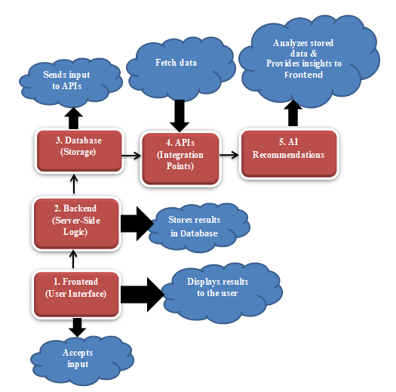

Fig.3. System Architecture Overview

# Conclusions aND Future enhancements

The proposed integration of GitHub and Google Scholar into a unified platform offers a novel solution to bridge the gap between academic research and software development. By leveraging APIs, intelligent linking algorithms, and AI-powered recommendations, the platform fosters enhanced collaboration, seamless knowledge sharing, and efficient resource accessibility. This system not only improves traceability between research and implementation but also supports multi-disciplinary innovation by providing a shared space for researchers and developers. With its potential to drive advancements in reproducibility, citation tracking, and people-centered software quality, the platform represents a significant step toward creating a more interconnected ecosystem for academia and technology.

Future enhancements could focus on real-time updates, advanced analytics, and extended support for diverse academic and development tools to maximize its impact. Despite advancements, challenges persist in designing a database that accommodates both code files (with version history) and academic publications (with metadata and citations). Implementing a secure, role-based authentication system for different user types (e.g., researchers, collaborators, and admins) adds complexity **[20]**. Additionally, real-time features demand substantial backend resources and synchronization, potentially impacting performance if not managed effectively.

##### References

1. Rasheed, Muhammad Imran, Muhammad Jawad Malik, Abdul Hameed Pitafi, Jawad Iqbal, Muhammad Khalid Anser, and Mazhar Abbas. "Usage of social media, student engagement, and creativity: The role of knowledge sharing behavior and cyberbullying." Computers & Education 159 (2020): 104002.
2. Maeda, Shintaro, Kento Koike, and Takahito Tomoto. "A knowledge sharing platform for learning from others’ code." In International Conference on Human-Computer Interaction, pp. 489-504. Cham: Springer International Publishing, 2022.
3. Ziegler, A., Kalliamvakou, E., Li, X.A., Rice, A., Rifkin, D., Simister, S., Sittampalam, G. and Aftandilian, E., 2022, June. Productivity assessment of neural code completion. In Proceedings of the 6th ACM SIGPLAN International Symposium on Machine Programming (pp. 21-29).
4. Wattanakriengkrai, Supatsara, Bodin Chinthanet, Hideaki Hata, Raula Gaikovina Kula, Christoph Treude, Jin Guo, and Kenichi Matsumoto. "GitHub repositories with links to academic papers: Public access, traceability, and evolution." Journal of Systems and Software 183 (2022): 111117.
5. Imai, Saki. "Is github copilot a substitute for human pair-programming? an empirical study." In Proceedings of the ACM/IEEE 44th International Conference on Software Engineering: Companion Proceedings, pp. 319-321. 2022.
6. Vaithilingam, Priyan, Tianyi Zhang, and Elena L. Glassman. "Expectation vs. experience: Evaluating the usability of code generation tools powered by large language models." In Chi conference on human factors in computing systems extended abstracts, pp. 1-7. 2022.
7. Oliveira, Gabriel P., Ana Flávia C. Moura, Natércia A. Batista, Michele A. Brandão, Andre Hora, and Mirella M. Moro. "How do developers collaborate? Investigating GitHub heterogeneous networks." Software Quality Journal 31, no. 1 (2023): 211-241.
8. Singh, Nongmeikapam Thoiba, Jyoti Rani, Pardeep Kaur, and Richa Grover. "CampusConnect: A Collaborative College Hub for Reselling and Sharing Knowledge." In 2024 2nd International Conference on Self Sustainable Artificial Intelligence Systems (ICSSAS), pp. 1308-1311. IEEE, 2024.
9. Wang, Hongyu, Brian Kishiyama, David Lopez, and Jeong Yang. "An Overview of Infrastructure as Code (IaC) with Performance and Availability Assessment on Google Cloud Platform." In International Conference on Advances in Computing Research, pp. 497-514. Cham: Springer Nature Switzerland, 2024.
10. Eswaran, Ushaa, Vivek Eswaran, Keerthna Murali, and Vishal Eswaran. "Blockchain-Based Knowledge Sharing and Collaboration." Blockchain Technology Applications in Knowledge Management (2025): 71-114.
11. Saroar, SK Golam, Waseefa Ahmed, Elmira Onagh, and Maleknaz Nayebi. "GitHub marketplace for automation and innovation in software production." Information and Software Technology 175 (2024): 107522.
12. Wang, Tianlei, Shaowei Wang, and Tse-Hsun Peter Chen. "Study the correlation between the readme file of GitHub projects and their popularity." Journal of Systems and Software 205 (2023): 111806.
13. Di Rocco, Juri, Davide Di Ruscio, Claudio Di Sipio, Phuong T. Nguyen, and Riccardo Rubei. "Hybridrec: A recommender system for tagging github repositories." Applied Intelligence 53, no. 8 (2023): 9708-9730.
14. Delgado‐Quirós, Lorena, Isidro F. Aguillo, Alberto Martín‐Martín, Emilio Delgado López‐Cózar, Enrique Orduña‐Malea, and José Luis Ortega. "Why are these publications missing? Uncovering the reasons behind the exclusion of documents in free‐access scholarly databases." Journal of the Association for Information Science and Technology 75, no. 1 (2024): 43-58.
15. Da Silveira, Marcos, Louis Deladiennee, Emmanuel Scolan, and Cedric Pruski. "A knowledge-sharing platform for space resources." Data & Knowledge Engineering 151 (2024): 102286.
16. Singh, Vinay. GIT: A Beginner's Guide to Version Control System Excellence'by Vinay Singh and Rakshit Singh. Dorrance Publishing, 2023.
17. Di Rocco, Juri, Davide Di Ruscio, Claudio Di Sipio, Phuong T. Nguyen, and Riccardo Rubei. "Hybridrec: A recommender system for tagging github repositories." Applied Intelligence 53, no. 8 (2023): 9708-9730.
18. Kleminski, Rajmund, Przemysiaw Kazienko, and Tomasz Kajdanowicz. "Analysis of direct citation, co-citation and bibliographic coupling in scientific topic identification." Journal of Information Science 48, no. 3 (2022): 349-373.
19. Chigbu, Uchendu Eugene, Sulaiman Olusegun Atiku, and Cherley C. Du Plessis. "The science of literature reviews: Searching, identifying, selecting, and synthesising." Publications 11, no. 1 (2023): 2.
20. Gill, Sukhpal Singh, Huaming Wu, Panos Patros, Carlo Ottaviani, Priyansh Arora, Victor Casamayor Pujol, David Haunschild et al. "Modern computing: Vision and challenges." Telematics and Informatics Reports (2024): 100116.