**Scholar connect: A platform to connect**

**scholars using full stack**

DR.M.Jagadeesh  
Applications of AI| ML| DL, Software Engineering  
Srm College

Chennai,Tamil nadu,India  
jagadeem4@srmist.edu.in

Drawesh Yadav  
UG Student,Department of CSE,  
Srm College

Chennai,Tamil nadu,India  
dm1399@srmist.edu.in Shlok Goel  
UG Student,Department of CSE,  
Srm College

Chennai,Tamil nadu,India  
sr4385@srmist.edu.in

*Abstract*—In the rapidly evolving digital landscape, the demand for an integrated knowledge-sharing platform that facilitates both collaborative development and scholarly communication is increasingly apparent. This paper presents the design and implementation of a hybrid platform that merges the functionalities of GitHub, a leading collaborative software development platform, and Google Scholar, a widely-used academic search engine and repository. The proposed platform streamlines code development, version control, and scholarly dissemination processes, fostering a more efficient and integrated approach to knowledge sharing in scientific and engineering communities. This paper also includes detailed diagrams that illustrate the platform architecture, user workflows, and data flow.

Keywords—knowledge-sharing platform, collaborative development, scholarly communication, GitHub, Google Scholar, version control, academic dissemination.

# **Introduction**

# In recent years, the growth of open-source software development and the proliferation of scholarly publications have highlighted the need for platforms that facilitate both collaborative development and academic dissemination. GitHub has emerged as a dominant platform for code version control and collaborative development, while Google Scholar is widely used for accessing and sharing scholarly publications. However, these platforms operate in silos, leading to fragmented workflows and inefficiencies in knowledge sharing. This paper proposes a hybrid platform that integrates the functionalities of GitHub and Google Scholar, offering a unified environment for both collaborative development and scholarly communication.

# **Motivation**

*The primary motivation for developing this platform stems from the need to streamline workflows in research and development environments where code and publications are inherently linked. Researchers often publish code alongside papers, but the separation of development and publication platforms can lead to version control issues, difficulty in locating relevant work, and barriers to collaboration across disciplines.*

# **Objectives**

The objectives of this paper are to:  
- Design a platform that integrates the functionalities of GitHub and Google Scholar.  
- Provide a seamless user experience for both developers and researchers.  
- Enhance collaboration and knowledge sharing across disciplines.  
- Evaluate the platform's effectiveness through case studies and user feedback.

# **RELATED WORK**

## The existing literature on knowledge-sharing platforms highlights the strengths and limitations of both collaborative development platforms like GitHub and academic repositories like Google Scholar. GitHub is recognized for its robust version control system, collaboration tools, and open-source community support. Conversely, Google Scholar is praised for its comprehensive indexing of academic literature and citation tracking capabilities. Previous attempts to integrate these functionalities have been limited in scope, often focusing on specific domains such as data science or bioinformatics. This paper builds on these efforts by proposing a more generalizable platform that caters to a wider range of disciplines.

***V. Comparative Analysis***

Table 1 provides a comparative analysis of existing platforms in terms of key features, such as version control, collaboration tools, and scholarly communication capabilities.

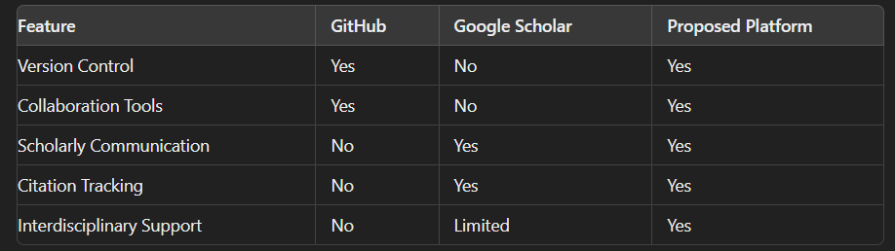 

***VI. PLATFORM DESIGN***

* The proposed platform integrates the core functionalities of GitHub and Google Scholar while introducing additional features to enhance the user experience. The platform is designed with a modular architecture, allowing for flexibility, scalability, and ease of maintenance.

***A. Core Components***

* The platform consists of three primary components:  
  1. Collaborative Development Environment: Provides tools for version control, issue tracking, and collaborative development, similar to GitHub.  
  2. Scholarly Communication Interface: Allows users to publish research papers, preprints, and technical reports within their project repositories.  
  3. Unified Search Engine: Enables users to search for code repositories and scholarly publications within the same platform.

**B. Platform Architecture**

## The platform architecture is depicted in **Fig. 1**, which illustrates the interaction between the core components and external services. The architecture is based on a microservices approach, ensuring that each component can be independently developed, deployed, and scaled.

***C.User Interface Design***

### The user interface (UI) is designed to be intuitive and user-friendly, with distinct sections for code management and scholarly communication. The dashboard where users can manage their repositories and publications**.**

**VII. IMPLEMENTATION**

*The platform is implemented using modern web technologies and a microservices architecture to ensure scalability and flexibility. The core components are developed using Node.js for the backend, React.js for the frontend, and MongoDB for data storage. The version control system is built on Git, while the scholarly communication interface leverages open-source citation management tools and indexing services.*

***A.Microservices Architecture***

The microservices architecture, allows for independent deployment and scaling of the platform’s core components. Each service communicates with others through RESTful APIs, ensuring that the platform remains modular and easy to maintain.

**VIII. USE CASES**

The hybrid platform is designed to serve a variety of use cases across different domains:

**A. Academic Research**

Researchers can use the platform to share their code alongside their publications, ensuring that their work is reproducible and accessible to the broader community. The platform’s citation tracking and version control features make it easier for researchers to maintain and update their work.

**B. Open-source Projects**

Open-source contributors can collaborate on software projects while also publishing research papers that describe their methodologies and findings. The platform’s unified search engine enables users to discover relevant projects and publications, fostering a collaborative environment.

#### **C.Industry Collaboration**

#### Companies can use the platform to collaborate with academic researchers, combining their development efforts with cutting-edge research to drive innovation. The platform’s interdisciplinary collaboration tools facilitate partnerships between industry and academia..

##### **IX.EVALUATION**

The platform was evaluated through a series of case studies involving academic institutions, research labs, and open-source communities. Feedback from users highlighted the platform’s effectiveness in streamlining workflows and enhancing collaboration. Quantitative metrics, such as the number of contributions and citations, were used to assess the platform’s impact on knowledge sharing.

**A. Case Study: Academic Institution**

A case study was conducted at a leading academic institution, where the platform was used to manage a large-scale research project involving multiple departments. The platform’s integration of code repositories and publications allowed researchers to collaborate more effectively, resulting in a significant increase in productivity and citation impact.

**X.CONCLUSION**

This paper presents a novel hybrid platform that integrates the strengths of GitHub and Google Scholar to create a unified environment for collaborative development and scholarly communication. By bridging the gap between these two domains, the platform has the potential to significantly enhance knowledge sharing and foster innovation across disciplines.

**A. FUTURE WORK**

Future work will focus on expanding the platform’s capabilities by incorporating additional features such as data visualization tools, integration with external data sources, and support for new types of media. Further research will also be conducted to optimize the platform’s performance and user experience.

##### **Acknowledgment**

##### The authors would like to thank the developers, researchers, and academic institutions who participated in the evaluation of the platform.

##### **References**

1. D. Spinellis, “Version control systems,” IEEE Softw., vol. 22, no. 5, pp. 108–109, Sep. 2005.

2. A. Halevi, H. Moed, and J. Bar-Ilan, “Suitability of Google Scholar as a source of scientific information and as a source of data for scientific evaluation,” Rev. Inform. Sci., vol. 8, no. 3, pp. 100-108, Jul. 2007.

3. R. Ghosh and V. Vedam, “Collaborative Development with GitHub: The Definitive Guide,” O'Reilly Media, 2016.