Food Ordering Behaviour Analytics
Tableau Dashboard Project Report
Data Analysis, Dashboard Explanation, Findings and Recommendations
Dashboard: Food Ordering Behaviour | Author: Vinayak Pillai
Tableau Public | Dataset: food_ordering_behavior_dataset.csv

1. Introduction
Online food ordering has become part of everyday urban life. Customers choose from many cuisines, restaurant types and meal occasions, and platforms and restaurants need to understand who orders, what they order, where they order from, and how satisfied they are. Understanding these behaviours helps in planning menus, promotions, delivery operations and customer-experience improvements.
The Food Ordering Behaviour Analytics project analyzes 50,000 food orders placed across six Indian cities. Each order records the customer’s age, the city, cuisine, meal type, restaurant type, order value, delivery fee, the time taken to place the order, the rating given, and contextual factors such as company (alone, family, friends, partner), mood, hunger level and weather.
The project uses Tableau to convert the dataset into an interactive dashboard. The dashboard combines key performance indicators (KPIs) with charts on city and cuisine preferences, age-group spending, ordering company, ordering time, customer ratings and revenue by meal type. This report explains every chart on the dashboard, shows how each one should be read, and summarizes the findings that can be drawn from the data.
The analysis is based only on the 50,000 orders and six cities available in the dataset and should not be interpreted as a representation of the whole food-delivery market.

2. Problem Statement
Food-ordering businesses collect large numbers of orders, but raw order records do not by themselves show which cities, cuisines, meal types or customer groups matter most. Without systematic analysis it is difficult to see where demand is concentrated, how revenue is spread across meal occasions, which customer segments spend more, and whether customer satisfaction differs between groups.
Therefore, the problem addressed by this project is:
To analyze food-ordering behaviour across cities, cuisines, meal types, age groups and ordering situations, and to present the results as an interactive Tableau dashboard that supports data-driven decisions.

3. Objectives
The main objectives of the project are:

3.1 Summarize overall performance
To present headline KPIs: total orders, total order value, total delivery fees and average customer rating.

3.2 Compare cities
To compare order volumes across cities and identify which city–cuisine combinations are the strongest and weakest.

3.3 Analyze cuisine preference
To measure how customer orders are distributed across the six cuisines.

3.4 Analyze spending by age group
To examine how order value differs across age groups and restaurant types.

3.5 Analyze ordering company
To understand whether customers order alone or with family, friends or a partner.

3.6 Analyze ordering time
To study the distribution of the time customers take to place an order.

3.7 Analyze satisfaction
To examine customer ratings across meal types.

3.8 Analyze revenue contribution
To measure how much revenue each meal type (breakfast, lunch, dinner, snacks) contributes.

3.9 Provide interactive exploration
To provide city, cuisine and meal-type parameters so that users can explore specific segments.

4. Dataset Description
The project uses the dataset food_ordering_behavior_dataset.csv. It contains 50,000 records and 19 fields. Each record is one food order. The orders come from 6 cities, 6 cuisines, 4 meal types and 4,000 distinct customers (user IDs), whose ages range from 18 to 44 years.

4.1 Dataset Fields
Field | Description
order_id | Unique identifier of the order
user_id | Identifier of the customer who placed the order
age | Age of the customer (18–44 years)
city | City of the order (Bangalore, Chandigarh, Delhi, Hyderabad, Mumbai, Pune)
order_time | Time of day (Morning, Afternoon, Evening, Night)
day_type | Weekday or Weekend
cuisine | Biryani, Chinese, Desserts, Fast Food, North Indian, South Indian
meal_type | Breakfast, Lunch, Dinner or Snacks
restaurant_type | Budget, Mid-range or Premium
order_value | Value of the order (100–999)
discount_applied | Whether a discount was applied (Yes/No)
delivery_fee | Delivery fee charged (20–99)
time_taken_to_order | Time the customer took to place the order, in minutes (1–14)
rating_given | Customer rating from 1 to 5
is_repeat_order | Whether the order is a repeat order (Yes/No)
mood | Customer’s mood (Celebrating, Happy, Lazy, Stressed)
hunger_level | Low, Medium or High
company | Who the customer ordered with: Alone, Family, Friends or Partner
rainy_weather | Whether it was raining (Yes/No)

5. Data Preprocessing
Data preprocessing was carried out before building the Tableau visualizations to confirm the consistency and reliability of the data.

5.1 Data Inspection
The dataset was inspected to understand the number of records and columns, field names, data types, missing values, numerical ranges, categorical values and potential duplicate records. The file contains 50,000 rows and 19 columns.

5.2 Missing Values
No missing values were found in any of the 19 fields. Every order therefore has a complete set of attributes, and no imputation or record removal was required.

5.3 Data Type Validation
Numerical fields
- order_id, user_id
- age
- order_value, delivery_fee
- time_taken_to_order
- rating_given
Categorical fields
- city, cuisine, meal_type, restaurant_type, company
- order_time, day_type, mood, hunger_level
- discount_applied, is_repeat_order, rainy_weather

5.4 Range Validation
The numeric fields were checked for reasonable ranges. All values fall within sensible limits:
Field | Minimum | Maximum | Average
age | 18 | 44 | 31.0
order_value | 100 | 999 | 547.73
delivery_fee | 20 | 99 | 59.64
time_taken_to_order (min) | 1 | 14 | 7.50
rating_given | 1 | 5 | 2.99

5.5 Duplicate Checking
The order_id field was checked and contains no duplicates, and no fully duplicated rows exist. The same customer (user_id) appears in several orders, which is expected because 4,000 customers placed 50,000 orders.

5.6 Text Consistency
Categorical fields were checked for consistent spelling and capitalization so that Tableau treats each category as one value (for example “Delhi” and “delhi ” would otherwise appear as separate cities). Each categorical field contains only its expected set of categories.

6. Data Preparation and Calculated Fields
After preprocessing, the dataset was connected to Tableau. Calculated fields, bins and parameters were created to support the dashboard.

6.1 Age Group
A calculated field groups customers into four age groups. Matching the totals displayed on the dashboard against the dataset shows that the groups correspond to the following age ranges:
Age Group | Age range | Orders
Child | 18–20 years | 5,669
GenZ | 21–30 years | 18,430
Millennial | 31–40 years | 18,452
Adult | 41–44 years | 7,449

Note: The group names and boundaries were reconstructed from the dashboard values and should be checked against the original Tableau calculation. Because the groups cover different numbers of age years (3, 10, 10 and 4), totals are not directly comparable between groups.

6.2 Time Taken To Order (Bin)
The time_taken_to_order field was grouped into bins of size 2 minutes (0, 2, 4 … 14). The bins are used both for the delivery-time chart and as a colour legend on the dashboard.

6.3 Parameters
Three parameters let the user focus the dashboard on a specific segment:
- City Parameter – selects a city (currently Pune)
- Cuisine Parameter – selects a cuisine (currently Chinese)
- Meal Type Parameter – selects a meal type (currently Snacks)

6.4 KPI Measures
The KPI cards use the following aggregations:
KPI | Calculation | Value
Total Orders | COUNT of order_id | 50,000
Order Value | SUM of order_value | 27.39M (27,386,555)
Delivery Fee | SUM of delivery_fee | 2.98M (2,982,136)
Avg. Rating Given | AVG of rating_given | 3.0 (2.994)

7. Exploratory Data Analysis
Exploratory Data Analysis (EDA) was conducted to identify the main patterns before and during dashboard development. The analysis focused on:
- Overall order volume, order value, delivery fees and ratings
- Order counts by city and by city–cuisine combination
- Cuisine preference
- Order value by age group and restaurant type
- Orders by company (alone, family, friends, partner)
- Time taken to place an order
- Ratings by meal type
- Revenue by meal type
- Additional factors: discounts, repeat orders, weather, day type, mood and hunger level
An important early finding is that the dataset is very evenly balanced. Cities, cuisines, meal types, restaurant types and companies each hold a similar share of orders, and the correlations between numeric fields (order value, delivery fee, time taken, age and rating) are all close to zero (between −0.006 and 0.012). The dashboard should therefore be read as showing small differences within a balanced dataset rather than strong contrasts.

8. Tableau Dashboard Development
Tableau was the visualization platform. The cleaned dataset was connected to Tableau and used to build worksheets that were combined into a single interactive dashboard titled Food Ordering Behaviour, published on Tableau Public. The dashboard contains 4 KPI cards, 8 analytical charts and 3 parameter controls.
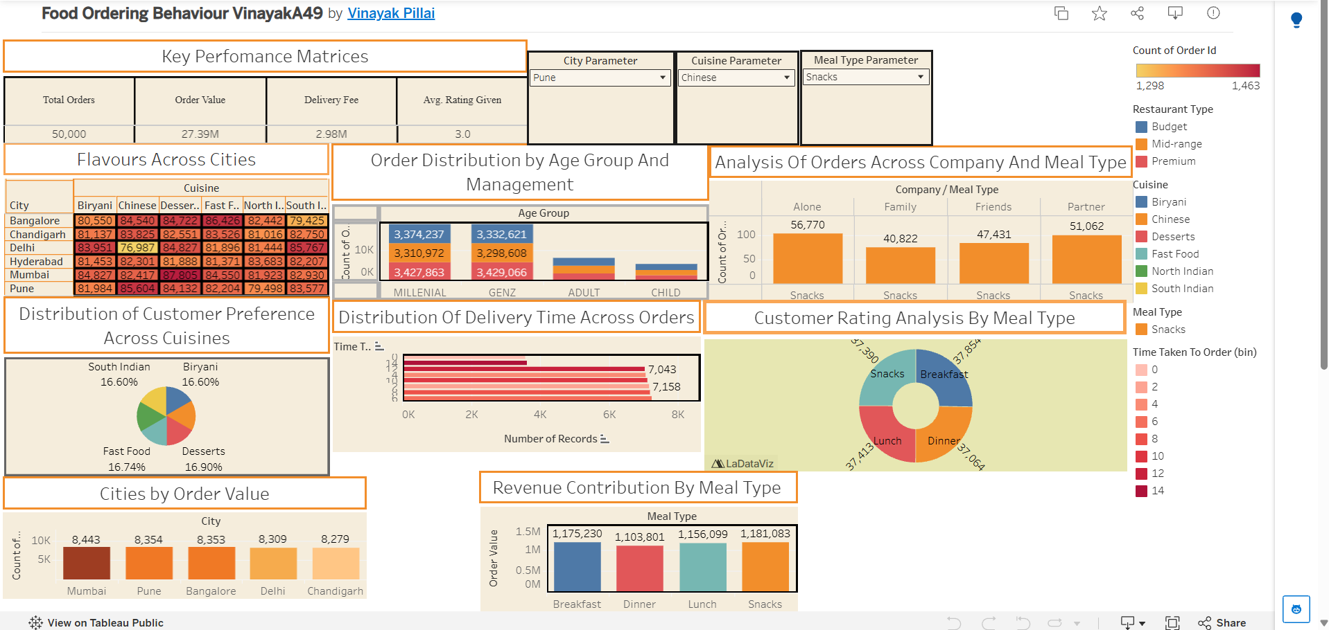
Figure: Complete Food Ordering Behaviour dashboard on Tableau Public

8.1 Worksheets Developed
# | Worksheet / Dashboard title | Chart type | What is plotted
1 | Key Performance Metrics | KPI cards | Total orders, order value, delivery fee, average rating
2 | Flavours Across Cities | Heat map (highlight table) | City × cuisine; colour = order count, label = delivery-fee total
3 | Order Distribution by Age Group and Management | Stacked bar | Order value by age group, split by restaurant type
4 | Analysis of Orders Across Company and Meal Type | Bar chart | Order value by company for the selected city, cuisine and meal type
5 | Distribution of Customer Preference Across Cuisines | Pie chart | Share of orders by cuisine
6 | Distribution of Delivery Time Across Orders | Horizontal bar (histogram) | Number of records per time-taken bin
7 | Customer Rating Analysis by Meal Type | Donut chart | Total rating points by meal type
8 | Cities by Order Value | Bar chart | Order count by city
9 | Revenue Contribution by Meal Type | Bar chart | Total order value by meal type

8.2 Dashboard Layout
KPI cards sit at the top-left of the dashboard so the headline numbers are seen first. The three parameter controls sit beside them. Below, the charts are arranged from general to specific: the city–cuisine heat map and age-group chart, then the company, cuisine and delivery-time charts, and finally ratings, city volume and revenue by meal type. Colour legends for restaurant type, cuisine, meal type and time-taken bins are placed in a column on the right.

8.3 Chart-by-Chart Explanation
This section explains each element of the dashboard: what it shows, how to read it, and what the data reveals. All figures are calculated from the dataset. Where the dashboard is filtered by the parameters (City = Pune, Cuisine = Chinese, Meal Type = Snacks) this is stated.

1. Key Performance Metrics (KPI Cards)
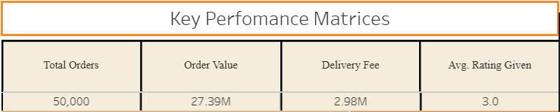
Figure: 1. Key Performance Metrics (KPI Cards) (as shown on the dashboard)
Purpose: Gives an instant summary of the whole dataset before the user looks at any detail.
What it shows: Four cards: Total Orders 50,000, Order Value 27.39M, Delivery Fee 2.98M and Avg. Rating Given 3.0.
How to read it: Each card is a single aggregated number across all orders. They are not affected by the parameters, so they always describe the complete dataset.
Insights: The average order is worth about 547.73 and the average delivery fee is about 59.64. Delivery fees therefore add roughly 10.9% on top of the total order value. The average rating of 3.0 out of 5 is exactly mid-scale, indicating neutral overall satisfaction.

2. Parameters (City, Cuisine and Meal Type)
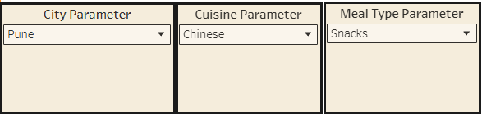
Figure: 2. Parameters (City, Cuisine and Meal Type) (as shown on the dashboard)
Purpose: Allows the user to filter selected charts to one city, one cuisine and one meal type.
What it shows: Three drop-down controls. In the captured view they are set to Pune, Chinese and Snacks.
How to read it: Changing a drop-down updates the charts connected to it. In this view the company chart reflects all three selections (Pune, Chinese, Snacks), and the revenue-by-meal-type chart reflects the selected city (Pune). The remaining charts show the full dataset.
Insight: This turns a static report into an exploration tool: a manager can check, for example, how Chinese snack orders in Pune differ from those in Delhi without building a new chart.

3. Flavours Across Cities (Heat Map)
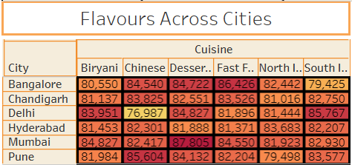
Figure: 3. Flavours Across Cities (Heat Map) (as shown on the dashboard)
Purpose: Shows which cuisines are most and least popular in each city.
What it shows: A grid of 6 cities (rows) × 6 cuisines (columns). Colour represents the number of orders (legend: 1,298 to 1,463; yellow is low, dark red is high). The number inside each cell is the total delivery fee collected for that combination.
How to read it: Look for dark-red cells (many orders) and yellow cells (few orders). Cell labels show delivery-fee revenue, which rises and falls with order count.
Insights: The highest order count is Mumbai – Desserts (1,463 orders; fee total 87,805). The lowest is Delhi – Chinese (1,298 orders; fee total 76,987), the only clearly yellow cell. Delhi is strongest for South Indian (1,439) and Biryani (1,430); Pune is strongest for Chinese (1,444); Bangalore for Fast Food (1,446). Overall the grid is fairly even: every combination lies between 1,298 and 1,463 orders, so no city is dependent on one cuisine.
Note: The colour legend measures order count while the printed labels are delivery-fee totals. A short chart note would prevent users from reading the labels as order counts.

4. Order Distribution by Age Group and Management (Stacked Bar)
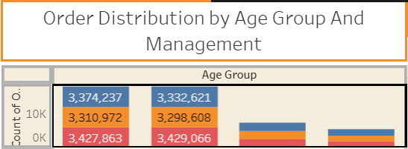
Figure: 4. Order Distribution by Age Group and Management (Stacked Bar) (as shown on the dashboard)
Purpose: Shows how much order value comes from each age group and which restaurant types (labelled “Management” in the title) they use.
What it shows: One bar per age group (Millennial, GenZ, Adult, Child). Each bar is stacked by restaurant type: blue = Budget, orange = Mid-range, red = Premium. The labels give the total order value in each segment.
How to read it: A taller bar means greater total order value. The size of each coloured block shows how that group’s spending splits between restaurant types.
Insights: Millennials (31–40) contribute the most order value at about 10.11M (36.9%), almost level with GenZ (21–30) at 10.06M (36.7%). Together they generate about 74% of all order value. Adults (41–44) contribute 4.13M (15.1%) and Children (18–20) 3.08M (11.3%). For both GenZ and Millennials, Premium restaurants are the largest block (3.43M each), while Mid-range is the smallest (3.30M and 3.31M).
Note: The two smaller groups cover fewer age years, so their lower totals partly reflect group size. On a per-order basis, Adults actually spend the most (average 554.53) and Children the least (543.75), though the difference is small. Labels for the Adult and Child bars are not displayed on the dashboard.

5. Analysis of Orders Across Company and Meal Type (Bar Chart)
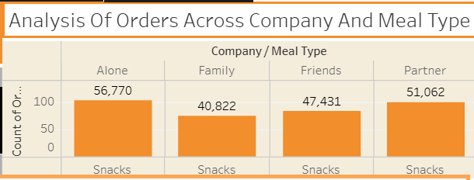
Figure: 5. Analysis of Orders Across Company and Meal Type (Bar Chart) (as shown on the dashboard)
Purpose: Shows whether customers tend to order alone or with others, within the segment chosen using the parameters.
What it shows: Total order value by company (Alone, Family, Friends, Partner) for the selected city, cuisine and meal type. In the captured view this is Pune, Chinese, Snacks, which contains 362 orders worth 196,085 in total.
How to read it: Each bar is the order value for one company type; the label gives the exact total.
Insights: In this segment Alone is highest at 56,770 (29.0%), followed by Partner 51,062 (26.0%), Friends 47,431 (24.2%) and Family 40,822 (20.8%). Solo diners therefore generate almost 40% more than families here.
Note: This pattern is specific to the selected segment. Across the full dataset the four company types are almost equal in order count (Partner 12,671; Friends 12,563; Alone 12,494; Family 12,272) and order value (Partner 6.99M, Friends 6.89M, Alone 6.85M, Family 6.65M). Small segments naturally vary more, so conclusions from a filtered view should be treated cautiously.

6. Distribution of Customer Preference Across Cuisines (Pie Chart)
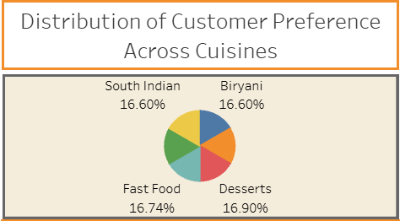
Figure: 6. Distribution of Customer Preference Across Cuisines (Pie Chart) (as shown on the dashboard)
Purpose: Shows each cuisine’s share of total orders.
What it shows: Six slices, one per cuisine (Biryani, Chinese, Desserts, Fast Food, North Indian, South Indian), labelled with percentage of orders. The dashboard labels are visible for Desserts, Fast Food, South Indian and Biryani.
How to read it: Larger slices mean more orders. Because the six slices are nearly equal, percentages matter more than slice size.
Insights: Desserts is the most ordered cuisine (16.90%, 8,452 orders), followed by Fast Food (16.74%), Chinese (16.70%), South Indian (16.60%), Biryani (16.60%) and North Indian (16.46%). The gap between first and last is only 0.45 percentage points, so customer preference is almost perfectly balanced across cuisines.

7. Distribution of Delivery Time Across Orders (Horizontal Bar)
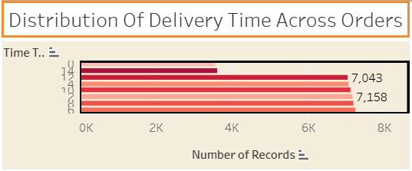
Figure: 7. Distribution of Delivery Time Across Orders (Horizontal Bar) (as shown on the dashboard)
Purpose: Shows how long customers take to complete their orders.
What it shows: The number of orders (Number of Records) in each 2-minute bin of the time_taken_to_order field. Bars are coloured by bin (light pink for short times to dark red for long times).
How to read it: Longer bars mean more orders in that time bin. The labels 7,158 and 7,043 mark the 2–3 minute and 12–13 minute bins.
Insights: Orders are spread almost uniformly: each full 2-minute bin holds about 7,000–7,250 orders (2–3 min: 7,158; 4–5 min: 7,058; 6–7 min: 7,234; 8–9 min: 7,199; 10–11 min: 7,113; 12–13 min: 7,043). The 0–1 minute bin (3,572) and the 14-minute bin (3,623) are about half as long because they contain only one value each (1 and 14 minutes). The average is 7.5 minutes.
Note: The field measures the time taken to place the order, not the time to deliver it. The chart title refers to “delivery time”; renaming it to “Time Taken to Place Order” would avoid confusion.

8. Customer Rating Analysis by Meal Type (Donut Chart)
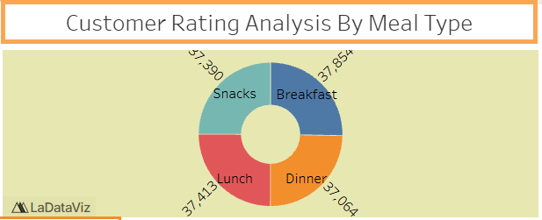
Figure: 8. Customer Rating Analysis by Meal Type (Donut Chart) (as shown on the dashboard)
Purpose: Compares customer ratings across breakfast, lunch, dinner and snacks.
What it shows: A donut split into four meal types. Each slice represents the sum of all ratings given to that meal type: Breakfast 37,854; Lunch 37,413; Snacks 37,390; Dinner 37,064.
How to read it: A larger slice means more total rating points. Because the sum depends on the number of orders as well as the score, it should be read together with the average rating.
Insights: Breakfast has the largest share (25.3%) and Dinner the smallest (24.8%). Average ratings confirm the same order: Breakfast 3.010, Dinner 2.992, Lunch 2.990 and Snacks 2.986. All four are essentially 3.0 out of 5, so satisfaction does not differ meaningfully between meal types.

9. Cities by Order Value (Bar Chart)
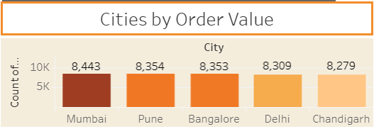
Figure: 9. Cities by Order Value (Bar Chart) (as shown on the dashboard)
Purpose: Ranks cities by the number of orders.
What it shows: One bar per city, ordered from highest to lowest and coloured from dark to light. The axis and labels show the count of orders: Mumbai 8,443; Pune 8,354; Bangalore 8,353; Delhi 8,309; Chandigarh 8,279.
How to read it: Taller, darker bars indicate higher order volume.
Insights: Mumbai leads and Pune is second, but the five visible cities differ by only about 2% (8,279 to 8,443). The sixth city, Hyderabad (8,262 orders), is the lowest in the dataset but is not visible in the captured view. When ranked by total order value Mumbai (4.64M) and Pune (4.62M) are again first and second, and Pune has the highest average order value (552.58).
Note: The chart title says “order value” but the chart measures order count. The title and the axis should be aligned.

10. Revenue Contribution by Meal Type (Bar Chart)
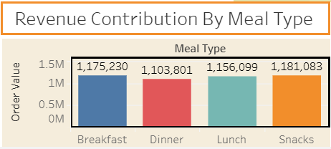
Figure: 10. Revenue Contribution by Meal Type (Bar Chart) (as shown on the dashboard)
Purpose: Shows which meal occasions generate the most revenue.
What it shows: Total order value for Breakfast, Dinner, Lunch and Snacks. In the captured view the City Parameter is set to Pune, so the bars add up to Pune’s total order value of 4,616,213.
How to read it: Bar height and label show revenue; each meal type is a different colour (blue Breakfast, red Dinner, teal Lunch, orange Snacks).
Insights: In Pune, Snacks lead with 1,181,083 (25.6%), followed by Breakfast 1,175,230 (25.5%), Lunch 1,156,099 (25.0%) and Dinner 1,103,801 (23.9%). Dinner is clearly the weakest meal occasion in Pune. Across the full dataset Breakfast is highest (6.92M) and Dinner is again lowest (6.75M), so low dinner revenue is a consistent pattern.

8.4 Tableau Visualization Techniques
Different visualization types were selected according to the analytical purpose:
Analysis | Visualization
Headline numbers | KPI cards
City × cuisine comparison | Heat map (highlight table)
Age group and restaurant type | Stacked bar chart
Ordering company | Bar chart
Cuisine share | Pie chart
Order-time distribution | Horizontal bar chart (histogram with bins)
Meal-type ratings | Donut chart
City ranking | Sorted bar chart with colour gradient
Revenue by meal type | Bar chart
Segment filtering | Parameter controls (drop-downs)

8.5 Dashboard Design
A warm cream background, orange chart-title boxes and a consistent colour palette give the dashboard a unified food-themed look. The design supports three perspectives:
Business management – headline KPIs, revenue by meal type and city ranking.
Marketing and menu planning – cuisine share, city–cuisine heat map and age-group spending.
Customer experience – ratings by meal type, ordering time and ordering company.

8.6 Dashboard Development Outcome
1 cleaned dataset (50,000 orders) → 9 analytical charts + KPI cards → 1 interactive dashboard with 3 parameters → findings and recommendations

9. Analysis, Observations & Findings

9.1 Overall Performance
Metric | Value
Total orders | 50,000
Total order value | 27,386,555
Average order value | 547.73
Total delivery fees | 2,982,136
Average delivery fee | 59.64 (about 10.9% of order value)
Average rating | 2.994 out of 5
Average time taken to order | 7.50 minutes

Observation: The business handled 50,000 orders worth about 27.4 million, with an average basket of roughly 548 and a neutral average rating of 3.0.

9.2 City Analysis
City | Orders | Order Value | Avg. Order Value
Mumbai | 8,443 | 4,640,319 | 549.61
Pune | 8,354 | 4,616,213 | 552.58
Bangalore | 8,353 | 4,539,656 | 543.48
Delhi | 8,309 | 4,536,740 | 546.00
Hyderabad | 8,262 | 4,528,001 | 548.05
Chandigarh | 8,279 | 4,525,626 | 546.64

Observation: Mumbai has the most orders and the highest total order value; Pune is second and has the highest average order value. The gap between the highest and lowest city is only 2.2% in order count, so demand is evenly distributed across the six cities.

9.3 Cuisine Analysis
Cuisine | Orders | Share | Avg. Order Value
Desserts | 8,452 | 16.90% | 547.47
Fast Food | 8,368 | 16.74% | 548.85
Chinese | 8,351 | 16.70% | 548.59
South Indian | 8,301 | 16.60% | 552.08
Biryani | 8,300 | 16.60% | 546.48
North Indian | 8,228 | 16.46% | 542.88

Observation: Desserts is the most ordered cuisine and North Indian the least, but the difference is under half a percentage point. South Indian orders have the highest average value (552.08).

9.4 Meal Type: Orders, Revenue and Ratings
Meal Type | Orders | Order Value | Avg. Rating
Breakfast | 12,578 | 6,924,753 | 3.010
Snacks | 12,521 | 6,860,530 | 2.986
Lunch | 12,512 | 6,855,039 | 2.990
Dinner | 12,389 | 6,746,233 | 2.992

Observation: Breakfast leads in orders, revenue and rating, whereas Dinner is last in orders and revenue. The dinner shortfall is about 2.6% below breakfast revenue. This is the most consistent (though small) pattern in the meal-type data.

9.5 Age Group Analysis
Age Group | Age Range | Orders | Order Value | Avg. Order Value
Millennial | 31–40 | 18,452 | 10,113,072 | 548.08
GenZ | 21–30 | 18,430 | 10,060,295 | 545.87
Adult | 41–44 | 7,449 | 4,130,691 | 554.53
Child | 18–20 | 5,669 | 3,082,497 | 543.75

Observation: Millennials and GenZ together account for about 74% of orders and order value. Adults have the highest average order value but form a small group. Within every group the three restaurant types are close in value, with Premium slightly ahead in GenZ, Millennial and Child groups and Budget ahead among Adults.

9.6 Ordering Company
Company | Orders | Order Value | Avg. Order Value
Partner | 12,671 | 6,987,173 | 551.43
Friends | 12,563 | 6,892,991 | 548.67
Alone | 12,494 | 6,852,346 | 548.45
Family | 12,272 | 6,654,045 | 542.21

Observation: Partner orders lead and Family orders are lowest in both number and average value across the dataset. The strong lead of “Alone” seen on the dashboard (Pune, Chinese, Snacks) is therefore a feature of that small segment rather than of the whole dataset.

9.7 Time Taken To Order
The average time to place an order is 7.5 minutes. Orders are spread almost evenly between 1 and 14 minutes, and each full 2-minute bin contains roughly 14% of orders. The correlation between time taken and order value is 0.003 and between time taken and rating is −0.003, so taking longer to order is not associated with spending more or rating differently.

9.8 Customer Ratings
Rating | Orders | Share
1 | 10,039 | 20.1%
2 | 10,035 | 20.1%
3 | 10,019 | 20.0%
4 | 9,980 | 20.0%
5 | 9,927 | 19.9%

Observation: Ratings are distributed almost perfectly evenly between 1 and 5. The average of 3.0 therefore does not mean most customers were “average”; it reflects equal numbers of happy and unhappy customers.

9.9 Other Factors Included in the Dataset
The dataset includes factors that are not on the dashboard. They were also examined and show very little variation:
Factor | Comparison | Avg. Order Value | Avg. Rating
Discount applied | Yes / No | 546.31 / 549.16 | 3.002 / 2.987
Repeat order | Yes / No | 550.72 / 544.75 | 2.997 / 2.992
Rainy weather | Yes / No | 545.88 / 549.58 | 3.000 / 2.989
Day type | Weekend / Weekday | 546.23 / 549.24 | 2.997 / 2.991
Restaurant type | Premium / Mid-range / Budget | 549.20 / 545.41 / 548.54 | 3.005 / 2.984 / 2.994

Observation: None of these factors changes order value or ratings by more than about 1%. Discounted orders have a slightly lower average value than non-discounted orders, and repeat orders are slightly more valuable than first-time orders.

9.10 Key Findings — Overall
- The business recorded 50,000 orders worth 27.39M, with an average order value of about 548 and an average rating of 3.0.
- Demand is evenly spread: all six cities are within 2.2% of each other, with Mumbai first and Hyderabad last.
- Mumbai–Desserts (1,463 orders) is the strongest city–cuisine combination and Delhi–Chinese (1,298) the weakest.
- Desserts is the most ordered cuisine (16.9%) and North Indian the least (16.5%); preference is almost equal across cuisines.
- Millennials and GenZ generate about 74% of order value; Premium restaurants lead within these groups.
- Adults (41–44) have the highest average order value (554.53) but are the smallest group by orders among the main segments.
- In the Pune–Chinese–Snacks segment, customers ordering alone contribute the most order value (29.0%), and families the least (20.8%).
- Time taken to place an order is evenly distributed from 1 to 14 minutes, with an average of 7.5 minutes.
- Ratings are evenly split across 1–5 stars, and meal types all average about 3.0.
- Breakfast earns the most revenue overall, Snacks the most in Pune, and Dinner is consistently the lowest.
- Delivery fees add about 10.9% on top of order value.
- Discounts, repeat orders, weather and day type have almost no effect on order value or ratings in this dataset.

9.11 Recommendations
1. Strengthen dinner demand
Dinner has the lowest order count and revenue overall and in Pune. Dinner-specific offers, combo meals or evening promotions could lift this meal occasion.
2. Target weak city–cuisine combinations
Delhi–Chinese is the lowest-volume cell on the heat map. Local promotions or new restaurant partnerships for Chinese food in Delhi could close the gap, while South Indian and Biryani can be promoted further in Delhi where they are strongest.
3. Focus marketing on GenZ and Millennials
These two groups generate about 74% of order value. Marketing, loyalty programmes and premium-restaurant offers should be designed around them.
4. Explore the Adult segment
Adults (41–44) have the highest average order value. Offers that increase how often they order could add value even though the group is small.
5. Tailor offers by company
In the Pune–Chinese–Snacks segment solo diners spend the most, while families spend the least. Solo-size meals and family bundles can be tested for different segments.
6. Investigate customer satisfaction
Ratings are split evenly between 1 and 5. Collecting reasons for low ratings (delivery, food quality, price) would show where improvements are possible.
7. Review delivery pricing
Delivery fees add about 10.9% to order value. Fee thresholds or free-delivery offers could be tested against order size.
8. Improve dashboard labelling
Align chart titles with what is measured (for example “Cities by Order Count”, “Time Taken to Place Order”) and show all six cities and all age-group labels.

9.12 Limitations
Limitation 1 — Six cities only
The dataset covers six Indian cities, so results should not be generalized to other cities or countries.
Limitation 2 — Very balanced data
Most categories have near-equal shares and correlations are close to zero. Differences described in this report are small and may not be statistically meaningful; the dataset may be synthetic or sampled evenly.
Limitation 3 — Observational data
The data describes associations only. It cannot explain why customers choose certain cuisines or meal types.
Limitation 4 — No order date
The dataset has no calendar date, so seasonal trends and growth over time cannot be analyzed.
Limitation 5 — Age-group definitions
Age groups were reconstructed from the dashboard values (Child 18–20, GenZ 21–30, Millennial 31–40, Adult 41–44). Group sizes differ, so totals are not directly comparable.
Limitation 6 — Time field meaning
The time_taken_to_order field measures how long ordering took, not delivery time.
Limitation 7 — Filtered view
Some charts on the published dashboard are filtered by the parameters (Pune, Chinese, Snacks). Their values describe that segment, not the whole dataset.
Limitation 8 — Currency not specified
The dataset does not state the currency of order value and delivery fee.

9.13 Conclusion
The Food Ordering Behaviour dashboard turns 50,000 orders into a clear, interactive picture of demand. It shows that orders and revenue are spread evenly across six cities and six cuisines, with Mumbai, Pune and Desserts slightly ahead and Delhi–Chinese and Dinner slightly behind. Millennials and GenZ are the most valuable age groups, and in the selected Pune–Chinese–Snacks segment solo diners contribute the most.
Ratings, ordering times and the effect of discounts, weather or repeat orders are all close to evenly distributed, meaning the dataset contains few strong behavioural contrasts. The dashboard’s main strength lies in its interactivity: the city, cuisine and meal-type parameters allow users to drill into specific segments. With small improvements to chart labelling and the addition of date information, it can become a more effective tool for planning menus, promotions and delivery operations.

