1



MINI - PROJECT REPORT

ON

“ Data Leakage Detection System ”

BY

Group Members | Seat NOS | Roll Nos
Aniket Paul | MITU19BTCS0219 | 2193039
Aman Lamsal | MITU19BTCS0157 | 2193031
Aniket Chakraverty | MITU19BTCS0064 | 2193038
Chakri Venkat Katam | MITU19BTCS0141 | 2198086

Under the Guidance of

Prof. Kiran Bidua
DEPARTMENT OF COMPUTER SCIENCE & ENGINEERING

MIT SCHOOL OF ENGINEERING

Loni Kalbhor ,Pune

M.I.T. SCHOOL OF ENGINEERING
2
DEPARTMENT OF COMPUTER ENGINEERING

LONI – KALBHOR PUNE

CERTIFICATE

This is to certify that the Mini- Project report entitled
“Data Leakage Detection System” submitted by
Group Members | Enrollment No: | Roll No:
Aniket Paul | MITU19BTCS0219 | 2193039
Aman Lamsal | MITU19BTCS0157 | 2193031
Aniket Chakraverty | MITU19BTCS0064 | 2193038
Chakri Venkat Katam | MITU19BTCS0141 | 2193086

is a record of bonafide work carried out by them, under my guidance, in partial fulfillment of the requirement for the Third Year of Engineering (CSE ‘NS’) at M.I.T. School of Engineering, Pune under MIT Art, Design & Technology University.

Date: 10/05/2022
Place:
Prof. Kiran Bidua

Dr. Rajneesh Kaur Sachdeo

Guide, Dean Engineering,
Department of CSE Head , Department of CSE
M.I.T. School of Engineering MIT School of Engineering
Loni Kalbhor, Pune Loni-Kalbhor, Pune

3

ACKNOWLEDGEMENT

We express our profound thanks to our Guide Prof. Kiran Bidua for his expert guidance, encouragement and inspiration during this work.

We sincerely thank Prof. Dr.R.R.Sachdeo, Head, Department of Computer Science, MIT School of Engineering, MIT-ADT University, Pune, for providing necessary facilities for completing the project. We are grateful to Prof. Dr. Kishore Ravande, Principal, MIT School of Engineering, MIT-ADT University, Pune, for providing us the facilities to carry out our project on the topic “Data Leakage Detection System”.

We also thank all the faculty members in the Department for their support and advice. We are very much grateful and thankful to our Parents for their immense love, affection, help, cooperation and encouragement to complete this course.

Finally, a special thanks to all our classmates and friends who helped and encouraged us to successfully complete our project work.

4

Sr. No. | Contents | Page No.
1 | Abstract | 5
3 | List of Figures | 5
 | - INTRODUCTION  - PROBLEM DEFINITION  - GOAL OF THE PROJECT  - FEATURES OF PROJECT  - PLATFORM / TECHNOLOGY  - SYSTEM MODEL  - DESIGN  - DATA FLOW DIAGRAM  - OUTPUT SCREENS  - GLOSARRY  - REFERENCS  - CONCLUSION | 6  7  7  8  9-12  13  14  14  15-19  20  21-22  23

ABSTRACT
5
We study the following problem: A data distributor has given sensitive data to a set of supposedly trusted agents (third parties). Some of the data are leaked and found in an unauthorized place (e.g., on the web or somebody's laptop). The distributor must assess the likelihood that the leaked data came from one or more agents, as opposed to having been independently gathered by other means. We propose data allocation strategies (across the agents) that improve the probability of identifying leakages. These methods do not rely on alterations of the released data (e.g., watermarks). In some cases, we can also inject “realistic but fake” data records to further improve our chances of detecting leakage and identifying the guilty party.

INTRODUCTION
6

- Data leakage is defined as the accidental or unintentional distribution of private or sensitive data to an unauthorised entity.
- Data leakage poses a serious issue for companies as the number of incidents and the cost to those experiencing them continue to increase.
- Data leakage is enhanced by the fact that transmitted data including emails, instant messaging, website forms, and file transfers among others, are largely unregulated and unmonitored on their way to their destinations.
- The main scope of this module is providing complete information about the data/content that is accessed by the users within the website. Forms Authentication technique is used to provide security to the website in order to prevent the leakage of the data.
- Continuous observation is made automatically and the information is send to the administrator so that he can identify whenever the data is leaked.

PROBLEM DEFINITON
We study the following problem: A data distributor has given sensitive data to a set of supposedly trusted agents (third parties). Some of the data are leaked and found in an unauthorized place (e.g., on the web or somebody's laptop).
We propose data allocation strategies (across the agents) that improve the probability of identifying leakages. These methods do not rely on alterations of the released data (e.g., watermarks). In some cases, we can also inject “realistic but fake” data records to further improve our chances of detecting leakage and identifying the guilty party.

GOAL OF THE PROJECT
Our goal is to detect when the distributor’s sensitive data has been leaked by agents, and if possible to identify the agent that leaked the data. Perturbation is a very useful technique where the data is modified and made “less sensitive” before being handed to agents. We develop unobtrusive techniques for detecting leakage of a set of objects or records. In this section we develop a model for assessing the “guilt” of agents.
We also present algorithms for distributing objects to agents, in a way that improves our chances of identifying a leaker. Finally, we also consider the option of adding “fake” objects to the distributed set. Such objects do not correspond to real entities but appear realistic to the agents. In a sense, the fake objects acts as a type of watermark for the entire set, without modifying any individual members. If it turns out an agent was given one or more fake objects that were leaked, then the distributor can be more confident that agent was guilty.

FEATURES OF THE PROJECT
8

- Data Leakage Detection propose data allocation strategies that improve the probability of identifying leakages.
- It can detect when the distributor’s sensitive data has been leaked by agents and if possible to identify the agent that leaked the data.
- We also present algorithms for distributing objects to agents, in a way that improves our chances of identifying a leaker.

We presented that whenever someone user share files with others there will be a secret key and if someone want to download or access file, they need a secret key which will be request to sender who share this file, after sharing secret key user can download that file, if someone download that file without asking secret key using guess method that will be notified as leaker.

9

PLATFORM / TECHNOLOGY USED IN THE PROJECT
1.Front End Technology:
HTML
The Hyper Text Markup Language or HTML is the standard markup language for documents designed to be displayed in a web browser. It can be assisted by technologies such as Cascading Style Sheets (CSS) and scripting languages such as JavaScript.
Web browsers receive HTML documents from a web server or from local storage and render the documents into multimedia web pages. HTML describes the structure of a web page semantically and originally included cues for the appearance of the document.
HTML elements are the building blocks of HTML pages. With HTML constructs, images and other objects such as interactive forms may be embedded into the rendered page. HTML provides a means to create structured documents by denoting structural semantics for text such as headings, paragraphs, lists, links, quotes and other items.
CSS3

Cascading Style Sheets (CSS) is a style sheet language used for describing the presentation of a document written in a markup language such as HTML. CSS is a cornerstone technology of the World Wide Web, alongside HTML and JavaScript.
CSS is designed to enable the separation of presentation and content, including layout, colors, and fonts. This separation can improve content accessibility; provide more flexibility and control in the specification of presentation characteristics; enable multiple web pages to share formatting by specifying the relevant CSS in a separate .css file, which reduces complexity and repetition in the structural content; and enable the .css file to be cached to improve the page load speed between the pages that share the file and its formatting.

JavaScript

JavaScript , often abbreviated JS, is a programming language that is one of the core technologies of the World Wide Web, alongside HTML and CSS. Over 97% of websites use JavaScript on the client side for web page behavior, often incorporating third-party libraries. All major web browsers have a dedicated JavaScript engine to execute the code on users' devices.
JavaScript is a high-level, often just-in-time compiled language that conforms to the ECMAScript standard.It has dynamic typing, prototype-based object-orientation, and first-class functions. It is multi-paradigm, supporting event-driven, functional, and imperative programming styles. It has application programming interfaces (APIs) for working with text, dates, regular expressions, standard data structures, and the Document Object Model (DOM).

Bootstrap
Bootstrap is a free and open-source CSS framework directed at responsive, mobile-first front-end web development. It contains HTML, CSS and (optionally) JavaScript-based design templates for typography, forms, buttons, navigation, and other interface components.

2. Backend Technology
PHP
PHP is a general-purpose scripting language geared toward web development.
PHP code is usually processed on a web server by a PHP interpreter implemented as a module, a daemon or as a Common Gateway Interface (CGI) executable. On a web server, the result of the interpreted and executed PHP code – which may be any type of data, such as generated HTML or binary image data – would form the whole or part of an HTTP response. Various web template systems, web content management systems, and web frameworks exist which can be employed to orchestrate or facilitate the generation of that response. Additionally, PHP can be used for many programming tasks outside the web context, such as standalone graphical applications and robotic drone control. PHP code can also be directly executed from the command line.

MySQL

MySQL is an open-source relational database management system (RDBMS). Its name is a combination of "My", the name of co-founder Michael Widenius's daughter, and "SQL", the abbreviation for Structured Query Language. A relational database organizes data into one or more data tables in which data may be related to each other; these relations help structure the data. SQL is a language programmers use to create, modify and extract data from the relational database, as well as control user access to the database. In addition to relational databases and SQL, an RDBMS like MySQL works with an operating system to implement a relational database in a computer's storage system, manages users, allows for network access and facilitates testing database integrity and creation of backups.
MySQL is free and open-source software under the terms of the GNU General Public License, and is also available under a variety of proprietary licenses. MySQL was owned and sponsored by the Swedish company MySQL AB, which was bought by Sun Microsystems (now Oracle Corporation). In 2010, when Oracle acquired Sun, Widenius forked the open-source MySQL project to create MariaDB.
SYSTEM MODEL
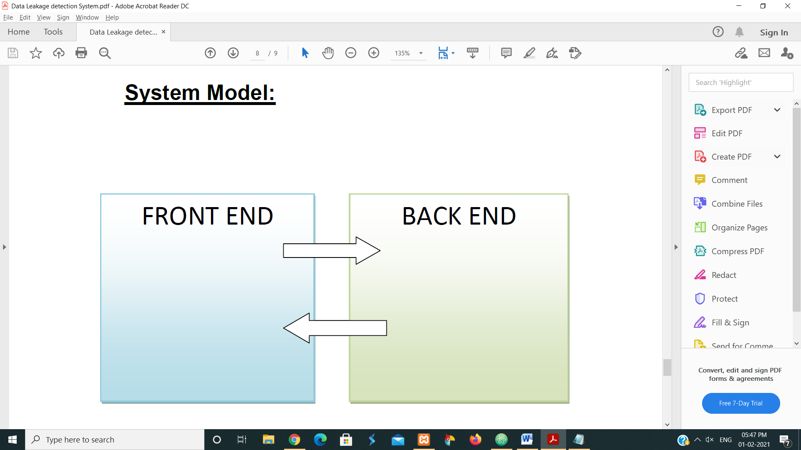

DESIGN
ER DIAGRAM
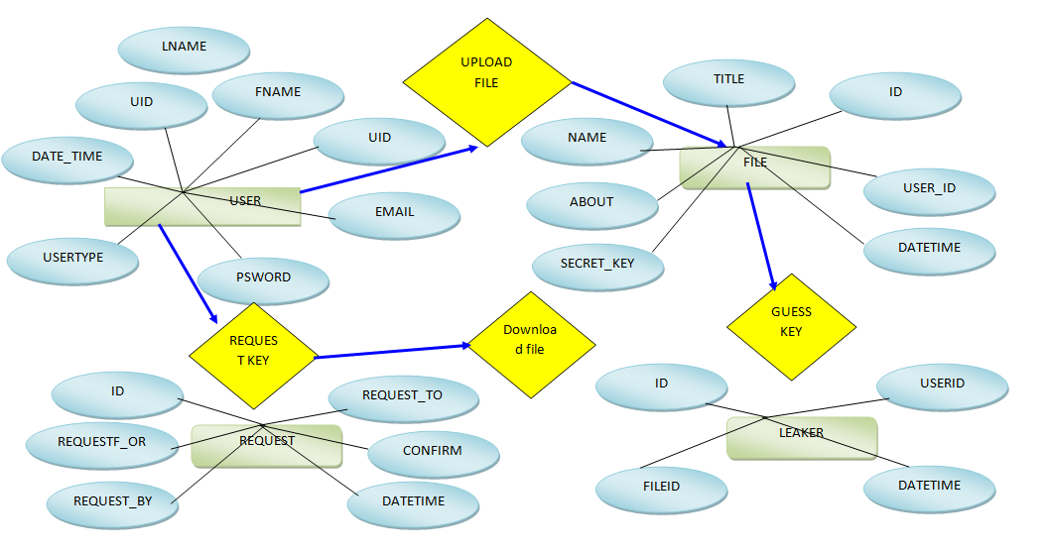
Data Flow Diagram

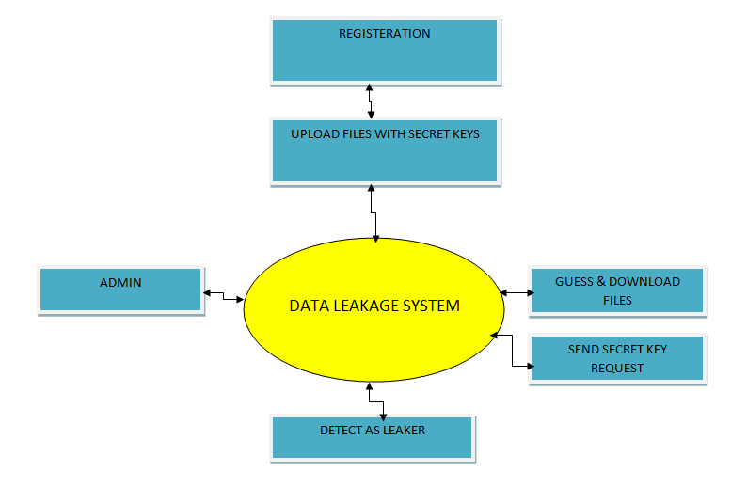

Output Images (CODE) :
- Dashboard/Login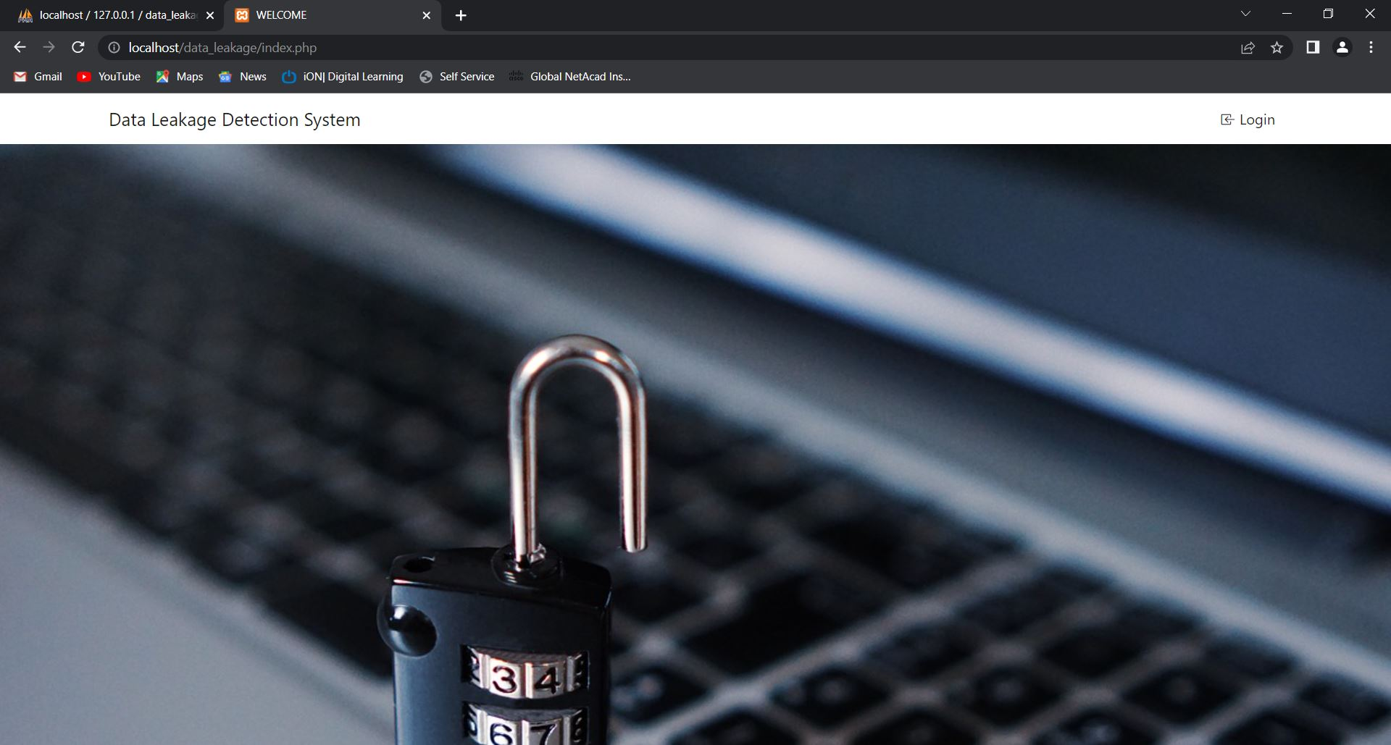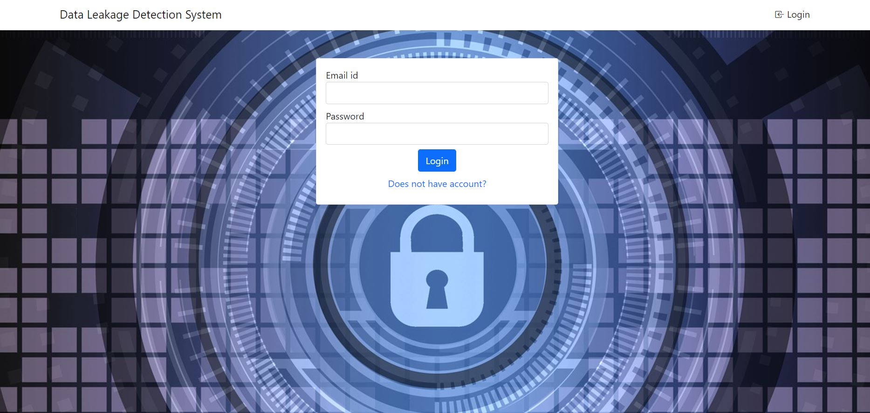
- ADMIN / User Registration Window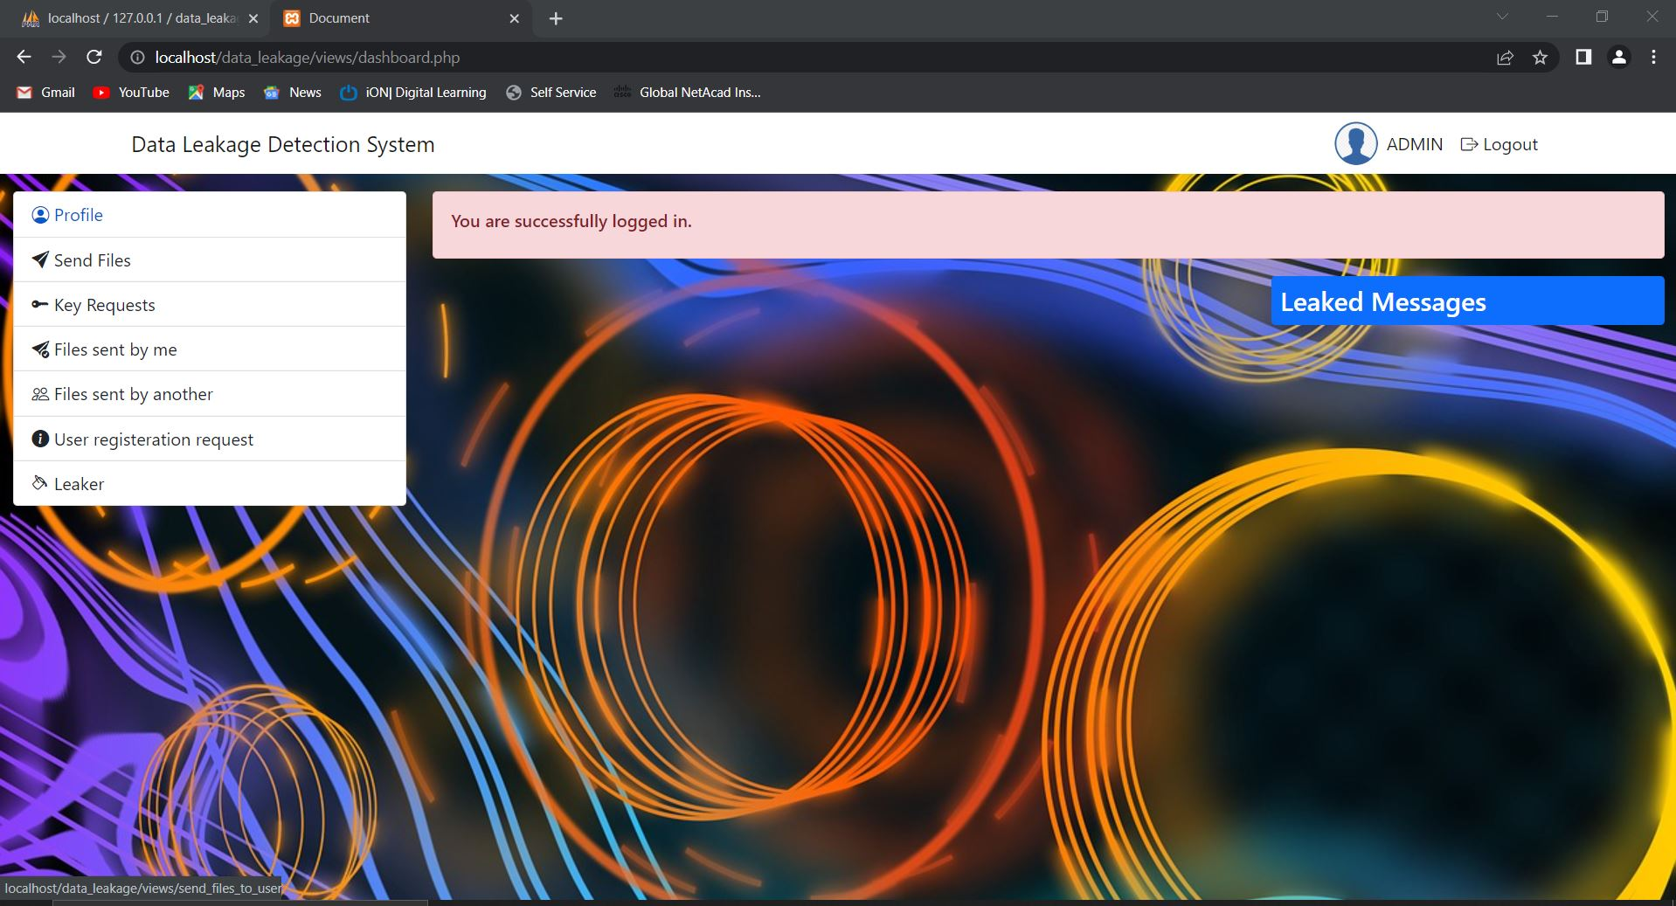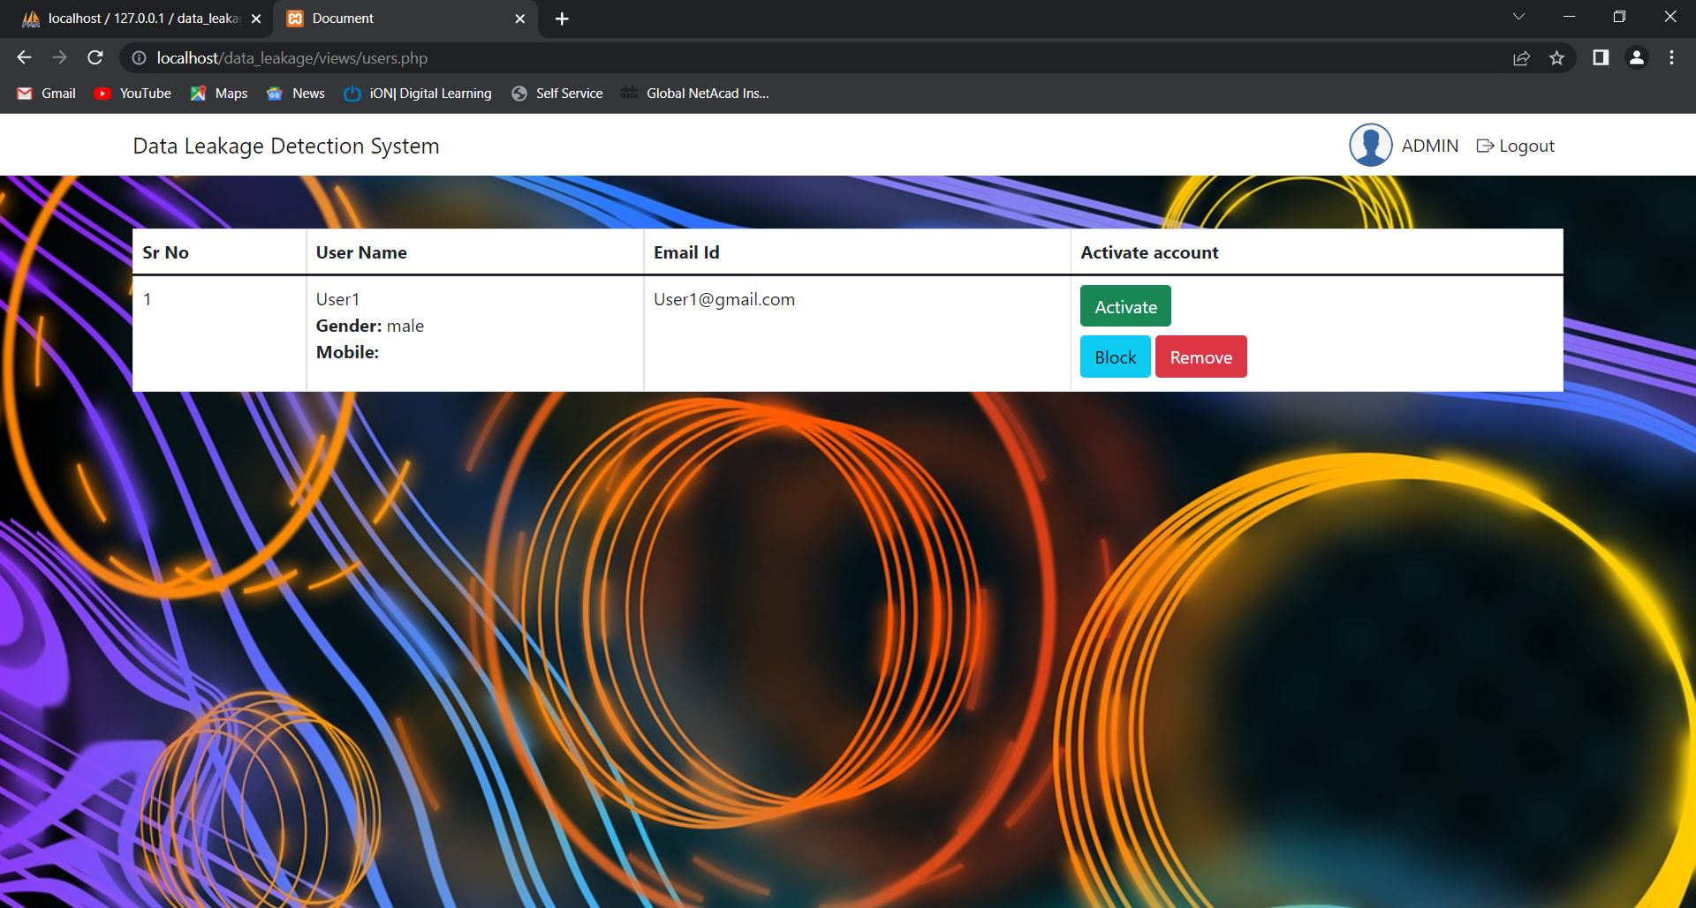
- USERS Window & File Transfer to other user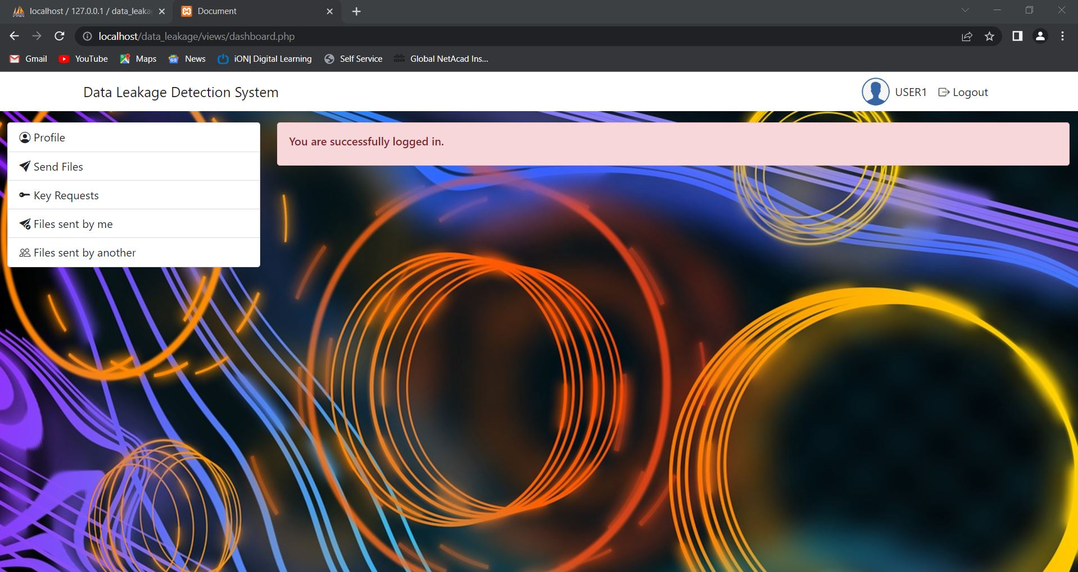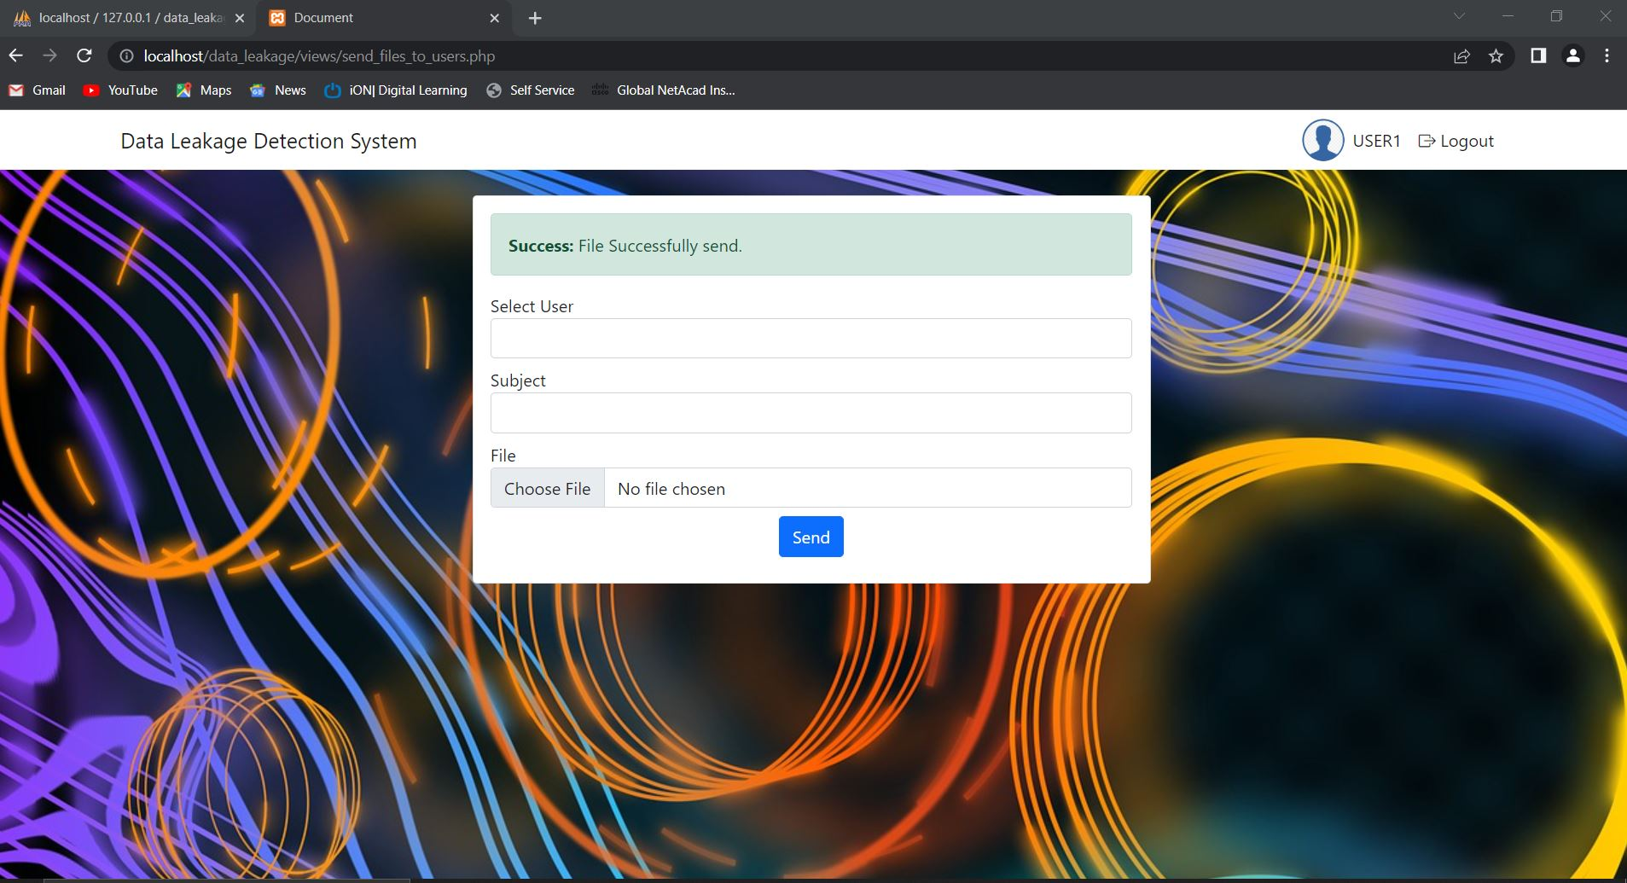
- Key Requests & Share
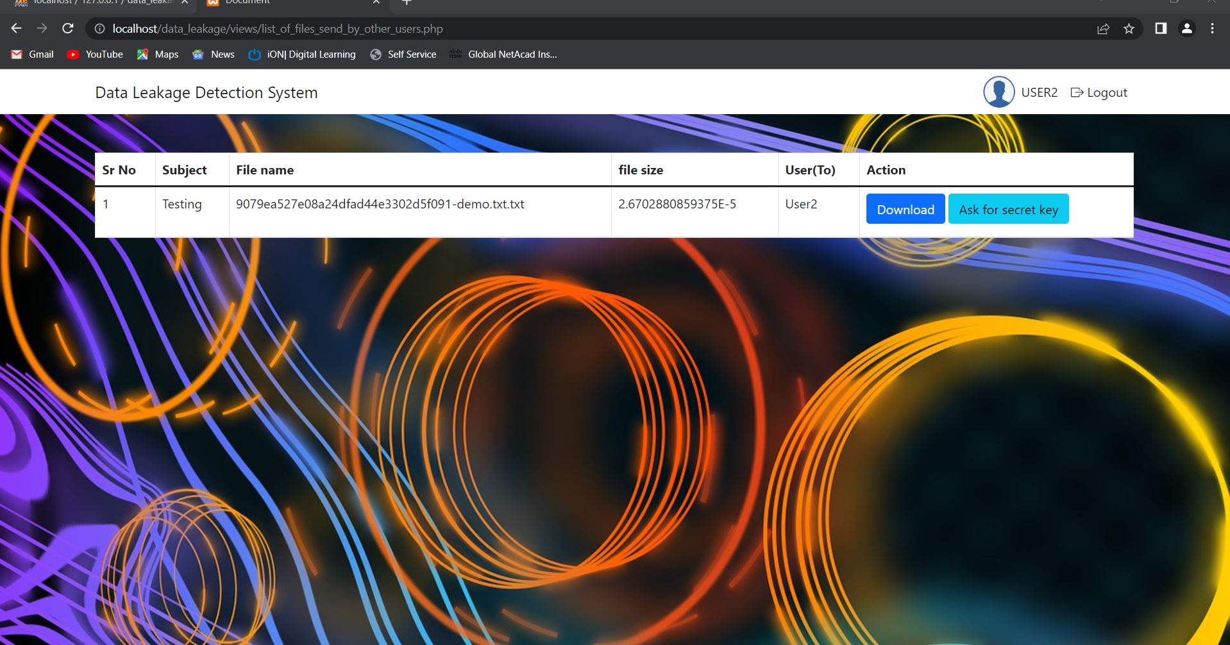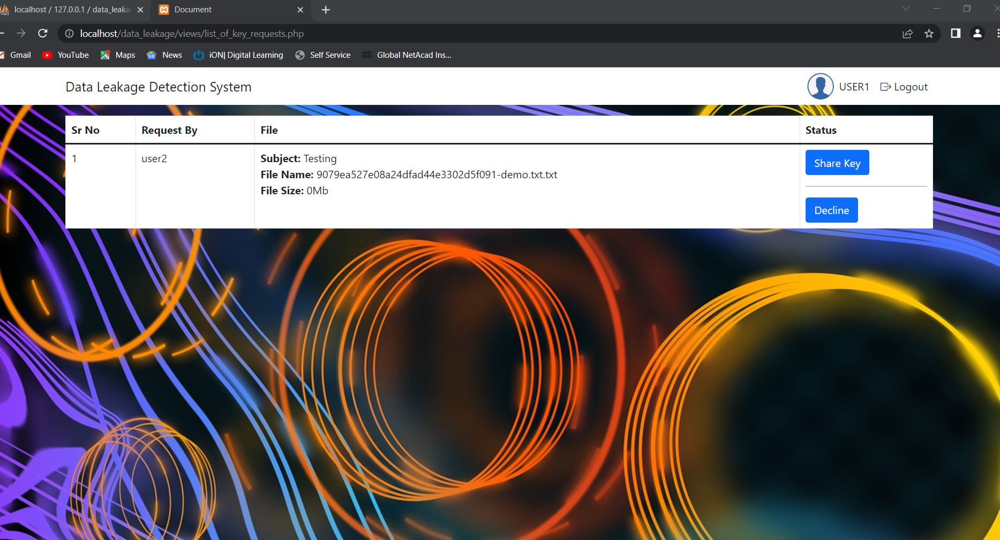
- Leaker Identify by the Admin & next picture is of Database Window

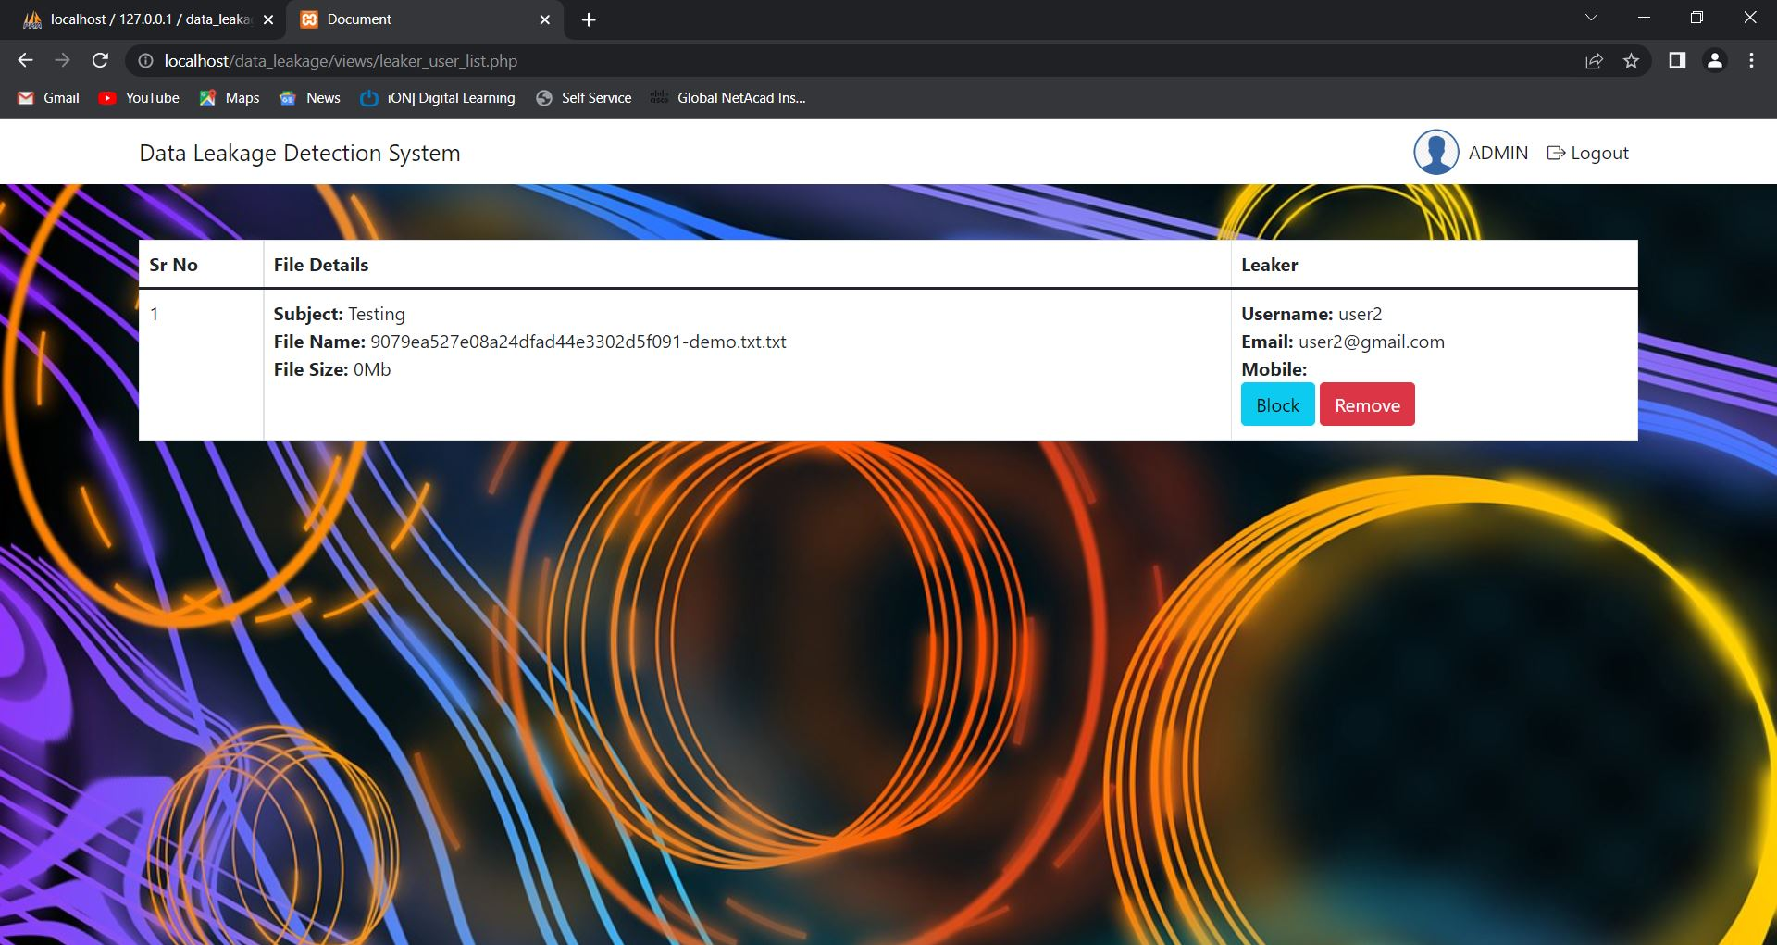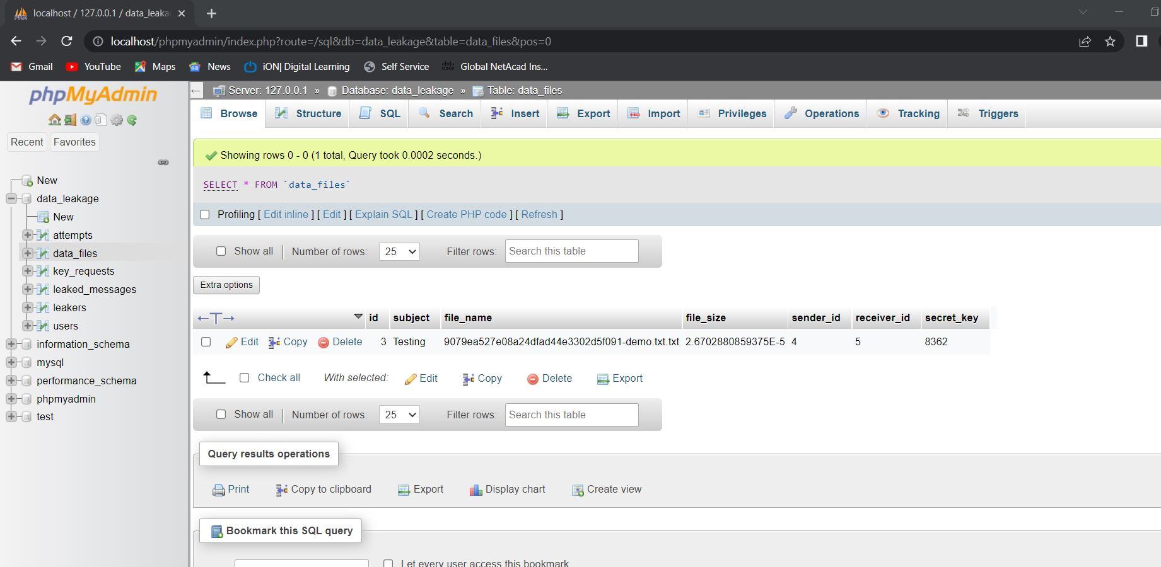

Glossary:
12

Data Leakage Detection Project propose data allocation strategies that improve the probability of identifying leakages. In some cases, we can also inject “realistic but fake” data records to further improve our chances of detecting leakage and identifying the guilty party.

REFRENCES:
13

[1] Sandip A.Kale, Prof. Kulkarni S.V. (Department Of Computer Sci.
&Engg,MIT College of Engg, Dr.B.A.M.University, Aurangabad(M.S),
India, Data Leakage Detection: A Survey, ( IOSR Journal of Computer
Engineering (IOSRJCE)ISSN : 2278-0661 Volume 1, Issue 6 (July-Aug
2012), PP 32-35 www.iosrjournals.org
[2] IEEE Transactions On Knowledge And Data Engineering, Vol. 22,
No. 3, March 2011 Data Leakage Detection Panagiotis Papadimitriou,
Member, IEEE, Hector Garcia-Molina, Member, IEEE P.P (2,4-5)
[3] Faith M. Heikkila, Data Leakage: What You Need to Know, Pivot
Group Information Security Consultant. P.P (1-3)
[4] Rudragouda G Patil Dept Of CSE, The Oxford College Of Engg,
Bangalore.International Journal Of Computer Applications In
Engineering Sciences [VOL I, ISSUE II, JUNE 2011] [ISSN: 2231-
4946] P.P (1, 4) Development Of Data Leakage Detection Using Data
Allocation Strategies
[5] Chun-Shien Lu, Member, IEEE, and Hong-Yuan Mark Liao,
Member, IEEE MultipurposeWatermarking for Image Authentication
and Protection
[6] A. Shabtai, a. Gershman, M. Kopeetsky, y. Elovici Deutsche
Telekom Laboratories at Ben-Gurion University, Israel. Technical
Report TR-BGU-2409-2010 24 Sept. 2010 1 A Survey of Data Leakage
Detection and Prevention Solutions P.P (1-5, 24-25)
[7] Panagiotis Papadimitriou 1, Hector Garcia-Molina 2 Stanford
University 353 Serra Street, Stanford, CA 94305, USA P.P (1, 4-5)
A Model for Data Leakage Detection
[8]Web-based Data Leakage Prevention Sachiko Yoshihama1, Takuya
Mishina1, and Tsutomu Matsumoto2 1 IBM Research - Tokyo, Yamato,
Kanagawa, Japan fsachikoy
[9] Joseph A. Rivela Senior Security Consultant P.P (4-6) Data
Leakage: Affordable Data Leakage Risk Management
[10] Data Leakage Prevention: A news letter for IT Professionals Issue
5 P.P (1-3)
[11] Panagiotis Papadimitriou, Student Member, IEEE, and Hector
Garcia-Molina, Member, Data Leakage Detection IEEE P.P (2-6)IEEE
transactions on knowledge and data engineering, vol. 23, no. 1,
JANUARY 2011

CONCLUSION:
14
In our project of Data leakage detection, we presented that whenever someone user share files with others there will be a secret key and if someone want to download or access file, they need a secret key which will be request to sender who share this file, after sharing secret key user can download that file, if someone download that file without asking secret key using guess method that will be notified as leaker.

