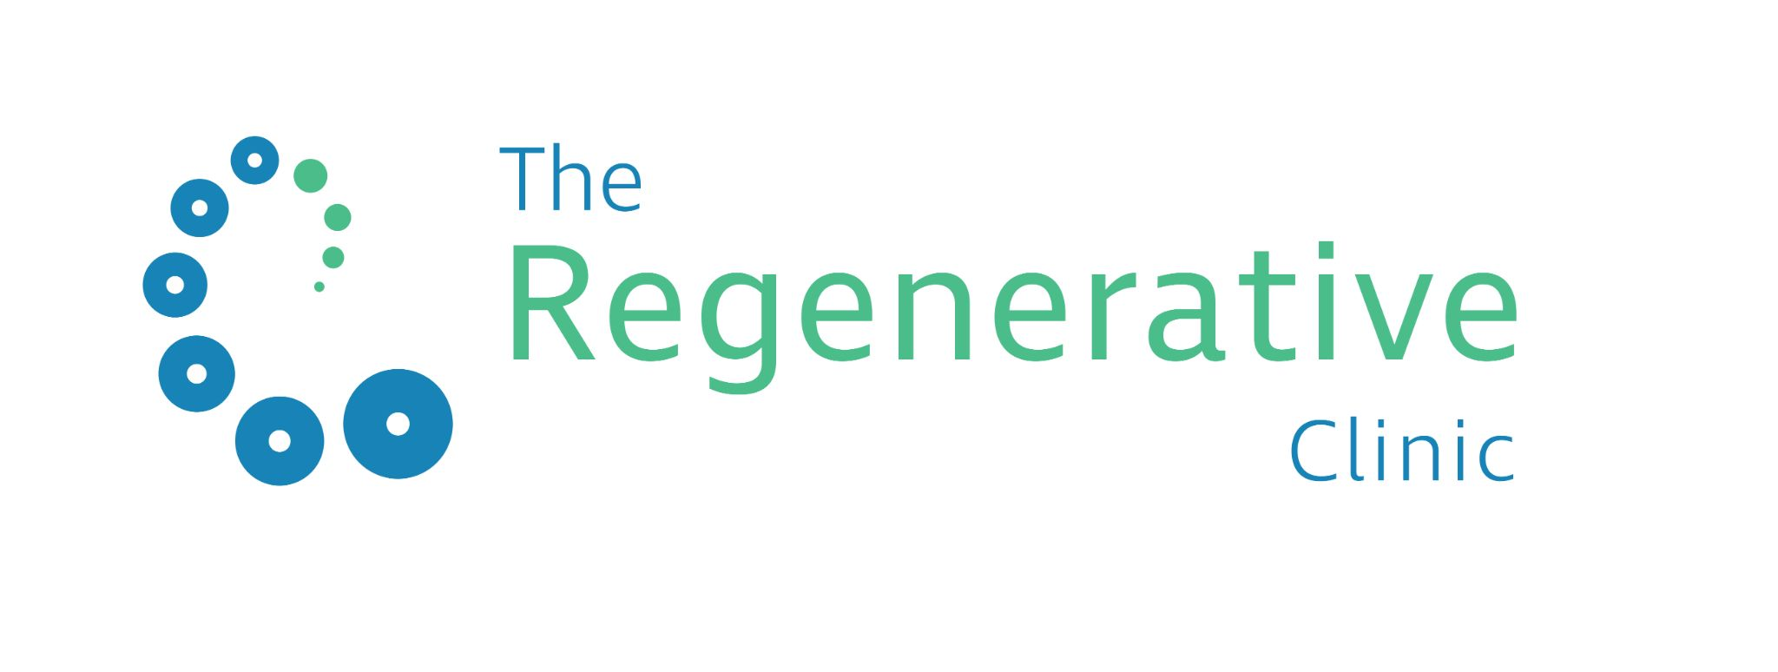

CQC license number: 1-5052573392

Swab Date: «swab_date» Swab Time: «swab_time»

Reported Date: «pcr_date» Report Time: «pcr_time»

Analysed at: The Regenerative Clinic Limited, 39A Welbeck Street, London, W1G 8DH

# -----------------------------------------------------------------------------------------------------

**TEST TO RELEASE CERTIFICATE**

Name: «forename» «surname»

D.O.B: «DOB»

Passport: «PASSPORT»

Unique ID: «PREFIX_ID»

Contact No: «phone»

PCR - Covid -19 RNA: **POSITIVE**

**Clinical comment:**

SARS-CoV-2 (COVID-19) RNA IS DETECTED in the sample, there IS evidence of current SARS-CoV2 (COVID-19) infection at the time of testing.

This result was produced using a direct RT-PCR.

Your coronavirus test result is positive. You had the virus when the sample was taken. If you have not had symptoms of coronavirus, you must self-isolate for 10 days as of your swab date. If you have symptoms of coronavirus, you must isolate for 10 days from the day your symptoms started.

The day after your symptom onset, or the test date, is counted as your first full day of isolation.

People you live with must also self-isolate. You may be contacted for “contact tracing” and check that you, and those you live with are isolating.

Contact 111 if you need medical help. In an emergency, dial 999.

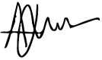

**Professor Adrian Wilson**

MBBS, BSc (Hons), FRCS (Tr&Orth)

Medical Director - The Regenerative Clinic Limited

This is a pathology result from The Regenerative Clinic Limited. Please call 020 3637 5566 with any questions.

# -------------------------------------------------------------------------------------------------

Authorised by: Clinical pathology, The Regenerative Clinic Limited, CQC license number: 1-5052573392