Drazen Zack

11/13/18

**Assignment 2**

**Tableau Visualization**

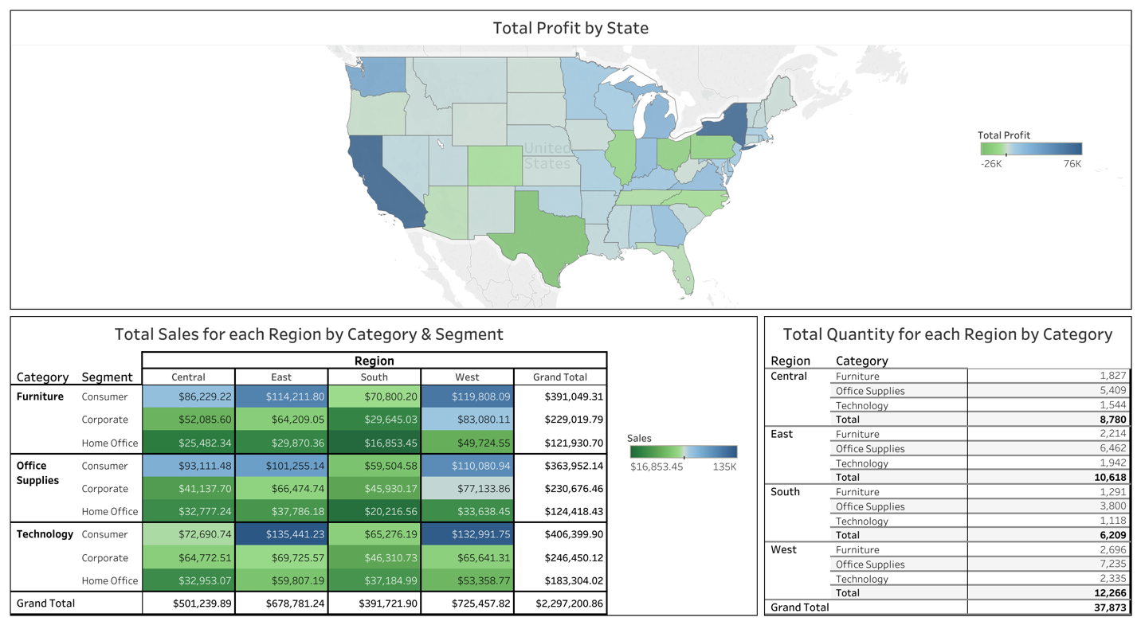

A dashboard was created to visually display the profit, sales and quantity information. The top of the dashboard presents a map of the US with each state assigned a color to depict the total profit from that state. The darker the blue the higher the total profit from that state and the darker the green the lower the profit from that state. The bottom left portion of the dashboard contains a table of total sales by region because state would not fit for each category by each segment. The darker the blue the more sales and darker the green the less sales. The bottom right area of the dashboard displays a table of the total quantity of items sold for each region by category.

There are several conclusions that can be obtained from the map. The most profit is coming from two states: New York and California. This makes sense because those states contain the two biggest cities in the country. The data shown by the colors on the map indicates that the superstore is doing quite well in the northeast and west coast areas. The abundance of states with light blue to light green shading in the middle of the country indicates that there is less profit in the states in the middle of the country. If there was a region for the company to look to improve its profitability, it is the middle of the country. The single state with the greatest potential for improvement in profits appears to be Texas. It has the darkest green shading, which means the company is losing money there. Since the state contains the third biggest city in the US, there seems to be an opportunity for growth in that state.

The table on the bottom left displays the sales from each region by category and customer segment. One prominent feature in this table was that the South had the smallest total sales among the regions. This is consistent with the previously noted fact that the profit map indicated that Texas, the biggest state in the South, had the lowest profit among the states. Another observation is that the super stores sells the most to consumers for all regions and categories. Technology has the most sales for each category counting all segments in that category. The largest sales amounts are in the East and West regions. This is also consistent with the profit map because the East includes New York and the West includes California. Both of these states registered a dark blue on the profit map.

The bottom left area of the dashboard displays a table listing the total quantity of items sold for each region by category. The data in this table indicates that most of the quantity is going to the East or West region, which is consistent with the sales table that indicates that these regions have the highest sales amounts. The regional quantity data also indicates that office supplies is the category with the largest quantities of items sold in all regions.

**Top Half**

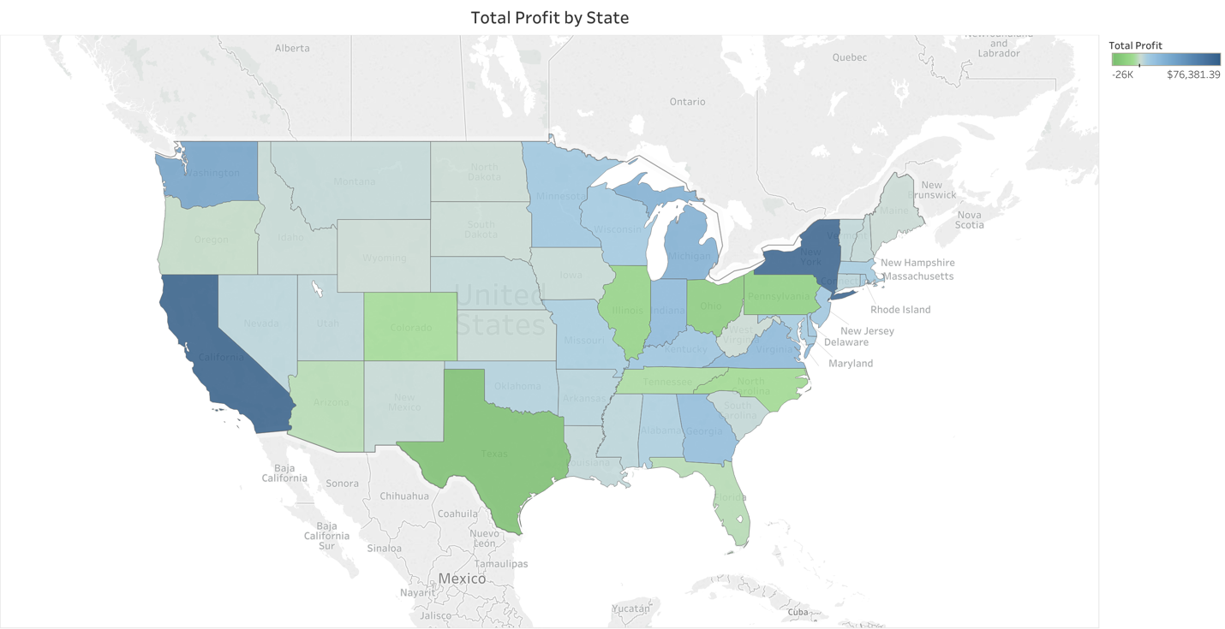

**Bottom Left Half**

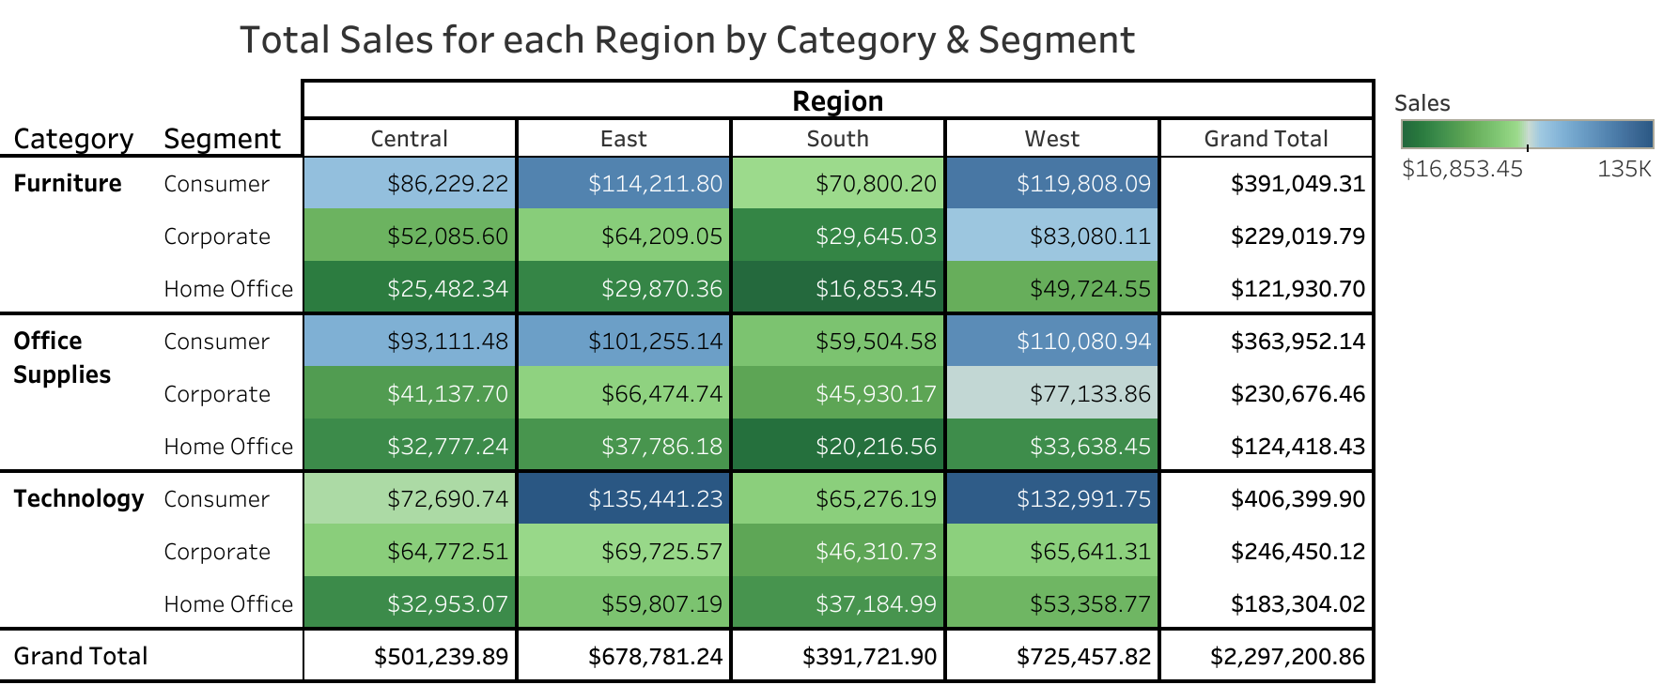

**Bottom Right Half**

