# Advanced Microeconomics: Theories of value and distribution

Question set #4 (**Due on December 11, 2017**)

*General Instructions*: Read the questions carefully and make your answers as precise as possible. It is preferable that the answers are submitted as WORD or PDF files compatible with Windows OS. You can submit handwritten answers provided that they are (a) legible; (b) neatly written; and (c) scanned as a submit handwritten answers provided that they are (a) legible; (b) neatly written; and (c) scanned as a PDF file A firm producing hockey sticks has a production function given by  In the short-run, the quantity of capital that the firm has is fixed at $k=100$. The rental rate for $k$ is $v=\$1,$ and the wage rate for is

* 1. Calculate the firm’s short-run *total* cost function and *average* cost function. **5 points**
  2. Calculate the firm’s short-run *marginal* cost function. **2 points**
  3. Plot the short-run average and marginal cost functions for the following values of $q:\left\{25,50,100,200\right\}.$**7 points**
  4. At what level of $q$ does the short-run average and marginal cost curves intersect? **2 points**
  5. Explain why the short-run marginal cost curve will always intersect the short-run average curve at its lowest point. **7 points**

Suppose that the quantity of capital that the firm has is fixed at

* 1. Calculate the firm’s total cost function in terms of $q, w, v and \overline{k}$. **5 points**
  2. Given $q, w$ and $v$, how should the quantity of capital chosen so as to minimize total cost? **7 points**
  3. Use your result from (g) to calculate the long-run total cost function. **5 points**
  4. For $w=\$4$ and $v=\$1$, plot the long-run total cost function. Your plot should show that the long-run total cost curve is an envelope for the short-run cost curves derived in part (c) by examining values of $\overline{k}$ of 100, 200 and 400. **10 points**

1. The total cost function of a firm is given by $C=qw^{2/3}v^{1/3}$.
   1. Use Shephard’s lemma to compute the (constant output) demand functions for $l$ and $k$. **10 points**
   2. Use your results from part (a) to calculate the underlying production function for $q$. **10 points**
2. Use Miller (2000) to answer the questions below.
   1. Describe the distinction between pure assembly and pure continuous manufacturing processing with examples. **15 points**
   2. How does the adjustment process to changes in output in these process differ from the adjustment process described in marginalist theory of the firm? **15 points**

SEE NEXT PAGE

# Advanced Microeconomics: Question set #4

**A.** The hockey sticks producing firm has a Cobb-Douglas production function of

**1.**

$q=f\left(k,l\right)=2∙\sqrt{k∙l}$,

where capital input is given $k_{1}=100$, hence, the short-run production function is:

$$q=f\left(k,l\right)=2∙\sqrt{k_{1}∙l}$$

As capital input is given or fixed in the short-run then the labor input is defined via the following representation of the above equation:

$$q=2∙{k_{1}}^{0.5}∙l^{0.5}$$

Then, the labor input is defined as function of $q$ and $k_{1}$:

$$l^{0.5}=\frac{q}{2∙{k_{1}}^{0.5}}=0.5∙q∙{k_{1}}^{-0.5}$$

Then, removing the square root from left hand side of the equation yields the following presentation of the above equation:

$${{(l}^{0.5})}^{2}={(0.5∙q∙{k_{1}}^{-0.5})}^{2}$$

$$l^{0.5∙2}=l={0.5}^{2}∙q^{2}∙{k_{1}}^{-0.5∙2}=0.25∙q^{2}∙{k_{1}}^{-1}$$

$$l=0.25∙q^{2}∙{k_{1}}^{-1}$$

Hence, the total short-term cost function is represented in the original form and then the labor input is being substituted by the above formula:

$$SC\left(v,w,q,k_{1}\right)=v∙k_{1}+w∙l=v∙k_{1}+w∙0.25∙q^{2}∙{k_{1}}^{-1}$$

Given the data $v=\$1$, $w=\$4$ and $k_{1}=100$, the **short-term total cost** **function** is being solved:

$$SC\left(1, 4, q, 100\right)=1∙100+4∙0.25∙q^{2}∙{100}^{-1}=100+\frac{1}{100}∙q^{2}=100+\frac{q^{2}}{100}$$

Given the result, the **short-term average cost function** is defined as:

$$SAC=\frac{SC}{q}=\frac{100+\frac{q^{2}}{100}}{q}=\frac{1}{q}∙\left(100+\frac{q^{2}}{100}\right)=\frac{100}{q}+\frac{q}{100}$$

**B.** Given the above result, the **short-term marginal cost function** is defined as:

$$SMC=\frac{∂SC}{∂k}=\frac{2}{100}∙q=\frac{1}{50}∙q$$

**C.** The results of plotting the short-run average and marginal cost functions for the following values of $q:\left\{25,50,100,200\right\}$ are following:

1) plotting in table format

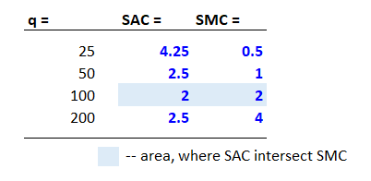

1) plotting in chart format

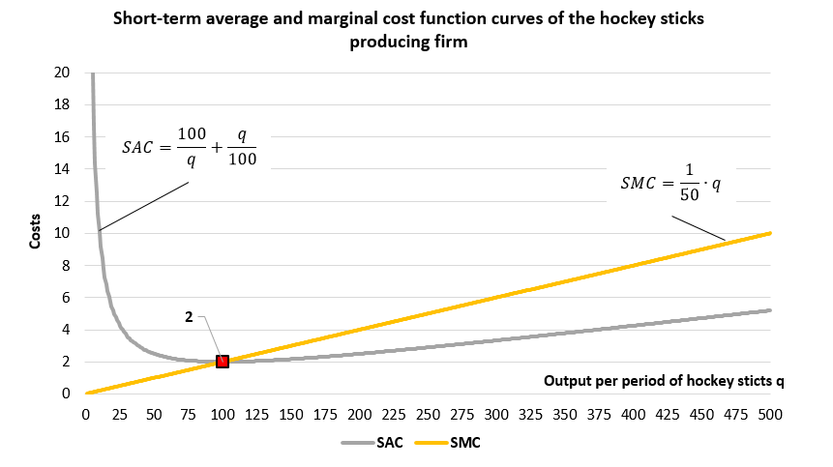

**D.** To define mathematically the point where $SAC$ crosses $SMC$ let’s resolve this equation:

$$SAC = SMC$$

$$\frac{100}{q}+\frac{q}{100}=\frac{1}{50}∙q$$

$$\frac{100}{q}=\frac{2}{100}∙q-\frac{1}{100}∙q=\frac{1}{100}∙q$$

$$100∙100=q∙q$$

$$q^{2}={100}^{2}$$

$$q=\sqrt{{100}^{2}}=100$$

**E.** To explain why the short-run marginal cost curve $SMC$ will always intersect the short-run average curve $SAC$ at its lowest point there is a need to present the solution first in mathematical terms and then it allows to illustrate the logic in plain English:

1) MATHEMATICAL ILLUSTRATION

We need to find the minimum point for the short-term average cost curve by solving the derivative of this function to $q$ variable being equal to zero:

|  |  |  |
| --- | --- | --- |
| $$\frac{∂SAC}{∂q}=0$$ | as $SAC=SC/q$ then we solve the derivative, according to the rule of (textbook, p.25, rule equation #8) | |
| $$\frac{∂(SC/q)}{∂q}=\frac{{SC}^{'}∙q-SC∙q^{'}}{q^{2}}=\frac{\left({∂SC}/{∂q}\right)∙q-SC∙\left({∂q}/{∂q}\right)}{q^{2}}$$ | | [*] |

Since $\left({∂SC}/{∂q}\right)$ is short-term marginal cost function and $\left({∂q}/{∂q}\right)=1$ then the proper changes are made to the above equation:

$$\frac{∂(SC/q)}{∂q}=\frac{SMC∙q-SC∙1}{q^{2}}=0$$

$$SMC∙q-SC∙1=0$$

$$SMC∙q=SC$$

$$SMC=\frac{SC}{q}=SAC$$

Hence, we found that at minimum point of the $SAC$ curve, short-term marginal cost curve crosses short-term average cost curve.

1) LOGICAL ILLUSTRATION

As long as short-term marginal costs are lower than short-term costs (which is the points on the $SMC$ curve are below the $SC$ curve, which is U-shape), the tangent to the short-term average cost $SAC$ curve is negative – this means that this part of the $SAC$ curve is downward sloping. Conversely, as long as short-term marginal costs are higher than short-term costs (points on the SMC curve are above the $SC$ curve), then the tangent to the $SAC$ curve is positive and the $SAC$ curve itself is upward sloping in this area. Lastly, when short-term marginal costs are equal to the short-term costs, then the tangent to the $SAC$ curve is zero hence the $SAC$ is in the inflection point here. These considerations are drawn from the above mentioned formula [*], which is derivate of $SAC$ curve that depends on the $SMC$ and $SC$ in this way ($SMC∙q-SC$).

**F.** Having the quantity of capital that the firm has fixed at $k=\overline{k}$, the firm’s total cost function in terms of $q, w, v and \overline{k}$ is defined by the this formula:

$q=f\left(k,l\right)=2∙\sqrt{k∙l}$,

The relevant Lagrangian for minimizing the cost of production is:

$$L=v∙k+w∙l+λ∙(q_{0}-2∙k^{0.5}∙l^{0.5})$$

|  |  |  |
| --- | --- | --- |
| $$\frac{∂L}{∂k}=v+λ∙\left(-2\right)∙{0.5∙k}^{0.5-1}∙l^{0.5}=v-λ∙k^{-0.5}∙l^{0.5}=0$$ | $$v=λ∙k^{-0.5}∙l^{0.5}$$ | [1] |
| $$\frac{∂L}{∂l}=w+λ∙(-2)∙{0.5∙l}^{0.5-1}∙k^{0.5}=w-λ∙l^{-0.5}∙k^{0.5}=0$$ | $$w=λ∙l^{-0.5}∙k^{0.5}$$ | [2] |
| $$\frac{∂L}{∂λ}=q_{0}-2∙k^{0.5}∙l^{0.5}=0$$ | $$q_{0}=2∙k^{0.5}∙l^{0.5}$$ | [3] |

Dividing the second equation by the first one yields this equation:

$$\frac{w}{v}=\frac{λ∙l^{-0.5}∙k^{0.5}}{λ∙k^{-0.5}∙l^{0.5}}=\frac{k^{0.5}∙k^{0.5}}{l^{0.5}∙l^{0.5}}=\frac{k^{0.5+0.5}}{l^{0.5+0.5}}=\frac{k}{l}$$

This result allows to make substitution of $k$ and $l$ into the production function to find these variables’ relation to $q$, $v$ and $w$:

1. Labor
$$k=l∙\frac{w}{v}$$

$$q=f\left(k,l\right)=2∙\sqrt{l∙\frac{w}{v}∙l}=2∙l∙\sqrt{\frac{w}{v}}$$

$$l\left(v,w,q\right)=0.5∙q∙\sqrt{\frac{v}{w}}=0.5∙q∙v^{0.5}∙w^{-0.5}$$

2. Capital

$$l=k∙\frac{v}{w}$$

$$q=f\left(k,l\right)=2∙\sqrt{k∙k∙\frac{v}{w}}=2∙k∙\sqrt{\frac{v}{w}}$$

$$k\left(v,w,q\right)=0.5∙q∙\sqrt{\frac{w}{v}}=0.5∙q∙v^{-0.5}∙w^{0.5}$$

Hence, now we can derive the **total cost function**:

$$C\left(v,w,q\right)=v∙k+w∙l=v∙0.5∙q∙v^{-0.5}∙w^{0.5}+w∙0.5∙q∙v^{0.5}∙w^{-0.5}=$$

$$=0.5∙q∙v^{0.5}∙w^{0.5}+0.5∙q∙v^{0.5}∙w^{0.5}= q∙v^{0.5}∙w^{0.5}$$

However, this total cost function can be presented too as a function of capital input (which is given $k=\overline{k}$):

$$q=f\left(\overline{k},l\right)=2∙\sqrt{\overline{k}∙l}$$

$$l\left(\overline{k},q\right)={(0.5∙q)}^{2}∙{\overline{k}}^{-1}$$

$$C\left(v,w,\overline{k}\right)=v∙\overline{k}+w∙{\left(0.5∙q\right)}^{2}∙{\overline{k}}^{-1}=v∙\overline{k}+w∙0.25∙q^{2}∙{\overline{k}}^{-1}$$

**G.** To decide the quantity of capital that should be chosen so as to minimize total cost, there is this solution, by taking derivative of the $C\left(v,w,\overline{k}\right)$ and solving the final equation equaled to zero for $\overline{k}$:

$$\frac{∂C\left(v,w,\overline{k}\right)}{∂\overline{k}}=v+w∙0.25∙\left(-1\right)∙q^{2}∙{\overline{k}}^{-1-1}=v-0.25∙w∙q^{2}∙{\overline{k}}^{-2}$$

$$\frac{∂C\left(v,w,\overline{k}\right)}{∂\overline{k}}=0=v-0.25∙w∙q^{2}∙{\overline{k}}^{-2}=0$$

$$v=0.25∙w∙q^{2}∙{\overline{k}}^{-2}$$

$${\overline{k}}^{-2}=\frac{v}{0.25∙w∙q^{2}}$$

$$\frac{1}{{\overline{k}}^{2}}=\frac{v}{0.25∙w∙q^{2}}$$

$$\frac{0.25∙w∙q^{2}}{v}=\frac{{\overline{k}}^{2}}{1}$$

$${\overline{k}}^{2}=\frac{0.25∙w∙q^{2}}{v}$$

$${\left({\overline{k}}^{2}\right)}^{1/2}={\left(\frac{0.25∙w∙q^{2}}{v}\right)}^{1/2}$$

$$\overline{k}={0.5∙q∙\left(\frac{w}{v}\right)}^{1/2}=0.5∙q∙w^{0.5}∙v^{-0.5}$$

**H.** The **total cost function** (as derived above):

$$C\left(v,w,q\right)=v∙k+w∙l=v∙0.5∙q∙v^{-0.5}∙w^{0.5}+w∙0.5∙q∙v^{0.5}∙w^{-0.5}=$$

$$=0.5∙q∙v^{0.5}∙w^{0.5}+0.5∙q∙v^{0.5}∙w^{0.5}= q∙v^{0.5}∙w^{0.5}$$

**I.** Under given $w=\$4$ and $v=\$1$, the long-run total cost function is:

$$C\left(1,4,q\right)=q∙v^{0.5}∙w^{0.5}=q∙1^{0.5}∙4^{0.5}=2∙q$$

The chart below plots different $SC$ curves with $\overline{k}\left\{100;200;400\right\}$ and it illustrates that total cost function curve $C$ is an “envelope” for the $SC$ curves.

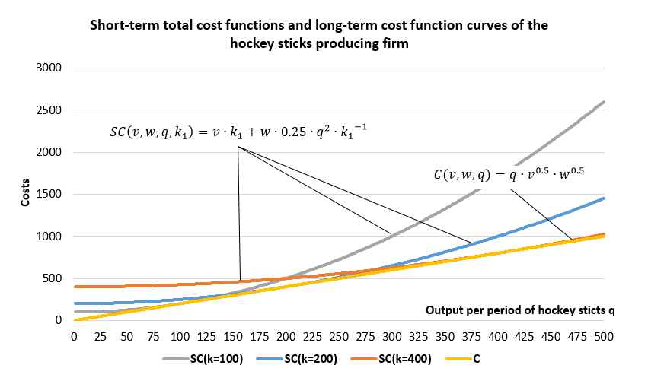

Mathematically, the same conclusion can be made by finding a cost-minimizing level of capital by differentiating $SC$ by $k$ and solving the obtained equalizing it to zero:

$$SC\left(1,4,q,k\right)=v∙k+w∙l=v∙k+w∙0.25∙q^{2}∙k^{-1}=$$

$$=1∙k+4∙0.25∙q^{2}∙k^{-1}=k+q^{2}∙k^{-1}$$

$$\frac{∂SC\left(1,4,q,k\right)}{∂k}=1+q^{2}∙\left(-1\right)∙k^{-1-1}=1-q^{2}∙k^{-2}$$

|  |  |  |
| --- | --- | --- |
| $$\frac{∂SC\left(1,4,q,k\right)}{∂k}=0$$ | => | $$1-q^{2}∙k^{-2}=0$$ |

$$1=q^{2}∙k^{-2}$$

$$q^{2}=\frac{1}{k^{-2}}$$

$$k^{2}=q^{2}$$

$$k=q$$

Solving $SC\left(1,4,q,k\right)$ with $k=q$ yields:

$$SC\left(1,4,q,k\right)=k+q^{2}∙k^{-1}=q+q^{2}∙q^{-1}=q+q=2∙q$$

Hence, effectively, when $k=q$, short-term cost function $SC\left(1,4,q,k\right)=2∙q$ equals to long-term cost function $C\left(1,4,q\right)=2∙q$.

**A.** Given the total cost function of $C=qw^{2/3}v^{1/3} ,$ the demand functions for $k$ and $l$ are defined using the Shepard’s lemma:

**2.**

$$k^{c}\left(v,w,q\right)=\frac{∂C(v,w,q)}{∂v}=q∙w^{\frac{2}{3}}∙{\frac{1}{3}∙v}^{\frac{1}{3}-1}=\frac{1}{3}∙q∙w^{\frac{2}{3}}∙v^{-\frac{2}{3}}=\frac{1}{3}∙q∙{\left(\frac{w}{v}\right)}^{2/3}$$

$$l^{c}\left(v,w,q\right)=\frac{∂C(v,w,q)}{∂w}=q∙w^{\frac{2}{3}-1}∙{\frac{2}{3}∙v}^{\frac{1}{3}}=\frac{2}{3}∙q∙w^{-\frac{1}{3}}∙v^{\frac{1}{3}}=\frac{2}{3}∙q∙{\left(\frac{v}{w}\right)}^{1/3}$$

**B.** Hence, the underlying production function $q$ is derived this way:

STEP #1

|  |  |  |
| --- | --- | --- |
| $$k=\frac{1}{3}∙q∙{\left(\frac{w}{v}\right)}^{2/3}$$ |  | $$3∙\frac{k}{q}={\left(\frac{w}{v}\right)}^{\frac{2}{3}}$$ |
| $$l=\frac{2}{3}∙q∙{\left(\frac{v}{w}\right)}^{1/3}$$ | $$\frac{3}{2}∙\frac{l}{q}={\left(\frac{v}{w}\right)}^{\frac{1}{3}}$$ |

STEP #2

|  |  |  |
| --- | --- | --- |
| $$\frac{w}{v}={\left(3∙\frac{k}{q}\right)}^{3/2}$$ |  | $${\left(3∙\frac{k}{q}\right)}^{3/2}={\left(\frac{3}{2}∙\frac{l}{q}\right)}^{-3}$$ |
| $$\frac{w}{v}={\left(\frac{3}{2}∙\frac{l}{q}\right)}^{-3}$$ |

STEP #3

|  |  |  |
| --- | --- | --- |
| $$\frac{{\left(3∙k\right)}^{3/2}}{q^{3/2}}=\frac{{\left(2∙q\right)}^{3}}{{\left(3∙l\right)}^{3}}$$ |  | $${\left(3∙k\right)}^{3/2}{∙\left(3∙l\right)}^{3}=q^{3/2}{∙\left(2∙q\right)}^{3}$$ |

STEP #4

|  |  |  |
| --- | --- | --- |
| $$3^{3/2}∙27∙k^{3/2}∙l^{3}={8∙q}^{\frac{3}{2}+3}$$ |  | $$3^{3/2}∙\frac{27}{8}∙k^{3/2}∙l^{3}=q^{\frac{9}{2}}$$ |

STEP #5

|  |  |  |
| --- | --- | --- |
| $${\left[q^{\frac{9}{2}}\right]}^{2/9}={\left[3^{3/2}∙\frac{27}{8}∙k^{3/2}∙l^{3}\right]}^{2/9}$$ |  | $$q={\left[3^{3/2}∙\frac{27}{8}\right]}^{2/9}∙{\left(k^{3/2}\right)}^{2/9}∙{\left(l^{3}\right)}^{2/9}$$ |

STEP #5 (FINAL)

|  |  |  |
| --- | --- | --- |
| $$q={\left[3^{3/2}∙\frac{27}{8}∙k^{3/2}∙l^{3}\right]}^{2/9}$$ |  | $$q=1.889∙k^{1/3}∙l^{2/3}$$ |

**A.** The distinction between pure assembly and pure continuous lies in:

**3.**

1) the shutdown-and-startup costs. If these are low then the manufacturing production is considered an assembly-type, otherwise if these are high than it is a continuous-type one;

2) the adjustment process. An assembly type production unit adjusts via varying the plant’s work periods, while a continuous-type unit adjusts by varying the plant’s within-week work period.

Examples of **pure assembly** manufacturing production: car assembly enterprise, bakery shop, mining of some natural resource that is demand elastic (marble, granite).

Examples of **pure continuous** manufacturing production: utilities like water utilities and electrical power generation industry (coal-, hydro-, nuclear-power plants); steel production, metallurgic coke production, cement production.

**B.** The marginalist theory of the firm has diminishing returns as centerpiece of its intellectual premise. The adjustment process in the firm by marginalists occurs this way: over short run with each new and small (marginal) addition of one input (such a labor, etc), while other input (such as capital) is unchanged or kept constant, produces a declined marginal product. Hence, the notion of diminishing marginal productivity arises.

However, by Miller (2000) reality looks a bit different as his paper claims: “60 years of empirical studies of short-run cost curves” revealed that instead of U-shaped short-run curves SAC and SMC, which cross each other at the point of SAC minimum, these curves are flat and equal up to the point of full capacity utilization. This paper also points out that another shortage of the marginalist theory of the firm that it confuses stocks and flows of capital. The latter is not only fixed in the short run, it is also indivisible. There is a notion of capital services derived from install capital stock. The very capital services and labor services, the flows, are divisible and hence they are variable.

In the above mentioned (in 3.A) real-life manufacturing firms do adjust their operating processes by varying these two flows: for example, by shutting-down out of operations or re-launching into operations some units of the firms, using along the way capital and labor simultaneously (not by varying an increase/decrease of labor) as variable flows of services. For instance, in the car assembly production unit there may be an addition of previously idle line of production (flow of capital and labor services re-activated) or stoppage of it in response to demand (these services are put to rest). Another example, power generation plants have several (usually) identical production “blocks” (a manufacturing chain consisting of fuel firing machine, power turbine, electricity generator), if there is less demand from the electric grid then one block could be put off for a while, then if there is an increase in demand from power grid, then it is put back into operations. So adjustments are done in units of the firm.