Contact
Address:
Kannankara, Niranam North, Thiruvalla, Pathanamthitta, Kerala,689621

Phone:
+91 6282904280

Email:
Abhilashkannankara1@gmail.com

LinkedIn:
linkedin.com/in/abhilash-k-610210227

GitHub:
github.com/drazox

Languages
English-★★★★☆ Malayalam-★★★★★
Hindi -★★★★☆

Achievements
● NSS Volunteer 2019-21
● Participated in Professional students’
summit 2K20

Hobbies
● Writing ● Design
● Sketching ● Photography

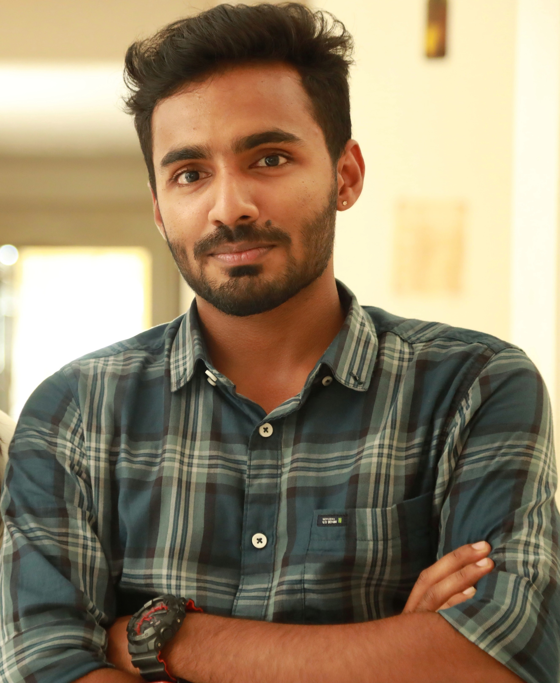

Objective
An enthusiastic fresher with highly motivated and leadership skills, completed Bachelor of Engineering degree in Electronics and Communication Engineering. Always willing to innovate the new things which can improve the existing technology.

Education
● 2018-2022
Bachelor of Technology | College of Engineering, Aranmula
ELECTRONICS & COMMUNICATION ENGINEERING
● 2016-2018
Higher Secondary | Bishop Hodges H.S.S, Mavelikara
COMPUTER SCIENCE | KERALA STATE BOARD- 80%
● 2015-2016
High School | MGM.H.S.S, Thiruvalla
KERALA STATE BOARD– 97%

Skill Highlights
- CPP  - Python, Django  - Communication  - Strong decision maker | - HTML  - CSS  - Javascript  - Bootstrap

PROFESSIONAL DEVELOPMENTS
INTERNSHIPS
● Embedded System and Robotics
Completed internship in "Embedded System and Robotics" at
INFOX Technologies,Kochi
● Full-Stack Data Science with Python
Ongoing 6-Months internship based on Front-End & Back-End
of Full-Stack Data Science with Python in Softronics,Palakkad

PROJECT
E-RATION DISTRIBUTION SYSTEM
The main objective of the project is to replace the manual
distribution of Public Distribution System with automated one
by using Arduino microcontroller, Bluetooth module, Finger-
print sensor, separate solid and liquid dispensing unit.
By our designed and implemented system, we can completely
avoid corruption by the current ration system and the
customer can buy their materials at any time without waiting
in a queue.

ABHILASH K

