|

NaNa Sodium

Design Document

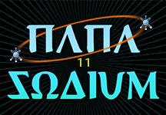

Dhruvin Balar and Shahil Patel

Friday, January 8th, 2016

ICS3U1

Ms. Navabi

Table of Contents

Screens 2

Graphic Pictures 4

Methods Organization 5

# Screens

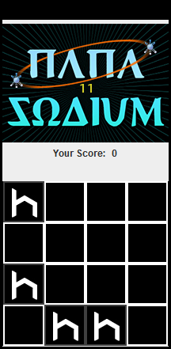

1

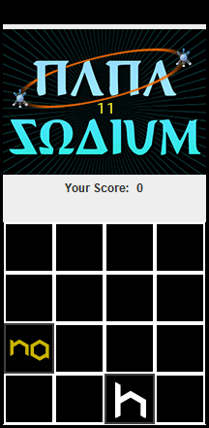

4 68

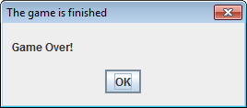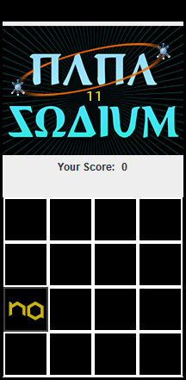

1 626

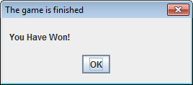

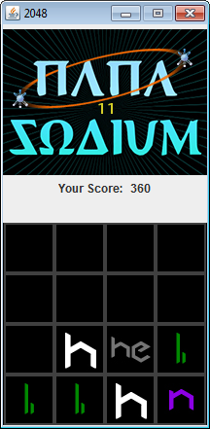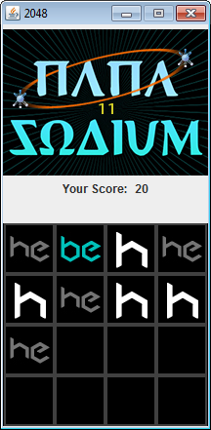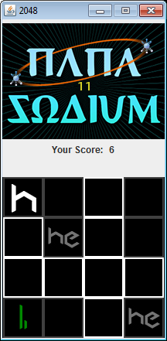

# Graphic Pictures

F:\ICS Culminating\2048\images\icon128.jpgF:\ICS Culminating\2048\images\icon64.jpgF:\ICS Culminating\2048\images\icon1024.jpgF:\ICS Culminating\2048\images\icon2048.jpgF:\ICS Culminating\2048\images\icon512.jpgF:\ICS Culminating\2048\images\icon256.jpgF:\ICS Culminating\2048\images\icon32.jpgF:\ICS Culminating\2048\images\icon16.jpgF:\ICS Culminating\2048\images\icon8.jpgF:\ICS Culminating\2048\images\icon4.jpgF:\ICS Culminating\2048\images\icon2.jpg

Nitrogen Icon

Carbon Icon

Neon Icon

Sodium Icon

Fluorine Icon

Oxygen Icon

Boron Icon

Lithium Icon

Hydrogen Icon

Helium Icon

Beryllium Icon

Project Logo

# Methods Organization

|  |  |
| --- | --- |
| **Method Name** | **Description** |
| Game2048 | This method creates and initializes the grid array. Also it will initialize the variables which are going to be used in the game. The winning level will be read from the text file that has been created. The current level and current score will show the user their progress in the game. Moreover, the game shall start by inserting the first number tile. |
| newSlot | This method will insert a new random number tile on the grid every time the user makes a move. |
| play | This method will allow the tiles to move to the user preferred direction. It will be called when a button on the keyboard is pressed. |
| initConfig | This method will initialize the GUI with the icons and logo. It will assign variables for that specific logo and slot icons. |
| initSlots | This method will initialize individual slots that hold the number. |
| createLogoPanel | This method will create a logo panel which will show the user the logo. |
| createScorePanel | This method will create a score panel which will show the user the score. |
| createGridPanel | This method will create a grid panel which will sort the element tiles. |
| createFrame | This method contains the main, logo, score, and grid panels. |
| delay | This method will help animate the screen by delaying the icon that will be shown. |
| showGameOver | This method will display the “Game Over Frame”. |
| showGameWon | This method will display the “Game Win Frame”. |
| addListener | This method will detect any buttons pressed on the keyboard. |
| setScore | This method will show the score in the game. |
| setNewSlotBySlotIndex | This method assigns a new slot of index. |
| clearSlot | This method will clear a slot index on the grid. |
| setGridByIndex | This method will take in a grid array with slots represented by indices and displays it. |
| main | This is the main method of the program. It will initialize the three objects: “Game2048Gui”, “Game2048”, and “Game2048Listener”. |
| keyPressed | This method will detect any key pressed on the keyboard. |
| keyReleased | This method will detect any key released on the keyboard. |
| keyTyped | This method will detect any key typed on the keyboard. |