ROADMAP
Your 46-Day Path from
Absolute Beginner to Edge AI Engineer
Raspberry Pi 4 (4 GB) + Windows laptops + two Pis + 2 hours a day (about 9 weeks at 5 days a week)

The plan in one picture
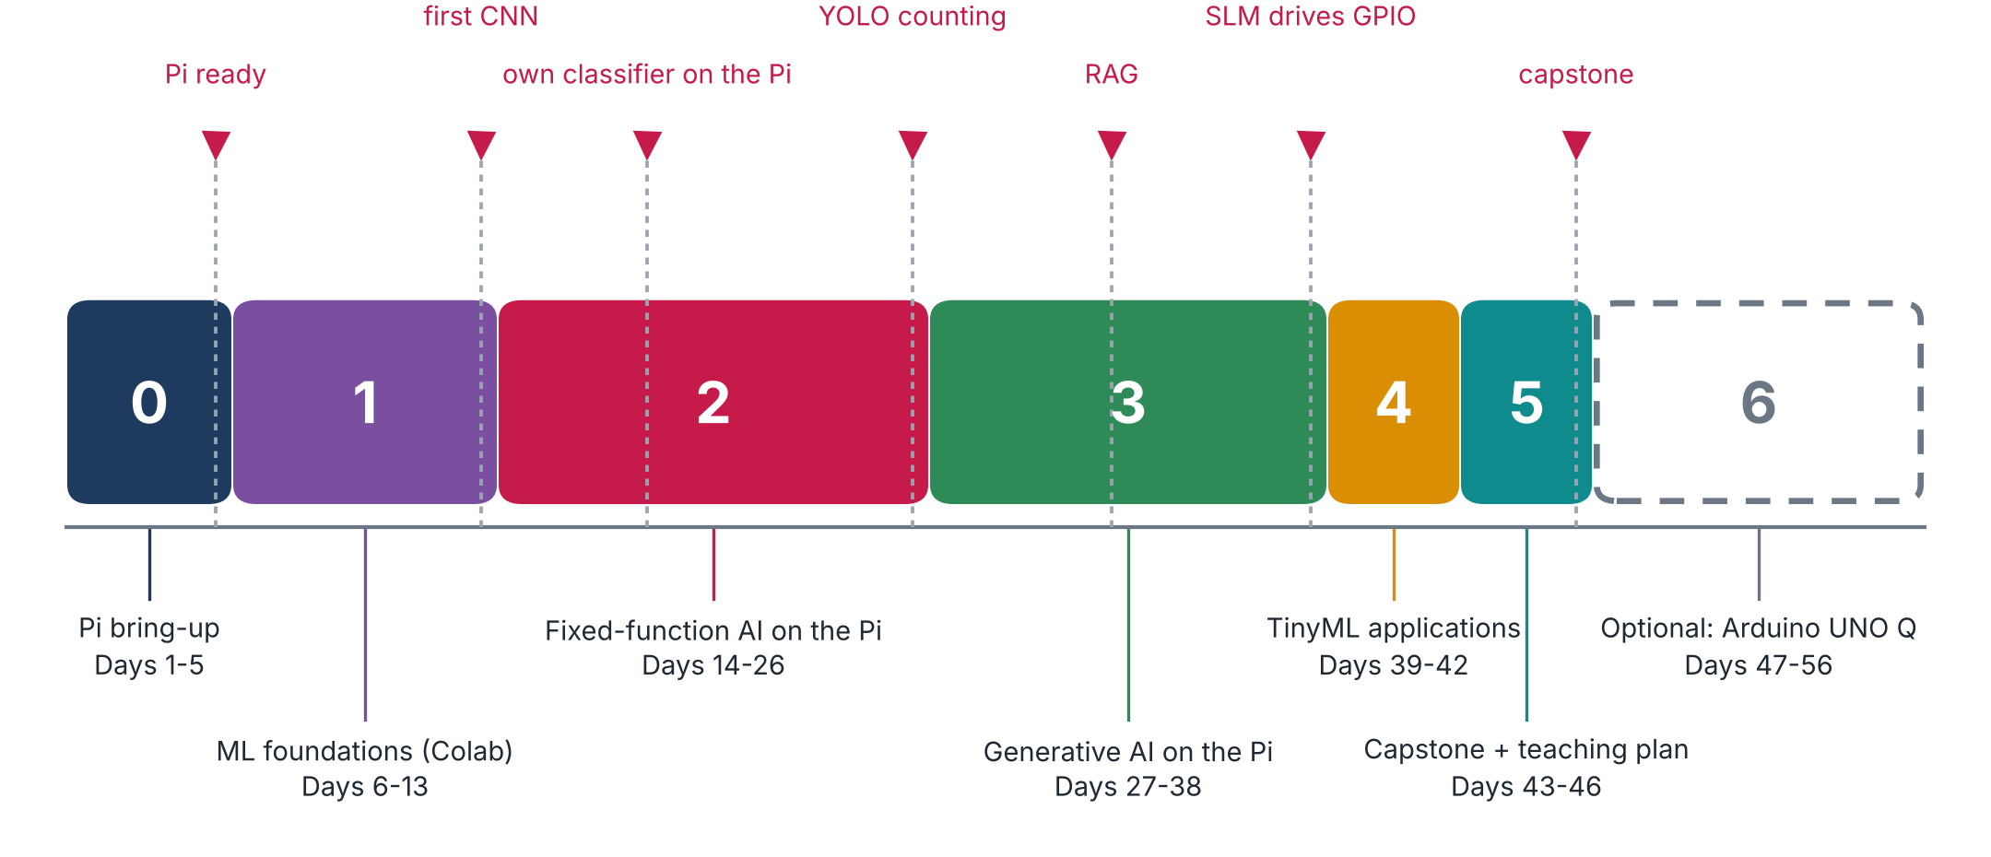
Figure 1. Six phases, 46 core days, and an optional Arduino UNO Q track. Red flags are the milestones you will be able to demonstrate.
Phase | Days | What you learn | What you need
0 Pi bring-up | 1-5 | Flash, boot, SSH, Linux basics, camera, Python + Jupyter on the Pi | Pi 4, microSD, power, laptop
1 ML foundations (Colab) | 6-13 | Neurons, DNNs, CNNs, datasets, metrics, overfitting, Edge Impulse intro | Laptop + Google Colab, no Pi needed
2 Fixed-function AI on the Pi | 14-26 | Image classification, object detection (SSD, FOMO), YOLO, counting objects | Camera (Pi camera or USB webcam), Edge Impulse account
3 Generative AI on the Pi | 27-38 | RNN text, distillation, small language models (Ollama), RAG, agents, vision-language, audio, GPIO, IoT control | USB mic + speaker, breadboard, LEDs, button, sensors
4 TinyML applications | 39-42 | Anomaly detection, keyword spotting, image apps on microcontrollers, responsible AI | Concepts only (no microcontroller board needed)
5 Capstone + teaching plan | 43-46 | Your own project, write-up, and the plan to teach it to students | Whatever the project needs
6 Optional: Arduino UNO Q | 47-56 | The same ideas on a different board (after you master the Pi and ML) | Arduino UNO Q (not owned yet)

How to use the plan
• One day = about 2 hours. Read the tutorial, watch the animation, do the lab, then print the sketch notes and add your own comments.
• Two Pis, two laptops: do every day twice. Pass 1 is the learning pass on one Pi (about 2 hours). Pass 2 is the consolidation pass on the other Pi, from your notes only, which should take less time. Alternate which Pi you learn on. This catches mistakes that hide behind copy-paste.
• Name your Pis differently (for example raspi-office and raspi-home) and keep the same user name on both. Keep code and notes in the GitHub repo and use git pull, so both Pis and both laptops stay in sync.
• Phase 1 (ML foundations) needs no Pi, only Google Colab, so it is a good block to do when you are travelling.
• Book page numbers below are PDF pages of the book file (printed page + 1). The splits of long chapters across days are estimates; I will adjust them as we go.
CAREFUL Honest limits of this plan
• Pi 4 with 4 GB: the vision chapters will run fine. The language-model chapters (Phase 3) were written for a Pi 5 and will be slower here, and only small models fit. We will choose model sizes to match your board and I will report slower-than-book results as they are.
• Software versions: a newer Raspberry Pi OS may ship a newer Python than the book used, and TensorFlow Lite can be picky about that. Day 4-5 includes the check.
• Online services (Colab, Edge Impulse, model downloads) need Internet access, and your office network may restrict some of them. Plan to use a phone hotspot on those days if needed.
• UNO Q chapters are from a different online book and course slides that I have not read yet; the RAG classes for it are marked 'to be developed' in the course README.

What to prepare, and when
By day | Item | Why
1 | Pi 4, microSD (32 GB+), USB-C power 5 V / 3 A, card reader, Wi-Fi details | Everything in Phase 0
4 | Pi camera module (CSI) or a USB webcam | Camera test and all vision projects
6 | Google account (Colab) | ML foundations
13 | Edge Impulse account | Training in Phase 2 (check the current free tier)
27 | Internet on the Pi for model downloads; enough free space on the microSD | Ollama and models
35 | USB microphone and speaker | Audio pipeline
36 | Breadboard, jumper wires, LEDs + resistors, push button, DHT temperature sensor, BMP280 pressure sensor | GPIO and sensors (the repo scripts use these; confirm the exact parts in the chapter before buying)
47+ | Arduino UNO Q (optional) | Alternative hardware track

Day-by-day plan
C = class number in the course repositories (IESTI05 = Edge AI, IESTI01 = TinyML). Book pp. = PDF pages of 'Edge-AI-Engineering book.pdf'. A dash means the day is based on slides, notebooks and docs rather than the book.
Day | Topic | Source | Book pp. | You will have
Phase 0 - Pi bring-up (days 1-5)
1 | Meet the Pi 4, flash the microSD, first SSH | IESTI05 C3 | 20-21, 25-27, 29-39 | Pi answers over SSH
2 | Remote access: file transfer, remote desktop, two Pis and two networks | IESTI05 C3 | 38-44, 56-61 | Copy files both ways; desktop opened remotely
3 | Linux command line | IESTI05 C2 (slides + linux_intro.pdf) | - | Navigate, edit, install, htop
4 | Camera, swap memory, updates | IESTI05 C3 slide 10 | 43-55, 62-64 | First photo taken on the Pi
5 | Python virtual environment + Jupyter on the Pi | IESTI05 C4 | 65-75 | Notebook running on the Pi
Phase 1 - ML foundations (Colab) (days 6-13)
6 | Colab and Python review; what is TinyML | IESTI01 C2-C4b | - | Colab notebook running
7 | The machine-learning paradigm | IESTI01 C5 | - | First model fitted
8 | Neural-network building blocks | IESTI01 C6 | - | A small network in TensorFlow
9 | Regression with a DNN | IESTI01 C7 | - | Regression model + plot
10 | Classification with a DNN | IESTI01 C8 | - | Classifier + confusion matrix
11 | Datasets, splits and metrics | IESTI01 C9 | - | Train/validation/test done right
12 | Convolutions; image classification with a CNN | IESTI01 C10-C11 | - | CNN trained in Colab
13 | Edge Impulse intro (Cifar-10); preventing overfitting | IESTI01 C12-C13 | - | Model trained in Edge Impulse
Phase 2 - Fixed-function AI on the Pi (days 14-26)
14 | TensorFlow Lite + MobileNetV2 inference | IESTI05 C5 | 75-86 | Classify an image on the Pi
15 | Live camera classification; a model trained from zero | IESTI05 C5 | 86-93 | Live classification from the camera
16 | Custom classifier: goal and data collection | IESTI05 C6 | 94-102 | Your own dataset
17 | Train in Edge Impulse | IESTI05 C7 | 103-111 | Trained, quantised model
18 | Test, deploy and run live on the Pi | IESTI05 C7 | 112-130 | First custom classifier on the Pi
19 | Object detection fundamentals | IESTI05 C8 | 131-145 | Pre-trained detector on an image
20 | Pre-trained detectors and live stream | IESTI05 C8 | 146-153 | Live detection
21 | Custom detection: data and labeling | IESTI05 C9 | 154-168 | Labeled dataset
22 | SSD MobileNet in Edge Impulse; deploy | IESTI05 C10 | 169-187 | Detector on the Pi
23 | FOMO (lightweight detection) | IESTI05 C10 | 188-202 | FOMO model on the Pi
24 | YOLO with Ultralytics on the Pi | IESTI05 C11 | 203-219 | YOLO inference, NCNN export
25 | YOLO: custom training and deployment | IESTI05 C12 | 220-237 | Custom YOLO model
26 | Counting objects (bees) + Part 1 mini-project | IESTI05 C13-C14, Part 1 assignment | 238-264 | Counting pipeline
Phase 3 - Generative AI on the Pi (days 27-38)
27 | Text generation with an RNN (VerneBot) | IESTI05 C15 | 265-289 | Tiny text generator
28 | Knowledge distillation in practice | book chapter | 290-308 | Distilled model
29 | Small language models: first model with Ollama | IESTI05 C16-C17 | 309-335 | SLM answering on the Pi
30 | Ollama with Python | IESTI05 C18 | 336-360 | Python chat script
31 | Function (tool) calling | IESTI05 C19 | 361-375 | SLM calling a Python function
32 | Retrieval-augmented generation (RAG) | IESTI05 C20 | 376-388 | Question answering over your documents
33 | Agents with small models | IESTI05 C20a | 560 onward | Simple tool-using agent
34 | Vision-language models (Florence-2) | book chapter | 389-433 | Image captioning on the Pi
35 | Audio and vision AI pipeline | book chapter | 434-458 | Speech in, answer out
36 | GPIO and physical computing: LEDs, buttons | IESTI05 C21 | 459-485 | LED and button under code control
37 | Sensors and notebooks | IESTI05 C21 | 486-510 | Sensor readings logged
38 | SLMs for IoT control | IESTI05 C22 | 511-557 | A language model switching hardware
Phase 4 - TinyML applications (days 39-42)
39 | Anomaly detection and K-means | IESTI01 C21-C22 | - | Anomaly detector (concept + notebook)
40 | Keyword spotting (concepts) | IESTI01 C23-C24 | - | KWS pipeline understood
41 | Image apps on microcontrollers; data collection | IESTI01 C25-C27 | - | Person detection concept
42 | Responsible AI; going further with Edge AI | IESTI01 C28-C29 | - | Checklist for responsible deployment
Phase 5 - Capstone + teaching plan (days 43-46)
43 | Choose and plan the project | IESTI05 Part 1 / Part 2 assignments | - | One-page project plan
44 | Build | - | - | Working prototype
45 | Build, test and measure | - | - | Measured results (honest ones)
46 | Present, write up, and plan how to teach it | - | - | Report + teaching plan
Phase 6 - Optional: Arduino UNO Q (days 47-56)
47 | UNO Q: foundations and setup | IESTI05 UNO Q Ch0-Ch1 | - | Board working
50 | SLMs on the UNO Q; benchmarking; Python | IESTI05 UNO Q Ch2 (C19-C21) | - | Model running
53 | Multimodal and agentic AI | IESTI05 UNO Q Ch3, Ch5 | - | Agent running
55 | Physical AI: Bridge between the two processors | IESTI05 UNO Q Ch4 | - | Language model driving hardware

NOTE Checkpoints (what you can show a student)
• Day 5: a Pi you can log into from either laptop, with Python and Jupyter ready.
• Day 13: a CNN you trained yourself. Day 18: your own image classifier running live on the Pi.
• Day 26: YOLO counting objects. Day 32: a question-answering system over your own documents (RAG).
• Day 38: a small language model switching real hardware. Day 46: your capstone and the plan to teach it.

