EDGE AI WITH THE RASPBERRY PI
Course Roadmap:
From Absolute Beginner to Edge AI Engineer
46 core days of about 2 hours each (roughly nine weeks at five days a week), on a Raspberry Pi 4 or Raspberry Pi 5, plus an optional Arduino UNO Q track.

The course in one picture
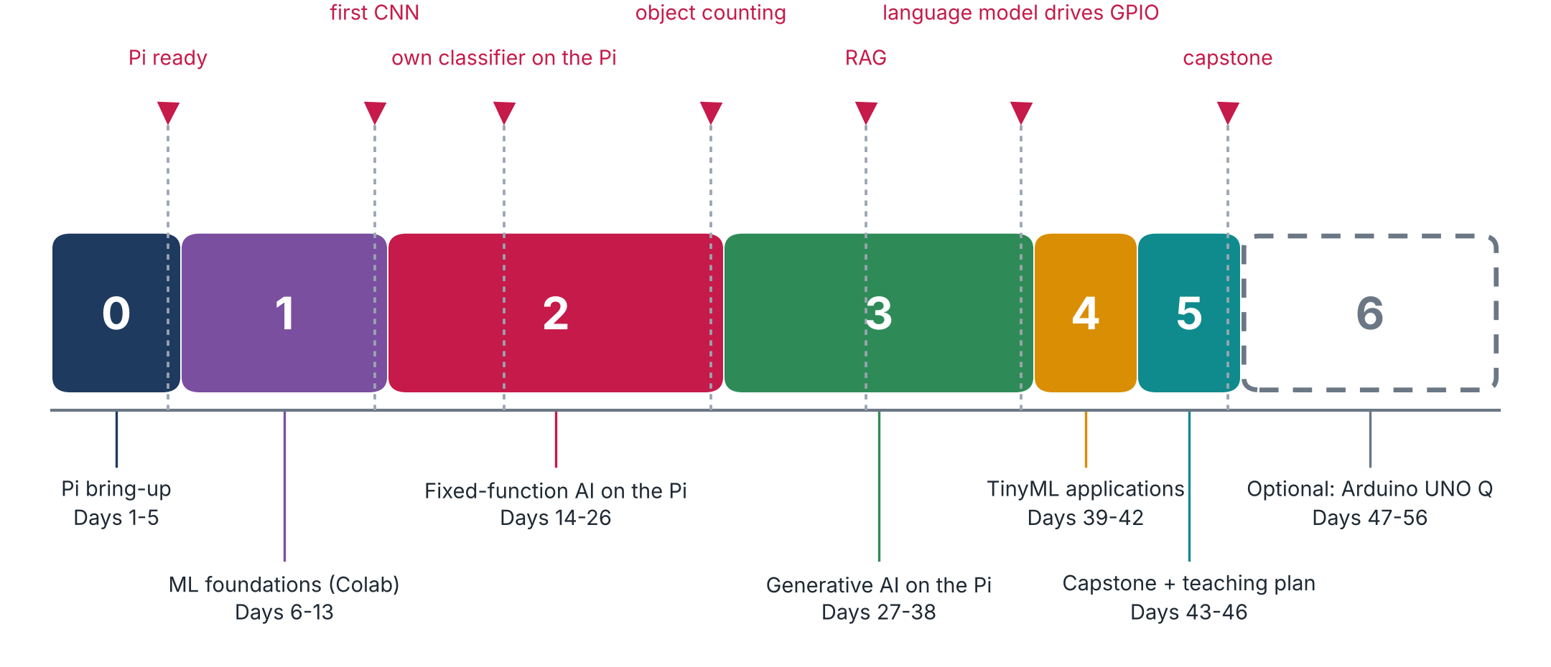
Figure 1. Six phases, 46 core days, and an optional extension. The red flags are milestones you will be able to demonstrate.
Phase | Days | What you learn | What you need
0 Pi bring-up | 1-5 | Flash, boot, remote access, Linux basics, camera, Python and Jupyter on the Pi | Raspberry Pi 4 or 5, microSD, power supply, laptop
1 ML foundations (Colab) | 6-13 | Neurons, deep neural networks, CNNs, datasets, metrics, overfitting, Edge Impulse first steps | Laptop and Google Colab; the Pi is not needed
2 Fixed-function AI on the Pi | 14-26 | Image classification, object detection (SSD, FOMO), YOLO, counting objects | Pi camera or USB webcam; Edge Impulse account
3 Generative AI on the Pi | 27-38 | RNN text, distillation, small language models, RAG, tools, agents, vision-language, audio, GPIO, IoT control | USB microphone and speaker; breadboard, LEDs, button, sensors
4 TinyML applications | 39-42 | Anomaly detection, keyword spotting, image applications on microcontrollers, responsible AI | Concepts only: no microcontroller board needed
5 Capstone + teaching plan | 43-46 | Your own project, the write-up, and the plan to teach it to students | Whatever the project needs
6 Optional: Arduino UNO Q | 47-56 | The same ideas on a second hardware platform, after the Pi and ML are mastered | Arduino UNO Q board (optional)

How the course works
• One day is about two hours. Each day has a full tutorial (complete in itself: no book or website is needed), a narrated animation where it helps, hands-on steps, a quiz and a set of notebook-style notes with space for your own comments.
• Pi 4 and Pi 5. Every day works on both boards. Where the boards differ (speed, memory, power, camera cable, model sizes) the lesson says so.
• Learn it twice. If you have two Pis, do each day once on one Pi (the learning pass), then repeat it on the other from your notes only (the consolidation pass). Give the Pis different host names, keep the same user name, and keep your code and notes in a shared online repository.
• Phase 1 needs no Pi: only Google Colab, so it can be done anywhere.
• Lesson sizes are estimates. A day that needs longer is simply continued the next day.
CAREFUL Notes on hardware and software
• Pi 4 and Pi 5: the vision phases run well on both. A Pi 4 does not run language models well (only very small models, slowly), so Phase 3 is best done on a Pi 5 (8 GB recommended). With only a Pi 4 you still complete the course and treat Phase 3 as a guided demonstration with the smallest models.
• Software versions: a newer Raspberry Pi OS may ship a newer Python than some machine-learning packages support. Days 4 and 5 include the check and the remedy (virtual environments, or an older OS image).
• Online services (Colab, Edge Impulse, model downloads) need Internet access; if your network restricts them, use a phone hotspot on those days.
• Arduino UNO Q is an optional extension; the core course does not need it.

What to prepare, and when
By day | Item | Why
1 | Raspberry Pi 4 or 5, microSD (32 GB or more), the matching USB-C power supply, card reader, Wi-Fi details | Everything in Phase 0
4 | Pi camera module (check the camera cable: it differs between Pi 4 and Pi 5) or a USB webcam | Camera test and all vision projects
6 | Google account | Colab, ML foundations
13 | Edge Impulse account (check the current free tier) | Training in Phase 2
27 | Internet on the Pi for model downloads; enough free space on the card | Ollama and models
35 | USB microphone and speaker | Audio pipeline
36 | Breadboard, jumper wires, LEDs with resistors, push button, DHT temperature sensor, BMP280 pressure sensor (confirm the exact parts in the lessons before buying) | GPIO and sensors
47+ | Arduino UNO Q (optional) | Alternative hardware track

Day-by-day syllabus
Day | Topic | What you do | You will have
Phase 0 - Pi bring-up (days 1-5)
1 | Meet the Raspberry Pi; flash the microSD; first boot and SSH | Learn Edge AI and the Pi 4 / Pi 5; write the OS to a card; boot; log in from your laptop | A Pi you can log into remotely
2 | Remote access in depth | Copy files both ways (scp, SFTP); open the desktop remotely; add a second Wi-Fi network; work with more than one Pi | Files and desktop reachable from your laptop
3 | The Linux command line | Navigate, create, edit and delete files; permissions; processes; monitoring with htop | Confidence in the terminal
4 | Camera, swap memory and updates | Connect a Pi camera or USB webcam; capture a photo; adjust swap; update the system | First photo captured on the Pi
5 | Python environment and Jupyter on the Pi | Create a virtual environment; install packages; run Jupyter remotely | A notebook running on the Pi
Phase 1 - ML foundations (Colab) (days 6-13)
6 | Google Colab, Python refresher, what TinyML is | Run notebooks in the cloud; revise Python and NumPy | A working Colab setup
7 | The machine-learning paradigm | Fit a first model from data and compare it with rule-based code | Your first trained model
8 | Neural-network building blocks | Neurons, layers, activations, loss, gradient descent; build a small network | A small network trained from scratch
9 | Regression with a deep neural network | Predict a number from data; plot predictions | A regression model
10 | Classification with a deep neural network | Predict classes; read a confusion matrix | A classifier with metrics
11 | Datasets, splits and metrics | Train / validation / test splits; accuracy, precision, recall, F1 | Correct model evaluation
12 | Convolutions; image classification with a CNN | Filters and pooling; build and train a CNN | A CNN trained in Colab
13 | Edge Impulse first project; preventing overfitting | Train in the browser; dropout and data augmentation | A model ready to export
Phase 2 - Fixed-function AI on the Pi (days 14-26)
14 | TensorFlow Lite and the first inference on the Pi | Install TensorFlow Lite; run a pre-trained image classifier | An image classified on the Pi
15 | Live camera classification; a model trained from scratch | Classify live camera frames; run a small CIFAR-10 model | Live classification
16 | Custom classifier: goal and data collection | Define the problem; collect and organise your own images | Your own dataset
17 | Training in Edge Impulse | Impulse design, pre-processing, training, accuracy versus speed | A trained, quantised model
18 | Test, deploy and run live on the Pi | Test the model; deploy it; run live inference | Your own classifier on the Pi
19 | Object detection fundamentals | Bounding boxes, labels, post-processing; a pre-trained detector | Detection on still images
20 | Detection on a live stream | Run a detector on the camera stream | Live object detection
21 | Custom detection: data and labelling | Collect and label images for detection | A labelled detection dataset
22 | SSD MobileNet in Edge Impulse; deployment | Train, deploy and post-process an SSD model | A detector on the Pi
23 | FOMO: lightweight detection | Train and deploy a FOMO model | FOMO running on the Pi
24 | YOLO with Ultralytics on the Pi | Run YOLO; export to an efficient format | YOLO inference on the Pi
25 | YOLO: custom training and deployment | Train YOLO on your data; deploy it | A custom YOLO model
26 | Counting objects; Phase 2 mini-project | Build a counting pipeline; complete a small project | A counting system
Phase 3 - Generative AI on the Pi (days 27-38)
27 | Text generation with an RNN | Tokens, embeddings, training a small text generator | A tiny text generator
28 | Knowledge distillation | Teach a small student model from a larger teacher | A distilled model
29 | Small language models: first model with Ollama | Install Ollama; choose a model that fits your board (Pi 5 recommended); chat | A language model answering on the Pi
30 | Ollama with Python | Use the Python library; build a chat script | A Python chat program
31 | Function (tool) calling | Let the model call Python functions | A tool-using model
32 | Retrieval-augmented generation (RAG) | Build a vector store; retrieve context for answers | Question answering over your documents
33 | Agents with small models | Design a tool set; build a simple agent loop | A working agent
34 | Vision-language models | Run a vision-language model (Florence-2) for captioning and detection | Image captioning on the Pi
35 | Audio and vision AI pipeline | Microphone to speech-to-text to language model to speech | Speech in, answer out
36 | GPIO and physical computing: LEDs and buttons | Wire a circuit; control it from Python | An LED and button under code control
37 | Sensors and notebooks | Read temperature, humidity and pressure sensors; log data | Sensor data logged
38 | Small language models for IoT control | Let a language model switch real hardware | Language-model-driven hardware
Phase 4 - TinyML applications (days 39-42)
39 | Anomaly detection and K-means | Cluster data; detect anomalies | An anomaly detector (concept + notebook)
40 | Keyword spotting (concepts) | Audio features and the keyword-spotting pipeline | The pipeline understood
41 | Image applications on microcontrollers; data collection | Person detection concept; ways to collect data | A data-collection plan
42 | Responsible AI; going further with Edge AI | Fairness, privacy, safety, lifecycle | A responsible-deployment checklist
Phase 5 - Capstone + teaching plan (days 43-46)
43 | Choose and plan the project | Define the goal, data, model and hardware | A one-page project plan
44 | Build | Implement the system | A working prototype
45 | Build, test and measure | Measure accuracy, speed and resource use honestly | Measured results
46 | Present, write up, plan how to teach it | Report, demo, lesson plan | Report + teaching plan
Phase 6 - Optional: Arduino UNO Q (days 47-56)
47 | UNO Q: foundations and setup | Understand the board; set it up | Board working
50 | Language models on the UNO Q; benchmarking; Python | Run and benchmark models; script them | Model running
53 | Multimodal and agentic AI on the UNO Q | Combine vision, language and tools | An agent running
55 | Physical AI: the two processors working together | Connect a language model to hardware through the bridge | A language model driving hardware

NOTE Checkpoints: what you can demonstrate
• Day 5: a Pi you can log into from your laptop, with Python and Jupyter ready.
• Day 13: a convolutional network you trained yourself. Day 18: your own image classifier running live on the Pi.
• Day 26: objects counted by a vision system. Day 32: a question-answering system over your own documents (RAG).
• Day 38: a small language model switching real hardware. Day 46: your capstone project and the plan to teach it.

Acknowledgments and references
This course is a compilation: it combines material from the sources below with new explanations, examples, diagrams, exercises and comments written for this course. The original authors are gratefully acknowledged.
[1] Rovai, M. (2025). Edge AI Engineering: Hands-on with the Raspberry Pi. Open textbook for the course IESTI05, Federal University of Itajubá (UNIFEI), Brazil. Version of 23 October 2025. Online edition: https://mjrovai.github.io/EdgeML_Made_Ease_ebook/
[2] Rovai, M. (2026). IESTI05 - Edge AI: Edge Machine Learning Systems Engineering. Course slides, notebooks and video lectures (second semester 2026), UNIFEI, Brazil. Course videos listed by the author: Class 1 (course introduction) https://youtu.be/QAb3MFHwe78 ; Class 2 (Introduction to Linux) https://youtu.be/QkIHILtl0h4 ; Class 3 (Raspberry Pi setup walkthrough) https://youtu.be/YtjsM36LzVE (lectures in Portuguese).
[3] Rovai, M. (2026). IESTI01 - TinyML: Machine Learning for Embedding Devices. Course materials (first semester 2026), UNIFEI, Brazil. https://github.com/Mjrovai/UNIFEI-IESTI01-TinyML
[4] Rovai, M. TinyML4D: lectures, books, papers and tutorials for embedded machine-learning education. https://github.com/Mjrovai/TinyML4D
[5] Raspberry Pi Imager: download page and software. https://www.raspberrypi.com/software/
[6] Raspberry Pi Ltd. Raspberry Pi documentation (hardware specifications of the Raspberry Pi 4 and Raspberry Pi 5, operating system, remote access). https://www.raspberrypi.com/documentation/

