**Sol-Gel-Derived Hybrid Method for the Synthesis of Composite of Silicon Rubber with h-BN for Characteristic Applications in Elastomeric Thermal Pads**

Abstract

Elastomeric thermal pads are the materials that is used to support a heat sink for an effective and efficient heat dissipation process. These pads contain Rubber and thermally conductive filler. Rubber is responsible for flexibility property while filler plays a role in the thermal conductivity property. In this study, a different types of silicone resin (MQ) Vi-MQT , Al-MQT synthesized by hydrolysis-polycondensation method introduced in silicone rubber/boron nitride (*h*-BN) composite to enhance the thermal conductivity with acceptable flexibility property. Introduction of MQ resins reduced the crosslink density, thermal stability, tensile strength and hardness of silicone resin while it improved the elongation property. Replacing MQ resin with Vi-MQT and Al-MQT resin improved the properties of silicone rubber. Addition Vi-MQT resin reduced the crosslink density, tensile strength and hardness and improved the elongation and thermal stability while Al-MQT resin did not give significant effect to the crosslink density, tensile strength and hardness but it also improved the elongation and reduced the thermal stability. High filler concentration of *h*-BN enhanced the thermal conductivity of composite up to 3.253 W m-1 K-1, reduced the tensile strength to 1.248 MPa and elongation 22% but increased hardness upto 75 shore A. Addition of silicone resin improved the thermal conductivity of all composites MQ, Vi-MQT3 and Al-MQT3 resin increased up to 3.661, 3.962 and 4.817 W m-1 K-1, tensile strength up to 1.274, 1.290 and 1.312 Mpa, elongation at break upto 125, 188 and 150% and hardness reduced to 69, 71 and 72 shore A. respectively. The addition of these silicone resin also showed the effect on density, volatile content, flame resistance and volume resistivity.

**Introduction**

Thermal management is a crucial aspect on microelectronic design, proposing a challenge to efficiently dissipate heat from heat source to ambient. Generally, the heat generated by the device is transferred to a heat sink by heat conduction.1-3 However, utilization of heat sink for heat transfer is restricted due to surface irregularities issue between the device and heat sink surfaces. Elastomeric thermal pads are thermally conductive rubber, consist of rubber/polymeric elastomer material filled with thermally conductive inorganic filler. Silicone rubber is a popular matrix that used for thermal pads. Silicone rubber is an elastomer (rubber-like material) composed of siloxane (consist of silicon and oxygen alternately, -Si-O-) as backbone chain with some substituents attaches on silicon atom.4,5 The thermal conductivity of silicone rubber only about 0.2 W m-1 K-1, 6-9 cannot satisfy the requirement of thermal conductive application. Addition of inorganic filler can provide a thermally conductive path, which very important aspect for effective heat transfer. Ceramic fillers, like oxide and nitride, were widely used as inorganic filler for elastomer thermal pads. Nitride-based filler, such as aluminum nitride (AlN) and boron nitride (BN), get more attention to become an inorganic filler due to its higher thermal conductivity and electrical resistivity, compared with other ceramic-based fillers, make it suitable filler for thermal insulating materials.10-12

Some researches were conducted to investigate the performance of silicone rubber/boron nitride composite. Kemaloglu et al. 13 conducted research to investigate the properties of thermally conductive micro- and nanosize BN reinforced silicone rubber composites. The addition of BN to the silicone rubber decreased the tensile strength and the strain at break of the composites regardless of BN types due to poor interfacial interaction, wherein the nanosize filler showed better performance than microsize. The hardness of composites with nanosize filler increased higher than microsize. The thermal conductivity of micro-size composite showed a higher value than nanosize, probably due to lower aspect ratio in nanosize BN filler. Ha et al.14 also tried to enhance the thermal conductivity of PDMS with incorporated of BN as thermally conductive filler. The thermal conductivity of PDMS composite increased from 0.2219 W m-1 K-1 to 1.5971 W m-1 K-1 with the addition of 100 phr of BN filler, led to approximately 700% thermal conductivity enhancement of the composites. The tensile strength of composite also increased from 0.418 MPa to 2.827 MPa with an addition of 100 phr of filler but the elongation increased 19% to 37.3 % at 50 phr on addition of 50 phr, after that decreased from 37.3% to 30.0% on addition of 100 phr. Shi et al.15 improved the elongation of poly(L-lactide) (PLLA) with the addition of MQ resin without sacrificing their tensile strength. MQ resins can dissolve well in PDMS, make it possible as a universal modifier for silicone elastomers. Robinson et al.16 investigated the influence of BN on the network structure and properties of PDMS composite materials. The tensile modulus of composite increased from 0.16 MPa to 8.53 MPa on 0.5 of BN filler weight fraction and thermal conductivity increased up to 0.84 W m-1 K-1.Chen et al.17 investigated the influence of MQ resins on the performance of PDMS composites with nano-silica sol. They obtained the extradinary enhancement of elongation at break propertyn round 10 times and tensile property also increased with the addition of MQ resin. Gu et al.18 successfully synthesize the polymethyl-vinyl siloxane rubber (VMQ) composite with *h*-BN to obtain high thermally conductive rubber. They give strongly argue that the addition of *h*-BN filler would increase the thermal conductivity of composites increased from 0.179 W m-1 K-1 of neat VMQ rubber to 1.110 W m-1 K-1 on addition of 40% of weight filler which is 6 times larger than neat VMQ rubber and tensile strength increased from 0.28 MPa to 3.31 MPa with addition of 20% of weight filler but then decreased from 3.31MPa to 1.75 Mpa on 40% addition.This phenomenon was due to incomplete dispersion of *h*-BN fillers and more defects were formed. Fang et al.19 combined BN foam (BNF) with BN nanosheets (BNNS) on PDMS and investigated its effect on the thermal, mechanical and dielectric properties of composites. They obtained the thermal conductivity increased from 0.21 W m-1 K-1 of neat PDMS to 0.36 W m-1 K-1 for 10% weight of BNNS/PDMS composite and to 0.56 W m-1 K-1 for 10% weight of BNNS/BNF/PDMS, indicating enhancement of thermal conductivity with BN filler addition,the tensile strength from1.41 MPa to 1.65 MPa and Young’s modulus 0.99 MPa to 1.32 MPa on 10% weight addition of BNNS/BNF/PDMS.The breakdown strength increased from 16.8 MV m-1 to 21.8 MV m-1 with increasing BNNS loading from 0 to 10% weight, resulting in good insulation property.

Liang et al.20 conducted study about hybridization of reduced graphene oxide (RGO) with MQ silicone resin to enhance the thermal conductivity and mechanical performance of silicone rubber composite. They obtained improvement of shore A hardness, tensile strength and elongation at break as 254%, 528% and 327% with 20% weight of RGO/MQ fillers, compared with neat silicone rubber. The thermal conductivity enhanced significantly from 0.27 W m-1 K-1 to 0.51 W m-1 K-1 with addition of 25% weight of RGO/MQ fillers ascompared to same weight of RGO filler only. Kuo et al.21 use of heatsinks combined with elastomeric thermal pads is a solution for heat dissipation. Silicone rubber composites exhibit excellent thermal conductivity with the incorporation of boron nitride (BN) as a filler. TEOS was doped onto to the surface of hydroxyl-functionalized BN using a simple sol–gel process for surface modification. The thermal conductivity and surface modification of the composites improved 16.52% on BN filler addition up to 45 wt%. The addition of TEOS not only improved the filler dispersion in the composite system but also reduced the interfacial mismatch between the BN and silicone rubber. The tensile strength and hardness increased on addition of the BN filler, but elongation at the break decreased with high filler loadings. Kuo et al.22 synthesized the silicone thermal pads using the Taguchi method and concluded that the optimum experimental combination was BNNSs with lamella thickness (B24), a BNNS loading level of 20wt%, and an Al2O3 loading level of 60 wt%. The thermal conductivity, tensile strength and Shore hardness of the silicone thermal pads were 5.25 W/mK, 7.55 kg/cm2 and65.2 (Shore A) which prepared by thermosetting. The thermal conductivity and tensile strength were higher than that of commercially available silicone thermal pads by 34.48% and 20.26%, respectively. The control factor influencing the thermal conductivity and tensile strength of silicone thermal pads was the BNNS loading level, with contribution degrees of 34.66% and 50.13%, respectively. Kuo et al.23 synthesized the nano-size filler as a thermally conductive filler for a silicone thermal pad (STP) by exfoliating hexagonal-boron nitride (h-BN) with the chemical exfoliation-free radical polymerization method to produce boron nitride nano-sheets (BNNSs). As the free radical polymerization reaction time increased, the interlayer distance of BNNSs lengthened to 0.35 nm, while the thickness of h-BN sheets decreased.

Elastic Thermal pads can propose good thermal conductivity without the difficulty associated with thermal grease, managing of these materials is more accessible than thermal grease. Elastomeric thermal pads, is a logical extension of thermal grease: cured conductive paste in form of a pad. Elastomeric thermal pads can be compressible to within 25% of their total thickness to conform surface irregularities, compete with flowability of thermal grease 24. Flashback of the main issue on poor flexibility of silicone rubber composites with an inorganic particle, the existence of silicone resin may become a promising and attractive solution to obtain high thermally conductive rubber without sacrificing the flexibility. Silicone resin modified with some functional group to enhance the reinforcing effect on the silicone rubber/*h*-BN composites.

Boron nitride (BN) consist of boron (B) and nitrogen (N) atoms, covalently bonded in a honeycomb configuration, as a layered structure. The most investigated structure is *c*-BN and *h*-BN. The *c*-BN has sp3 atomic bonding, while the *h*-BN has characteristic sp2 atomic bonding.11,25,26 *h*-BN is the most stable under standard conditions and is an sp2-hybridized two dimension-layered insulator. *h*-BN has various properties, such as excellent lubricant properties, anisotropy parallel and perpendicular to a basal plane, constant wide band gap ranging from 5.5 to 6.4 eV, superior anti-oxidative and structural stabilities, chemical inertness, non toxicity and environmental safety, high thermal conductivity (600 Wm-1K-1 for the in-plane direction, 30Wm-1K-1 for out-of-plane direction) and superior thermal expansion coefficient, as well as superior mechanical properties.10-12 These characteristics render *h*-BN as an excellent filler in thermally conductive while electrically insulating composites. Despite these exceptional properties and potential application, the practical applications of *h*-BN are highly restricted by their high surface energy and a strong tendency to agglomerate, causing an issue on dispersion and interfacial quality.10 These two factors are well known as the most critical to the properties and functionalities of polymer composites.

In recent years, sol-gel material has been widely applied to improve mechanical properties and thermal stability of composite materials.27 As a sol-gel material, silicone resin is useful as reinforcing fillers in some applications because of their silica content and particle-like physical structure. Silicone resins often called MQ resins, are tridimensional highly branched silicon-based macromolecules consisted of different functional siloxane units.27-29 Introducing various functional groups on the chemical structure being used to provide some specific purposes. MQ resins immediately dissolve in a hydrocarbon solvent and in PDMS. This key feature makes it possible to use them widely in compositions with PDMS as reinforcing additives and fillers, curing catalyst and crosslinking agents of composite materials. It can be argued that MQ resins are an almost universal modifier for silicone polymers that improve the properties of all formulations. 27

In this study, silicon resins were synthesized by using sol-gel method to modify the silicone rubber reinforced *h*-BN filler composites and investigate the influence of silicone resins addition on physical, mechanical, thermal stability, density, volatile content and flame resistance properties of silicone rubber/*h*-BN composites. By using above properties, New silicone rubber as elastic thermal pads performance can be evaluated.

**Table 1**. Target value of this research

|  |  |  |
| --- | --- | --- |
| Property | Standard | Target Value |
| Density at 23oC (g cm-3) | ASTM D792 | < 2.0 |
| Tensile strength (MPa) | ASTM D412 | > 1.0 |
| Elongation at break (%) | ASTM D412 | > 100 |
| Hardness (shore A) | ASTM D2240 | < 75 |
| Thermal conductivity (W m-1 K-1) | ISO 22007 | > 3.0 |
| Volatile content | ASTM E595 | < 1.0 |
| Flame resistance | UL 94 | V-0 |
| Volume Resistivity (Ω cm) | ASTM D 257 | > 1010 |

# **Material and method**

## Materials

I used the following chemicals to synthesize the silicone resins-hBN composite; Tetraethoxysilane (TEOS, 98%, Acros Organic Co.Ltd., Germany), Trimethylchlorosilane (TMCS, 98%, Acros Organic Co.Ltd., Germany), Aluminum ethoxide (ATE, >98% Tokyo Chemical Industry Co., Japan), Vinyltrimethoxylsilane (VTMS, OFS-6300, Ya-Hu-Chi Industrial Co., Taiwan), and. TMCS as M unit, TEOS as Q unit, VTMS as T unit. Two-system silicone rubber (KET-1001-10 A/B, Shin Etsu Co. Ltd., Taiwan), Toluene, industrial grade solvent (Trans Chief Chemical Industry Co. Ltd., Taiwan.) Tetrahydrofuran (THF, 99% HPLC grade, Duksan Pure Chemicals Co., South Korea.), Sodium bicarbonate (NaHCO3, Chruch & Dwight Co., USA.) was used as a neutralizing agent. Hexagonal boron nitride (*h*-BN, U Materials Co.Ltd., Taiwan).

**Experimental Design**

This study was divided into two steps, i.a., preparation of silicone resins and preparation of elastomeric thermal pads. The first step was synthesized silicone resin with functional monomers. Then, silicone resins along with silicone rubber and the *h*-BN particle were compounded on two-roll mixing mill machine, and thermoformed to form a thermal pad.

**Preparation of silicone resins**

The silicone resins were synthesized using a hydrolysis-polycondensation method. TMCS was used as M unit, TEOS was used as a Q unit, and VTMS and ATE were used as T unit. The [M]/[Q+T] molar ratio that used is 0.8, based on a previous study. 30,31 The concentration of T unit was varied to 1, 3 and 5 % of TEOS weight. The synthesis of MQ resin was as follows, a mixture of TMCS and toluene was added into the three-necked flask and the temperature was held constant at 30oC. An appropriate amount of deionized water was added to the mixture for 10 min and then heated up to 70oC. An amount of TEOS, VTMS and/or ATE were dripped (90 min) into the flask and held for 2 hr. After cooling to room temperature, the mixture was separated from the organic solution and washed repeatedly with the NaHCO3 solution until pH at 6. Then, the mixture was dissolved in toluene and evaporated at 150oC for 24 h to remove the solvent and unreacted monomer. Detail of the synthesis process was shown in Figure 1., and the experimental details were shown in Table 2

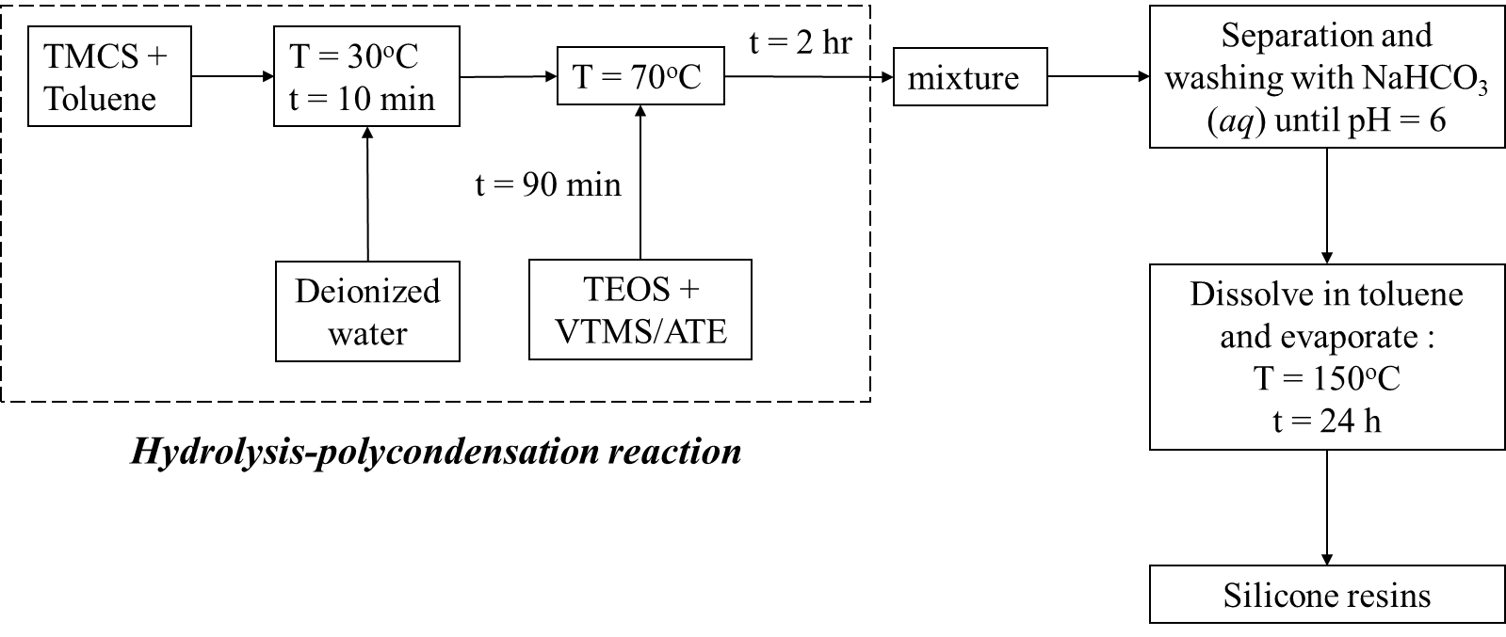

Figure 1. Schematic route of a hydrolysis-polycondensation method for silicone resin synthesis.

Table 2. Components and its quantities in the silicone resins synthesis.

**Preparations of elastomeric thermal pads from silicon Resins and h-BN**

The elastomeric thermal pads were formed with the thermoforming process, as shown in Figure 2. The silicone resin was dissolved in toluene with a weight ratio of resin: toluene is 10:1 before mixed with silicone rubber. The mixing process was performed under mechanical stirring with 1000 rpm for 3 min and held for 1 hour for the homogeneous mixture, then, the *h*-BN particle was incorporated into the mixture. After mixing process, the mixture was placed in a stainless steel mold and compression-molded at 90oC at pressure 1500 psi for 30 min in an electrically heated hot-press machine (Taiwan: GF-50, You Found Hydrolics Industrial Co. Ltd.). After the hot-press process, the specimen was put on a drying oven at 150oC for 6 h. Detail experimental conditions were listed in Table 3.

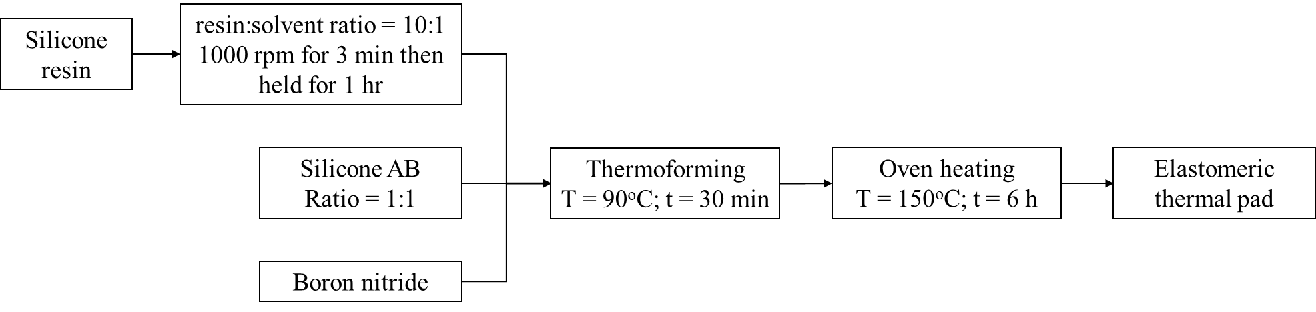

Figure 2. Schematic route of the thermoforming process to form thermal pads

## Characterization

The chemical structure analysis of silicone resins was characterized by Fourier Transform Infrared (FTIR) spectroscopy using an FTS-1000 Infrared Spectrometer (Bio-Rad Digilab) in the frequency range of 4000-600 cm-1 in transmittance mode. Specimen was prepared using potassium bromide (KBr) pellet method using weight ration of resin:KBr is 1:20. The molecular weight analysis of silicone resins was determined bu ACQUITY Advanced Polymer Chromatography (APC, Waters Co.Ltd.) using tetrahydrofuran as an eluent and polystryrene as standard. Crosslink density (*Ve*) was calculated based on ASTM D6814 standard. The Flory-Rehner equation for crosslink density: 32

 (1)

Where *Ve* is effective number of chains in a real network per unit volume, *Xl* is polymer-solvent interation parameter (0.845), *Vl* is molecular volume of solvent (106.54X10-3 L mol-1) and *Vr* is volume fraction of polymer in a swollen network in equilibrium with pure solvent. *Vr* is volume fraction of polymer in a swollen network in equilibrium with pure solvent is calculated as: 33,34

 (2)

where *wdry* is weight of dry rubber, *ρrubber* is rubber density, *wabsorbed* is weight of solvent absorbed by sample and *ρsolvent* is solvent density.Thermal stability of silicone rubber composite was performed with thermogravimetry analysis (TGA Q500, TA Instrument) in the range of 30 to 650oC with a heating rate of 10oC min-1 under nitrogen flow at 40 mL min-1.Heat resistance of material (Theat-resistance index) 18 can be determined using equation as follows:

 (3)

Thermal conductivity was performed with thermal conductivity analyzer (Hot Disk TPS 2500S) using transient plane source method, followed ISO 22007-2 standard. The mechanical properties were determined using a universal tensile tester (Chun Yen Testing Machines, CY-6040A) with weight loading of 500 kg and cross-head speed of 10 mm min-1, under ASTM D412 standard. The hardness was measured with a hardness tester durometer, shore A type (Teclock, GS-709). The morphology of silicone resin and fractography of silicone rubber composite were observed using scanning electron microscopy (SEM, JEOL JSM-6930LV). The samples were platinum coated to enhance its conductivity with an auto fine coater (JEOL JFC-1300) for 80 seconds. The density of composite was determined using ASTM D792 standard. The mass loss and volatile content was determined using ASTM E595 standard. The flame resistance was determined using UL-94 standard. The resistivity of composite was measured using resistivity meter based on ASTM D257.

**Results and Discussion**

### **Chemical structure analysis**

Silicone resins were successfully synthesized using hydrolysis-polycondensation method. Chemical structure analysis using FTIR was performed to validate the synthesis result. The FTIR results for Vi-MQT and Al-MQT were shown in Figure 3., and Figure 4., respectively. The broad peak at 3124 cm-1 indicates hydroxyl group from residual silanol bond (Si-OH) that prove the hydrolysis has occurred in the reaction. 35 The peak at 2962 and 2902 cm-1 indicate of asymmetric and symmetric stretching methyl group. 36 The peak at 1402 cm-1 is representative of the unsaturated methyl group on MQ resin structure.35 The sharp peak at 1086 cm-1 indicates Si-O-Si symmetric stretching in cyclic structures 36 represented as Q unit in resin, and peaks at 1256, 845 and 756 cm-1 are indicated as methyl group from silanol that represents of M unit.37,38

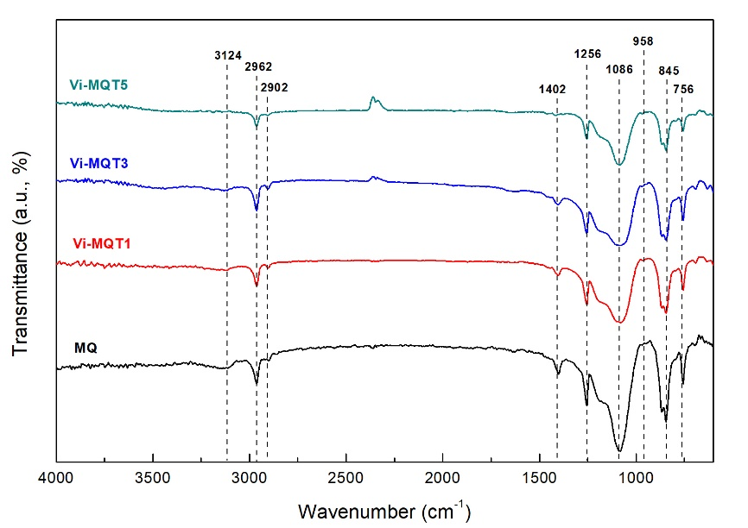

Figure 3. FTIR spectra of MQ resin and Vi-MQT resins.

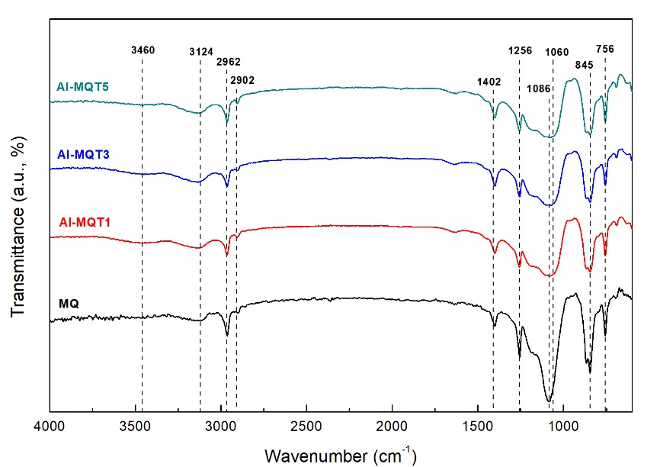

Figure 4. FTIR spectra of MQ resin and Al-MQT resins.

In Figure 4., it can be seen that small peak appeared at 958 cm-1 that refer to the out-of-plane C-H brand from the vinyl group. 35,39 This peak has small intensity due to the small addition of vinyl group in resin. Decreasing intensity trend of an unsaturated methyl group at 1402 cm-1 occurred with the addition of the vinyl group in resin structure. The vinyltrisilanol structure reacted with residual silanol group from siloxane prepolymer, compete simultaneously with trimethylsilanol. This phenomenon also causes the disappearance of the peak at 3124 cm-1 in highest vinyl content addition on the Vi-MQT resin. In Figure 5., it clearly is seen that new broad peak revealed at 3460 cm-1, indicated hydroxyl group that be expected from Al-OH. The peak at 1086 cm-1 also be widened due to new peak revealed at 1060 cm-1 that indicated asymmetric stretching Al-O-Si bond. 27 For a better understanding of the difference of MQ, Vi-MQT and Al-MQT structure, comparison of FTIR spectrum is shown in Figure 5. Based on the results, it can be concluded that the silicone resins synthesis has been successfully done.

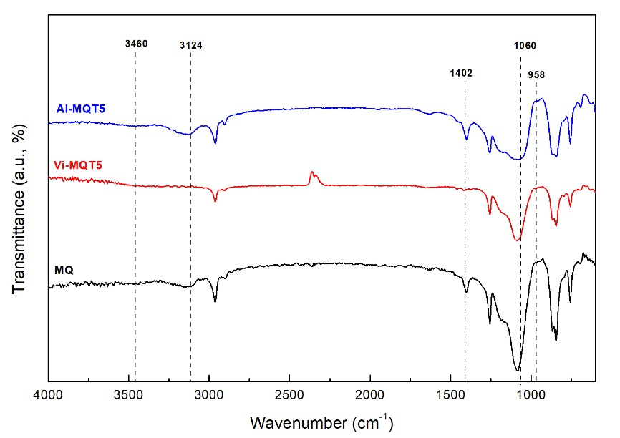

Figure 5. Spectrum comparison of silicone resins.

### **Molecular weight and morphology of silicone resins**

The molecular weight of silicone resins was listed in Table 4. The number average and weight average molecular weight of MQ resin, Mn and Mw, was 41301 g mol-1 and 47982 g mol-1, respectively, with narrow molecular weight distribution (PDI) as 1.161. For Vi-MQT and Al-MQT showed a similar decreasing trend of molecular weight with higher addition of T unit in their structure. 40 Addition of T unit in MQT structure decreases the Mn and Mw until 18906 and 28641 g mol-1, respectively, for Vi-MQT and 17497 and 27114 g mol-1, respectively, for Al-MQT. The decreasing trend of molecular weight was due to increasing of the end-capping unit in the synthesis reaction. An end-capped unit from M and T unit would react with silanol group from siloxane prepolymer, caused the propagating process was stopped and yielded a smaller size of the polymer. 36

Table 4. Physical appearance of silicone resins.

### **Structure of crosslinked network**

The composite was characterized its structure, thermal stability and mechanical properties. Incorporation of silicone resins would change the crosslinked network structure of silicone rubber. The effect of addition MQ resin on the crosslink density of silicone rubber is shown in Figure 6, and corresponding values are summarized in Table 5. From the results, it can be seen that the density of silicone rubber did not change significantly with the addition of MQ resin. The gel content, crosslink density (*Ve*) and a molecular weight between crosslinks (Mc) of silicone rubber were changed with the addition of MQ resin. Gel content and *Ve* reduced with the addition of MQ resin, while the Mc increased with the addition of MQ resin. The gel content of silicone rubber decreased from 97.77% to 77.19% and *Ve* also reduced from 1.787X 10-4 until 0.735X 10-4, while Mc enhanced from 5901 to 14622 g mol-1 with the addition of 30 phr MQ resin.

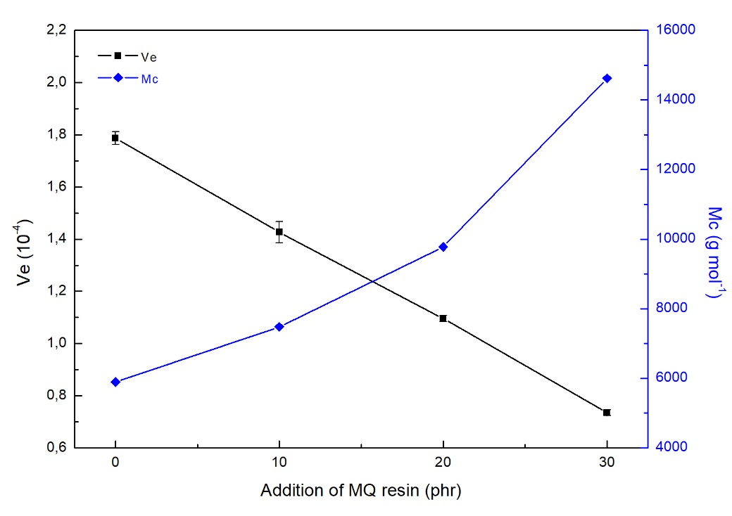

Figure 6. Crosslink density and molecular weight between crosslinking points of silicone rubber with addition of MQ resin.

**Table 5.** Network structure of silicone rubber with addition of MQ resin.

Addition of MQ resin to silicone rubber was replaced with Vi-MQT and Al-MQT resin to investigate its influence in the crosslinked network structure of silicone rubber, as shown in Figure 7., and summary of its value was listed in Table 6. The 10 phr of the silicone resin was chosen. Addition of Vi-MQT reduced the gel content and *Ve* of silicone rubber. Incorporation of Vi-MQT5 showed highest decline value of crosslink density of silicone rubber, even it has a lower value than the addition of 30 phr of MQ resin addition (0.642 X10-4 compared with 0.735 X10-4). For Al-MQT5 addition on silicone rubber showed similar the crosslink density property like MQ resin (1.418 X10-4 compared with 1.426 X10-4).

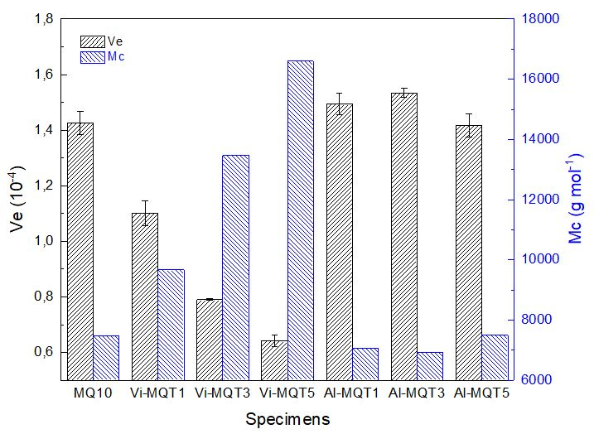

Figure 7. Crosslink density and molecular weight between crosslinking points of silicone rubber with addition of silicone resins.

Table 6. Network structure comparison of silicone rubber with silicone resin addition.

### **Thermal stability analysis**

Figure 8, showed the effect of MQ resin addition on thermal stability of silicone rubber and the important characteristic thermal degradation data were listed in Table 7. Increasing addition of MQ resin would decrease the characteristic thermal degradation of silicone rubber. The initial characteristic temperatures at 5% of weight loss decreased from 428.22oC for neat silicone rubber to 281.02oC for the addition of MQ resin up to 30 phr. However, at 30% of weight loss, the characteristic temperature of weight loss increased from 526.29oC for neat silicone rubber to 596.54oC for the addition of 20 phr and then slight decreased to 581.08oC for further addition (MQ-30). Temperature at 450-650oC is degradation of backbone structure region.36,41,42 In silicone rubber/*h*-BN composite system, the addition of *h*-BN in silicone rubber slightly increase its initial characteristic thermal degradation. However, with the addition of MQ resin in all composition, the thermal stability of the composite decreased. The initial characteristic degradation temperature at neat silicone rubber/*h*-BN composite is 429.56oC then decreased to 383.02, 329.31 and 294.12oC for addition of MQ resin from 10 until 30 phr. Temperature of maximum degradation rate increased with addition of MQ resin, from 507.85oC to 588.00, 584.24 and 572.94oC with addition of MQ resin from 10 to 30 phr, respectively. From the results, it can be concluded addition of MQ resin decreased thermal stability of silicone rubber/*h*-BN composite. Moreover, the residual yields of composites decreased with the addition of MQ resin to 38.39%, which were far lower than neat composite (64.75%).17

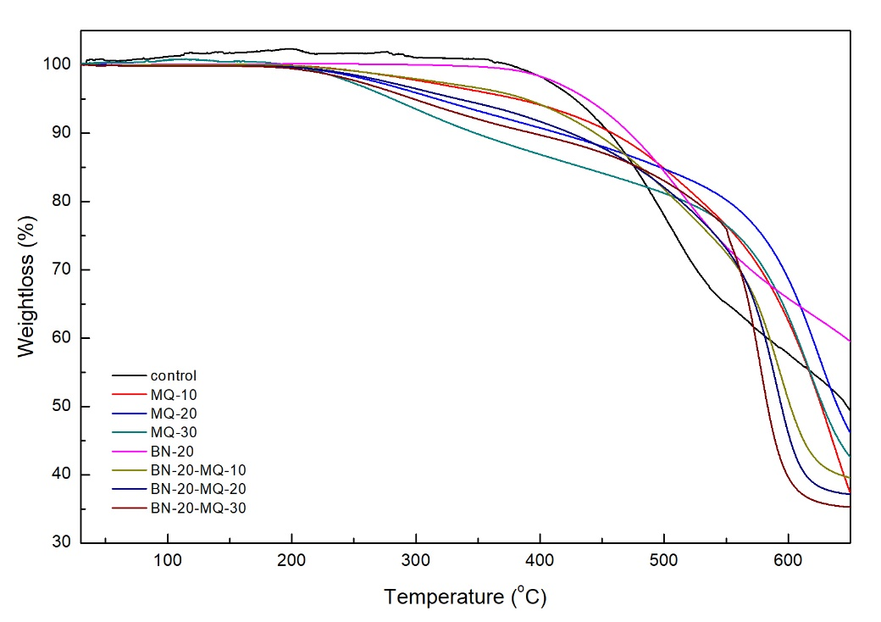

Figure 8. Thermal degradation of silicone rubber composites with addition of MQ resin in N2 atmosphere.

Table 7. Characteristic degradative data of composites with addition of MQ resin.

Addition of MQ resin to silicone rubber was replaced with Vi-MQT and Al-MQT resin to investigate its influence in the thermal stability of silicone rubber composites, as shown in Figure 9, and summary of its value was listed in Table 8. Addition of Vi-MQT resin to replace MQ resin improved the initial characteristic thermal degradation of silicone rubber. The initial characteristic temperatures at 5% of weight loss decreased from 373.84oC to 235.15, 388.88 and 381.08oC for the addition of Vi-MQT1, Vi-MQT3 and Vi-MQT5 silicone resin. For temperature at 30% of weight loss, the temperatures slightly decreased to 563.67oC at Vi-MQT1 addition from 578.04oC then increased to 590.43oC and 681.68oC for Vi-MQT3 and Vi-MQT5 addition. The corresponding heat-resistance index showed similar trend with T30, from 243.21oC of MQ resin addition to 239.24, 249.80 and 275.10oC for addition of Vi-MQT1, Vi-MQT3 and Vi-MQT5 resin, respectively.

The temperature at 30% of weight loss also decreased from 578.04oC of MQ resin addition to 573.65, 549.45 and 549.89oC for addition of Al-MQT1, Al-MQT3 and Al-MQT5 resin, respectively. The corresponding heat resistance index reduced from 243.21oC of MQ resin addition to 240.60, 233.18 and 228.93oC for addition of Al-MQT1, Al-MQT3 and Al-MQT5 resin, respectively, resulting lower thermal stability of silicone rubber. Based on the results, it can be concluded that vinyl-silicone resin effectively improved the thermal stability of silicone composite compared with MQ, aluminum-silicone resins and even neat silicone composite, with the best improvement with addition of Vi-MQT5 resin.

**Table 8.** Characteristic degradative data of composites with addition of Vi-MQT and Al-MQT resin

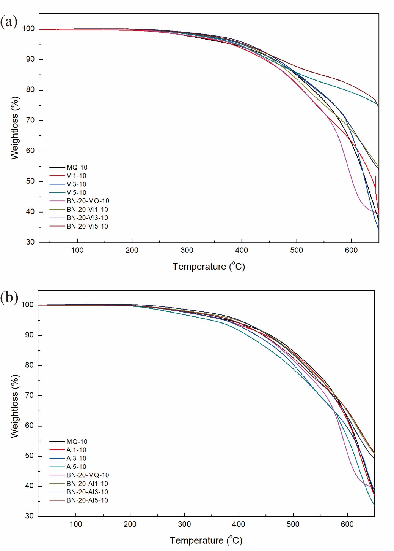

Figure 9. Thermal degradation of silicone rubber composites with addition of (a) Vi-MQT resin and (b) Al-MQT in N2 atmosphere.

### **Mechanical properties analysis**

The effect of addition MQ resin on mechanical properties of silicone rubber and silicone rubber/*h*-BN composite is shown in Figure 10. From the results, it can be seen that addition of MQ resin in both of silicone rubber and its composites significantly changed the mechanical properties. Addition of MQ resin in silicone rubber reduced the tensile strength and hardness but improved the elongation at break properties. 43 The tensile strength reduced from 2.099 MPa to 0.856 MPa on 30 phr of MQ resin addition.

Incorporation of an *h*-BN particle in silicone rubber also reduced the tensile strength of silicone rubber, from 2.099 MPa to 1.648 MPa, and elongation of silicone rubber, from 737% to 657%. Addition of 10 phr MQ resin slightly enhanced the tensile property, from 1.648 MPa to 1.659 MPa. Further addition of MQ resin (20 and 30 phr) even exceed the tensile value of the neat silicone rubber/*h*-BN composite, as shown in Figure 12 (a), however, its value is reduced compared with silicone composite with addition of 10 phr MQ resin. In composites, structure showed increment trends of elongation at break, due to the good interfacial reaction between filler and matrix. Addition of MQ resin also reduced the hardness properties both of silicone rubber and silicone rubber/*h*-BN composites.

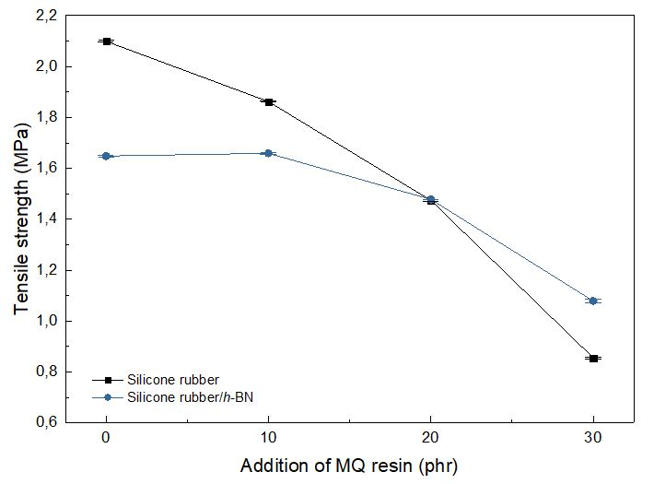

(a)

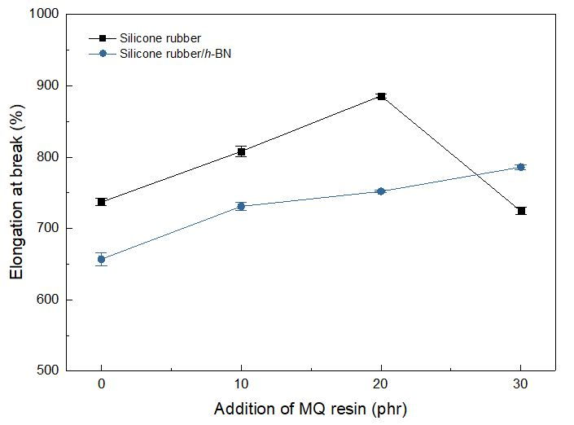

(b)

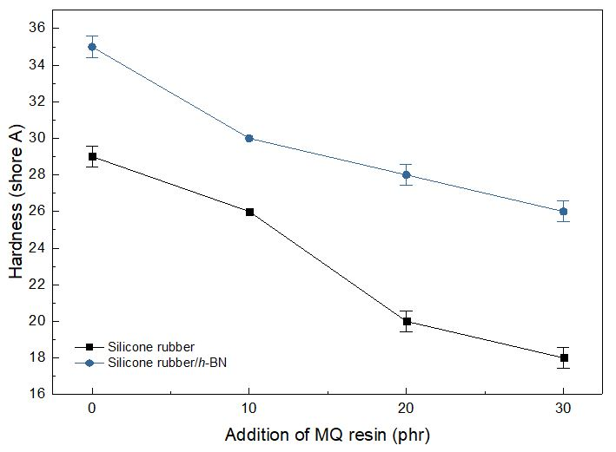

(c)

Figure 10. Mechanical properties of silicone rubber composites with addition of MQ resin; (a) tensile strength, (b) elongation at break and (c) hardness.

Addition of MQ resin to silicone rubber was replaced with Vi-MQT and Al-MQT resin to investigate its influence on the mechanical properties of silicone rubber and its composite with the *h*-BN particle, as shown in Figure 11.The 10 phr of the silicone resin was chosen. It can be seen that replacing MQ resin with Vi-MQT would reduced the tensile strength of silicone rubber, from 1.862 MPa to 1.823, 1.777 and 1.530 MPa for addition of Vi-MQT1, Vi-MQT3 and Vi-MQT5 resin, respectively. For addition Al-MQT in silicone rubber/*h*-BN composite, the best value was obtained by addition of Al-MQT3 with 1.711 MPa. The existence of hetero-metal bond promoted synergy effect that can be dispersed homogeneously in the oligosiloxane structure. 41 Addition of vinyl-silicone resin enhanced the elongation property, from 808% with MQ resin addition to 847, 877 and 987% for addition of Vi-MQT1, Vi-MQT3 and Vi-MQT5 resin, respectively. Addition of aluminum-silicone resin improved the elongation property, from 808% with MQ resin addition to 817, 870 and 867% for addition of Al-MQT1, Al-MQT3 and Al-MQT5 resin, respectively. In composite system, addition of vinyl-silicone resin gives better improvement on elongation at break property than aluminum-silicone resin. Addition of Vi-MQT5 resin could enhanced up to 1063% while addition of Al-MQT3 only showed 793 % elongation, compared with MQ resin addition at 731%. The hardness of silicone resin significantly reduced with the addition of Vi-MQT resin, but slightly enhanced with the addition of Al-MQT resin due to the existence of Al-O bond in the structure.

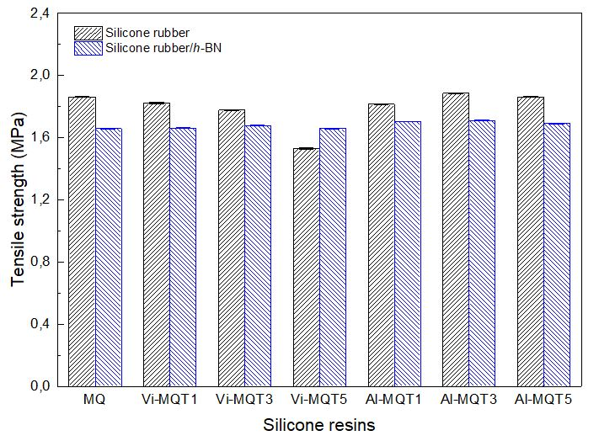

(a)

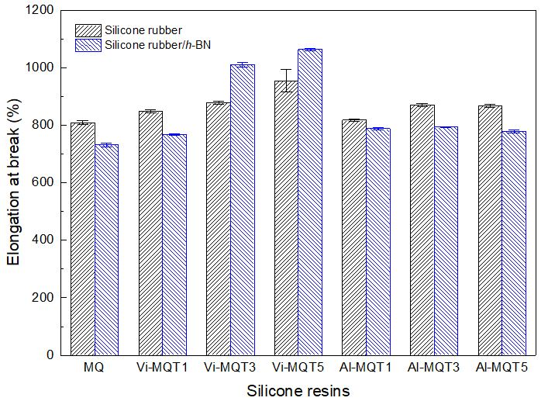

(b)

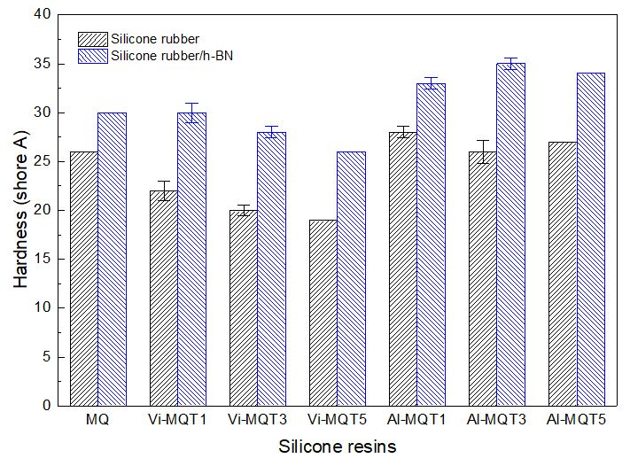

(c)

Figure 11. Mechanical properties of silicone rubber composites with addition of silicone resin; (a) tensile strength, (b) elongation at break and (c) hardness.

Evaluation Performance of Silicone Rubber Composite

The thermal conductivity will enhance significantly with the existence of high filler loadings. Addition of high filler does not only improve the thermal conductivity property of silicone rubber but also some properties will be affected, especially for its flexibility property. Based on the preliminary results, MQ, Vi-MQT3 and Al-MQT3 resin were chosen as a modifier of silicone rubber/*h*-BN to form a thermal pad. Addition of silicone resin was made constant, at 10 phr. *h*-BN filler concentration was increased up to 100 phr. The critical concentration for percolation of cubical particles in polymer matrices is known to be around 30% volume. The 100 phr filler concentration is higher than 30% volume, 14 caused the silicone rubber matrix was saturated, prevent it for being filled. The thermal pad was evaluated its performance based on the target value of this study, as shown in Table 1.

### **Thermal conductivity**

The thermal conductivity property of thermal pads is shown in Figure 12. It can be seen that the thermal conductivity of composite enhanced with higher addition of filler loading. The thermal conductivity of composite improved from 0.213 W m-1 K-1 in neat silicone rubber to 3.253 W m-1 K-1 with the addition of 100 phr of the *h*-BN particle, resulting 1427% enhancement of thermal conductivity. Addition of 20 phr particle only resulted in 0.501 W m-1 K-1 of thermal conductivity (135% enhancement). Addition of silicone resin improved the thermal conductivity of silicone rubber composite. In neat silicone rubber, the addition of silicone resin reduced its thermal conductivity, from 0.213 W m-1 K-1 to 0.189, 0.174 and 0.199 W m-1 K-1 with the addition of MQ, Vi-MQT3 and Al-MQT3 resin, respectively. Addition of low *h*-BN content (20 phr) resulting in a similar trend with the former result. The existence of silicone resin in the structure of silicone rubber will enhance the free volume and reduce the covalent bond which is a very important aspect for thermal conduction mechanism in the polymer material. Further addition of *h*-BN particle yielded higher thermal conductivity on the composite with silicone resin compared with the pristine one. The thermal conductivity improved from 3.253 W m-1 K-1 at composite without silicone resin addition to 3.611, 3.962 and 4.817 W m-1 K-1 at composite with the addition of MQ, Vi-MQT3 and Al-MQT3 resin, respectively, at 100 phr filler concentration. The best improvement of thermal conductivity was achieved by silicone composite with Al-MQT3 resin. Higher thermal conductivity on silicone rubber composite with Al-MQT3 resin was due to synergistic effect of *h*-BN filler with silicon and aluminum atom in silicone resin structure. 44

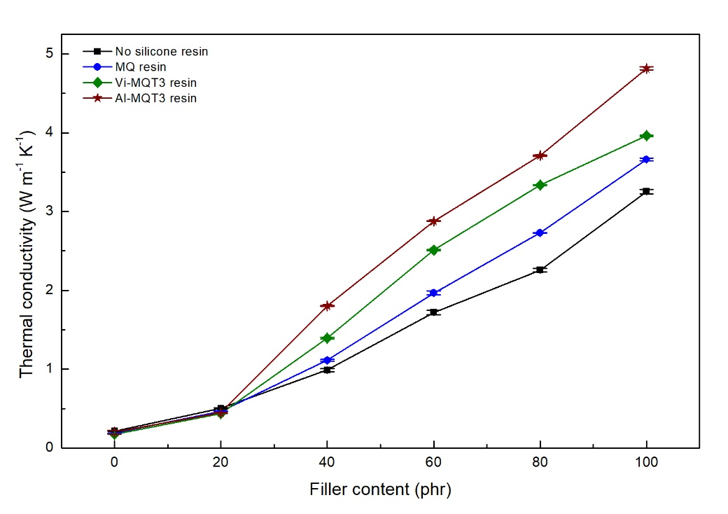

Figure 12. Thermal conductivity of silicone rubber composites.

Mechanical properties

The mechanical properties of thermal pads were shown in Figure 13. The tensile strength of silicone rubber decreased with the addition of *h*-BN particle, from 2.099 MPa of neat silicone rubber to 1.248 MPa with the addition of 100 phr particles. This is typical for composites with poor interfacial interaction. 13 In high filler loading, an incomplete dispersion of filler occurred and more defects were formed.18 Therefore the tensile strength of silicone rubber/*h*-BN composites was decreased. However in a composite system, composite with silicone resin showed better tensile strength, as shown in Figure 15 (a). In high filler loadings (100 phr), the tensile strength of composite improved to 1.274, 1.290 and 1.312 MPa for the addition of MQ, Vi-MQT3 and Al-MQT3 resin, respectively. The elongation of silicone rubber decreased with the addition of high *h*-BN loadings, from 737% of neat silicone rubber to 22% of silicone rubber with 100 phr *h*-BN particle. This behaviour is generally explained as the effect in the lack of matrix/filler adhesion and poor filler distribution in the matrix. 45 The hardness property increased with the addition of high *h*-BN filler loadings, from 29 shore A of neat silicone rubber to 75 shore A of silicone rubber with 100 phr *h*-BN particle. Addition of silicone resin slightly reduced the hardness of silicone rubber composites. In high filler loadings, the hardness property reduces to 69, 71 and 72 shore A for the addition of MQ, Vi-MQT3 and Al-MQT3 resin, respectively. Addition of MQ resin resulted in lowest hardness property of silicone rubber composites.

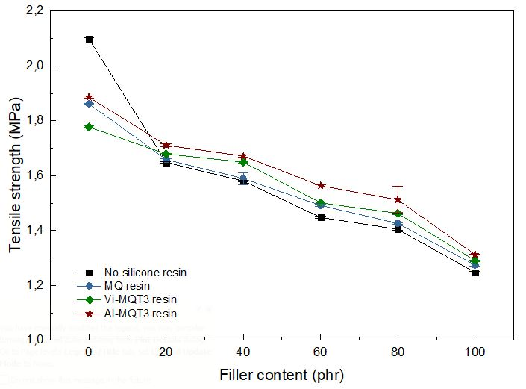

(a)

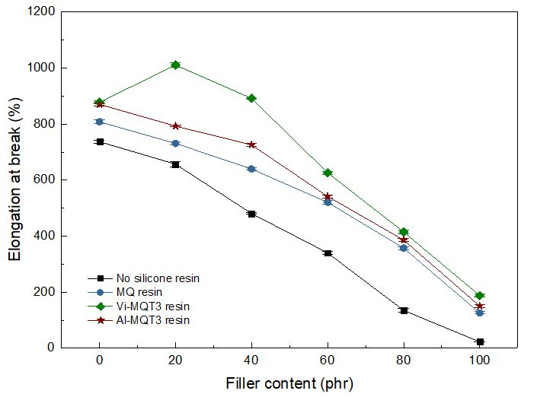

(b)

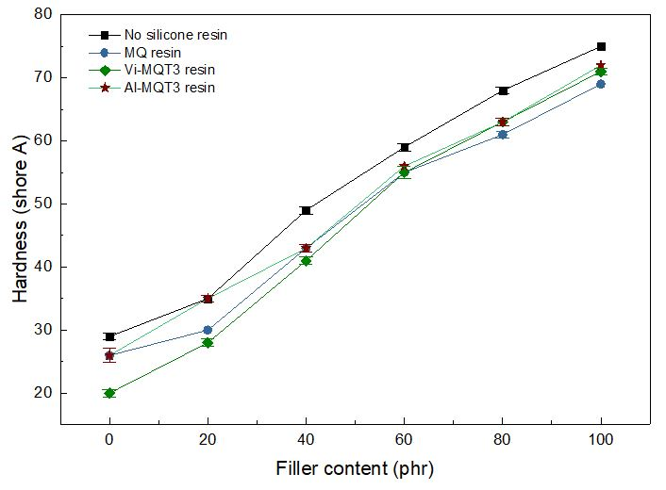

(c)

Figure 13. The mechanical properties of silicone rubber composites; (a) tensile strength, (b) elongation at break and (c) hardness.

**Density of Thermal Pads**

The density property of thermal pads are shown in Figure 14. It can be seen that the addition of *h*-BN particle increased the density of silicone rubber. The density increased from 1.054 g cm-3 at neat silicone rubber to 1.418 g cm-3 with the addition of 100 phr *h*-BN particle. This phenomenon naturally occurs due to differences in density between the silicone rubber and *h*-BN filler. High filler loading will increase the density of composites. Addition of silicone resin slightly decreased the density of composite to 1.405, 1.407 and 1.411 g cm-3 for the addition of MQ, Vi-MQT3 and Al-MQT3 resin, respectively.

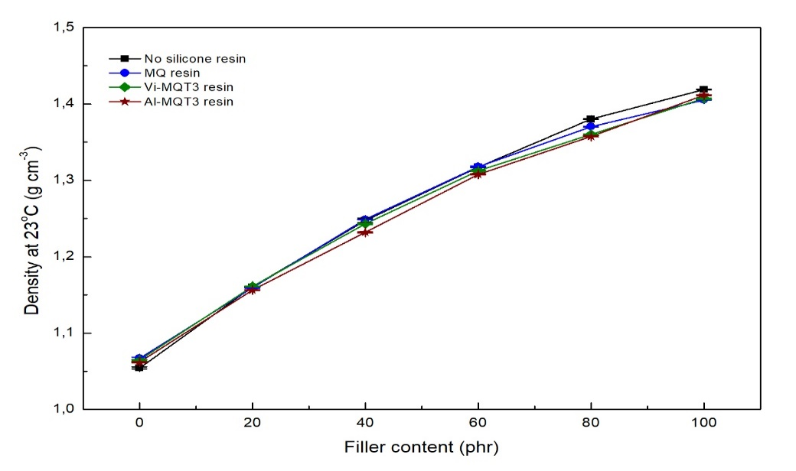

Figure 14. Density of silicone rubber composites.

**Volatile Content of Composite**

The volatile content of thermal pads are shown in Figure 15. It can be seen that the volatile content of silicone rubber reduced with the addition of *h*-BN filler, from 0.963% of neat silicone rubber to 0.152% of addition of 100 phr filler content. Addition of silicone resin in the structure of composite increased the volatile content at 100 phr filler addition to 0.196, 0.699 and 0.214% for MQ, Vi-MQT3 and Al-MQT3 resin, respectively. Increasing of volatile content was due to the lower crosslink density of silicone rubber compared with neat silicone rubber.

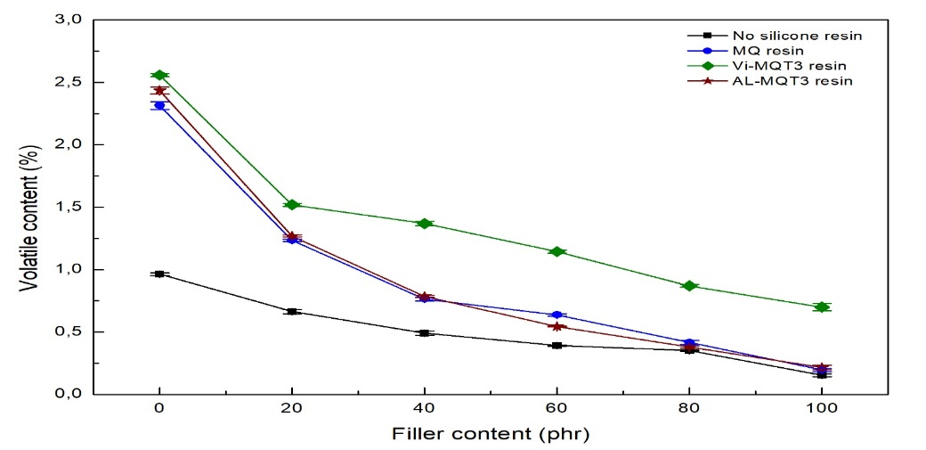

Figure 15. Volatile content of silicone rubber composites.

**Flame Resistance of Composite**

The flame resistance category of silicone rubber composites was listed in Table 9. It can be seen that silicone rubber considerably flammable, both in neat silicone rubber and silicone rubber modified with silicone resins. Once being ignited, silicone rubber burns rapidly and release a large amount of heat [46]. Addition of flame retardant material can enhance its flame resistance. *h*-BN can be introduced into silicone rubber to enhance its flame resistance property. Based on the result, satisfying flame resistance of silicone rubber can be achieved with the addition of more than 80 phr of the *h*-BN particle. Addition of silicon resin did not give significant influence to flame retardancy property.

Table 9. Results of flame retardancy test of silicone rubber composites.

**Volume Resistivity of composites**

The volume resistivity of silicone rubber composites was listed in Table 10. It can be seen that composites with high addition of filler loading enhanced its volume resistivity, from >1013 to >1011 Ω cm at 100 phr of *h*-BN. The existence of impurities and defects in the structure also can enhance the volume resistivity of composite [47]. Addition of silicone resin did not give significant effect to volume resistivity property.

**Table 10.** Results of volume resistivity test of silicone rubber composites.

### **Performance evaluation**

From the earlier discussions, the performance evaluation of silicone rubber composite is shown in Table 11. It can be observed that silicone rubber/*h*-BN composites possess good thermal conductivity, mechanical properties and other properties. The density of composite with silicone resin showed a slight reduction compared with the neat composite. The density value for all of samples was lower than the predetermined limit. The tensile strength of silicone composite was exceeds the expected value and improve with the addition of silicone resin, the best improvement was achieved by addition of Al-MQT3 resin. Silicone composite without silicone resin showed low elongation at break, only 22%, as expected from poor compatibility between the silicone rubber and *h*-BN particle. Addition of silicone resin successfully enhanced its flexibility more than doubled, with the best improvement was achieved by addition of Vi-MQT3 resin. The hardness of silicone composite achieved the maximum predetermined value and the addition of silicone resin slightly reduced the hardness with the best reduction by addition of MQ resin. The thermal conductivity of composite achieved the predetermined value and improve with the addition of silicone resin with the best improvement by addition of Al-MQT3 resin. The volatile content of silicone resin enhanced with addition of silicone resin due to the lower crosslink density, however the value still below than the predetermined limit. The flame retardancy and volume resistivity properties did not change significantly with the addition of silicone resin and its value still on a safe level. Based on the results, It can be concluded that addition of silicone resin enhanced the properties of silicone composite and satisfy all of predetermined target value in this research.

Table 11. Performance evaluation of silicone rubber composite modified by silicone resin

**Morphology of composites**

The morphology of neat silicone rubber and silicone composite is shown in Figure 16. It can be seen in Figure 16. (a), the morphology of neat silicone rubber is plain and smooth. Addition of 20 phr of *h*-BN, as shown in Figure 16. (b), the filler did not spread homogeneously, tend to form agglomerates. This phenomenon was due to poor compability between filler and matrix. Further addition of *h*-BN, as shown in Figure 16. (c), the silicone composite showed rough surface due to the existence of filler agglomerates and some void was formed among the agglomerates. This condition leads to reduction of some properties, especially mechanical properties.

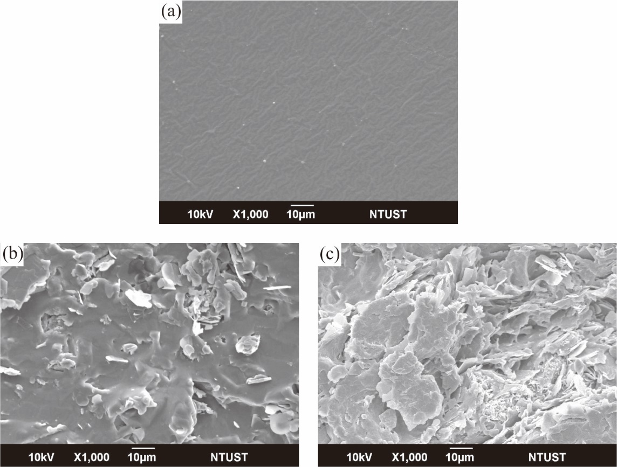

Figure 16. Fracture morphology of (a) neat silicone rubber, and silicone composite with (b) 20 phr and (c) 100 phr of filler addition.

The comparison of fracture surface morphology of silicone composite with 100 phr of *h*-BN filler is shown in Figure 17. Analysis of these images reveals that agglomeration of *h*-BN filler and void generated when the filler peeled off. In Figure 17. (a), it can be seen that the composite has many defects and void, indicating poor compatibility between filler and matrix.47 Matrix cannot be binding filler well, resulting in the interfacial phase filled with air and yield poor composite properties. The existence of air inside the composite would enhance the thermal resistance of the material, resulting in ineffective of the heat transfer process. Addition of silicone resin, as shown in Figure 17. (b-d), showed better morphology than a pristine one. Silicone resin acts as a bridge and enhance the adhesion property of silicone rubber, resulting in better compatibility between filler and matrix. Better compatibility will enhance its filler distribution and improved some properties of the composite, especially for mechanical properties. The high level of filler distribution is not always resulting in high thermal conductivity. In Figure (c), it has the best filler distribution and no filler agglomeration was formed. Compared with Figure (c), the addition of aluminum-silicone resin as shown in Figure (d) showed filler distribution is not too good, however, its thermal conductivity was highest among the others. Regardless of the synergistic effect as mentioned before, the high level of filler distribution will enhance the interfacial interaction between filler and matrix, lead to increase of thermal contact resistance. The effective way of heat transfer is from filler-to-filler. It other words, filler agglomerations is needed to accelerate the heat transfer process. Based on the morphology results, Figure 17. (d) has some filler agglomerations with sufficient filler distribution, resulting higher thermal conductivity.

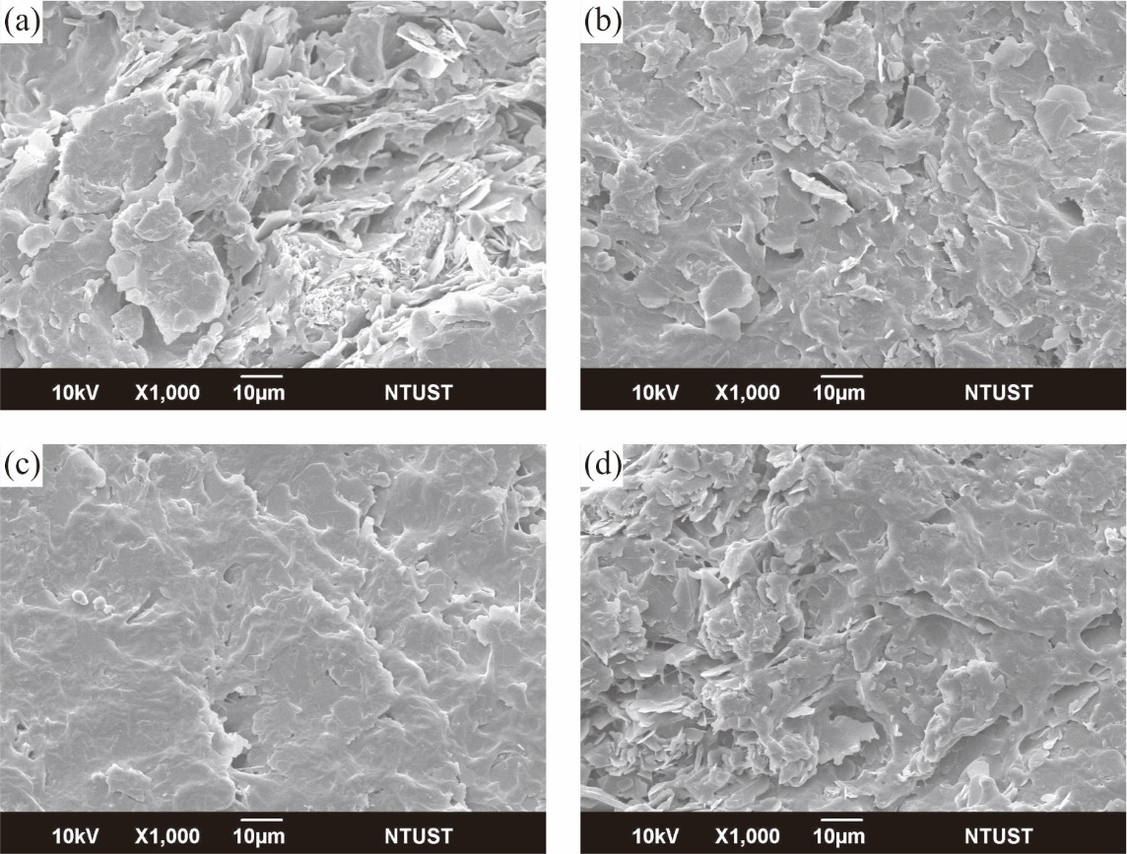

Figure 17. Fracture morphology comparison of (a) neat silicone composite and silicone composite with addition of (b) MQ, (c) Vi-MQT3 and (d) Al-MQT3 resin

# **Conclusions**

The silicone resin was synthesized using hydrolysis-polycondensation method as a modifier for silicone rubber/*h*-BN composites. Three kinds of silicone resin have been obtained i.e., MQ resin, vinyl-silicone resin (Vi-MQT resin) and aluminum-silicone resin (Al-MQT resin). Addition of vinyl- and aluminum-bond as functional unit reduced the molecular weight of MQ resin due to shorter propagation process . The thermal stability of Vi-MQT and Al-MQT resin was higher than MQ resin due to higher bond dissociation energy, except Al-MQT5 resin. Both of Vi-MQT and Al-MQT resin yielded higher residue content than MQ resin. Addition of MQ unit only improved the thermal stability of composite when the concentration is 10 phr. Addition of Vi-MQT and Al-MQT resin enhanced the thermal stability due to crosslinking reaction and by hetero-metal synergistic effect in silicone resin structure respectively. When it applied on the composite system, silicone composite with Vi-MQT resin showed higher thermal stability. Enhancement on the characteristic temperatures at maximum degradation of silicone composite with the addition of silicone resin indicated stronger interaction between the silicone rubber and particles with the addition of silicone resins. Increasing filler concentration of *h*-BN up to 100 phr enhanced the thermal conductivity and hardness composite up to 3.253 W m-1 K-1 and 75 shore A but reduced the tensile strength to 1.248 MPa and elongation 22% respectively. Addition of silicone resin improved the thermal conductivity of composites, up to 3.661, 3.962 and 4.817 W m-1 K-1 for MQ, Vi-MQT3 and Al-MQT3 resin, respectively. The tensile strength improved up to 1.274, 1.290 and 1.312 MPa for MQ, Vi-MQT3 and Al-MQT3 resin, elongation at break increased to 125, 188 and 150% , and hardness 69, 71 and 72 shore A with the addition of MQ, Vi-MQT3 and Al-MQT3 resin, respectively. The volatile content of composite increased from 0.152% of the neat composite to 0.196, 0.699 and 0.214% for MQ, Vi-MQT3 and Al-MQT3 resin, respectively. The density, flame resistance and volume resistivity can change with the addition of silicone resins. Addition of silicone resin slightly decreased the density of composite to 1.405, 1.407 and 1.411 g cm-3 for the addition of MQ, Vi-MQT3 and Al-MQT3 resin, respectively. Addition of silicone resin in the structure of composite increased the volatile content at 100 phr filler addition to 0.196, 0.699 and 0.214% for MQ, Vi-MQT3 and Al-MQT3 resin. *h*-BN can be introduced into silicone rubber to enhance its flame resistance property. It can be seen that composites with high addition of filler loading enhanced its volume resistivity, from >1013 to >1011 Ω cm at 100 phr of *h*-BN. In the future, the results can be used as a breakthrough for developing new composite material as elastomeric application and attract an interest of the industrial communities for large-scale production.