**Hybrid Sol-Gel-Derived Method for the Synthesis of Silicon Rubber Composites with h-BN for Characteristic Applications in Elastomeric Thermal Pads**

Abstract

Elastomeric thermal pads are materials that are used to support heat sinks for effective and efficient heat dissipation. These pads contain rubber and a thermally-conductive filler. Rubber is responsible for their flexibility while the filler’s role is to efficiently dissipate heat. In this study, two different types of silicone resin (MQ), Vi-MQT and Al-MQT, were synthesized by the hydrolysis-polycondensation method and introduced in a silicone rubber/boron nitride (*h*-BN) composite to enhance the thermal conductivity of the material while retaining acceptable flexibility properties. Introduction of the MQ resin reduced crosslink density, thermal stability, tensile strength and hardness of the silicone resin composite while it improved elongation. Replacing the MQ resin with Vi-MQT and Al-MQT resins improved the silicone rubber’s properties. The addition of Vi-MQT resin reduced crosslink density, tensile strength and hardness and improved its elongation and thermal stability properties. While Al-MQT resin did not have significant effect on crosslink density, tensile strength or hardness, it also improved elongation and reduced thermal stability. High filler concentration of *h*-BN in the composite enhanced thermal conductivity up to 3.253 W m-1 K-1, while it reduced tensile strength to 1.248 MPa and elongation to 22% but increased hardness up to 75 shore A. Addition of silicone resin improved the thermal conductivity of all MQ, Vi-MQT3 and Al-MQT3 resin composites up to 3.661, 3.962 and 4.817 W m-1 K-1, respectively. For the same three resins, tensile strength was increased up to 1.274, 1.290 and 1.312 Mpa, elongation at break raised to 125, 188 and 150% and hardness reduced to 69, 71 and 72 shore A. respectively. The addition of silicone resin also showed an effect on density, volatile content, flame resistance and volume resistivity.

Introduction

Thermal management is a crucial aspect of microelectronic design, as it is a challenge to efficiently dissipate heat from heat source to the ambient. Generally, the heat generated by the device is transferred to a heat sink by heat conduction.1-3 However, the utilization of heat sinks for heat transfer is made problematic by the existence of small surface irregularities between the device and heat sink surfaces. Elastomeric thermal pads, made of a thermally conductive rubber consisting of rubber/polymeric elastomer material mixed with thermally conductive inorganic filler, are one way adopted to approach this problem. A popular matrix used for such thermal pads is silicone rubber, an elastomer (rubber-like material) composed of siloxane (a functional group consisting of alternate silicon and oxygen atoms, -Si-O- on a backbone chain with substituents branching from the silicon atom.)4,5 The thermal conductivity of silicone rubber alone, being about 0.2 W m-1 K-1, 6-9, cannot satisfy the requirement of a thermal conductive application. However, addition of an inorganic filler can provide a thermally conductive path, which is a very important requirement for effective heat transfer. Ceramic fillers, like oxides and nitrides, are widely used as inorganic filler for elastomer thermal pads. Nitride-based fillers, such as aluminum nitride (AlN) and boron nitride (BN), have attracted much attention for their use in thermal pads due to their higher thermal conductivity and electrical resistivity compared with other ceramic-based fillers, making them a suitable filler for thermal dissipation materials.10-12

Research has been conducted to investigate the performance of silicone rubber/boron nitride composites. Kemaloglu et al. 13 studied the properties of thermally conductive micro- and nanosize BN reinforced silicone rubber composites. The addition of BN to the silicone rubber decreased the tensile strength and the strain at break of the composites regardless of BN type due to poor interfacial interaction, while the nanosize filler showed better performance than the microsize. The hardness of the composites with the nanosize filler also increased more than with the microsize. The thermal conductivity of the microsize composite was higher than the nanosize, probably due to the lower aspect ratio of the nanosize filler. Ha et al.14 also worked to enhance the thermal conductivity of PDMS, incorporating BN as a thermally conductive filler. The thermal conductivity of the PDMS composite increased from 0.2219 W m-1 K-1 to 1.5971 W m-1 K-1 with the addition of 100 phr of BN filler, for an approximately 700% thermal conductivity enhancement. The tensile strength of the composite also increased from 0.418 MPa to 2.827 MPa with the addition of 100 phr of filler. Elongation increased 19% to 37.3% on addition of 50 phr, but for the addition of 100 phr, it only increased to 30.0%, 7.3% less than the figure for the addition of 50 phr. Shi et al.15 improved the elongation of poly(L-lactide) (PLLA) with the addition of MQ resin without sacrificing its tensile strength. MQ resins dissolve well in PDMS, making their use possible as a universal modifier for silicone elastomers. Robinson et al.16 investigated the influence of BN on the network structure and properties of PDMS composite materials. The tensile modulus of the composites increased from 0.16 MPa to 8.53 MPa on a 0.5 BN filler weight fraction and thermal conductivity increased up to 0.84 W m-1 K-1. Chen et al.17 investigated the influence of MQ resins on the performance of PDMS composites with nano-silica sol. They obtained an extradinary enhancement of elongation at break of around 10 times and other tensile properties also increased with the addition of MQ resin. Gu et al.18 successfully synthesized the polymethyl-vinyl siloxane rubber (VMQ) composite with *h*-BN to obtain high thermally conductive rubber. They presented a strong argument for their use, showing that the addition of *h*-BN filler to such composites increased their thermal conductivity from 0.179 W m-1 K-1 for neat VMQ rubber to 1.110 W m-1 K-1 on addition of 40% weight filler, a figure which is 6 times larger than that for neat VMQ rubber. Tensile strength also increased from 0.28 MPa to 3.31 MPa with the addition of 20% filler by weight but then decreased from 3.31MPa to 1.75 Mpa for the addition of 40%. This phenomenon was due to the incomplete dispersion of *h*-BN filler and more defects being formed. Fang et al.19 combined BN foam (BNF) and BN nanosheets (BNNS) with PDMS and investigated their effect on the thermal, mechanical and dielectric properties of the composites. They obtained thermal conductivity increases for the BNNS/PDMS composite from 0.21 W m-1 K-1 for neat PDMS to 0.36 W m-1 K-1 for a 10% addition by weight of BNNS and for the BNNS/BNF/PDMS one to 0.56 W m-1 K-1 for the same percentage addition of BNNS/BNF, both enhancements of thermal conductivity. The tensile strength and Young’s modulus of the BNNS/BNF/PDMS composite also increased from 1.41 MPa to 1.65 MPa and from 0.99 MPa to 1.32 MPa, respectively. The breakdown strength of the BNNS composite rose from 16.8 MV m-1 to 21.8 MV m-1 for the same loading, indicating good insulation properties.

Liang et al.20 conducted a study of the hybridization of reduced graphene oxide (RGO) with MQ silicone resin to enhance the thermal conductivity and mechanical performance of the silicone rubber composite. They obtained improvement of shore A hardness, tensile strength and elongation at break of 254%, 528% and 327% with 20% by-weight additions of RGO/MQ filler, compared with neat silicone rubber, respectively. Thermal conductivity for the RGO/MQ filler was significantly higher than for the RGO filler at 0.51 W m-1 K-1 for the former for a 25% addition by weight, as compared with the 0.27 W m-1 K-1 for the latter for the same concentration. Kuo et al.21’s use of heatsinks combined with elastomeric thermal pads is a general solution for heat dissipation. Silicone rubber composites in such pads exhibit excellent thermal conductivity with the incorporation of boron nitride (BN) as a filler. In the study, TEOS was doped onto the surface of hydroxyl-functionalized BN using a simple sol–gel process for surface modification. The thermal conductivity and surface modification of the composites improved 16.52% on BN filler addition up to 45 wt%. The addition of TEOS not only improved the filler dispersion in the composite system but also reduced the interfacial mismatch between the BN and silicone rubber. The tensile strength and hardness increased on addition of the BN filler, but elongation at the break decreased with high filler loadings. Kuo et al.22 synthesized similar silicone thermal pads using the Taguchi method and concluded that the optimum experimental combination was BNNSs with lamella thickness (B24), a BNNS loading level of 20wt%, and an Al2O3 loading level of 60 wt%. The thermal conductivity, tensile strength and Shore hardness of the silicone thermal pads, which were prepared by thermosetting, were 5.25 W/mK, 7.55 kg/cm2 and 65.2 (Shore A), respectively. Their thermal conductivity and tensile strength were 34.48% and 20.26% higher than those of commercially available silicone thermal pads, respectively. A controlling factor influencing the thermal conductivity and tensile strength of the silicone thermal pads was the BNNS loading level, with contribution degrees of 34.66% and 50.13%, respectively. Kuo et al.23 synthesized a nano-size particle as a thermally conductive filler for a silicone thermal pad (STP) by exfoliating hexagonal-boron nitride (h-BN) with the chemical exfoliation-free radical polymerization method to produce boron nitride nano-sheets (BNNSs). As the free radical polymerization reaction time increased, the interlayer distance of BNNSs lengthened to 0.35 nm, while the thickness of the h-BN sheets decreased.

Elastic thermal pads can provide good thermal conductivity without the difficulty associated with thermal grease, as managing these materials is easier than thermal grease. Elastomeric thermal pads are themselves a logical extension of thermal grease: cured conductive paste in the form of a pad, compressible to within 25% of their total thickness to conform to irregular surfaces, and competing with the flowability of their semi-fluid rival 24. Solving the main issue of the poor flexibility of silicone rubber composites with an inorganic particle promises to make the existence of silicone resin an attractive solution to obtaining high thermally conductive rubber without sacrificing flexibility. Silicone resin modified with some functional group to enhance the reinforcing effect of the silicone rubber/*h*-BN composite would appear to be the way ahead.

Boron nitride (BN) consists of boron (B) and nitrogen (N) atoms, covalently bonded in a honeycomb configuration, as a layered structure. The most investigated structure is *c*-BN and *h*-BN. The *c*-BN has sp3 atomic bonding, while the *h*-BN has characteristic sp2 atomic bonding.11,25,26 *h*-BN is the most stable under standard conditions and is an sp2-hybridized two dimension-layered insulator. *h*-BN has various properties, such as excellent lubricant properties, anisotropy parallel and perpendicular to a basal plane, constant wide band gap ranging from 5.5 to 6.4 eV, superior anti-oxidative and structural stabilities, chemical inertness, non toxicity and environmental safety, high thermal conductivity (600 Wm-1K-1 for the in-plane direction, 30Wm-1K-1 for the out-of-plane direction) and a superior thermal expansion coefficient, as well as superior mechanical properties.10-12 These characteristics render *h*-BN as an excellent material for fillers in composites that are thermally conductive but also electrically insulating. Despite these exceptional properties and potential for widespread application, the practical applications of *h*-BN are highly restricted by their high surface energy and a strong tendency to agglomerate, causing problems with dispersion and interfacial quality.10 These two factors are well known as the most critical as far as the properties and functionalities of polymer composites are concerned.

In recent years, sol-gel materials have been widely applied to improve the mechanical properties and thermal stability of silicone rubber and other composites.27 As a sol-gel material, silicone resin is useful as a reinforcing constituent in some applications because of its silica content and particle-like physical structure. Silicone resins types often called MQ resins are tridimensional highly branched silicon-based macromolecules consisting of different functional siloxane units.27-29 Introducing various functional groups in the chemical structure is used to provide some specific functionality. MQ resins immediately dissolve in a hydrocarbon solvent and in PDMS. This key feature makes it possible to use them widely in compositions with PDMS as reinforcing additives and fillers, and curing catalysts and crosslinking agents developing composite materials. It has been argued that MQ resins are an almost universally-applicable modifier for silicone polymers that improve the properties of all formulations. 27

In this study, silicone resins were synthesized using the sol-gel process and different forms of silicone rubber reinforced *h*-BN filler composite created to investigate the influence of silicone resin additions on the physical, mechanical, thermal stability, density, volatile content and flame resistance properties of the silicone rubber/*h*-BN composites. Comparing these properties, the performance of new silicone rubbers as elastic thermal pads can be evaluated.

**Table 1**. Target values of this research

|  |  |  |
| --- | --- | --- |
| Property | Standard | Target Value |
| Density at 23oC (g cm-3) | ASTM D792 | < 2.0 |
| Tensile strength (MPa) | ASTM D412 | > 1.0 |
| Elongation at break (%) | ASTM D412 | > 100 |
| Hardness (shore A) | ASTM D2240 | < 75 |
| Thermal conductivity (W m-1 K-1) | ISO 22007 | > 3.0 |
| Volatile content | ASTM E595 | < 1.0 |
| Flame resistance | UL 94 | V-0 |
| Volume Resistivity (Ω cm) | ASTM D 257 | > 1010 |

# Materials and methods

## Materials

We used the following chemicals to synthesize the silicone resins-hBN composites; Tetraethoxysilane (TEOS, 98%, Acros Organic Co.Ltd., Germany), Trimethylchlorosilane (TMCS, 98%, Acros Organic Co.Ltd., Germany), Aluminum ethoxide (ATE, >98% Tokyo Chemical Industry Co., Japan), Vinyltrimethoxylsilane (VTMS, OFS-6300, Ya-Hu-Chi Industrial Co., Taiwan), and. TMCS as M unit, TEOS as Q unit, VTMS as T unit. Two-system silicone rubber (KET-1001-10 A/B, Shin Etsu Co. Ltd., Taiwan), Toluene, industrial grade solvent (Trans Chief Chemical Industry Co. Ltd., Taiwan.) Tetrahydrofuran (THF, 99% HPLC grade, Duksan Pure Chemicals Co., South Korea.), Sodium bicarbonate (NaHCO3, Church & Dwight Co., USA.) was used as a neutralizing agent. Hexagonal boron nitride (*h*-BN, U Materials Co.Ltd., Taiwan).

**Experimental Design**

This study was divided into two steps, i.a., preparation of silicone resins and preparation of elastomeric thermal pads. The first step was synthesized silicone resin with functional monomers. Then, silicone resins along with silicone rubber and the *h*-BN particle were compounded on two-roll mixing mill machine, and thermoformed to form a thermal pad.

**Preparation of silicone resins**

The silicone resins were synthesized using the hydrolysis-polycondensation method. TMCS was used as M unit, TEOS was used as a Q unit, and VTMS and ATE were used as T unit. The [M]/[Q+T] molar ratio of 0.8 that was used was based on a previous study. 30,31 The concentration of the T unit varied between 1, 3 and 5% of TEOS weight. The synthesis of MQ resin proceeded as follows: a mixture of TMCS and toluene was added into a three-necked flask and the temperature was held constant at 30oC. An appropriate amount of deionized water was added to the mixture for 10 min and then heated up to 70oC. An amount of TEOS, VTMS and/or ATE were dripped (90 min) into the flask and held for 2 hr. After cooling to room temperature, the mixture was separated from the organic solution and washed repeatedly with a NaHCO3 solution until pH reached 6. Then, the mixture was dissolved in toluene and evaporated at 150oC for 24 h to remove the solvent and unreacted monomer. Details of the synthesis process are shown in Figure 1., and experimental details are shown in Table 2.

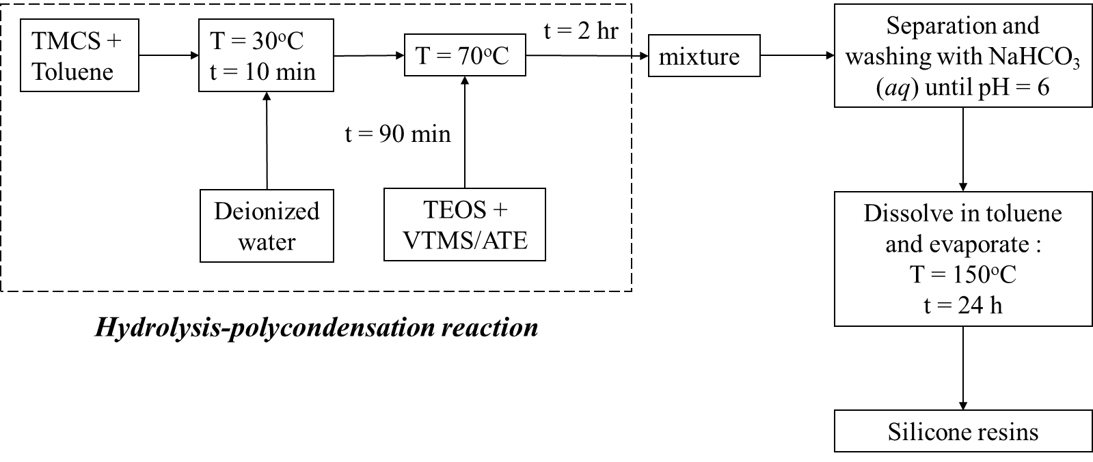

**Figure 1**. Schematic route of the hydrolysis-polycondensation of silicone resins

**Table 2.** Components and their quantities in the silicone resin synthesis

**Preparations of elastomeric thermal pads from silicone resins and h-BN**

The elastomeric thermal pads were formed with the thermoforming process, as shown in Figure 2. The silicone resin was dissolved in toluene with a weight ratio of resin to toluene of 10:1 before mixing with silicone rubber. The mixing process took the form of mechanical stirring at 1000 rpm for 3 min and holding for 1 hour to ensure a homogeneous mixture. Then, the *h*-BN particles were incorporated into the mixture. After the mixing process, the mixture was placed in a stainless steel mold and compression-molded at 90oC at a pressure of 1500 psi for 30 min in an electrically heated hot-press machine (Taiwan: GF-50, You Found Hydrolics Industrial Co. Ltd.). After the hot-press process, the specimen was put in a drying oven at 150oC for 6 h. Detailed experimental conditions are listed in Table 3.

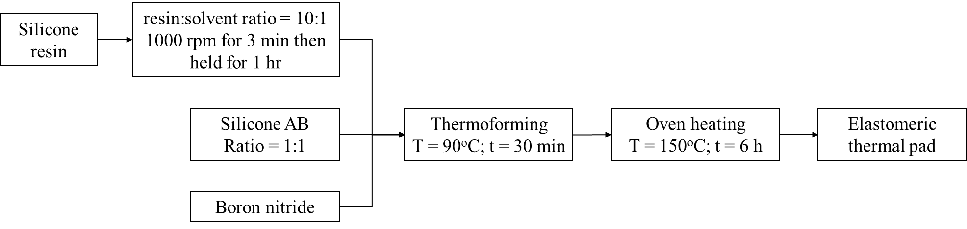

**Figure 2.** Schematic route of the thermoforming of thermal pads

## Characterization

The chemical structure analysis of the silicone resins was carried out by means of Fourier Transform Infrared (FTIR) spectroscopy using an FTS-1000 Infrared Spectrometer (Bio-Rad Digilab) in the frequency range of 4000-600 cm-1 in transmittance mode. Specimens were prepared using the potassium bromide (KBr) pellet method with a weight ratio of resin to KBr of 1:20. The molecular weight analysis of the silicone resins was determined by ACQUITY Advanced Polymer Chromatography (APC, Waters Co.Ltd.) using tetrahydrofuran as an eluent and polystryrene as standard. Crosslink density (*Ve*) was calculated based on the ASTM D6814 standard. The Flory-Rehner equation for crosslink density: 32

 (1)

Where *Ve* is the effective number of chains in a real network per unit volume, *Xl* is the polymer-solvent interation parameter (0.845), *Vl* is the molecular volume of the solvent (106.54X10-3 L mol-1) and *Vr* is the volume fraction of polymer in a swollen network in equilibrium with pure solvent, is calculated as: 33,34

 (2)

where *wdry* is the weight of the dry rubber, *ρrubber* is the rubber density, *wabsorbed* is the weight of solvent absorbed by the sample and *ρsolvent* is solvent density. The thermal stability of the silicone rubber composite was determined by thermogravimetry analysis (TGA Q500, TA Instruments) in the range of 30 to 650oC with a heating rate of 10oC min-1 under nitrogen flow at 40 mL min-1. The heat resistance of the material (Theat-resistance index) 18 can be determined using the equation:

 (3)

Thermal conductivity was tested with a thermal conductivity analyzer (Hot Disk TPS 2500S) using the transient plane source method, and following the ISO 22007-2 standard. Mechanical properties were determined using a universal tensile tester (Chun Yen Testing Machines, CY-6040A) with weight loading of 500 kg and cross-head speed of 10 mm min-1, under the ASTM D412 standard. The hardness was measured with a hardness tester durometer, shore A type (Teclock, GS-709). The morphology of the silicone resin and fractography of the silicone rubber composite were observed using scanning electron microscopy (SEM, JEOL JSM-6930LV). The samples were platinum coated to enhance their conductivity with an auto fine coater (JEOL JFC-1300) for 80 seconds. The density of the composite was determined using the ASTM D792 standard. The mass loss and volatile content were determined using the ASTM E595 standard. The flame resistance was determined using the UL-94 standard. The resistivity of the composite was measured using an ASTM D257 resistivity meter.

# Results and Discussion

## Chemical structure analysis

Silicone resins were successfully synthesized using hydrolysis-polycondensation. Chemical structure analysis using FTIR was performed to validate the synthesis results. The FTIR results for Vi-MQT and Al-MQT are shown in Figure 3., and Figure 4., respectively. The broad peak at 3124 cm-1 indicates the existence of a hydroxyl group from a residual silanol bond (Si-OH), which proves that hydrolysis occurred in the reaction. 35 The peaks at 2962 and 2902 cm-1 indicate asymmetric and symmetric stretching of the methyl group. 36 The peak at 1402 cm-1 is representative of the unsaturated methyl group of the MQ resin structure.35 The sharp peak at 1086 cm-1 indicates Si-O-Si symmetric stretching in cyclic structures 36 represented as the Q unit in the resin. The peaks at 1256, 845 and 756 cm-1 are indicative of the methyl group from silanol that represents the M unit.37,38

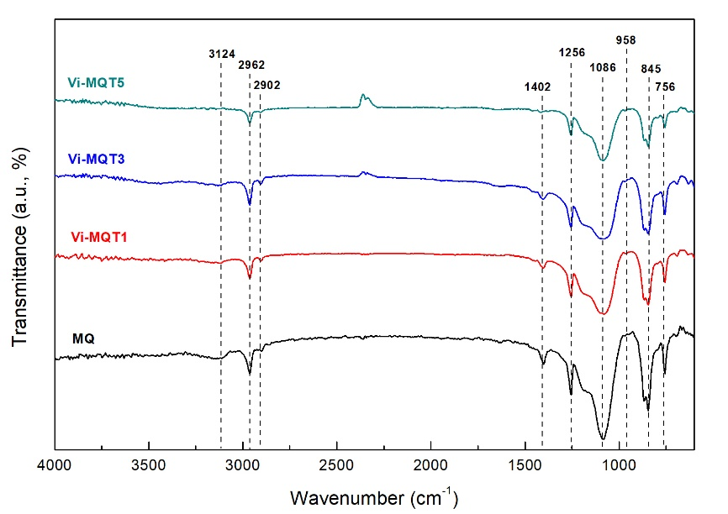

**Figure 3.** FTIR spectra of MQ resin and Vi-MQT resins.

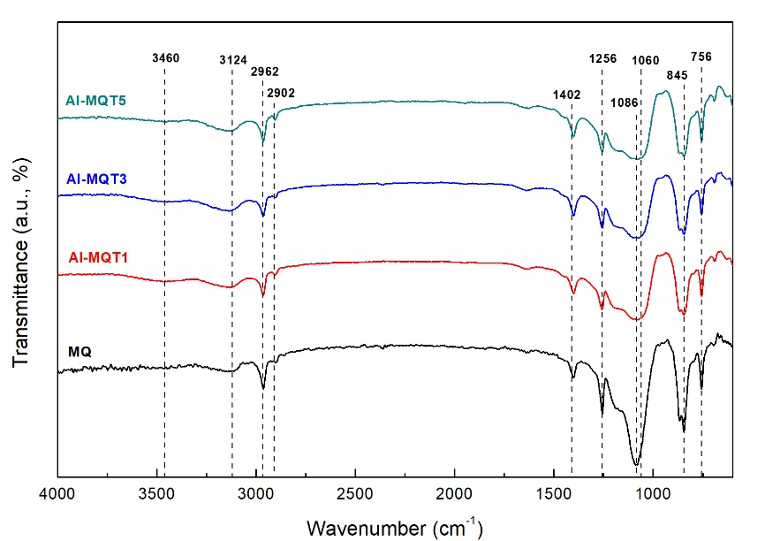

**Figure 4.** FTIR spectra of MQ resin and Al-MQT resins.

In Figure 4., it can be seen that a small peak appears at 958 cm-1 (not marked in figure), referring to the out-of-plane C-H band from a vinyl group. 35,39 This peak is a small intensity one due to the small presence of the vinyl group in the resin. The decreasing intensity trend for an unsaturated methyl group at 1402 cm-1 co-occurred with the addition of the vinyl group to the resin structure. The vinyltrisilanol structure reacted with the residual silanol group from the siloxane prepolymer, competing simultaneously with trimethylsilanol. This phenomenon also caused the disappearance of the peak at 3124 cm-1 for the highest vinyl content concentration in the Vi-MQT resin. From Figures 3 and 4., it clearly is seen that a new broad peak is revealed at 3460 cm-1, indicating the hydroxyl group that is to be expected from Al-OH. The peak at 1086 cm-1 also widened due to the new peak revealed at 1060 cm-1 that indicates asymmetric stretching of the Al-O-Si bond. 27 For a better understanding of the difference of the MQ, Vi-MQT and Al-MQT structures, a comparison of the FTIR spectra is shown in Figure 5. Based on the results, it can be concluded that the silicone resin synthesis was successfully completed.

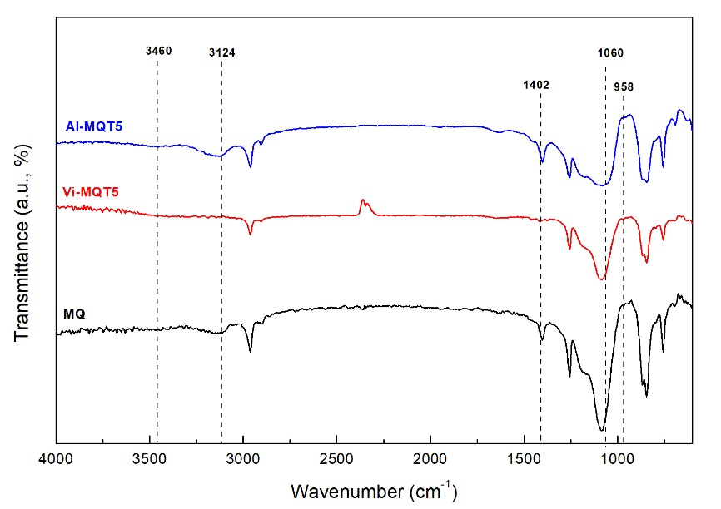

**Figure 5.** Spectrum comparison of silicone resins.

## Molecular weight and morphology of silicone resins

The molecular weight of the silicone resins is listed in Table 4. The number average and weight average molecular weight of the MQ resin, Mn and Mw, was 41301 g mol-1 and 47982 g mol-1, respectively, with a narrow molecular weight distribution (PDI) of 1.161. Vi-MQT and Al-MQT showed the same decreasing trend in molecular weight with greater addition of T units to the resins. 40 Adding T units to the MQT structure decreased Mn and Mw to a final level of 18906 and 28641 g mol-1, respectively, for the Vi-MQT resins and 17497 and 27114 g mol-1, respectively, for the Al-MQT ones. The decreasing trend in molecular weight was due to an increase in the end-capping units in the synthesis reaction. An end-capped unit from an M and T unit would react with a silanol group from the siloxane prepolymer, causing the propagating process to stop and yield a smaller-sized polymer. 36

**Table 4.** Physical appearance of silicone resins.

## Structure of crosslinked network

The composite exhibited characteristic structural, thermal stability and mechanical properties. Incorporation of silicone resins changed the crosslinked network structure of the silicone rubber. The effect of additional MQ resin on the crosslink density of the silicone rubber is shown in Figure 6, and corresponding values are summarized in Table 5. From the results, it can be seen that the density of silicone rubber did not change significantly with the addition of MQ resin. However, the gel content, crosslink density (*Ve*) and molecular weight between crosslinks (Mc) of silicone rubber did change. Gel content and *Ve* were reduced with the additional MQ resin, while Mc increased. with the addition of MQ resin. The gel content of the silicone rubber decreased from 97.77% to 77.19% and *Ve* also fell from 1.787X 10-4 to 0.735X 10-4, while Mc rose from 5901 to 14622 g mol-1 with the addition of 30 phr MQ resin.

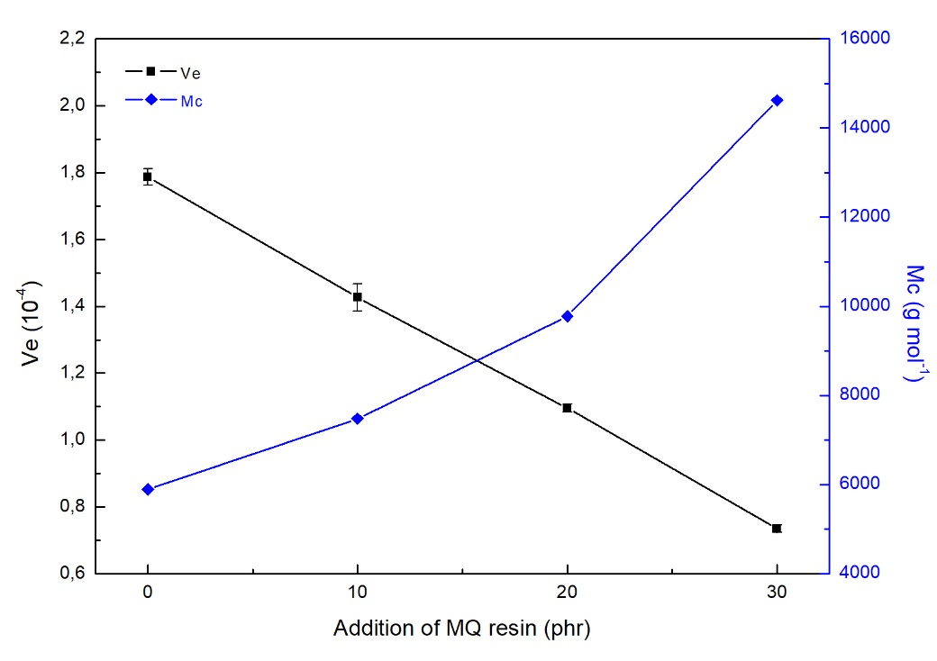

**Figure 6.** Crosslink density and molecular weight between crosslinking points of silicone rubber with addition of MQ resin.

**Table 5.** Network structure of silicone rubber with addition of MQ resin.

Addition of Vi-MQT and Al-MQT resins to the silicone rubber was then substituted for MQ addition to investigate their influence on the silicone rubber crosslinked network structure, as shown in Figure 7., with a summary of the values listed in Table 6. A 10 phr level for silicone resin was chosen. Addition of Vi-MQT reduced the gel content and *Ve*. Incorporation of Vi-MQT5 produced the highest decline in crosslink density, with even a lower value than the addition of 30 phr of MQ resin (0.642 X10-4 compared with 0.735 X10-4). On the other hand, Al-MQT5 addition on silicone rubber showed a similar crosslink density to that of MQ resin (1.418 X10-4 compared with 1.426 X10-4).

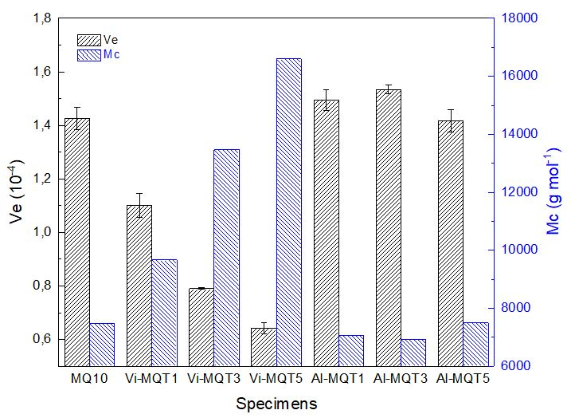

**Figure 7.** Crosslink density and molecular weight between crosslinking points of silicone rubber with addition of silicone resins.

**Table 6.** Network structure comparison of silicone rubber with silicone resin addition.

### Thermal stability analysis

Figure 8, shows the effects of MQ resin addition on the thermal stability of the silicone rubber. The important characteristic thermal degradation data are listed in Table 7. Increasing addition of MQ resin decreased the characteristic thermal degradation of the silicone rubber. The initial characteristic temperatures at 5% of weight loss decreased from 428.22oC for neat silicone rubber to 281.02oC for the addition of MQ resin up to 30 phr. However, at 30% of weight loss, the characteristic temperature of weight loss increased from 526.29oC for neat silicone rubber to 596.54oC for the addition of 20 phr and then slightly decreased to 581.08oC for the addition of 30 phr (MQ-30). It is to be noted that temperatures in the 450-650oC range result in degradation of the backbone structure region.36,41,42 In the silicone rubber/*h*-BN composite system, the addition of *h*-BN to neat silicone rubber slightly increased its initial characteristic thermal degradation. However, with the addition of MQ resin in all concentrations, the thermal stability of the composite decreased. The initial characteristic degradation temperature of the neat silicone rubber/*h*-BN composite was 429.56oC, but this figure then decreased to 383.02, 329.31 and 294.12oC for the addition of MQ resin from 10 to 30 phr. On the other hand, the temperature of maximum degradation rate increased with the addition of MQ resin, from 507.85oC to 588.00, 584.24 and 572.94oC with the addition of MQ resin from 10 to 30 phr, respectively. From the results, it can be concluded the addition of MQ resin decreased thermal stability of the silicone rubber/*h*-BN composite. Moreover, the residual yields of composites decreased with the addition of MQ resin to 38.39%, a figure which is far lower than that for the neat composite (64.75%).17

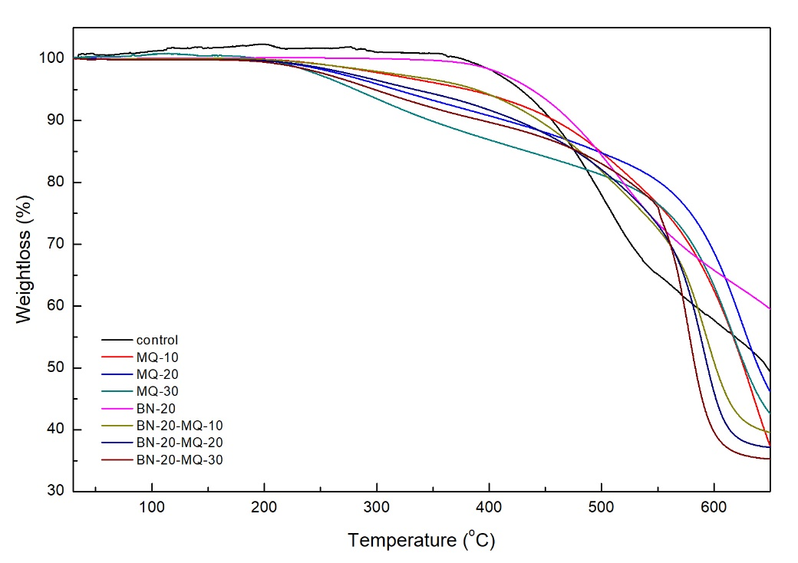

**Figure 8.** Thermal degradation of silicone rubber composites with addition of MQ resin in N2 atmosphere.

**Table 7.** Characteristic degradative data of composites with addition of MQ resin.

Vi-MQT and Al-MQT resin was substituted in place of MQ resin to investigate their influence as an addition to silicone rubber on the thermal stability of silicone rubber composites, with results shown in Figure 9, and summarized in Table 8. The use of Vi-MQT resin in place of MQ resin improved the initial characteristic thermal degradation of silicone rubber. The initial characteristic temperatures at 5% of weight loss decreased from 373.84oC to 235.15, and then rebounded to 388.88 and 381.08oC for the addition of Vi-MQT1, Vi-MQT3 and Vi-MQT5 silicone resins, respectively. The temperatures at 30% of weight loss slightly decreased to 563.67oC for Vi-MQT1 addition, down from 578.04oC, and then increased to 590.43oC and 681.68oC for Vi-MQT3 and Vi-MQT5, respectively. The corresponding heat-resistance indexes showed a similar trend with T30 changing from the 243.21oC of the MQ resin composite to 239.24, 249.80 and 275.10oC for the Vi-MQT1, Vi-MQT3 and Vi-MQT5 resin ones, respectively.

The temperature at 30% of weight loss also decreased from 578.04oC for the MQ resin composite to 573.65, 549.45 and 549.89oC for the Al-MQT1, Al-MQT3 and Al-MQT5 resin ones, respectively. The corresponding heat resistance indexes decreased from the 243.21oC for the MQ resin composite to 240.60, 233.18 and 228.93oC for the Al-MQT1, Al-MQT3 and Al-MQT5 resin ones, respectively, indicating lower thermal stability of these silicone rubber composites. Based on the results, it can be concluded that vinyl-silicone resin effectively improves the thermal stability of silicone composites compared with MQ, aluminum-silicone resins and even neat silicone composite, with the best improvement being for addition of Vi-MQT5 resin.

**Table 8.** Characteristic degradative data of composites with addition of Vi-MQT and Al-MQT resin

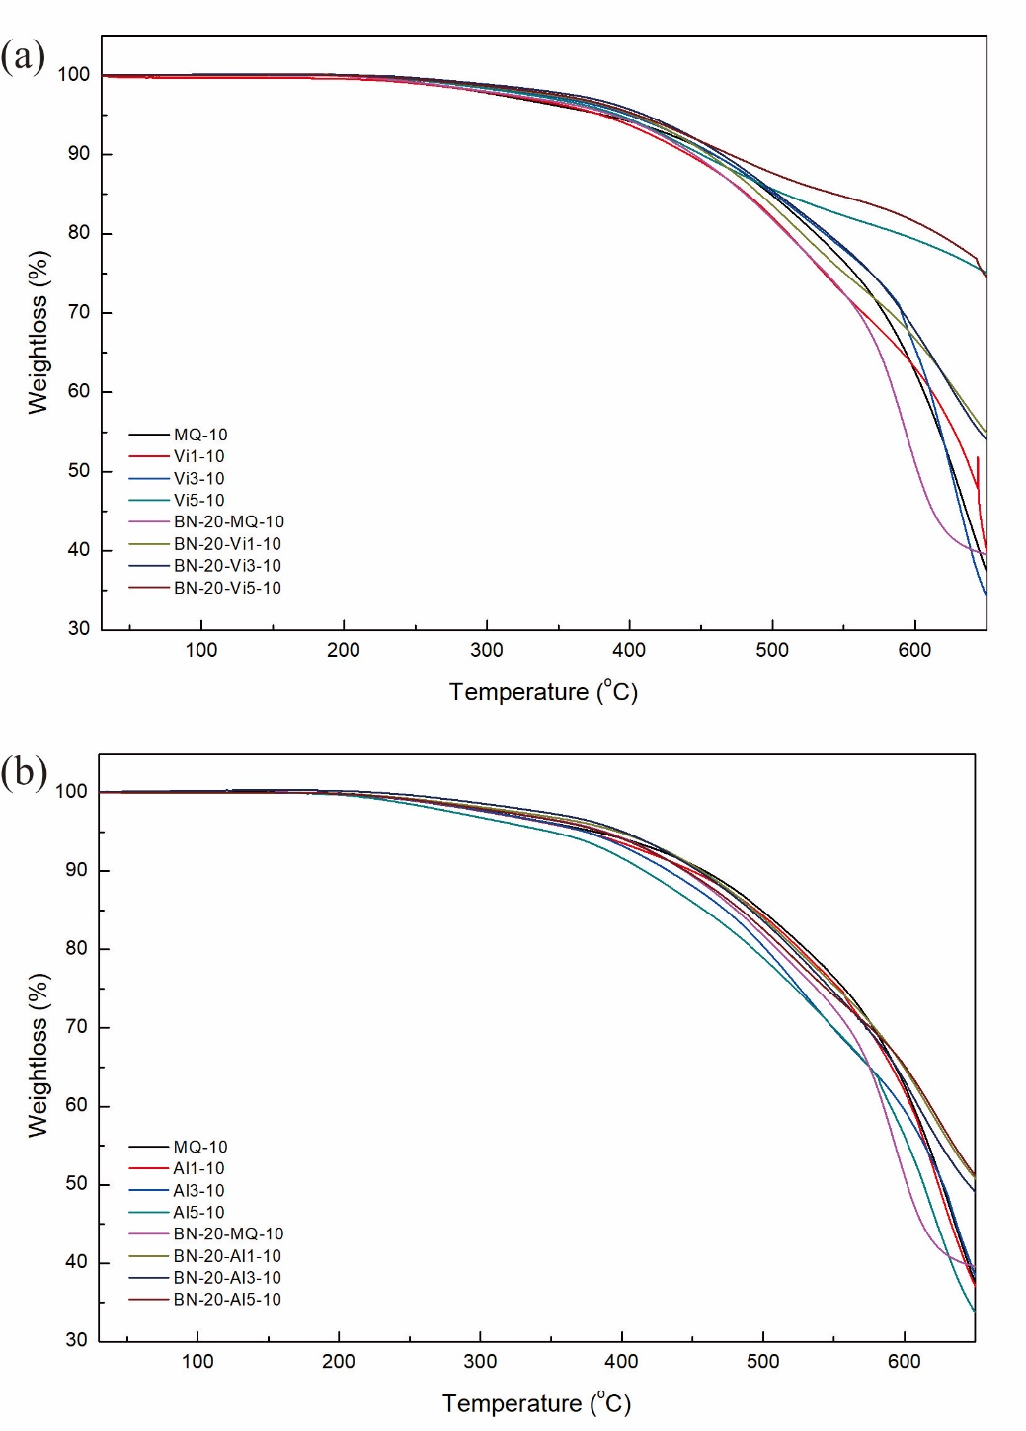

**Figure 9.** Thermal degradation of silicone rubber composites with addition of (a) Vi-MQT resin and (b) Al-MQT in N2 atmosphere.

### Mechanical properties analysis

The effect of adding MQ resin on the mechanical properties of silicone rubber and silicone rubber/*h*-BN composite is shown in Figure 10. From the results, it can be seen that the presence of MQ resin in both silicone rubber and its composites significantly changes their mechanical properties. Addition of MQ resin in silicone rubber reduces tensile strength and hardness but improves the elongation at break property. 43 In this study, tensile strength was reduced from 2.099 MPa to 0.856 MPa on 30 phr of MQ resin addition.

Incorporation of *h*-BN particles in silicone rubber also reduced tensile strength and elongation, from 2.099 MPa to 1.648 MPa, and 737% to 657%, respectively. Addition of 10 phr MQ resin then slightly enhanced tensile strength, up from 1.648 MPa to 1.659 MPa. Further addition of MQ resin (20 and 30 phr) even exceeded the tensile values for the silicone rubber with MQ resin but without *h*-BN particles for those phr values, as shown in Figure 10 (a). However, these values are reduced compared with the silicone composite with the addition of just 10 phr MQ resin. In the composites, structure showed an incremental trend in elongation at break, due to the good interfacial reaction between filler and matrix. Addition of MQ resin also reduced the hardness properties both of the silicone rubber and silicone rubber/*h*-BN composites.

(a)

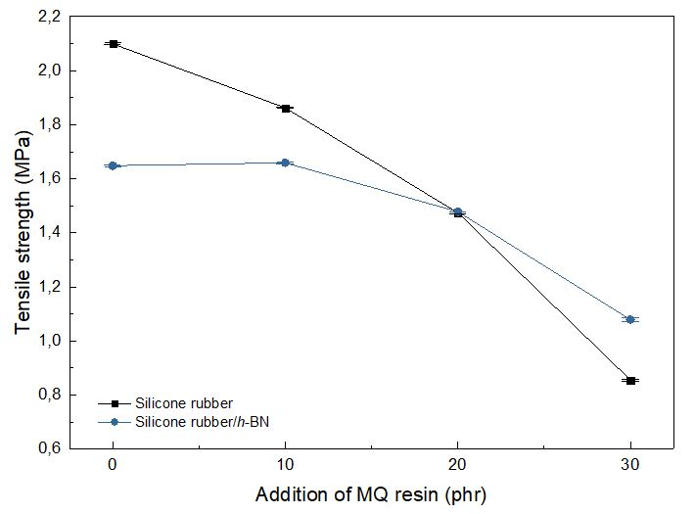

(b)

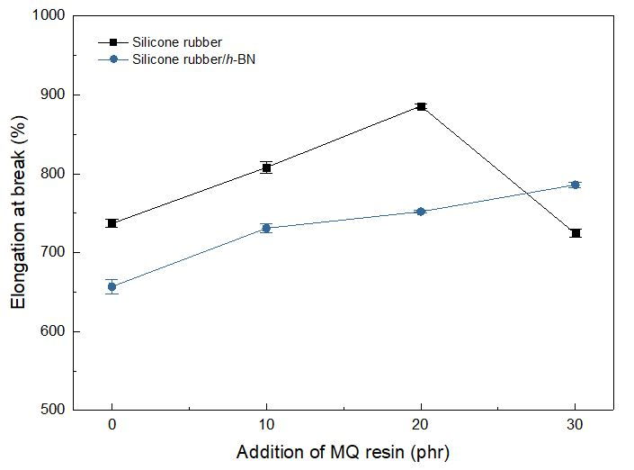

(c)

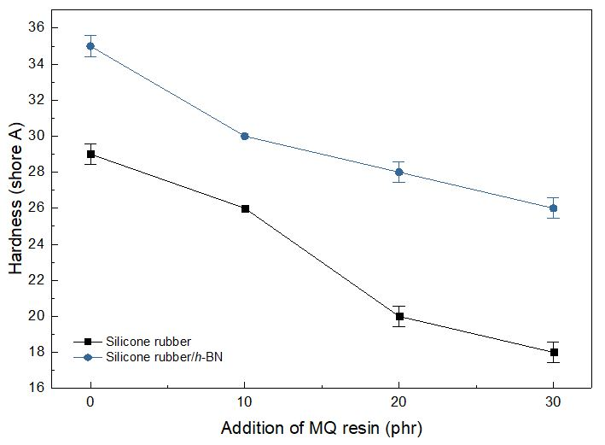

**Figure 10.** Mechanical properties of silicone rubber composites with addition of MQ resin; (a) tensile strength, (b) elongation at break and (c) hardness.

MQ resin was replaced with Vi-MQT and Al-MQT resin as an additive to silicone rubber to investigate their influence on the mechanical properties of silicone rubber and its composites with the *h*-BN particle, as shown in Figure 11. A figure of 10 phr of silicone resin was again chosen. It can be seen that replacing MQ resin with Vi-MQT reduced the tensile strength of silicone rubber, from 1.862 MPa to 1.823, 1.777 and 1.530 MPa for the three Vi-MQT resins, Vi-MQT1, Vi-MQT3 and Vi-MQT5, respectively. In the case of Al-MQT as additive to the silicone rubber/*h*-BN composite, the best value was obtained by Al-MQT3 at 1.711 MPa. The existence of a hetero-metal bond promotes a synergy effect that can disperse homogeneously in the oligosiloxane structure. 41 The vinyl-silicone resin additive enhanced elongation, from 808% with the MQ resin to 847, 877 and 987% for the three Vi-MQT1, Vi-MQT3 and Vi-MQT5 resins, respectively. Addition of the aluminum-silicone resin also improved elongation, from 808% with the MQ resin to 817, 870 and 867% for the three Al-MQT1, Al-MQT3 and Al-MQT5 resins, respectively. But in the composite systems, the addition of a vinyl-silicone resin improved elongation at break properties more than the aluminum-silicone resins. Addition of the Vi-MQT5 resin enhanced elongation up to 1063% while addition of the Al-MQT3 one only resulted in 793% elongation, not much greater than the MQ resin’s 731%. The hardness of the silicone rubber was significantly reduced with the addition of Vi-MQT resin, but slightly increased with the addition of Al-MQT resin due to the existence of Al-O bonds in the structure.

(a)

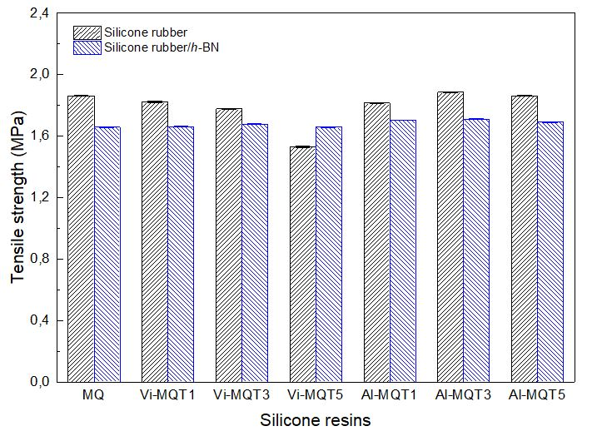

(b)

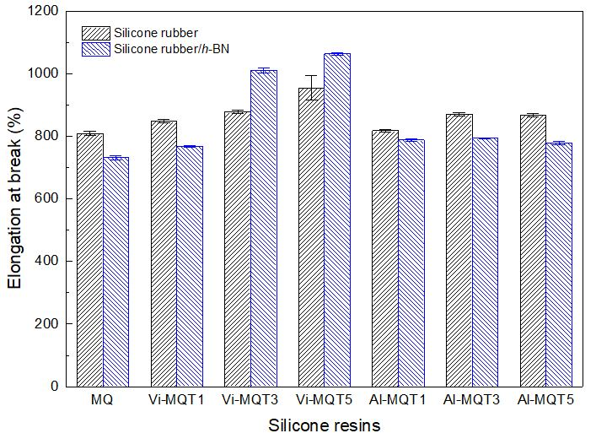

(c)

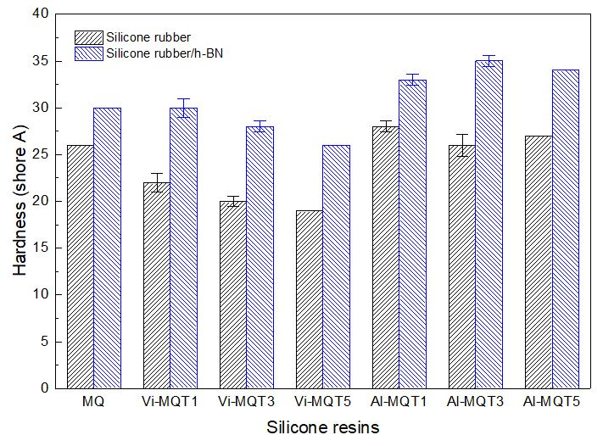

**Figure 11.** Mechanical properties of silicone rubber composites with addition of silicone resin; (a) tensile strength, (b) elongation at break and (c) hardness.

**Evaluation Performance of Silicone Rubber Composites**

Thermal conductivity is enhanced significantly by the existence of high filler loadings, but the addition of large amounts of filler not only improves the thermal conductivity of silicone rubber. Other properties are also affected, especially flexibility. Based on the above preliminary results, MQ, Vi-MQT3 and Al-MQT3 resin were chosen as modifiers of the silicone rubber/*h*-BN composite to form thermal pads. Addition of the silicone resin was kept constant, at 10 phr. The *h*-BN filler concentration was increased up to 100 phr. The critical concentration for the percolation of cubical particles in polymer matrices is known to be around 30% by volume. The 100 phr filler concentration is higher than 30% by volume, 14 and is a value where the silicone rubber matrix would become saturated, preventing it from being further filled. The performance of the thermal pads with these parameters was evaluated based on the target values of this study, as shown in Table 1.

### Thermal conductivity

The thermal conductivity of the thermal pads is shown in Figure 12. It can be seen that the thermal conductivity of the composites increased with higher filler loadings, improving from 0.213 W m-1 K-1 for neat silicone rubber to 3.253 W m-1 K-1 with the addition of 100 phr of *h*-BN particles, for a 1427% enhancement. The addition of 20 phr only resulted in 0.501 W m-1 K-1 of thermal conductivity (a 135% enhancement). Addition of silicone resin improved the thermal conductivity of the silicone rubber composite. For neat silicone rubber, however, the addition of silicone resin reduced its thermal conductivity, from 0.213 W m-1 K-1 to 0.189, 0.174 and 0.199 W m-1 K-1 for the three MQ, Vi-MQT3 and Al-MQT3 resins, respectively. Addition of small amounts of *h*-BN (20 phr) resulted in a similar relationship between the three resins as for neat silicone rubber. But, the presence of silicone resin in the structure of silicone rubber leads to the enhancement of the free volume and reduction of covalent bonds, which is a very important aspect of the thermal conduction process in polymer material. Further addition of *h*-BN particles yielded higher thermal conductivity on the composites with silicone resins compared with the pristine one. At the highest 100 phr filler concentration, thermal conductivity improved from 3.253 W m-1 K-1 for the composite without added silicone resin to 3.611, 3.962 and 4.817 W m-1 K-1 for the composites with the three MQ, Vi-MQT3 and Al-MQT3 resins, respectively. The best improvement in thermal conductivity was achieved by the Al-MQT3 resin silicone composite. The higher thermal conductivity on that composite was due to the synergistic effect of the *h*-BN filler with the silicon and aluminum atom in the silicone resin structure. 44

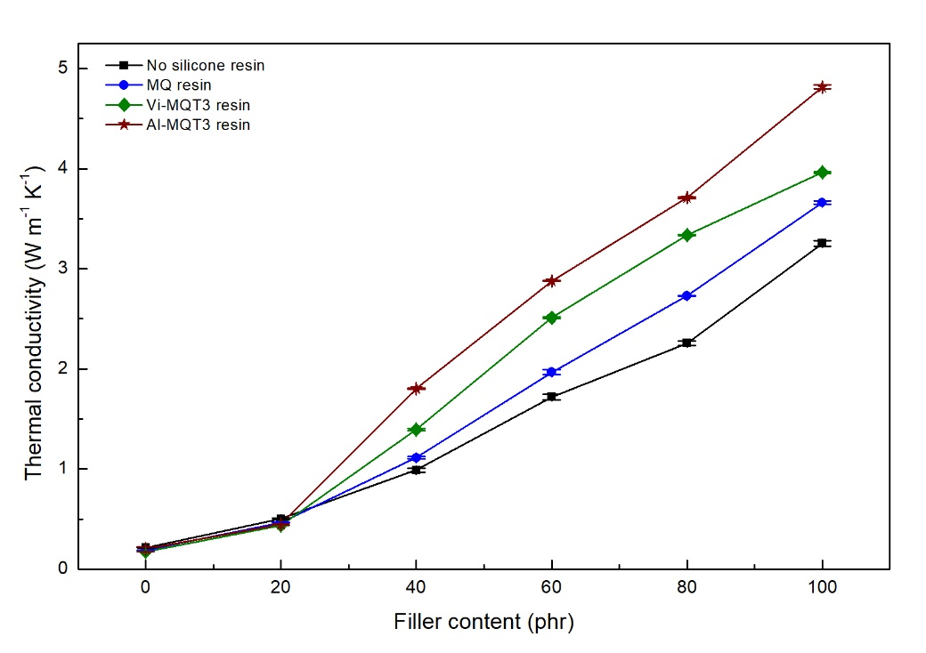

**Figure 12.** Thermal conductivity of silicone rubber composites.

### Mechanical properties

The mechanical properties of the thermal pads are shown in Figure 13. Tensile strength decreased with the addition of *h*-BN particles to neat silicone rubber, from 2.099 MPa for the neat state to 1.248 MPa for the 100-phr particle composite. This is typical for composites with poor interfacial interaction. 13 In high filler loadings, an incomplete dispersion of filler occurs and more defects are formed.18 Therefore the tensile strength of the silicone rubber/*h*-BN composites decreased. In the composites with silicone resin, better tensile strength was achieved, as shown in Figure 15 (a). For high filler loadings (100 phr), the tensile strength of the composite improved to 1.274, 1.290 and 1.312 MPa for the three MQ, Vi-MQT3 and Al-MQT3 resins, respectively. Elongation also decreased with high *h*-BN loadings, from 737% for neat silicone rubber to 22% for the 100-phr particle composite. This behaviour is generally explained as the effect of the lack of matrix/filler adhesion and poor filler distribution in the matrix. 45 On the other hand, hardness increased with high *h*-BN filler loadings, from 29 shore A for neat silicone rubber to 75 shore A for the rubber/100-phar *h*-BN composite. The addition of silicone resin slightly reduced the hardness of the silicone rubber composites. For the high filler loadings, hardness fell to 69, 71 and 72 shore A for the three MQ, Vi-MQT3 and Al-MQT3 resins, respectively. Addition of the MQ resin resulted in the lowest hardness of the silicone rubber composites.

(a)

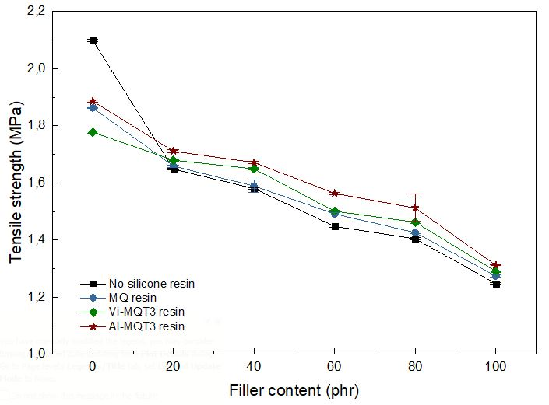

(b)

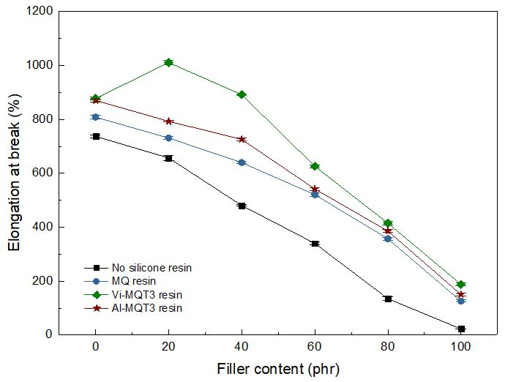

(c)

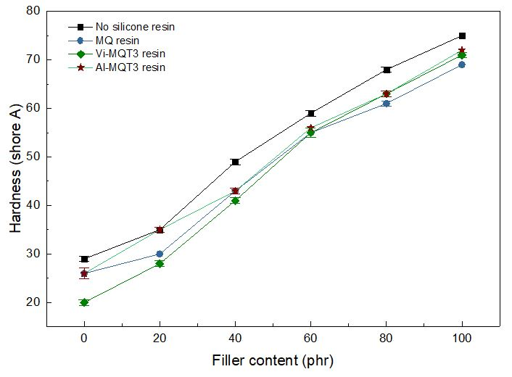

**Figure 13.** The mechanical properties of silicone rubber composites; (a) tensile strength, (b) elongation at break and (c) hardness.

### Density of Thermal Pads

The density of the thermal pads is shown in Figure 14. It can be seen that the addition of *h*-BN particles increased the density of the resulting composites, from 1.054 g cm-3 for neat silicone rubber to 1.418 g cm-3 for the 100-phr *h*-BN composite. This phenomenon simply occurs due to the differences in density of the silicone rubber and *h*-BN filler. High filler loadings will increase the density of the composite. Addition of silicone resin slightly decreased the composite densities to 1.405, 1.407 and 1.411 g cm-3 for the three MQ, Vi-MQT3 and Al-MQT3 resins, respectively.

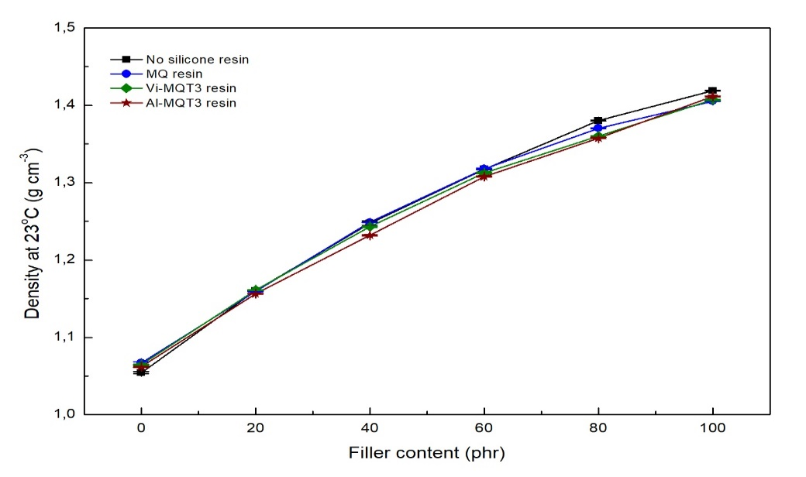

**Figure 14.** Density of silicone rubber composites.

### Volatile Content of Composite

The volatile content of the thermal pads is shown in Figure 15. It can be seen that the volatile content of silicone rubber was reduced by the addition of *h*-BN filler, from 0.963% for the neat silicone rubber to 0.152% for the 100-phr *h*-BN composite. Addition of silicone resin in the structure of the composite increased the volatile content for the 100-phr *h*-BN loading to 0.196, 0.699 and 0.214% for the three MQ, Vi-MQT3 and Al-MQT3 resins, respectively. The increase in volatile content was due to the lower crosslink density of the composite compared with neat silicone rubber.

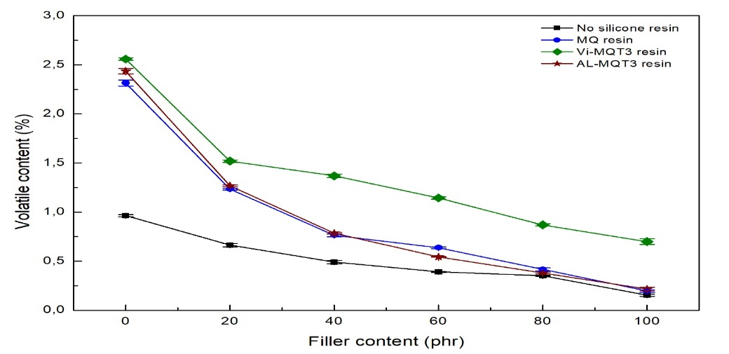

**Figure 15.** Volatile content of silicone rubber composites.

### Flame Resistance of Composite

The flame resistance of the silicone rubber composites is listed in Table 9. It can be seen that the composites are quite flammable, both in the form of neat silicone rubber and in that of silicone rubber modified with silicone resin. Once ignited, silicone rubber burns rapidly and releases a large amount of heat 46. Addition of flame retardant material can enhance its flame resistance. *h*-BN can be introduced into silicone rubber to enhance this property. Based on the results listed, it can be seen satisfying flame resistance properties can be achieved with the addition of more than 80 phr of *h*-BN particles. Addition of silicone resin did not have a significant influence on flame retardancy.

**Table 9**. Results of flame retardancy test of silicone rubber composites.

### Volume Resistivity of composites

The volume resistivity of silicone rubber composites is listed in Table 10. It can be seen that composites with high filler loadings have enhanced volume resistivity, from >1013 to >1011 Ω cm at 100 phr of *h*-BN. The existence of impurities and defects in the structure also can enhance volume resistivity 47. Addition of silicone resin did not have significant effect on volume resistivity property.

**Table 10.** Results of volume resistivity test of silicone rubber composites.

### Performance evaluation

The performance evaluation of the silicone rubber composites, drawing on data from the discussion above, is shown in Table 11. It can be observed that silicone rubber/*h*-BN composites possess good thermal conductivity, mechanical and other properties. The density of the composites with silicone resin showed a slight reduction compared with the neat composite. The density of all of the samples was lower than the predetermined limit. The tensile strength of the composites exceeded the expected value and improved with the addition of silicone resin, the best improvement being achieved by addition of Al-MQT3 resin. Composites without silicone resin showed low elongation at break, only 22%, as expected from the poor compatibility between the silicone rubber and *h*-BN particles. The addition of silicone resin was able to more than double flexibility, with the best improvement being achieved by addition of Vi-MQT3 resin. Hardness of the composites was less than the maximum predetermined value and the addition of silicone resin slightly reduced it, with the best reduction achieved by addition of MQ resin. Thermal conductivity of the composites surpassed the predetermined value and improved with the addition of silicone resin, with the best improvement being for addition of Al-MQT3 resin. Volatile content of the composites increased with the addition of silicone resin due to the lower crosslink density. However, values were still below the predetermined limit. Flame retardancy and volume resistivity did not change significantly with the addition of silicone resin and values continued at a safe level. Based on these results, it can be concluded that the addition of silicone resin enhances the properties of silicone composites, satisfying all of the predetermined target values of this research.

**Table 11.** Performance evaluation of silicone rubber composite modified by silicone resin

**Morphology of composites**

The morphology of neat silicone rubber and silicone composite is shown in Figure 16. As can be seen from Figure 16. (a), the morphology of the neat silicone rubber was plain and smooth. Figure 16. (b) shows on addition of 20 phr of *h*-BN, the filler failed to spread homogeneously, tending to form agglomerates due to poor compability between filler and matrix. On further addition of *h*-BN, as shown in Figure 16. (c), the silicone composite developed rough surfaces due to the existence of filler agglomerates and voids formed among the agglomerates. This condition led to reductions in the values of some properties, especially mechanical properties.

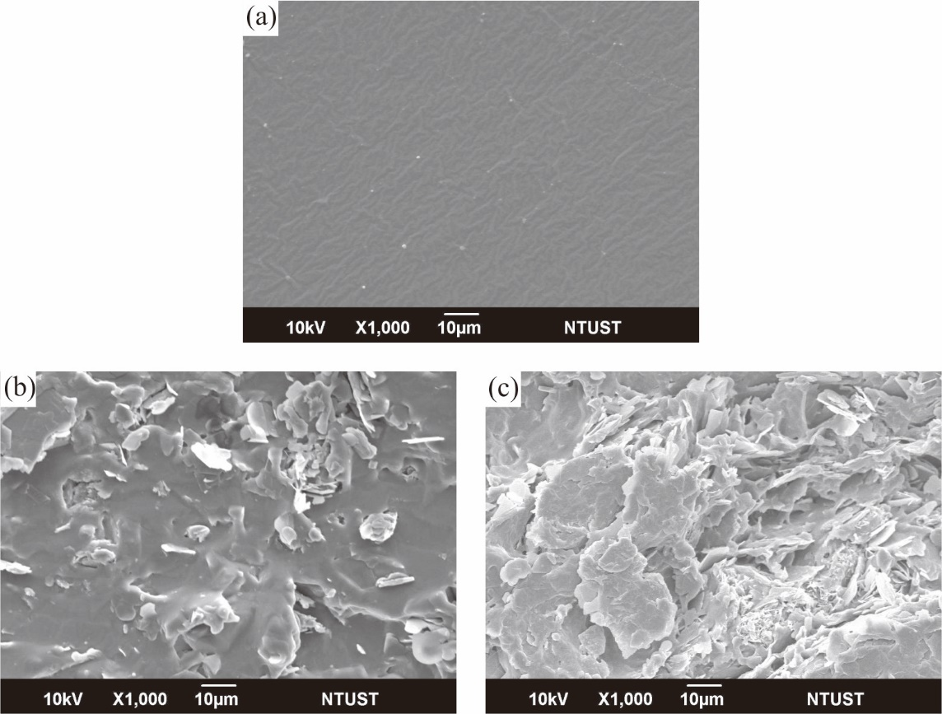

**Figure 16.** Fracture morphology of (a) neat silicone rubber, and silicone composite with (b) 20 phr and (c) 100 phr of filler addition.

A comparison of the fracture surface morphologies of different silicone composites with 100 phr of *h*-BN filler is shown in Figure 17. Analysis of these images reveals agglomerations of *h*-BN filler and voids generated when filler peeled off. In Figure 17. (a), it can be seen that the composite has many defects and voids, indicating poor compatibility between filler and matrix.47 The matrix cannot be binding filler well, resulting in interfacial phases filled with air and yielding poor composite properties. The existence of air inside the composite would enhance the thermal resistance of the material, resulting in ineffectiveness of the heat transfer process. Addition of silicone resin to the composite, as shown in Figure 17. (b-d), resulted in better morphology than the pristine one. The silicone resin acts as a bridge and enhances the adhesion of silicone rubber, resulting in better compatibility between filler and matrix. Better compatibility will enhance filler distribution and improve some properties of the composite, especially mechanical properties. But, a high level of filler distribution does not always result in high thermal conductivity. The composite in Figure (c) had the best filler distribution and no filler agglomerates were formed. Compared with the composite of Figure (c), the filler distribution of the aluminum-silicone one in Figure (d) was not as good. However, the thermal conductivity of that composite was higher than either those of Figure 17 (b,c) or of any of the others. Regardless of the synergistic effect as mentioned above, a high level of filler distribution will enhance interfacial interaction between filler and matrix, and lead to an increase of thermal contact resistance. The effective heat transfer route is from filler-to-filler. In other words, filler agglomerations are needed to accelerate the heat transfer process. Based on the morphology results, Figure 17. (d) shows the existence of some filler agglomerations with sufficient filler distribution results in higher thermal conductivity.

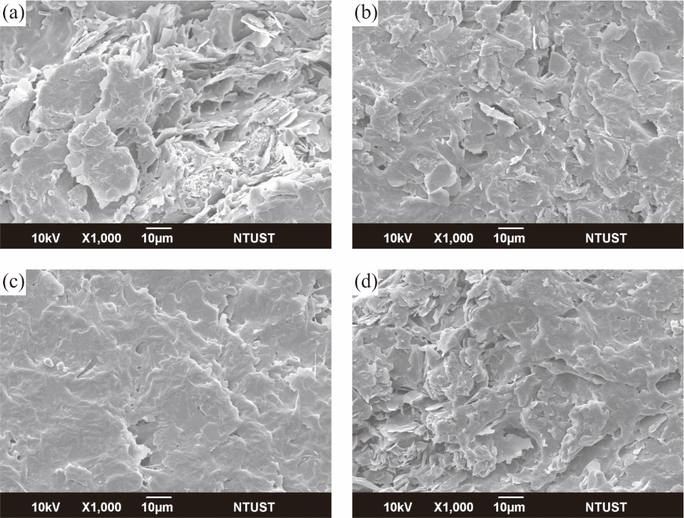

**Figure 17.** Fracture morphology comparison of (a) neat silicone composite and silicone composite with addition of (b) MQ, (c) Vi-MQT3 and (d) Al-MQT3 resin

# **Conclusions**

Silicone resin was synthesized using the hydrolysis-polycondensation method as a modifier for silicone rubber/*h*-BN composites. Three kinds of silicone resin were obtained i.e., MQ resin, vinyl-silicone resin (Vi-MQT resin) and aluminum-silicone resin (Al-MQT resin). Addition of vinyl and aluminum bonds as functional units reduced the molecular weight of the resulting MQ resin due to a shorter propagation process. The thermal stability of the Vi-MQT and Al-MQT resin was higher than the MQ resin due to higher bond dissociation energy, except for the Al-MQT5 resin. Both of the Vi-MQT and Al-MQT resins yielded higher residue content than the MQ resin. Addition of MQ units only improved the thermal stability of composites when the concentration was 10 phr. Addition of Vi-MQT and Al-MQT resins enhanced thermal stability due to the crosslinking reaction and hetero-metal synergistic effect in silicone resin structure, respectively. When applied in a composite system, silicone composites with Vi-MQT resin showed higher thermal stability. Enhancement of the characteristic temperatures at maximum degradation of the composites with the addition of silicone resins indicated stronger interaction between the silicone rubber and resin particles. Increasing filler concentration of *h*-BN up to 100 phr increased thermal conductivity and hardness of the composites to 3.253 W m-1 K-1 and 75 shore A but reduced tensile strength and elongation to 1.248 MPa and 22%, respectively. Addition of silicone resin improved thermal conductivity of the composites, up to 3.661, 3.962 and 4.817 W m-1 K-1 for the three MQ, Vi-MQT3 and Al-MQT3 resins, respectively. Tensile strength improved to 1.274, 1.290 and 1.312 MPa, elongation at break increased to 125, 188 and 150%, and hardness dropped to 69, 71 and 72 shore A with the addition of the three MQ, Vi-MQT3 and Al-MQT3 resins, respectively. Volatile content of the composites increased from 0.152% for the neat composite to 0.196, 0.699 and 0.214% for ones with the three MQ, Vi-MQT3 and Al-MQT3 resins, respectively. Density, flame resistance and volume resistivity also changed with the addition of silicone resin. Addition of silicone resin slightly decreased the density of composites to 1.405, 1.407 and 1.411 g cm-3 for the addition of the MQ, Vi-MQT3 and Al-MQT3 resins, respectively. Addition of silicone resin in the structure of composites increased the volatile content of 100-phr filler composites to 0.196, 0.699 and 0.214% for the MQ, Vi-MQT3 and Al-MQT3 resins. *h*-BN can be introduced into silicone rubber to enhance its flame resistance properties. Finally, composites with high filler loadings enhanced their volume resistivity, from >1013 to >1011 Ω cm at 100 phr of *h*-BN. In the future, the results will be of use aiding breakthroughs in the development of new composite material with elastomeric applications that attract the interest of industrial communities in large-scale production.