**Muhammad Bilal**

**🔴 Task 1 ->An introduction to Git.**

This will include installing Git and learning some basic commands: init, add, commit, etc.

Installation

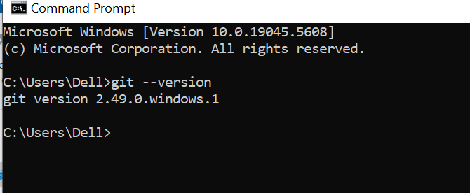

Git Init

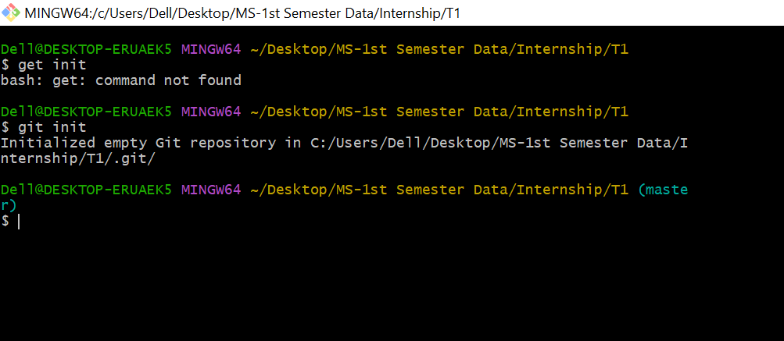

Git Add and status

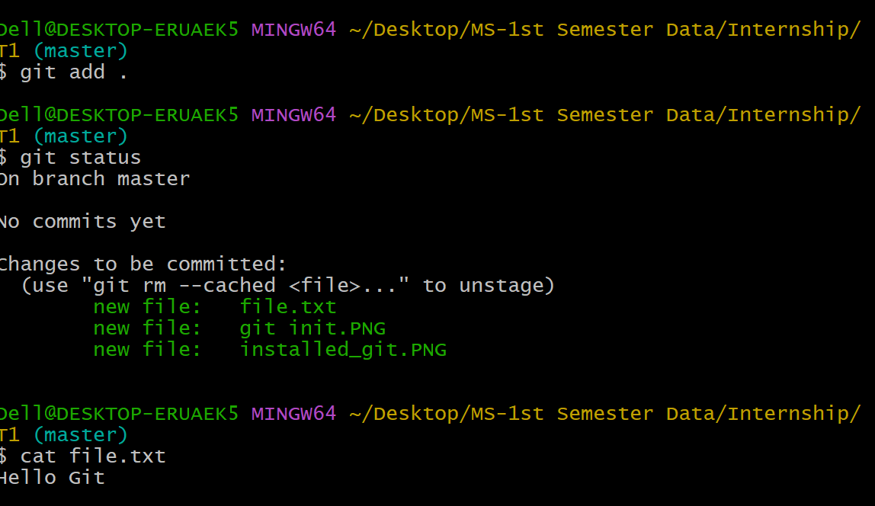

Git Commit and log

