This SER provides the specific vendor data for (35) oscillators manufactured by Q-Tech under contract to SWRI for the Deep Impact Program. Three oscillator characteristics are reported on here. They are : a) initial offset from the nominal operating frequency of 48.000000 MHz, b) the amount of frequency drift in the oscillators over a 24 hour period and c) the frequency shift in the oscillators as a function of temperature.
The vendor “post seal” serial numbers are #8279 through #8314, with the exception of #8297 which exhibited out of tolerance conditions during testing. Five figures are included in this SER and Oscillator #8297 is excluded from each of them.
This SER will also show verification for all oscillators to the requirements document FBBS 3.2.4.1.7.2 which states: ”The oscillator shall have a drift rate of less than 0.12 ppm in 24 hours and a temperature stability of 100 ppm (-55 to +125 deg C).”
Conclusions:
1) All oscillators meet the requirements
2) The drift with temperature plot for each oscillator is nearly sinusoidal for each. By limiting the range of interest to between –19 and +53 deg.C, the plot of change per degree C can be made linear with a small amount of error.
3) Oscillators #8306, #8290 and #8309 are of special interest since they are located in SCU’s FM001, FM002 and FM003 respectively.
4) This SER will help answer the DI system questions of how stable the Impactor VTC will be before and after Flyby/Impactor separation.
5) Related SER’s: SC-CDH-011, IMP-CDH-003, and SYS-GEN-011.
Figure 1 Initial Offset Discussion:

The initial offset values of parts/million (ppm) or usec/sec are from data taken at 25°C. Three different 25°C readings were supplied by the vendor as taken over a time period of about 3 months during different test phases for the oscillators. The values used for Figure 1 were the latest ones taken. The worst oscillator shows an offset or “initial accuracy” of about –13ppm (Osc. #8309) or about ½ of the specified 25ppm. This offset represents a constant timing error or bias to the VTC time being accumulated. A 1.0 ppm offset would produce a 0.0864 second error over 24 hours.

Figure 2 Aging Drift Discussion:

This figure shows the aging drift of the oscillator in ppm/day. Vendor supplied data was actually accumulated over a 15 day period at 70°C, where the frequencies were read at the beginning and end of that time. The data was simply divided by 15 to give a per day estimate. The worst case for the oscillators (Osc. #8283) for the 15 days was –0.56 ppm. The specified aging for 30 days at 70°C is 1.5 ppm. Since the early drift is typically worse than the drift after more aging, doubling the –0.56 ppm to –1.12 ppm as a 30 day estimate is conservative and within the 1.5 ppm allowed (meets specification).

Figure 3 and Figure 4 Temperature Drift Discussion:

Figure 4 shows the actual frequency change for a typical oscillator (#8279 for this figure) over the full -55°C to +125°C. It’s a nearly sinusoidal response over this entire range, but to simplify the calculations over our relatively narrow range of interest, the negative slope from -19°C to +53°C is used and considered linear over that range. This linear approximation for Oscillator #8279 is also shown on Figure 4.

Doing this for all oscillators produces the results shown in Figure 3. As can be seen from this figure, most oscillators are in the vicinity of –0.65 ppm/°C shift. This information together with the initial offset at 25°C and the operating temperature environment of a specific oscillator will allow a predicted frequency based on temperature to be estimated.

Figure 5 Total Temperature Range Stability Discussion:

Even though Figure 3 shows the temperature drift values that will be used for all oscillators, the question of whether or not the oscillators meet the specified temperature stability of 100 ppm over the specified full temperature range of -55°C to +125°C needs to be answered. Figure 4 shows the variation of oscillator frequency over this temperature range and the number of data points supplied by the vendor. This was for an individual unit, but all (35) units showed this same curve shape.

Using this plot data for each oscillator unit, the maximum and minimum data points were differenced and plotted in Figure 5. This figure shows the overall drift for the oscillators to range from about 49 ppm to about 62 ppm. All meet the specification of 100 ppm.

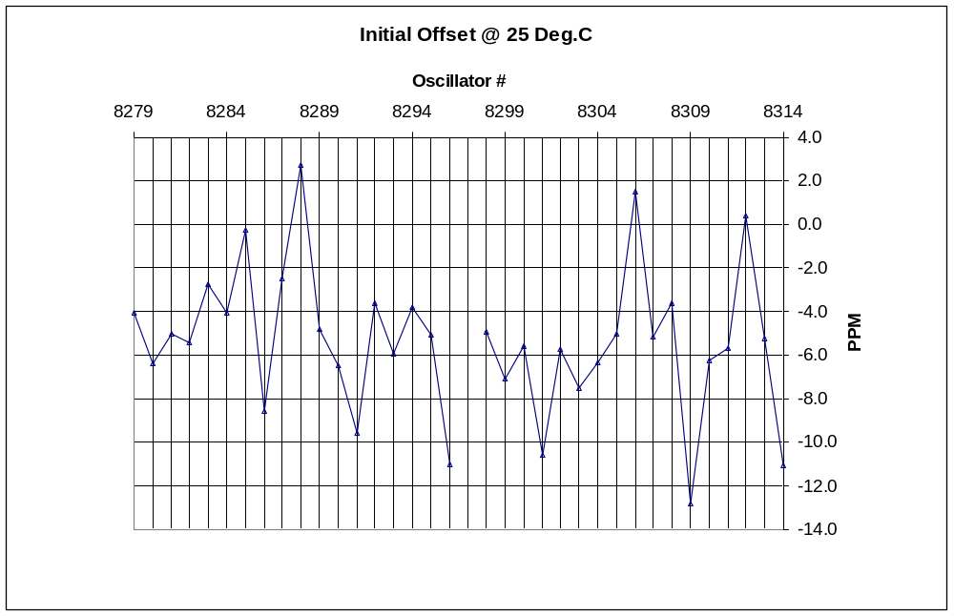

Figure 1 – Initial Oscillator Offset

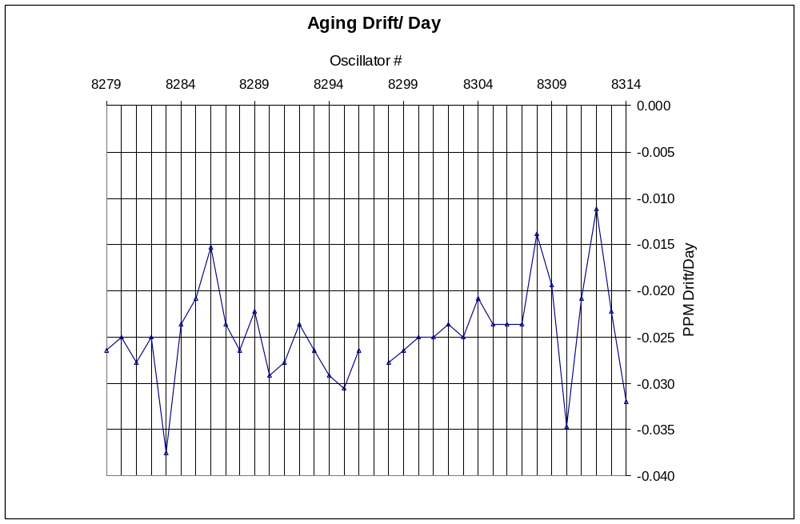

Figure 2 – Oscillator Aging Drift per Day

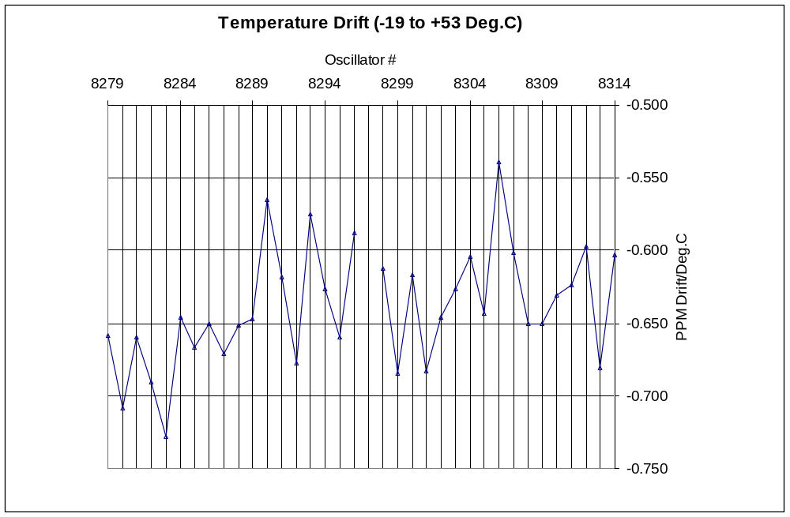

Figure 3 – Oscillator Limited Range Temperature Drift (-19 Deg.C to +53 Deg.C)

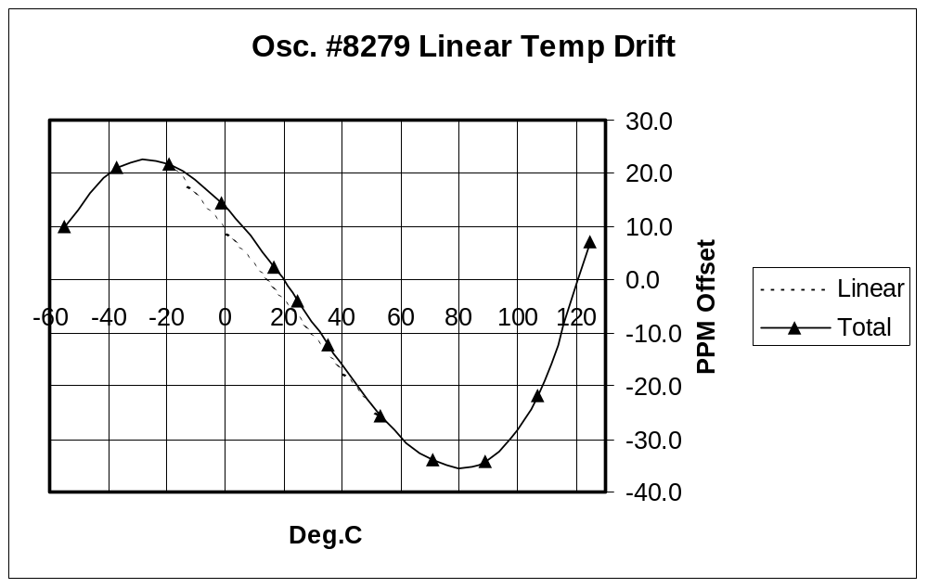

Figure 4 – Oscillator #8279 Temperature Drift from –55 to +125 Deg.C

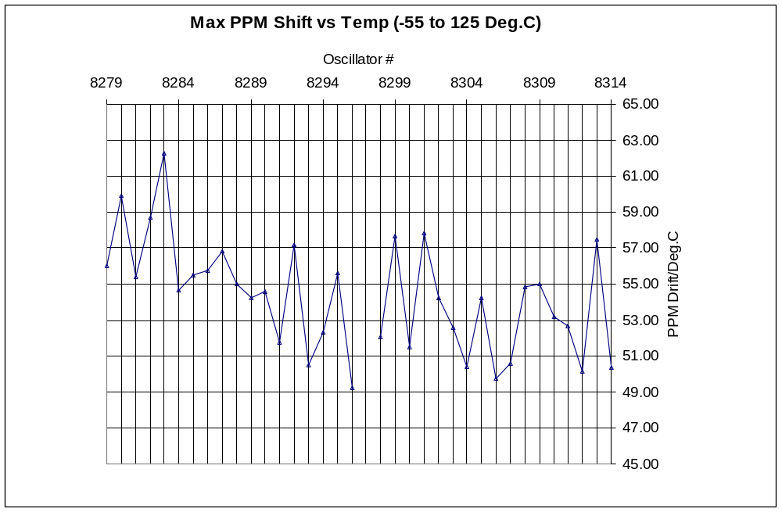

Figure 5 – Oscillator Total Temperature Shift (-55 Deg.C to +125 Deg.C)

