Deep Impact Spacecraft Clock Correlation
Brian Carcich
13.April, 2006

Abstract
Based on the available spacecraft data and advice from spacecraft engineering personnel, the earth/flyby clock correlation is good to one or two seconds, and the inter-spacecraft clock correlation is good to half a second.
For the purposes of this archive, we have adjusted the earth/flyby spacecraft clock correlation to agree with an interpolation, over the encounter period, of available earth/flyby timing correlation data, and we have adjusted the earth/impactor spacecraft clock correlation to agree with the flyby correlation on the Time Of Impact to within 60ms. The spacecraft-to-comet trajectory kernels have been adjusted to agree with these timing correlations.
It may be possible in the future to adjust the spacecraft clocks' correlations up to perhaps two seconds using the available temperature history of the spacecraft control unit baseplate as an analog for the spacecraft clocks' oscillators.

Introduction
This document summarizes the rationale for the archived correlations between the Deep Impact (DI) Flyby and Impactor Spacecraft Clocks (SCLKs) and Dynamical Barycentric Time (TDB) that are encapsulated in the SPICE SCLK-Kernel files in the PDS archive of DI data. This document also explains why the clock correlation was changed about 2 seconds, retroactively, shortly after impact with comet 9P/Tempel 1.

Background
The correlation between real time TDB and spacecraft clock time is essential to mission data analysis. The correlation, expressed as rates between known points in both time systems (SCLK & TDB), is determined from analysis of spacecraft clock correlation packet data, and made accessible via a standard SCLK versus SpaceCraft Event Time (SCLKvSCET) file in the format of a SPICE SCLK-Kernel. A complete explanation of the SPICE SCLK system is beyond the scope of this document, but is available at the NAIF web site, http://naif.jpl.nasa.gov/naif/doc_C.html as the Spacecraft Clock Required Reading document (sclk.req).
For the purposes of this document, the clock on either DI spacecraft is adequately described as two cascading counters. The "subtick" counter runs from 0 to 255 at about 256Hz and therefore overflows about once every second. The "tick" counter runs from 0 to [2^32 - 1] and increments every time the "subtick" counter overflows. This discussion will mostly focus on the "tick" count. However, it should be noted that the SCLK time is represented as strings of digits representing the two counters, separated by a period (e.g. "173727702.100"). It should also be noted that the separator is not a decimal point, and that the SCLK string 173727702.1 represents the same time as 1773727702.001, but a different time than 17727702.100.
In the formal SPICE system, there is also a partition prefix in the SCLK time (e.g. "1/0173727702.100"), but the partition may be ignored for the purposes of this document. As noted above, more information is available in the NAIF/SPICE Spacecraft Clock Required Reading document.
Shortly before launch in mid-January, 2006, the mission clocks' tick counts were set to be the number of seconds since the J2000 epoch (01-Jan-2000 12:00:00 UTC or +64.184s TDB). The Flyby clock's drift, i.e. the difference between SCLK tick and TDB rates, was about one second per day, and the Flyby clock ran slower than TDB. That is, the difference [TDB - SCLK ticks] increased about one second per day.
Based on the appearance of the impact flash in flyby images at encounter, the Time Of Impact (TOI) was 173727702.218 on the Flyby clock. Based on geometric analysis by Dennis Wellnitz of the Impactor's final encounter images TOI was 173727875.105 on the Impactor clock.
It should also be noted that there might be a delay between the actual impact and the appearance of the impact flash; co-investigators on the project have estimated this delay could be as large as 200ms.

Discussion
During DI operations, the spacecraft was commanded to generate clock correlation data from time to time. The periods between successive correlations ranged from a few days to five weeks.
The Flyby SCLK correlation points closest to TOI are on DOYs 164 and 187, over twenty days before and two days after TOI. The Impactor SCLK correlation point closest to TOI is on DOY 164, over twenty days before TOI.
Based on interpolation between the Flyby SCLK correlation points, one of which is within two days of TOI, the Flyby-determined TOI of
173727702.218 +/- ~6 subticks

corresponds to

2005-185 05:44:34.265 UTC +/- 25ms

at the Flyby spacecraft. Light travel time means the impact actually took place 2ms earlier.
Based on that work, the NAV team adjusted the Impactor ephemeris so that TOI occurs at 05:44:34.200, and the clock rate of the Impactor SCLK-Kernel was adjusted so that the Impactor-determined TOI of
173727875.105 +/- ~77 subticks

corresponds to

2005-185 05:44:34.200 +/- 300ms

The 63ms of difference between the final correlations was due to a slight mis-communication, and it was declared by the Principal Investigator that this was close enough.

The Two-Second Shift
During mission operations, the project generated updated versions of the SCLK-Kernel files as clock correlation data became available. Due to operational restrictions, interpolation could not be used in these project kernels between the most recent correlation point and the previous point. Instead, the project used extrapolation, which process, when coupled with other restriction, caused artifacts in the correlation.
Here is a brief summary of the origin of the artifacts from the DI Flyby SCLK-Kernel file by Boris Semenov of JPL:
Traditionally the SCLK correlation function provided in the SCLKvSCET file had to comply with two requirements (in order to maintain correct tagging/sorting by UTC in the ground system):

- The correlation must be continuous, and
- The must be backward compatible (meaning that drift rates for the past epochs must not change).

To achieve that every update of SCLKvSCET introduced two points: one "real" data point with actual estimated drift and one "artificial" data point about 5000 seconds before the actual point with a bogus drift rate, just to connect the previous trend with the new one in a continuous fashion.

Arguably, the right thing to do to make the SCLK kernel better reflect real clock trend was to have the ``artificial'' points dropped and change coefficients of the ``real'' points to ``connect'' the real points into a continuous piece-wise line function. This way the drift rates that were initially estimated slightly incorrectly would be changed to make the correlation match the reality better.

Exactly this was done to the final official SCLKvSCET to get the modified version that used to produce this SCLK kernel.

Figure 1 presents a plot of (TDB - SCLK ticks) illustrates these processes graphically; it shows TDB advancing about one second per day relative to the flyby SCLK, as noted above.
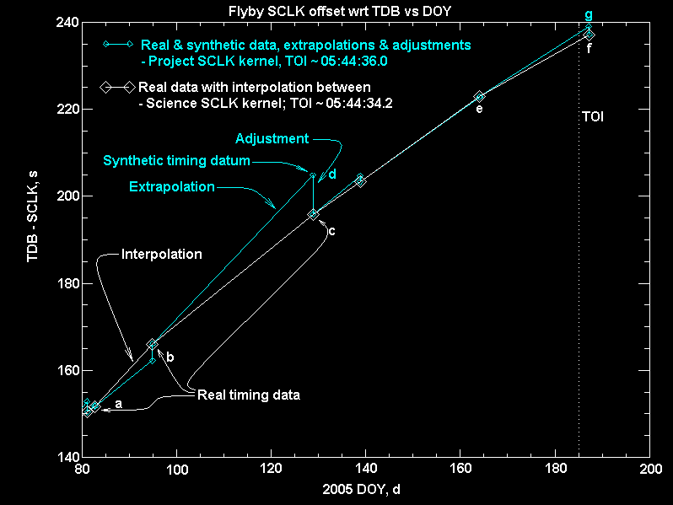
Figure 1. A plot of the TDB minus SCLK ticks, showing the TDB advancing about one second per day relative to the flyby SCLK.
The white curves and points show what Boris Semenov calls the "right thing to do" i.e. a piecewise linear interpolation between known points.
The cyan plots represent the project's synthetic approach to the data points. For more details of how this was done, see "Operational Approach to SCLKvSCET File Creation" below.
During encounter, the white segment "ef" represents the interpolated science correlation, and the cyan segment "eg" represents the extrapolated project correlation. At the Time Of Impact (TOI), the difference is about two seconds between the extrapolated and interpolated correlations.

Operational Approach to SCLKvSCET File Creation
Focusing on the interval from DOY 095 through 129, the actual correlation points available to the project during that interval were "a" on DOY 083 and "b" on DOY 095. Using those two points, the project calculated the segment "ab" by interpolation, and extrapolated that line forward in time past DOY 095 (cyan segment "bd" and beyond) for operational use. When the correlation point "c" became available on DOY 129, they created the correlation point "d" about 5000 seconds before "c" as an artifice to (1) maintain backward compatibility as noted above (i.e. to not change any SCLK to SCET conversions performed using segment "bd"), and (2) terminate the previous extrapolation from "b". They also created the segment "cd" to (1) bring the operational correlation back to a real datum, and (2) maintain a continuous correlation.

The Temperature Monkey Wrench
The SCLK oscillator rates are dependent on temperature, and Figure 2 presents two plots that indicate the approach and encounter temperature history of the SCUs. The time coverage is from about DOYs 170 through 187.
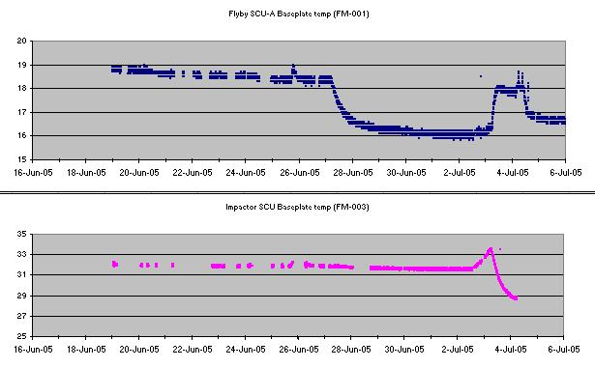
Figure 2. Two plots illustrating the temperature history of the SCUs for the approach and encounter phases of the mission.
There are also ground-based data that show the effect of temperature on the oscillator frequencies. The Figure 3 presents a plot that show the relative offset between the two spacecraft clocks during approach and encounter. Note that this plot is the offset of one spacecraft's SCLK relative to the other, and does not involve TDB or UTC. The point to be made here, however, is that both Amy Walsh and Brian Carcich have verified that the temperature variations around encounter, coupled with the effect of temperature on oscillator frequency, may account for the single blue point labeled "Possible bad point ..." and one second or more of uncertainty with respect to TDB and UTC.
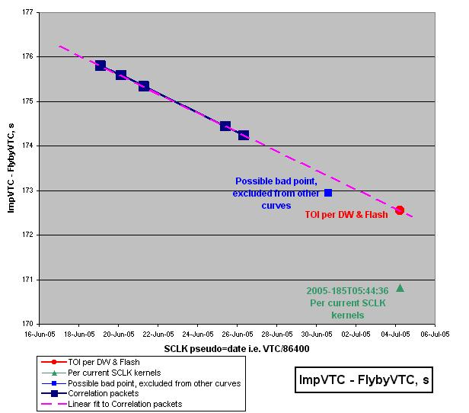
Figure 3. A plot showing the relative offset between the two spacecraft clocks during approach and encounter.

