Position Paper

**Author: Dr Kevin R Bond**

**Goal**: To get Delphi/Object Pascal/Pascal back into Education.

**Background**: The decline of Delphi in education.

**Reasons for the decline**:

1. Dwindling supply of Delphi/Object Pascal/Pascal-trained educators:
   1. Educators with knowledge of Delphi/Object Pascal/Pascal have retired.
   2. Fewer universities[1] teach Delphi/Object Pascal/Pascal, instead they teach one or more of the following C#, Java, Python, Julia, C, C++, Javascript, Ruby, Haskell, F#, Scheme, Scala, Erlang, Rust, Lisp, VHDL, Verilog, assembly languages.
   3. Pre-university courses (in the UK: GCSE Computer Science; A Level Computer Science) specify specific languages and Delphi/Object Pascal/Pascal is not one of them.
   4. Large corporations such as Microsoft, Oracle, Google have a direct influence on which programming languages are taught in universities through their funding of university research and indirectly through the market place (bigger demand for C#, Java, C++).
2. Competition from other languages
   1. Python is the dominant text-based programming language in schools for the age range 11-16 in UK and in other countries – see [EU Code Week](https://codeweek.eu/training/creative-coding-with-python) - that have taken the lead from the UK (Strongly influenced by Computing at School organisation, Raspberry Pi foundation and Engalnd’s Computing National Curriculum).
   2. Computer Science teacher training predominantly Python.
   3. Java indirectly via Greenfoot and Stride - [Greenfoot](https://www.greenfoot.org/door), [Stride | Programming Education Blog (kcl.ac.uk)](https://blogs.kcl.ac.uk/proged/category/software-tools/stride/).
   4. Java and Python indirectly via Karel the Robot, Karel J Robot (originally designed to teach structured programming in Pascal) - [karel.pdf (nclab.com)](https://nclab.com/wp-content/media/2018/09/karel.pdf) – it has moved from procedural to OOP and now back to procedural. MontyKarel teaches dynamic object-oriented programming in Python.
   5. Low or zero probability of encountering Pascal/Delphi on the numerous education online websites for learning programming, e.g.
      1. <https://projects.raspberrypi.org/en/codeclub>
      2. [The World Wide Web Consortium (W3C) | edX](https://www.edx.org/school/w3cx)
      3. <https://edu.google.co.uk/resources/programs/exploring-computational-thinking/index.html#!ct-materials>

**Reversing the decline**:

1. Education in schools/colleges/universities strongly influenced by
   1. Curriculum controllers
      1. Government education departments.
      2. University departments (Computer Science, Sciences, teacher trainers).
      3. Examining Boards (in UK: AQA, OCR, CIE, EDUQAS, WJEC, SQA).
      4. Qualification authorities (in England, OfQual; in Wales, Qualification Wales; in Scotland, SQA; in Northern Ireland, CCEA).
   2. Local government/local education authority advisors (Computing and IT advisors).
   3. Organisations
      1. In UK:
         * Computing at School (CAS) – <https://www.computingatschool.org.uk>;
         * Raspberry Pi foundation – <https://www.raspberrypi.org>;
         * Digital School House – <https://www.digitalschoolhouse.org.uk>;
         * BCS – <https://www.bcs.org>.
      2. In USA: Computer Science Teachers Association (CSTA) – [https://csteachers.org](https://csteachers.org/).
      3. In New Zealand: Computer Science Association of New Zealand – https//www.csanz.ac.nz; CS4S Teachers Network - <https://www.cs4strust.org.nz>.
2. Need for evangelists in the right position to influence teachers/lecturers
   1. Teacher trainers in education departments (a good example is Bertie Butentag, South Africa).
   2. Local education leaders (in UK they are called Subject Advisors and are employed by the local Education Authority).
   3. Hub leaders of a local computing hub.
   4. Teachers/Lecturers from the school sector and university sector with an enthusiasm for outreach work.
3. Need a resource pack for outreach work differentiated by age range and a project that can be engaged with out of school – see the history of Greenfoot, Professor Michael Kolling’s initiative, for how to do it (I have an unfinished project called Blackfoot based on Delphi[2].
4. Need to provide support
   1. Teachers/Lecturers
      1. Access to quality structured learning
      2. Access to resources to enable this learning
         * Delphi development system
         * Other, e.g. Lazarus and FreePascal
         * Online community forum for teachers
      3. Community hubs for teachers both online and in person
      4. Certification on completing course
      5. Accredited teacher specialists/hub leaders
5. Need website targetted at education that showcases and presents the case for using Object Pascal, lists resources that are available to get started with Pascal/Object Pascal/Delphi, e.g.
   1. PascalABC.NET- <https://pascalabc.net/en/>
   2. OnlineGDB - <https://www.onlinegdb.com/>

The teaching of computing in schools is relatively new, with limited research informing what to teach and how in upper secondary contexts.

Many countries have increased their focus on computing in primary and secondary education in recent years and the UK and Ireland are no exception. The four nations of the UK have distinct and separate education systems,

**RESEARCH-ARTICLE**

November 2019

Published By ACM

##### [**An International Comparison of K-12 Computer Science Education Intended and Enacted Curricula**](https://dl.acm.org/doi/10.1145/3364510.3364517)

* [Katrina Falkner](https://dl.acm.org/profile/81100603132),
* [[Author Picture](https://dl.acm.org/profile/81493659866)Sue Sentance](https://dl.acm.org/profile/81493659866),
* [Rebecca Vivian](https://dl.acm.org/profile/81555337056),
* [Sarah Barksdale](https://dl.acm.org/profile/99659350142),
* + 6

[Koli Calling '19: Proceedings of the 19th Koli Calling International Conference on Computing Education Research](https://dl.acm.org/doi/proceedings/10.1145/3364510)November 2019, Article No.: 4, pp 1–10<https://doi.org/10.1145/3364510.3364517>

This paper presents an international study of K-12 Computer Science implementation across Australia, England, Ireland, Italy, Malta, Scotland and the United States. We present findings from a pilot study, comparing CS curriculum requirements

SIGCSE

ITCSE

ITiCSE

ISSEP

Karel

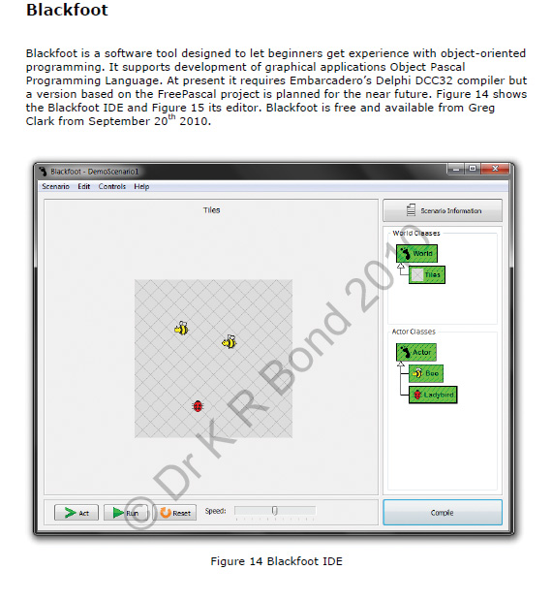

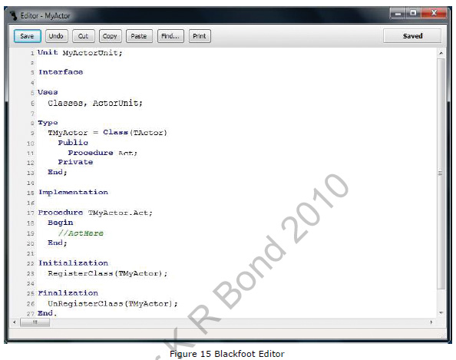

1. Delphi/Object Pascal/Pascal has disappeared from UK universities. Universities in Brazil, a big market for Delphi, are beginning to move away from Delphi.
2. See end of document.