Avoiding Plagiarism

Introduction

When writing your book, it’s important to ensure everything you write is completely original and not lifted or copied from elsewhere. We run every chapter from every book through anti-plagiarism tools designed to detect duplicated material. These tools search both the Internet and previously published books to help us produce the most valuable titles possible. We take a zero-tolerance approach to plagiarism, and so if you are discovered to be passing off other people’s content as your own, your contract will be cancelled, and any advances already paid to you will be recouped. There may be times, however, that you wish to legitimately use content from elsewhere in your book, such as quotes or images. In such instances, we decide what is acceptable on a case-by-case basis.

What is plagiarism?
Quite simply, plagiarism is using content that has been written and published (whether freely online, or in a market publication) by someone else. It can include a direct copy of text and images, and can even include text that has been structurally derived from someone else's work.
Plagiarism can be of one of the following types:
- Intentional – directly and knowingly using someone else's work.
- Accidental – often, an author may have reproduced someone else's work being unaware of plagiarism.
- Coincidental – technical writing will have very similar steps to other written works at times.
- Patch writing – taking someone else's writing and simply re-wording it.
- Self-plagiarism – copying your own work published elsewhere! This one is important – we need to have full copy-ownership of any material for the book.
All of these above mentioned types of plagiarism should be kept to a minimum or be simply non-existent (especially intentional).

About Quotes
Quotes can be included in our books, but we have to be careful about where we source them from and how lengthy they are. While it is natural to want to include someone else's words with attribution, this might not be as clear-cut as you might think. After all, if they said it and we cite our sources, what’s the problem?
Unfortunately, if the text you want to cite is from copyrighted material — like a book from a different publisher — then we might not be legally permitted to reproduce it, even with adequate attribution. If ever there’s anything you want to quote, your best bet is to speak to your editor and ask for their advice. They’ll be able to look into the specifics and see how much we’re able to include in your book. Additionally, one sure-fire way to guarantee we’re making the right decisions is to simply get in touch with the original author and copyright holder and request their permission to include a quote of theirs. Your editor will be able to walk you through this process.

Images
Images always help our books to stand out and look more emotive. Oftentimes, you might find an image online that you want to include in your work. Unfortunately, a lot of images available online are copyrighted, just as text is, and so they cannot simply be copy/pasted and included in your manuscript. If you do find an image that you’d like to reproduce, please consult the Image Guidelines that accompany this document in your author bundle, which will help you decide how to proceed. As always, if there’s anything you’re unsure about, you can consult your editor.

Image Plagiarism Guidelines
While writing your book, you might find that you want to include images to help\ add context to your work. We always encourage visual aids if it builds upon the message you’re trying to convey to the reader and to diversify the content. When seeking images from online, however, there are a few things we need to keep in mind. Images, just like text, can be subject to copyright, which might restrict what we can or can’t use. As we’re a commercial entity, we can’t easily justify Fair Use in our books, either. This short guide should give you a quick idea about how we should approach images, as well as how to find royalty-free replacements.

Have you found an image online?
If there’s an image you’ve found online and you would like to include it in your book, the first thing you should do is try to find out what kind of license it holds. Some
websites, like Wikimedia Commons, make this really easy – there’s a box right under the image that tells you exactly what you’re able to do with it. For other websites you might need to dig around to find the terms of service or similar copyright pages. Have a look through these and see how liberally they allow the use of their content. One thing you need to keep an eye out for is confirmation that we can use the content commercially.

Free to use content
If the content is free to use, in the public domain, or has a license attached to it that allows us to use it, such as Creative Commons licenses, then fantastic! Be aware though, some might have asterisks attached, such as the following Creative Commons ShareAlike license:
Under the following terms:
Attribution – You must give appropriate credit, provide a link to the license, and indicate if changes were made. You may do so in any reasonable manner, but not in any way that suggests the licensor endorses you or your use.

ShareAlike – If you remix, transform, or build upon the material, you must distribute your contributions under the same license as the original.

No Additional Restrictions – You may not apply legal terms or technological measures that legally restrict others from doing anything the license permits.

As a rule of thumb, we should always attribute the source where we found the image even when the license doesn’t require us to: it’s just good practice.
As a rule of thumb, we should always attribute the source where we found
the image even when the license doesn’t require us to: it’s just good Wikimedia
The easiest and most hassle-free way to include images in our book, however, is to find royalty-free images online. There are a number of ways to go about this. The first is to find a free image library online. Simply Googling “free image library” will turn up a number of results -- make sure you always check the terms of use for any images you like the look of, as some might have special restrictions attached to them.
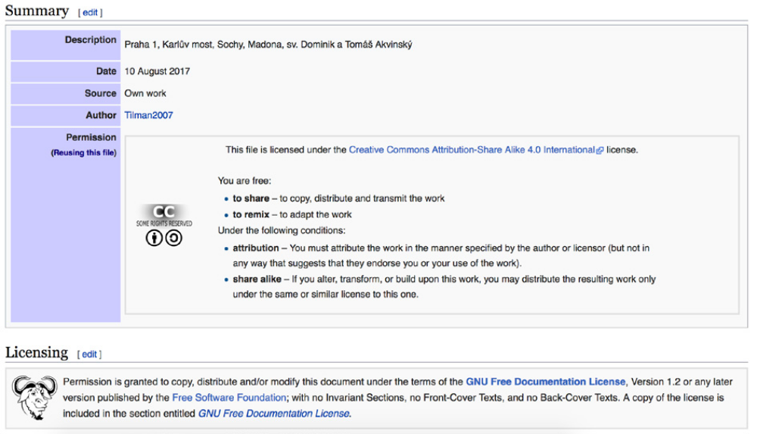practice.
One of the more useful image libraries that will have minimal restrictions attached to the material you might want to use is Wikimedia Commons: commons.wikimedia.org. Everything here is uploaded by volunteers, and almost all of it is free to reuse. Whenever you find an image you like, just scroll down to see what the license requirements underneath are.

Google Search
An alternate method to find free images is to refine your settings after making a Google search. Doing this is easy:

- Go to images.google.com
- Search for the item you want to find a replacement image for (for example, “Raspberry Pi Zero”)
- Click “Settings” at the top and navigate down to “Advanced search”
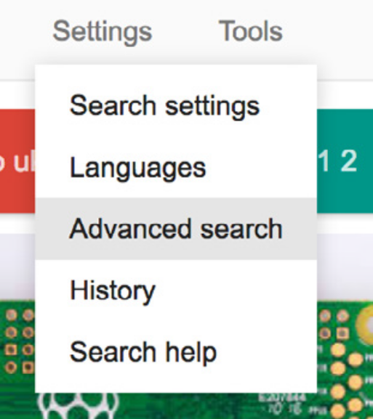
- From here, scroll to the bottom and find the “usage rights” dropdown. Click on this and select the bottom option, “free to use, share or modify, even commercially” (it’s imperative that you click the “even commercially” option as this will change the permissions of certain images).
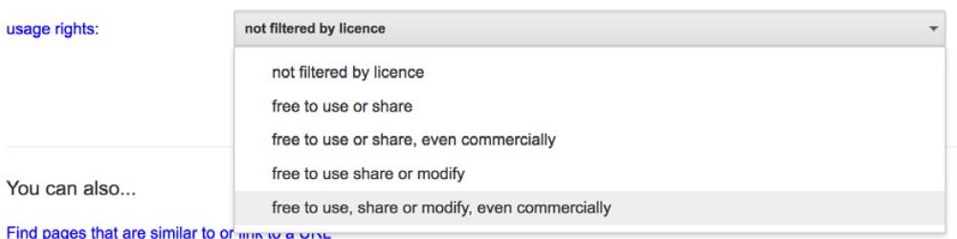

Hopefully, using all of the above methods, you will be able to find plenty of useful free images that can add real value to your book.

Self-plagiarism
It’s not uncommon to want to include work you’ve already written in your book. Perhaps this is a blog post or tutorial you wrote, or maybe it was something you’ve previously had published. There are certain considerations you may have to make when reusing previously written material. Firstly, if there is anything that you’ve had published elsewhere, the chances are that you don’t own the copyright for it, and it instead belongs to the publisher. In cases like this, there’s no option available to reproduce your content with us, as we wouldn’t be legally permitted to do so.
Where non-copyrighted work is concerned, however, there are still reasons why we shouldn’t recycle content. We want to make sure that all the books we publish provide a value for your readers that can’t be found elsewhere, especially for free. Many people who buy your book might have already read blog posts you have previously written, and some might have even enjoyed your past work so much that they decided to go out and buy your book! If they then discover that they have paid money for something they have already read for free, this could result in your work being negatively reviewed online, which will harm sales. Consequently, we can’t permit self-plagiarism, even when it’s legally acceptable.

Tips to avoid plagiarism
There's plenty you can do to avoid accidentally copying someone else's work.
Never copy and paste anything into your chapters. Always write something by yourself.
Copying text in and adapting it is largely just paraphrasing.
Write your own instructions. Even if the steps are the same, you want to instruct the reader on how to do them in your own words.
Criticize any materials you are using in your research – how can you make it better? Add value! It'll make your book more successful and unique. Open-source documentation is usually detailed but often poorly structured, especially when used in a book format.
Structural elements count too. Lay things out differently. Have they used a paragraph to explain something? Could you use bullet points instead? Always think about new, better ways to present information.
Furthermore, always consider your audience. We've developed a book idea with you that may be wildly different from the intended audience of another media form.

