Chapter 3: Advanced React Patterns
In this chapter, we’ll explore advanced React patterns combining hooks, state management, and performance optimization techniques. You’ll learn how to build scalable applications using modern React best practices.
In this chapter, you will learn about:
- Understanding React rendering behavior and optimization strategies
- Implementing advanced hook patterns for complex state management
- Choosing the right state management solution for your application
- Performance profiling and optimization techniques
- Building reusable custom hooks

Introduction
Modern React applications require careful consideration of performance, state management, and code organization. This chapter provides comprehensive guidance on advanced patterns that will help you build production-ready applications.

React Rendering Optimization
Understanding how React renders components is crucial for building performant applications. The following diagram illustrates the component rendering lifecycle:
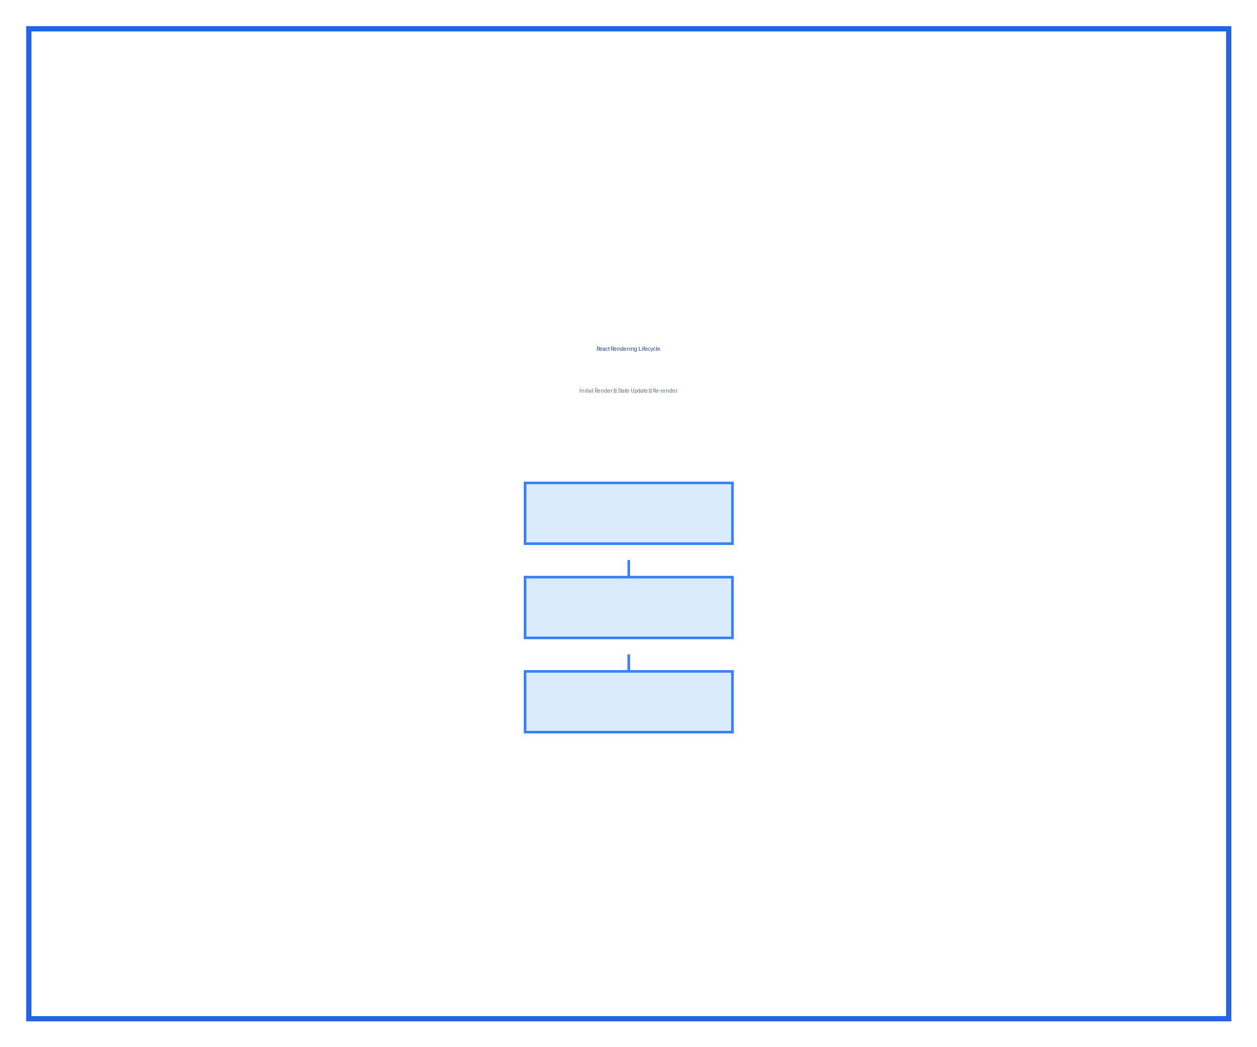
React rendering lifecycle showing initial render, state updates, and re-render cycle
Figure 3.1: React component rendering lifecycle and optimization points

Rendering Behavior Comparison
Different React features have varying impacts on rendering performance. The following table compares common optimization techniques:
Table 3.1: React rendering optimization techniques comparison
Technique | Use Case | Performance Impact | Complexity
React.memo | Pure functional components | High (prevents re-renders) | Low
useMemo | Expensive calculations | Medium (caches values) | Medium
useCallback | Callback prop optimization | Medium (prevents recreation) | Medium
Code splitting | Large applications | High (reduces bundle size) | High
Virtual scrolling | Long lists | Very High (only renders visible) | High

Custom Hooks Architecture
Custom hooks allow you to encapsulate and reuse stateful logic across components. The architecture diagram below shows the relationship between components and custom hooks:
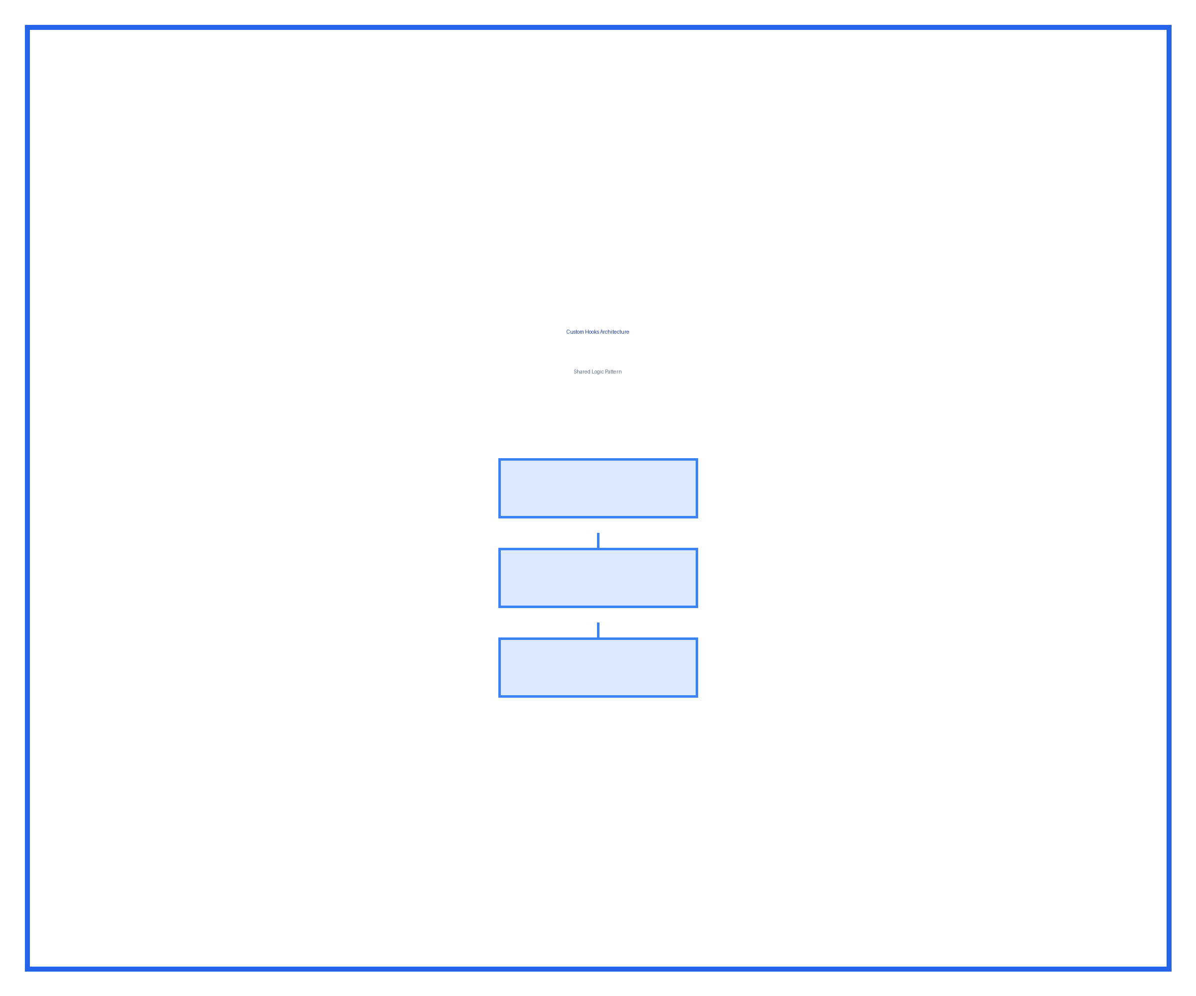
Architecture diagram showing custom hooks sharing logic between multiple components
Figure 3.2: Custom hooks architecture pattern

Hook Pattern Comparison
Table 3.2: Custom hook pattern comparison
Pattern | Best For | Reusability | Testing
useState wrapper | Simple state logic | High | Easy
useReducer wrapper | Complex state transitions | High | Easy
useEffect wrapper | Side effects | Medium | Moderate
Compound hooks | Multiple concerns | Medium | Complex

State Management Solutions
Choosing the right state management solution depends on your application’s complexity and requirements:
Table 3.3: State management solution comparison
Solution | Learning Curve | Bundle Size | DevTools | Best For
useState | Easy | 0 KB | React DevTools | Local state
useReducer | Easy | 0 KB | React DevTools | Complex local state
Context API | Easy | 0 KB | React DevTools | Prop drilling avoidance
Redux Toolkit | Moderate | 12 KB | Redux DevTools | Global state, time-travel
Zustand | Easy | 3 KB | Redux DevTools | Simple global state
Jotai | Easy | 5 KB | Basic | Atomic state
Recoil | Moderate | 21 KB | Excellent | Derived state graphs

State Management Decision Tree
The following flowchart helps you choose the appropriate state management solution:
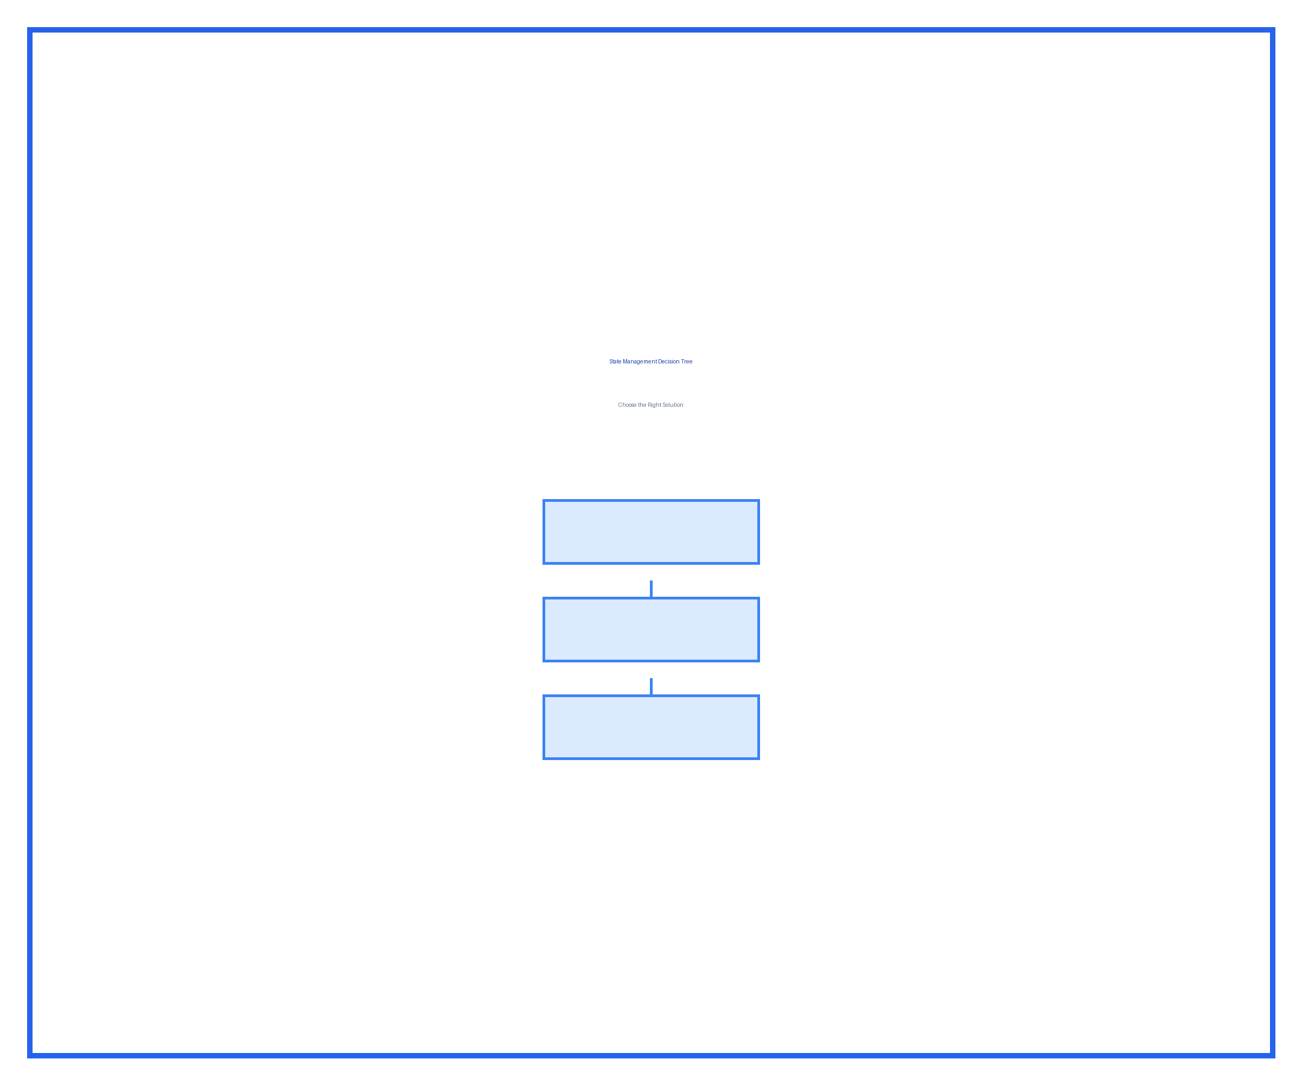
Decision tree flowchart for selecting state management solution based on app complexity
Figure 3.3: State management selection decision tree

Performance Profiling
Understanding your application’s performance characteristics is essential for optimization. The following table outlines key performance metrics:
Table 3.4: React performance metrics and thresholds
Metric | Good | Acceptable | Poor | Tool
Initial Load (FCP) | < 1s | 1-2s | > 2s | Lighthouse
Time to Interactive (TTI) | < 2s | 2-4s | > 4s | Lighthouse
Component Render Time | < 16ms | 16-50ms | > 50ms | React DevTools Profiler
Bundle Size (gzipped) | < 100 KB | 100-200 KB | > 200 KB | webpack-bundle-analyzer
Re-render Count | < 3 | 3-5 | > 5 | React DevTools Profiler

Profiling Workflow
The diagram below illustrates the recommended workflow for performance profiling:
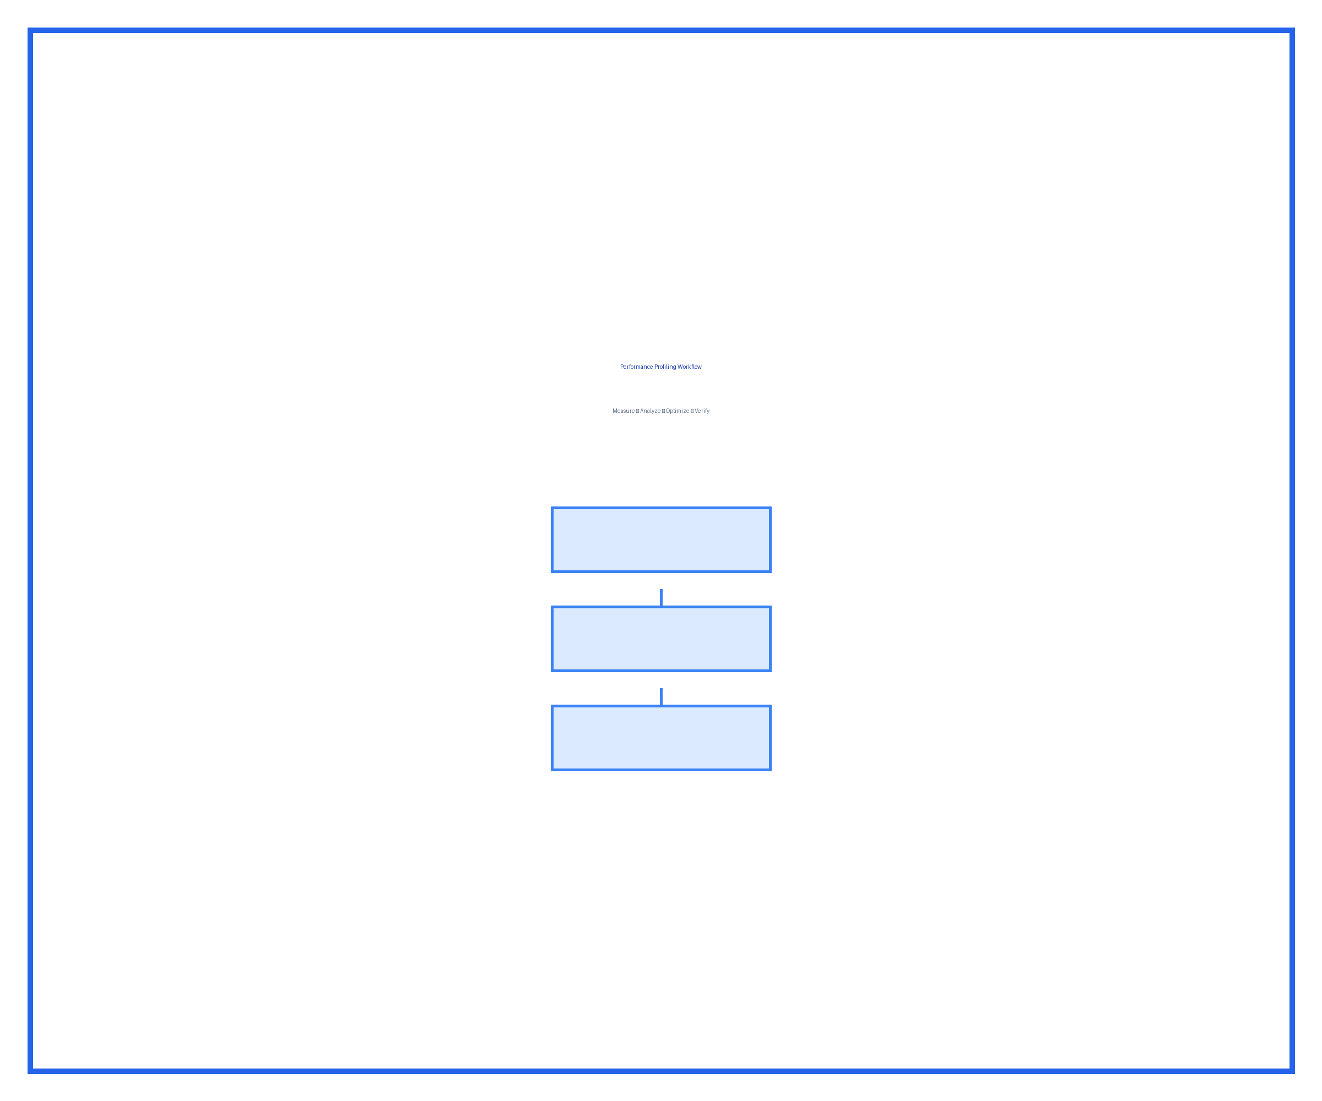
Performance profiling workflow showing measure, analyze, optimize, and verify steps
Figure 3.4: React performance profiling workflow

Code Examples

Example 1: Optimized Component with Memoization
import React, { memo, useMemo, useCallback } from 'react';

const ExpensiveList = memo(({ items, onItemClick }) => {
const sortedItems = useMemo(() => {
return items.sort((a, b) => a.value - b.value);
}, [items]);

const handleClick = useCallback((id) => {
onItemClick(id);
}, [onItemClick]);

return (
<ul>
{sortedItems.map(item => (
<li key={item.id} onClick={() => handleClick(item.id)}>
{item.name}
</li>
))}
</ul>
);
});

Example 2: Custom Hook for Data Fetching
import { useState, useEffect } from 'react';

function useDataFetch(url) {
const [data, setData] = useState(null);
const [loading, setLoading] = useState(true);
const [error, setError] = useState(null);

useEffect(() => {
fetch(url)
.then(res => res.json())
.then(json => {
setData(json);
setLoading(false);
})
.catch(err => {
setError(err);
setLoading(false);
});
}, [url]);

return { data, loading, error };
}

Implementation Checklist
Before implementing advanced React patterns, ensure you have the following prerequisites:
- Node.js 18+ installed
- React 18+ in your project
- Understanding of basic React hooks
- Familiarity with JavaScript ES6+ syntax
- Development environment with React DevTools

Step-by-Step Implementation Guide
Follow these steps to implement performance optimization in your React application:
- Profile your application using React DevTools Profiler
- Identify performance bottlenecks by analyzing render times
- Apply appropriate optimization techniques based on the bottleneck type
- Measure the impact of your optimizations
- Iterate if performance goals are not met

Common Optimization Mistakes to Avoid
Be aware of these common pitfalls when optimizing React applications:
- Over-optimizing components that render infrequently
- Using useMemo/useCallback without measuring benefit
- Creating too many custom hooks leading to abstraction complexity
- Ignoring bundle size while focusing only on render performance
- Applying optimizations before profiling

Best Practices Summary
The following table summarizes the key best practices covered in this chapter:
Table 3.5: React best practices summary
Category | Best Practice | Why It Matters
Rendering | Use React.memo for expensive components | Prevents unnecessary re-renders
State | Keep state as local as possible | Reduces complexity and re-renders
Effects | Clean up side effects properly | Prevents memory leaks
Hooks | Extract reusable logic to custom hooks | Improves code reusability
Performance | Profile before optimizing | Ensures optimization efforts are targeted
Bundle Size | Use code splitting for large apps | Improves initial load time

Summary
This chapter covered advanced React patterns for building performant, scalable applications:
- React rendering optimization techniques and when to use them
- Custom hooks architecture and patterns for code reusability
- Comprehensive comparison of state management solutions
- Performance profiling workflow and key metrics
- Best practices for production React applications
In the next chapter, we’ll explore testing strategies for React applications, including unit tests, integration tests, and end-to-end testing.

Questions and Answers
- When should I use React.memo versus useMemo?
  - React.memo prevents component re-renders, while useMemo caches computed values within a component.
- How do I choose between Context API and Redux?
  - Use Context API for simple prop drilling avoidance; use Redux for complex global state with time-travel debugging needs.
- What is the 16ms render time threshold?
  - 16ms allows 60 frames per second (1000ms / 60fps = 16.67ms), ensuring smooth user experience.
- Should I always optimize my components?
  - No, profile first. Premature optimization adds complexity without measurable benefit.
- How many custom hooks is too many?
  - Focus on reusability and single responsibility; there’s no hard limit, but excessive hooks may indicate over-abstraction.

