Dustin R. Callaway
2832 North 550 West · Pleasant Grove, UT 84062
Home: (801) 796-3438 · Mobile: (801) 709-3182
E-mail: drcallaway@gmail.com

EXPERIENCE SUMMARY | I have a broad technical background ranging from Java/JEE programming to Microsoft .NET development to Android mobile applications. With more than fifteen years of comprehensive Web/backend development experience, I have designed, developed, and deployed many successful Internet solutions using JEE (servlets/JSP/EJB/REST/SOAP), ASP.NET (C#), and HTML/JavaScript/Ajax. I am well versed in database and application server technologies and I am the author of the book Inside Servlets: Server-Side Programming for the Java Platform published by Addison-Wesley. | 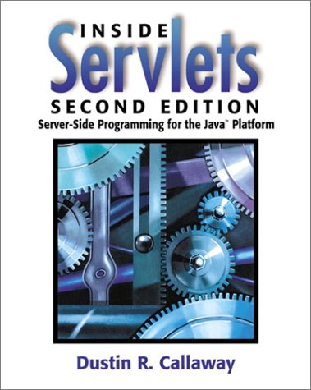

PROFESSIONAL  EXPERIENCE | Staff Software Engineer, Intuit, Inc., Orem, Utah March 2007 – Present  • Developed content driven architecture for next generation TurboTax product  • Created RESTful web service to manage debit card accounts (integrated with Visa service)  • Created scalable email management system for managing email campaigns  • Co-developed an Android application for managing TurboTax debit cards  Staff Software Engineer, Sybase, Inc., Orem, Utah June 1999 – March 2007  • Developed, deployed, and maintained complex J2EE-based online banking systems  • Designed and developed an online check register used by E*TRADE, Bank of America Military Bank, First Tennessee Bank, Citizens Bank, and others  • Designed and developed the Content Aggregation Server – a product that aggregates content from several service providers and returns the result within a single XML response  Senior Consultant, Uinta Business Systems, Inc., Orem, Utah May 1998 – June 1999  • Developed Internet/intranet applications using Java servlets, JDBC, and RMI  • Created high availability Web sites with the Sun NetDynamics application server  • Built and deployed an online voting system for the BYU student elections  • Developed various Java applications including an automated SMTP mail host, Java GUI protocol troubleshooting utility, and Java HTTP server  Senior Web Developer, Nu Skin International, Inc., Provo, Utah May 1997 – May 1998  • Developed Internet/intranet applications in Java, WebLogic Application Server, and Oracle  • Created Java servlets for web-enabling various Human Resources functions  • Re-wrote much of the company’s 100% Java server architecture (converted to Servlet API)  • Provided consulting and training for Visual Basic and Access to other teams  Senior Consultant, Provider Solutions, Inc., Provo, Utah Feb. 1996 - May 1997  • Developed client/server applications using Visual Basic 4/5, Access 95/97, and Oracle 7  • Performed project management and analysis responsibilities on many projects  • Taught Microsoft Certified Visual Basic and SQL Server courses  • Developed and maintained the company intranet  Consultant, Systems Resources Consulting, Inc., Chicago, Illinois Feb. 1995 - Feb. 1996  • Developed client/server applications using Visual Basic 3/4, Access 2/95, and SQL Server  • Designed and created a variety of business databases in Microsoft Access

EDUCATION | Bachelor of Science, Brigham Young University, Provo, Utah  Major: Computer Science  Major/Overall GPA: 3.65/3.55 (4.0 scale) | August 1994

WEB SITE | Current resume and personal profile are available at http://www.sourcestream.com/.

