Outline

1. Model set-up
   1. Model construct: L = 12288 km, dx = 4 km, dz = 625 m, Q_rad = -1 K/day, T_tpp = 200 K (isothermal above), SST = 300 K, surface “wind” = 3 m/s
   2. Initial environmental sounding: time- and spatial-mean 3D radiative convective equilibrium (RCE) vertical profile of T and q
   3. Initial disturbance: column saturated (keeping Tv constant) with scales [km] 0 < r < qr0, 1.5 < z < 9.375
   4. Look at GRADIENT winds
2. Strong sensitivity to domain size 🡪 CTRL L=12288 km to avoid any “artificial” influence of outer wall
3. Control run: L =12288
   1. Evolution
      1. Genesis: day 5-10
      2. Overshoot
         1. Vmax: day 10-15, ~10%,
         2. Rmax, r0: day 5-25, ~100%
      3. Quasi-linear decay to equilibrium
         1. Vmax: day 15-40
         2. Rmax, r0: day 20-60
4. Equilibrium storm sensitivity: GRADIENT Vmax, rmax, r0 (calculated from r12),
   1. Equilibrium = first 30-day period with absolute slope < 1% of mean per day
   2. Model-specific
      1. dx
      2. dz
   3. Model/environmental
      1. l_h
   4. Environmental/Initial
      1. Vpot
      2. f
      3. Initial disturbance
         1. mid-level moisture anomaly
            1. horizontal scale: qr0
            2. amplitude: qrh
         2. mid-level vortex
            1. horizontal scale: r0
            2. rmax/r0
   5. Conclusions: equilibrium storm sensitive only to Vpot/f; l_h somewhat too, though this is true for r12 and less so for model r0
5. Genesis storm (First time where Vmax = Equilibrium Vmax) sensitivity: same as III
   1. **Preliminary conclusions: Large moisture anomaly can generate large transient storm; not sure yet of interplay between moisture and mid-level vortex**

Sensitivity of time scales to equilibrium?

“Overshoot”

II. Sensitivity to domain size

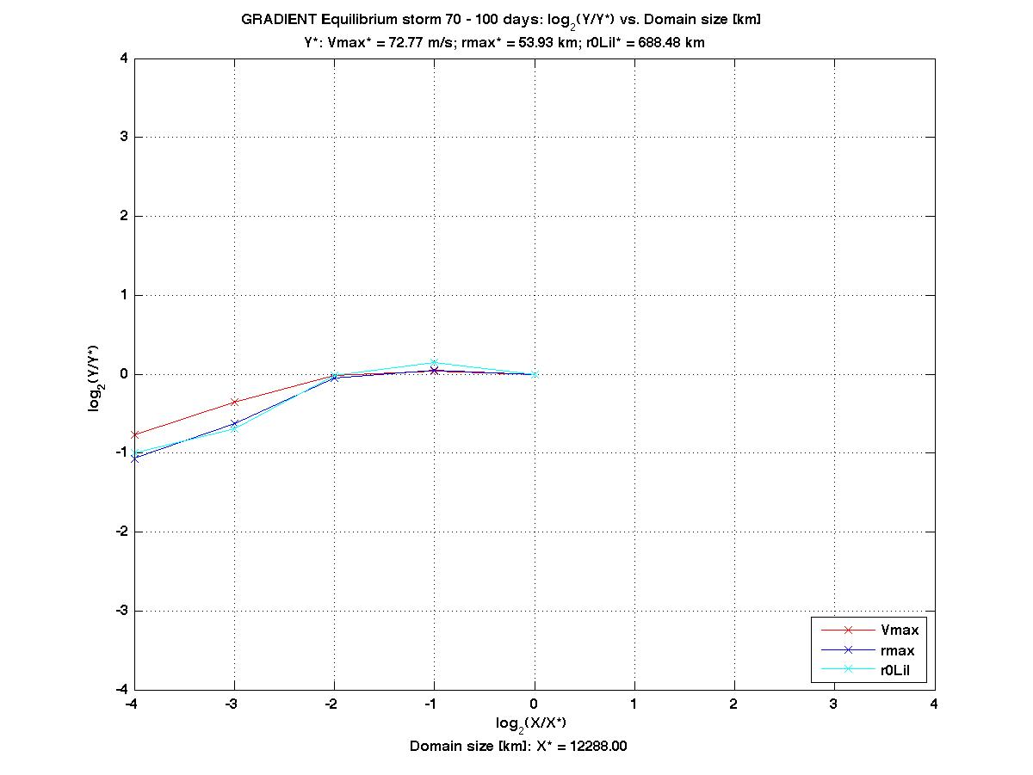

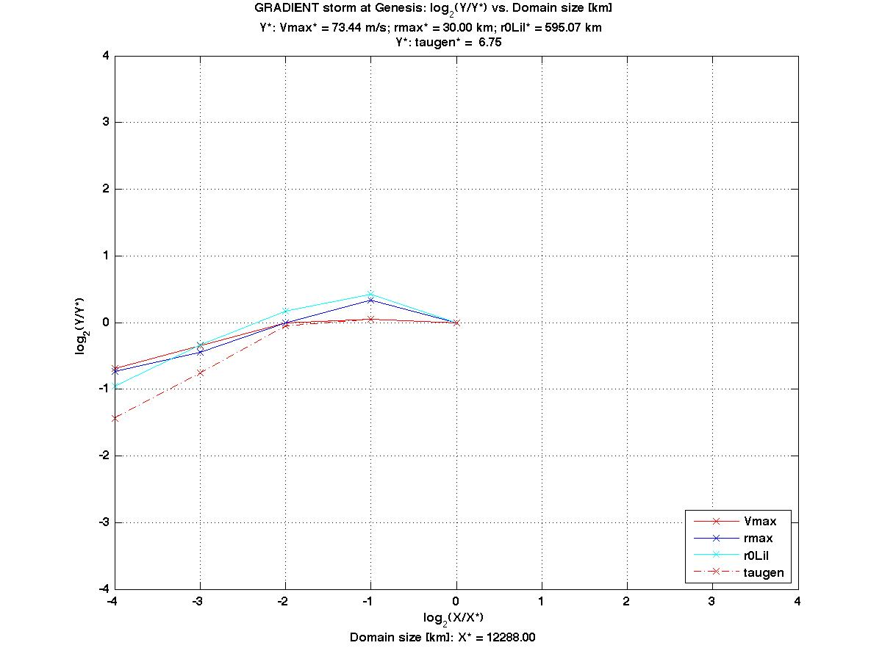

III. Control run evolution

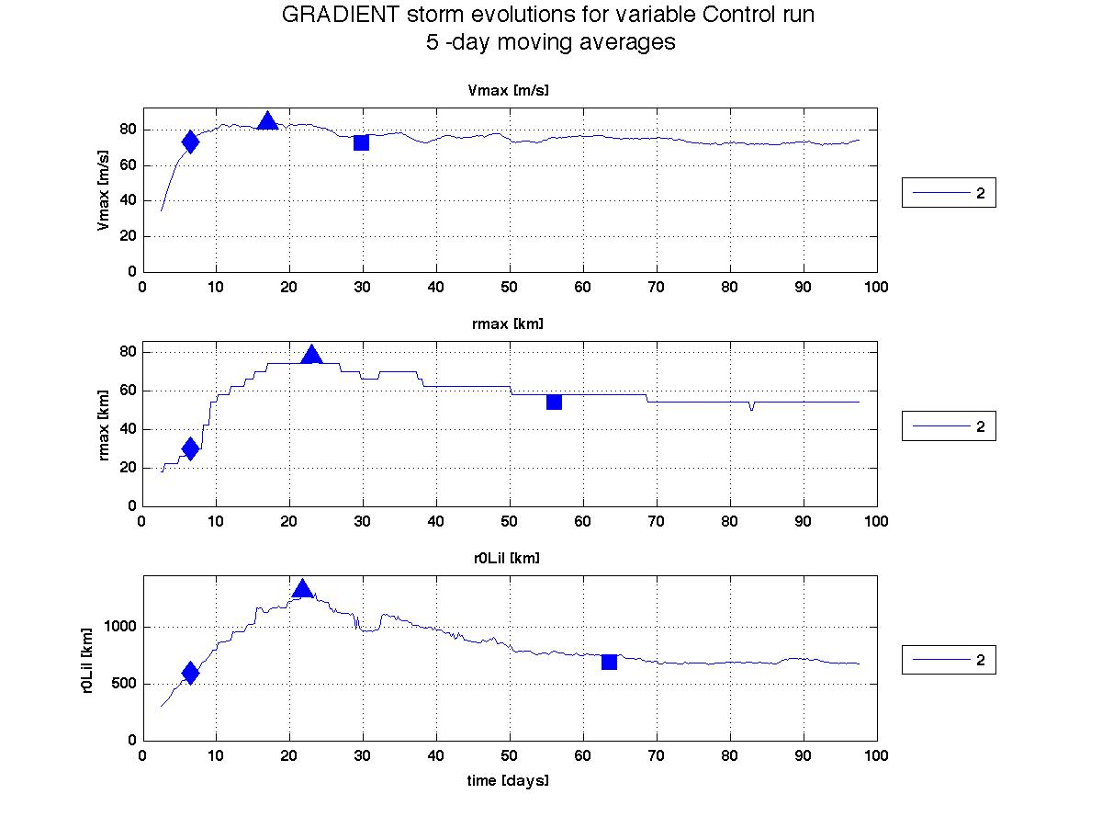

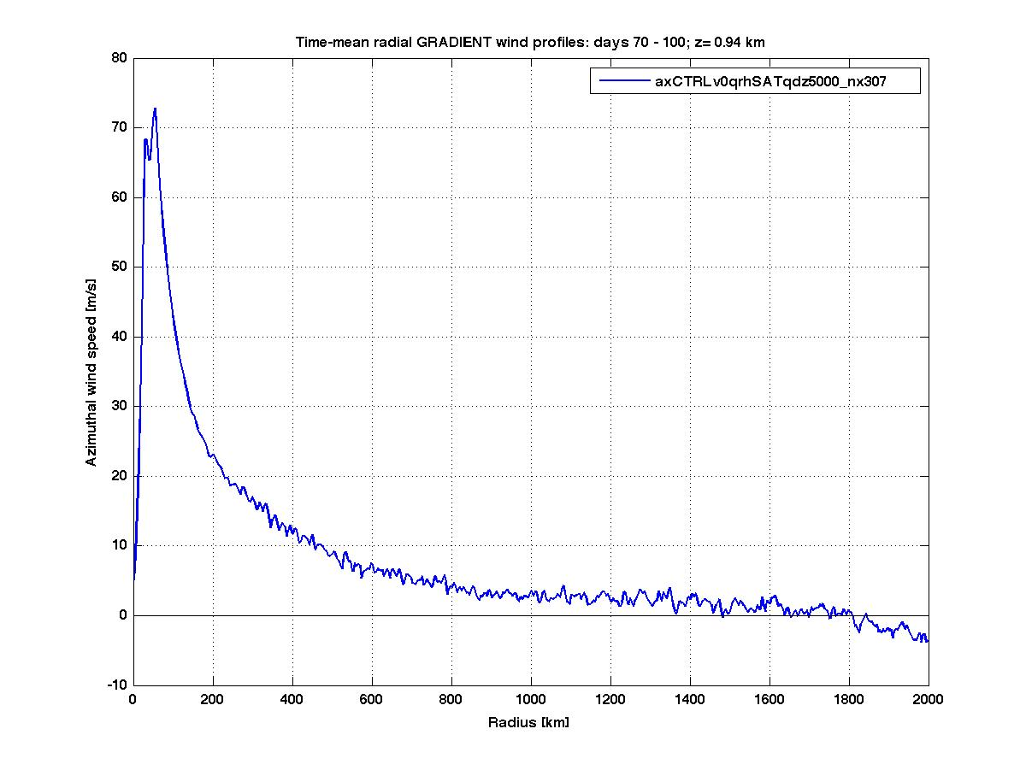

IV. Equilibrium storm sensitivity

Vpot

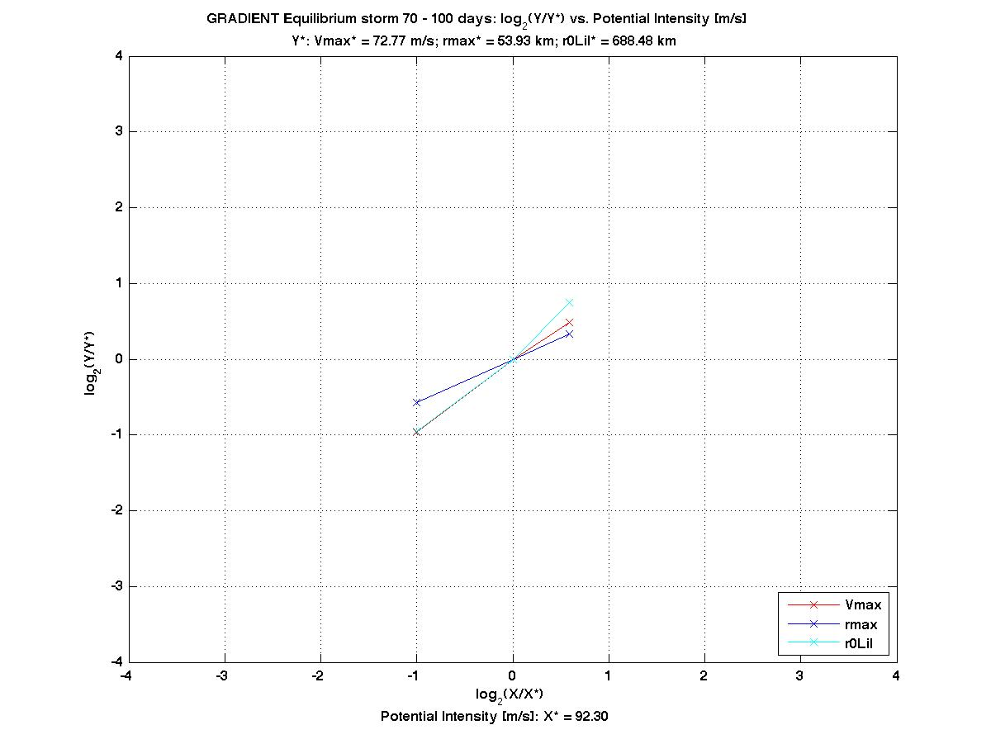

f

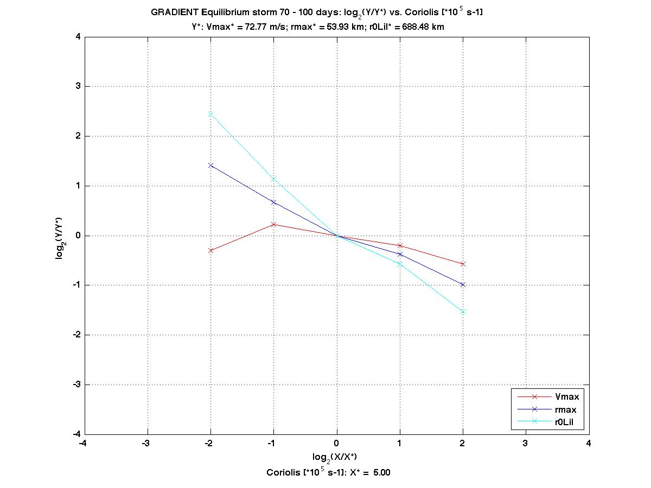

qro

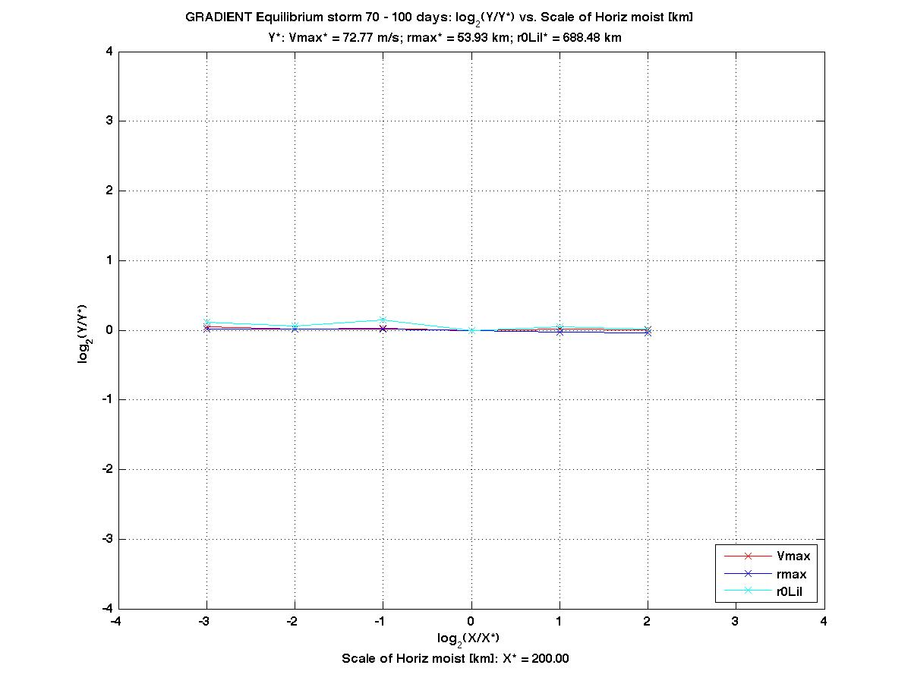

lh

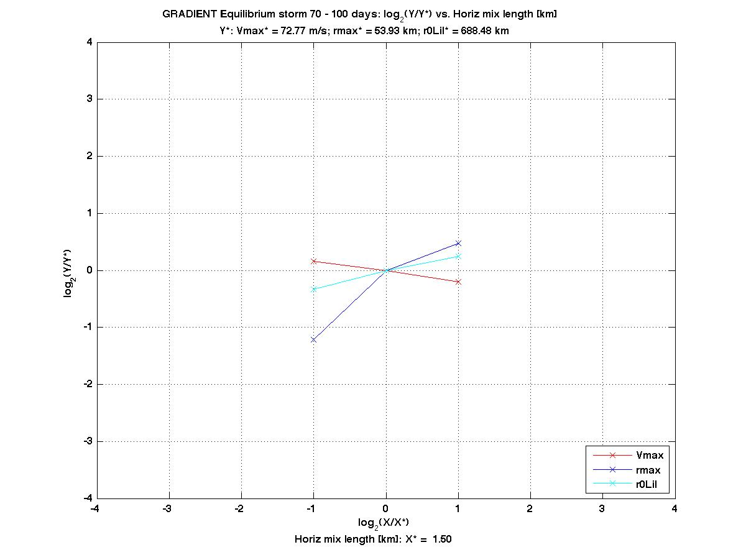  
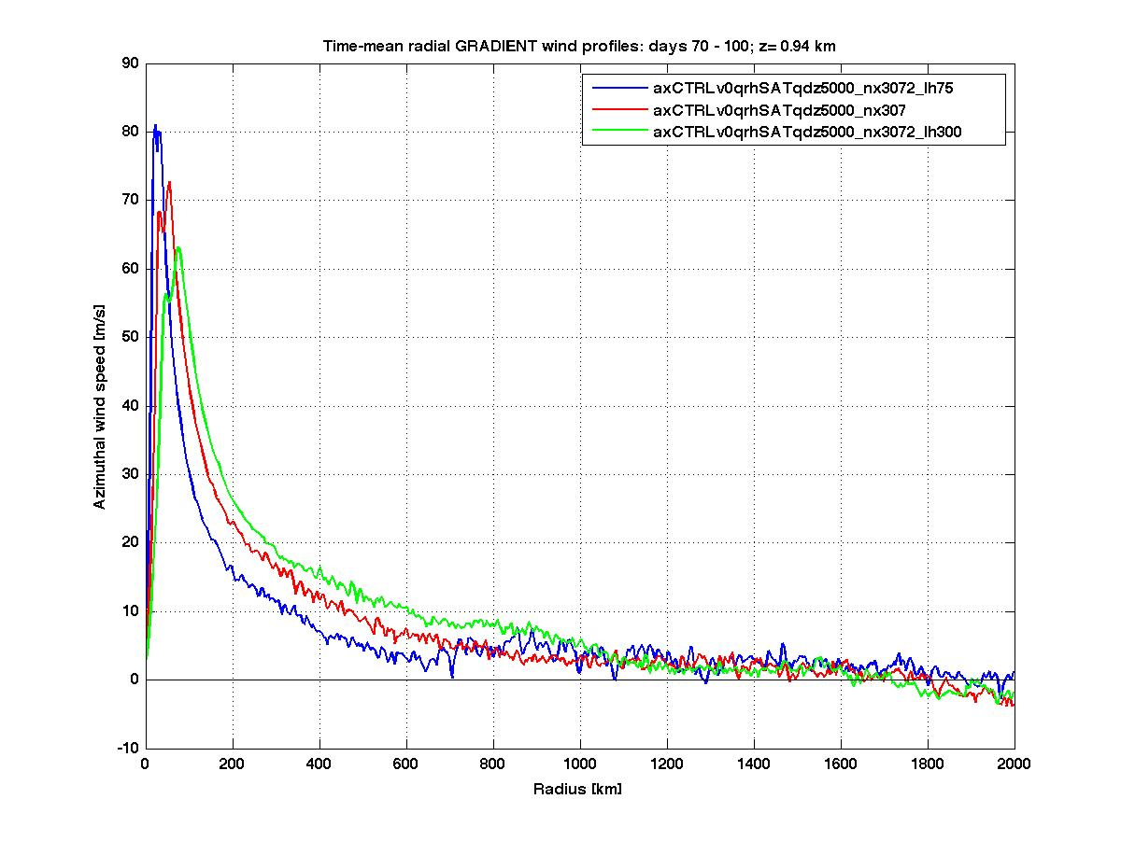

V. Genesis storm sensitivity

qro

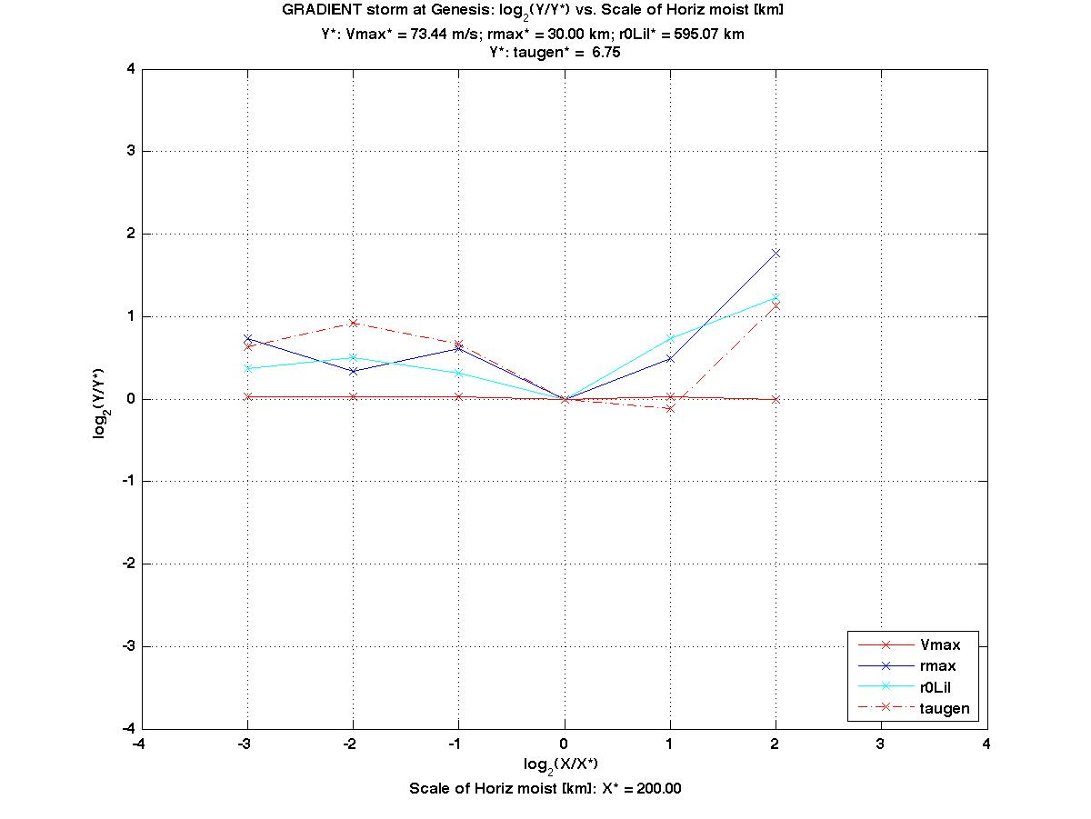

lh

