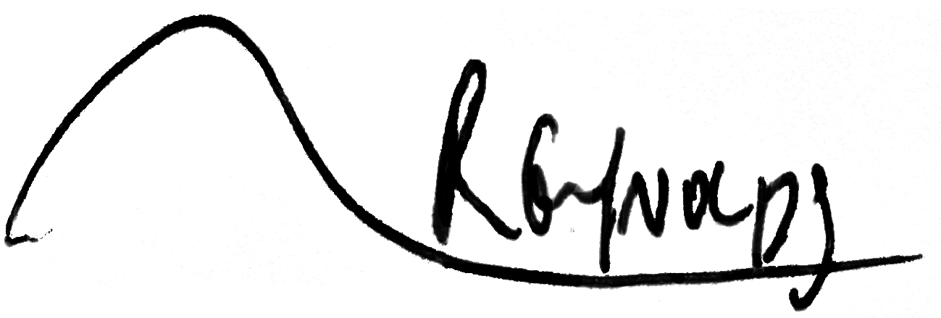

**Imperial Post-Doctoral, Post-CCT Research Fellowship (IPPRF)**

**IPPRF Application form**

**The IPPRF application process consists of *two stages*. Stage 1: Applicants must first gain support from the proposed ‘host’ Department in the Faculty of Medicine, Imperial College London using this form before proceeding to Stage 2 and finalising and submitting their Job applications. Please refer to the guidance notes before submitting your application.**

Deadline for submission of completed IPPRF application forms to Imperial Departments is**:**

**Monday 27 January 2020, 17.00hrs**

*(Following approval from the Department, please submit your IPPRF application form, CV and Job Application form via the Job Applicants section of the Imperial website by* ***Monday 24 February 2020 midnight****, Vacancy Reference:* **MED01594*)***

**Section 1**

To be completed by **Applicant, host Department Research Manager and Head of host Department**

**Application Summary**

|  |  |
| --- | --- |
| Name of Applicant including title | Dr Carl Jonathan Reynolds |
| Current Institution / Employer | Imperial College Healthcare NHS Trust |
| Clinical Specialty and CCT Date | Respiratory and general internal medicine. August 5th 2020 |
| Date PhD Obtained | *\*PhD to have been submitted by the time of application and awarded before starting the post, please state here date of submission and viva if required* |
| Address  (for correspondence) | 18 Heron Drive, N4 2FX |
| Email | Carl.reynolds@imperial.ac.uk |
| Telephone | 07737 904 807 |
| IPPRF Project Title | Idiopathic pulmonary fibrosis job exposures study (IPFJES) |
| Proposal Start Date | *1st September 2020*  *\*Projects must start between 1 September 2020 and 31 March 2021* |
| Signature of Applicant: Date: 26/01/2020 | |

|  |  |
| --- | --- |
| **Head of Department Approval** | |
| Name | Professor Edwin Chilvers |
| Department | NHLI |
| Faculty | Faculty of Medicine |
| Supervisor (name of proposed supervisor and host lab) | Professor Paul Cullinan |
| Research Division/Section | Respiratory/Genomic and Environmental Medicine |
|  | |
| *I understand that this scheme does not provide funds for the full economic cost of the research proposed and will not be responsible for continued support past the fellowship and that any costs around the ending of employment that result (directly or indirectly) in consequence of the scheme's limited fixed funding will need to be borne by the employing department/division.  By signing this form the Head of Department is agreeing to fund 50% of the award should the application be successful.*  Signature of Head of Department: Date: | |
| Signature of Departmental Research Manager: Date: | |

*Electronic signatures are permitted*.

**Section 2**

To be completed by **Applicant**

**Funding Requested**

2.1)Total Research expenses for the duration of the 2-year Fellowship *(based on an upper limit of £20k total)*

|  |  |  |
| --- | --- | --- |
| *Category* | *Breakdown by item headings* | *Category Total* |
| ***Research***  (to include equipment, **consumables, etc..** where required) | Taqman assays to NLRP3 SNPs e.g rs38529419 and smoking associated SNPs e.g rs16969968  Whole exome sequencing a sample of IPFJES participants | £8000  £8000 |
| ***Other/Miscellaneous***  (please describe) | Travel and subsistence costs for visits to collaborating centres and training in MR and bioinformatics | £4000 |
| Grand Total | | **£20000** |

2.2)Justification for requested support *(Reasons for the budget requested. Include details of how funds will be obtained to support the research costs not covered by the Fellowship if necessary). Max 1 side A4.*

|  |
| --- |
| It will be necessary to genotype participants in IPFJES for a panel of smoking susceptibility SNPs in order to carry out a mendelian randomisation study. Whole exome sequencing is likely to be a more general and useful approach but it will be helpful to validate this in a sample of participants in the first instance before obtaining further funding and scaling up. It will be valuable to gain experience of MR and bioinformatics by visiting centres of excellence such as Bristol and Cambridge. |

2.3)Salary costs*(Please insert a copy of the ‘InfoEd Recovery page’ created by the Host Department to show calculation of total salary costs relating to the applicants proposed 2-year post).*

|  |
| --- |
| Consultant salary |

##### Section 3

To be completed by **Applicant** - Please complete questions 3.1-3.6 and expand as necessary to a maximum of 4 pages

**Research Proposal**

|  |  |
| --- | --- |
| 3.1)Research question / Aims *(what are the key questions that you wish to answer)*  From lab bench to work bench: Do variants within NLRP3 inflammasome related genes alter the risk of Idiopathic Pulmonary Fibrosis (IPF) in patients with occupational exposure to asbestos or crystalline silica? | |
| I hypothesise that occupational asbestos and respirable crystalline silica induced activation of the NLRP3 inflammasome causes IPF via IL-1beta stimulated MUC5b hypersecretion in smokers. To test this I will apply a validated job exposure matrix to case-control study data from the Idiopathic Pulmonary Fibrosis Job Exposures Study. I will genotype the same cohort for the key MUC5b promotor polymorphism rs35705950, for polymorphisms in the NLRP3 inflammasome genes Nalp3, caspase-1, and IL-1beta, associated with enhanced IL-1beta release, and polymorphisms in genes associated with cigarette smoking. Because polymorphisms are randomly distributed in the population (mendelian randomisation) any associations with IPF would support a causal relationship providing certain assumptions hold, namely that the genetic variants associate with the risk factors of interest, are independent of the outcome, and only affect the outcome through their effect on the risk factor of interest.[1]  Idiopathic pulmonary fibrosis (IPF) is a progressive, fibrotic lung disease which in 2016 was the recorded cause of death for approximately 5000 people in England and Wales. Its incidence, currently around 7.5/100,000 person-years, has increased by 5% per annum in the period 1979-2016.[2][3] The diagnosis is made when there are characteristic honeycomb cystic changes, called usual interstitial pneumonia (UIP), on high resolution CT or biopsy once known causes of interstitial lung disease (such as drug toxicity, connective tissue disease, domestic, and occupational or environmental exposures) have been excluded.[4] However, a recent meta-analysis of epidemiological studies estimated 26% of cases may be attributable to occupational exposures, including to metal, silica, wood, and agricultural dusts.[5] Asbestosis, silicosis, chronic hypersensitivity pneumonitis, and rheumatoid arthritis-associated ILD can all give rise to UIP[6][7] and the potential for misdiagnosis as IPF is well recognised.[8][9] In light of this there have been calls for the systematic capture of key occupational and environmental data to elucidate specific causal exposures and improve diagnostic specificity.[10]  The ‘Idiopathic Pulmonary Fibrosis Job Exposures Study’ (IPFJES) collected lifetime occupational histories, DNA, and serum for 494 IPF cases and 466 hospital controls to investigate asbestos exposure in the aetiology of IPF. IPFJES was designed to overcome the risk of bias present in previous case-control studies due to low control participation rates and the use of binary self-reported exposure measures, and to permit investigation of gene-environment interaction. Smoking appeared to interact with occupational asbestos exposure to increase risk of IPF in participants carrying one or more copies of the minor allele of rs35705950 (manuscript in preparation), this common variant is the strongest identified genetic risk factor for IPF; minor allele frequency > 0.1 in Caucasian populations, OR 4.84 (95%CI 4.37-5.36, p=1.18x10-203) in a recent genome wide association study (GWAS) meta-analysis (total 2,668 IPF cases and 8,591 controls).[11] Its main effect is to increase airway expression of a distal airway glycopeptide called MUC5b (>30-fold).[12] MUC5b is a dominant constituent of the honeycomb cysts that characterise IPF.[13] It has recently emerged that rs3505950 is also a risk factor for asbestosis[14], chronic hypersensitivity pneumonitis, and rheumatoid arthritis associated ILD.[15]  There is strong intuitive sense for occult occupational inhalation of silica or asbestos fibres being an under-recognised cause of IPF since both are known to be fibrogenic and are frequently used in animal models of pulmonary fibrosis.[16] Interestingly, both silica and asbestos exposure also result in production of IL-1beta, via the NLRP3 inflammasome in a process that appears to be dependant on reactive oxygen species (ROS). IL-1beta is known to be a key proinflammatory cytokine in IPF and a potent stimulus for MUC5b expression.[17] Smoking cigarettes results in ROS exposure and is thought to increase the risk of asbestosis, silicosis, and IPF.[18][19] Of note, the lungs can also be an initiating site of rheumatoid arthritis.[20] Occupational exposure to respirable crystalline silica is associated with an increased risk of rheumatoid arthritis in men[21], and rheumatoid arthritis associated ILD (which causes UIP) is more common in men despite rheumatoid arthritis being more common in women.[22] Genetic variants in the NLRP3 inflammasome (e.g rs35829419) have been found to be associated with increased risks of rheumatoid arthritis[23], asbestosis[24], coal workers pneumoconiosis[25] (which is also associated with a MUC5b promoter SNP[26]), and susceptibility to infection.[27][28]  Additional evidence for the importance of common pathways in UIP-related disease is provided by the demonstration of the effectiveness of the anti-fibrotic nintedanib, a treatment licensed for IPF, in non-IPF UIP[29] and the observation that it is also effective in animal models of silicosis.[30] It is also intriguing that IBD-like colitis has been observed as a side effect of antifibrotic agents; NLRP3 inflammasome variants are strongly implicated in IBD.[31]  In summary, there is (i) recognition that a proportion of IPF is associated with unrecognised occupational exposures; (ii) convergence on the importance of excessive MUC5b expression in several diseases that can cause UIP, some of which e.g silicosis, asbestosis, are occupational; (iii) a plausible biological mechanism, namely alveolar macrophage NLRP3 inflammasome activation and increased IL-1beta expression. The latter leads to increased MUC5b expression, impaired mucociliary clearance, greater alveolar epithelial exposure to injurious agents (infectious or otherwise), and UIP.  Mendelian randomization (MR) is a technique that uses randomly distributed genetic variants as natural experiments to provide evidence about putative causal relations between modifiable risk factors and disease.[1] Through its use of genetic variance it can overcome problems of confounding and reverse causality. MR can be used within a case-control study design to help triangulate suspected causal associations.[32] It could be usefully applied to IPFJES to investigate interactions between occupational silica and asbestos exposure, smoking, and NLRP3 inflammasome variants, with respect to IPF risk, in order to better understand the aetiology of IPF and potentially identify new therapeutic targets.  During my fellowship I will pioneer the use of novel methods in occupational lung disease beginning with mendelian randomisation in IPF to investigate causal occupational exposure-response pathways. | |
| 3.3)Research plan *(Details of routine methods are not required)*  - Occupational phenotyping of IPF; in particular assessing occupational asbestos and silica exposure through well validated quantitative means  - Genotyping IPFJES cohort for SNPs in the NLRP3 inflammasome associated with enhanced IL-1beta release  - Genotyping IPFJES cohort for SNPs associated with smoking  - Exome sequencing IPFJES cohort  - Performing the largest GWAS meta-analysis of IPF to date  - Carrying out the first two-sample MR studies of risk factors in IPF (to isolate the NLRP3 inflammasome) including smoking, gastro-oesophageal reflux disease, iron status, and cytokine profiles in IPF  - Colocalisation study of GWAS NRLP3 inflammasome loci across asbestosis, silicosis, RA, CHP, and IPF  My research plans are deliberately non-sequential. Occupational phenotyping for asbestos and silica will make use of already collected lifetime occupational histories coded to the standard occupational classification 1990 which will permit application of validated job-exposure matrices. DNA has already been extracted for the IPFJES cohort and commercial taqman assays for genotyping my SNPs of interest are readily available. I would arrange exome sequencing externally subject to securing adequate funding. Participants in IPFJES consented for future research including GWAS and collaboration, and data sharing with, commercial organisations. Instruments for performing two-sample MR studies of smoking, GORD, iron status, and cytokine profiles in IPF are readily available from exposure GWAS.[36][37][38][39] Variant summary data from a recent pooled meta-analysis of IPF GWAS is available for academic research on application.[11] | |
| 3.4)Where appropriate, describe the potential impact of the research proposed  Occupational asbestos and crystalline silica exposure is an important cause of respiratory morbidity and mortality in the UK and globally. Insights into exposure-disease relationships including the role of NLRP3 Inflammasome are likely to generalize to other disease areas, inform prevention efforts, and help to identify candidate drug targets. | |
| 3.5)Describe how the award would further your career?  During my PhD I have developed skills in occupational epidemiology including study design, exposure assessment, and gene-environment interaction analysis. The award would allow me to bring new methods to aetiological occupational epidemiology such as mendelian randomisation studies and genomics with a view to making a contribution to the field and a successful mid-level award application. | |
| 3.6) Ethics | |
| Will animals be used? No Are licences already in place?  No | Will human subjects or samples be used?  Yes Is regulatory approval already in place? Yes |

**Appendix**

Figure 1: Proposed occupational asbestos and silica exposure IPF relation

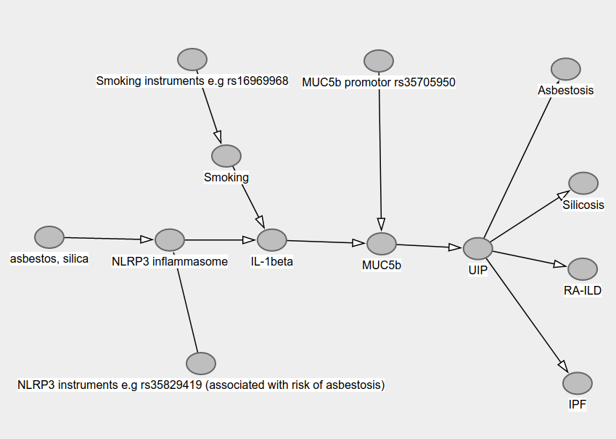

**References**

1 Davies NM, Holmes MV, Davey Smith G. Reading mendelian randomisation studies: A guide, glossary, and checklist for clinicians. BMJ (Clinical research ed) 2018;362:k601. doi:10.1136/bmj.k601

2 Navaratnam V, Fleming K, West J et al. The rising incidence of idiopathic pulmonary fibrosis in the uk. Thorax 2011;66:462–7.

3 Navaratnam V, Hubbard RB. The mortality burden of idiopathic pulmonary fibrosis in the united kingdom. American journal of respiratory and critical care medicine 2019;200:256–8. doi:10.1164/rccm.201902-0467LE

4 Raghu G, Remy-Jardin M, Myers JL et al. Diagnosis of idiopathic pulmonary fibrosis. An official ats/ers/jrs/alat clinical practice guideline. American journal of respiratory and critical care medicine 2018;198:e44–68. doi:10.1164/rccm.201807-1255ST

5 Blanc PD, Annesi-Maesano I, Balmes JR et al. The occupational burden of nonmalignant respiratory diseases. An official american thoracic society and european respiratory society statement. American journal of respiratory and critical care medicine 2019;199:1312–34. doi:10.1164/rccm.201904-0717ST

6 Arakawa H, Johkoh T, Honma K et al. Chronic interstitial pneumonia in silicosis and mix-dust pneumoconiosis: Its prevalence and comparison of ct findings with idiopathic pulmonary fibrosis. Chest 2007;131:1870–6. doi:10.1378/chest.06-2553

7 allen. Differential diagnosis of usual interstitial pneumonia: When is it truly idiopathic? European respiratory review : an official journal of the European Respiratory Society 2014;23:308–19. doi:10.1183/09059180.00004914

8 Monsó E, Tura J, Pujadas J et al. Lung dust content in idiopathic pulmonary fibrosis: A study with scanning electron microscopy and energy dispersive x ray analysis. Br J Ind Med 1991;48:327–31.

9 Morell F, Villar A, Montero M-Á et al. Chronic hypersensitivity pneumonitis in patients diagnosed with idiopathic pulmonary fibrosis: A prospective case-cohort study. Lancet Respir Med 2013;1:685–94. doi:10.1016/S2213-2600(13)70191-7

10 Nett RJ, Wood JM, Blackley DJ. Collecting occupational exposure data would strengthen idiopathic pulmonary fibrosis registries. American journal of respiratory and critical care medicine Published Online First: October 2019. doi:10.1164/rccm.201908-1631LE

11 Allen RJ, Guillen-Guio B, Oldham JM et al. Genome-wide association study of susceptibility to idiopathic pulmonary fibrosis. American journal of respiratory and critical care medicine Published Online First: November 2019. doi:10.1164/rccm.201905-1017OC

12 Evans CM, Fingerlin TE, Schwarz MI et al. Idiopathic pulmonary fibrosis: A genetic disease that involves mucociliary dysfunction of the peripheral airways. Physiological reviews 2016;96:1567–91. doi:10.1152/physrev.00004.2016

13 Seibold MA, Smith RW, Urbanek C et al. The idiopathic pulmonary fibrosis honeycomb cyst contains a mucocilary pseudostratified epithelium. PloS one 2013;8:e58658. doi:10.1371/journal.pone.0058658

14 Platenburg MGJP, Wiertz IA, Vis JJ van der et al. The muc5b promotor risk allele for idiopathic pulmonary fibrosis predisposes to asbestosis. The European respiratory journal Published Online First: January 2020. doi:10.1183/13993003.02361-2019

15 Namba N, Kawasaki A, Sada K-E et al. Association of muc5b promoter polymorphism with interstitial lung disease in myeloperoxidase-antineutrophil cytoplasmic antibody-associated vasculitis. Annals of the rheumatic diseases 2019;78:1144–6. doi:10.1136/annrheumdis-2018-214263

16 Hancock LA, Hennessy CE, Solomon GM et al. Muc5b overexpression causes mucociliary dysfunction and enhances lung fibrosis in mice. Nature communications 2018;9:5363. doi:10.1038/s41467-018-07768-9

17 O’Dwyer DN, Ashley SL, Gurczynski SJ et al. Lung microbiota contribute to pulmonary inflammation and disease progression in pulmonary fibrosis. American journal of respiratory and critical care medicine 2019;199:1127–38. doi:10.1164/rccm.201809-1650OC

18 Dickson RP, Huffnagle GB, Flaherty KR et al. Radiographic honeycombing and altered lung microbiota in patients with idiopathic pulmonary fibrosis. American journal of respiratory and critical care medicine 2019;200:1544–7. doi:10.1164/rccm.201903-0680LE

19 B Moore B, Lawson WE, Oury TD et al. Animal models of fibrotic lung disease. American journal of respiratory cell and molecular biology 2013;49:167–79. doi:10.1165/rcmb.2013-0094TR

20 Dostert C, Pétrilli V, Van Bruggen R et al. Innate immune activation through nalp3 inflammasome sensing of asbestos and silica. Science (New York, NY) 2008;320:674–7. doi:10.1126/science.1156995

21 Baumgartner KB, Samet JM, Stidley CA et al. Cigarette smoking: A risk factor for idiopathic pulmonary fibrosis. Am J Respir Crit Care Med 1997;155:242–8. doi:10.1164/ajrccm.155.1.9001319

22 Mossman BT, Churg A. Mechanisms in the pathogenesis of asbestosis and silicosis. Am J Respir Crit Care Med 1998;157:1666–80.

23 Catrina AI, Joshua V, Klareskog L et al. Mechanisms involved in triggering rheumatoid arthritis. Immunological reviews 2016;269:162–74. doi:10.1111/imr.12379

24 Stolt P, Yahya A, Bengtsson C et al. Silica exposure among male current smokers is associated with a high risk of developing acpa-positive rheumatoid arthritis. Annals of the rheumatic diseases 2010;69:1072–6. doi:10.1136/ard.2009.114694

25 Rosenman KD. Rheumatoid arthritis and pneumoconiosis. American journal of respiratory and critical care medicine 2012;185:1024; author reply 1025–1024; author reply 1026. doi:10.1164/ajrccm.185.9.1024a

26 Mathews RJ, Robinson JI, Battellino M et al. Evidence of nlrp3-inflammasome activation in rheumatoid arthritis (ra); genetic variants within the nlrp3-inflammasome complex in relation to susceptibility to ra and response to anti-tnf treatment. Annals of the rheumatic diseases 2014;73:1202–10. doi:10.1136/annrheumdis-2013-203276

27 Kukkonen MK, Vehmas T, Piirilä P et al. Genes involved in innate immunity associated with asbestos-related fibrotic changes. Occupational and environmental medicine 2014;71:48–54. doi:10.1136/oemed-2013-101555

28 Ji X, Hou Z, Wang T et al. Polymorphisms in inflammasome genes and risk of coal workers’ pneumoconiosis in a chinese population. PloS one 2012;7:e47949. doi:10.1371/journal.pone.0047949

29 Ji X, Wu B, Jin K et al. MUC5B promoter polymorphisms and risk of coal workers’ pneumoconiosis in a chinese population. Molecular biology reports 2014;41:4171–6. doi:10.1007/s11033-014-3100-2

30 Pontillo A, Oshiro TM, Girardelli M et al. Polymorphisms in inflammasome’ genes and susceptibility to hiv-1 infection. Journal of acquired immune deficiency syndromes (1999) 2012;59:121–5. doi:10.1097/QAI.0b013e3182392ebe

31 Abate E, Blomgran R, Verma D et al. Polymorphisms in card8 and nlrp3 are associated with extrapulmonary tb and poor clinical outcome in active tb in ethiopia. Scientific reports 2019;9:3126. doi:10.1038/s41598-019-40121-8

32 Flaherty KR, Wells AU, Cottin V et al. Nintedanib in progressive fibrosing interstitial lung diseases. The New England journal of medicine 2019;381:1718–27. doi:10.1056/NEJMoa1908681

33 Wollin L, Wex E, Pautsch A et al. Mode of action of nintedanib in the treatment of idiopathic pulmonary fibrosis. The European respiratory journal 2015;45:1434–45. doi:10.1183/09031936.00174914

34 Fiddler CA, Simler N, Parfrey H et al. Severe colitis associated with pirfenidone use in idiopathic pulmonary fibrosis. Annals of the American Thoracic Society 2016;13:1430–2. doi:10.1513/AnnalsATS.201602-118LE

35 Lawlor DA, Tilling K, Davey Smith G. Triangulation in aetiological epidemiology. International journal of epidemiology 2016;45:1866–86. doi:10.1093/ije/dyw314

36 Wootton RE, Richmond RC, Stuijfzand BG et al. Evidence for causal effects of lifetime smoking on risk for depression and schizophrenia: A mendelian randomisation study. Psychological medicine 2019;1–9. doi:10.1017/S0033291719002678

37 An J, Gharahkhani P, Law MH et al. Gastroesophageal reflux gwas identifies risk loci that also associate with subsequent severe esophageal diseases. Nature communications 2019;10:4219. doi:10.1038/s41467-019-11968-2

38 Gill D, Benyamin B, Moore LSP et al. Associations of genetically determined iron status across the phenome: A mendelian randomization study. PLoS medicine 2019;16:e1002833. doi:10.1371/journal.pmed.1002833

39 Georgakis MK, Gill D, Rannikmäe K et al. Genetically determined levels of circulating cytokines and risk of stroke. Circulation 2019;139:256–68. doi:10.1161/CIRCULATIONAHA.118.035905