Meta-analysis Tutorials in R

Nicotine Gum and Smoking Cessation

This meta-analysis tutorial was adopted and modified from chapter 12 of “A Handbook of Statistical Analyses Using R” written by Brian S. Everitt and Torsten Hothorn. The following url will take you directly to a pdf of this chapter. In this tutorial we post the majority of the script used, as well as further explanations of the script and analysis techniques.

<http://cran.r-project.org/web/packages/HSAUR/vignettes/Ch_meta_analysis.pdf>

For the first part of this tutorial we will focus on the fixed effects meta-analysis conducted on nicotine gum and smoking cessation. The study goal was to gather results from various published randomized trials which tested the ability of nicotine gum to help smokers quit. To analyze this the studies estimated the overall *odds ratio* (i.e. the odd of quitting smoking for those given the gum, dived by the odds of quitting for those not receiving the gum).

In R the odds ratios and corresponding confidence intervals can be computed using the **meta.MH** function for a fixed effects meta-analysis.

For more information about odds ratios and how to interpret an odds ratio visit this site

<http://www.ncbi.nlm.nih.gov/pmc/articles/PMC2938757/>

For a review on fixed effects models visit in meta-analysis view slide 22 of this presentation

<https://www.zoology.ubc.ca/~bio501/lecturepdf/11.Meta-analysis.pdf>

*All R code will be written in maroon font to help set it apart from the main text of this tutorial.*

To begin with we will need to install and load the packages necessary for this analysis. If you do not already have the following packages then use all the lines of code, if you already have the packages load them using the library function.

install.packages("rmeta")

install.packages("HSAUR")

library(rmeta)

library(HSAUR)

The data set we will be working with is included in the **HSAUR** package. This meta-analysis uses results from 26 studies and includes four variables.

data("smoking", package = "HSAUR")

?smoking

In this example we are first use a fixed effects model so we will use the **meta.MH** function. A fixed effects model is used when studies have similar mean effect sizes and negligible between study variances.

For complete information on the fixed effects (a.k.a. Mantel-Haenszel) function look at the information provided in R.

?meta.MH

The following line will run the fixed effects model to calculate the individual odds ratio for each study, the Mantel-Haenszel summary, and Woolf’s test for heterogeneity.

smokingOR <- meta.MH(smoking[["tt"]], smoking[["tc"]],smoking[["qt"]], smoking[["qc"]],names = rownames(smoking))

Use the summary function to return the results of the analysis.

summary(smokingOR)

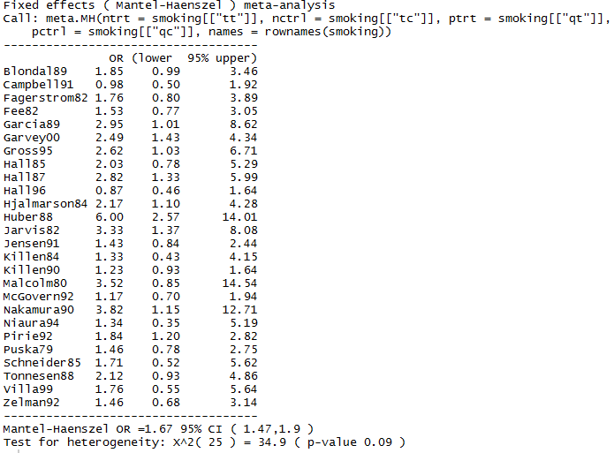

The summary puts the published paper in the first column, the individual odds ratio for that study is in the second column, and the last two columns provide a 95% C.I. for the odds ratio estimate.

The Mantel-Haenszel odds ratio is a calculated pooled odds ratio for all the studies combined with its associated C.I. and it is displayed under the dashed line at the bottom of the summary.

The examination of heterogeneity of effect sizes among studies begins with a formal test for its presence. In this case we see the p-value is non-significant so there does not seem to be a statistically significant difference in the effect sizes among studies. This means a fixed effects model is appropriate.

Using the plot function in the **meta.MH package** produces a standard meta-analysis plot where the C.I. for each study is a horizontal line, and the point estimate is displayed as a square whose height is inversely proportional to the standard error of the estimate. The summary odds ratio (i.e. the Mantel-Haenszel odds ratio) is drawn as a diamond with horizontal limits at the confidence limits and its width is inversely proportional to its standard error.

plot(smokingOR)

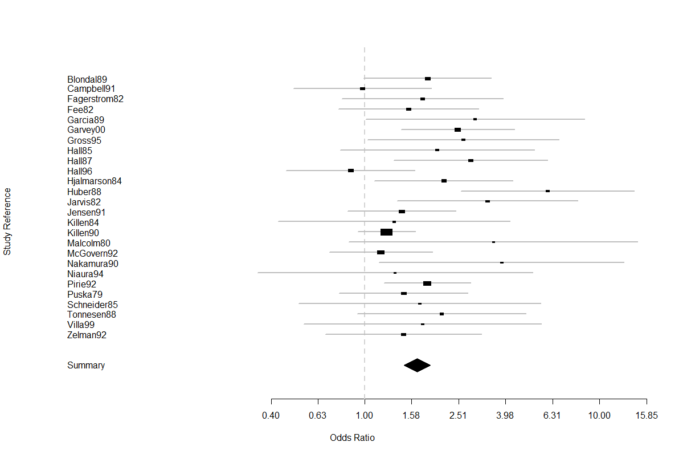

When performing a meta-analysis one thing you can check for is publication bias, if you want to read more about publication bias go to this source

<http://metaanalysis.com/downloads/PBPreface.pdf>

To create a funnel plot using the nicotine data set you can use the following function.

funnelplot(smokingOR)

abline(v = 0, lty = 2)

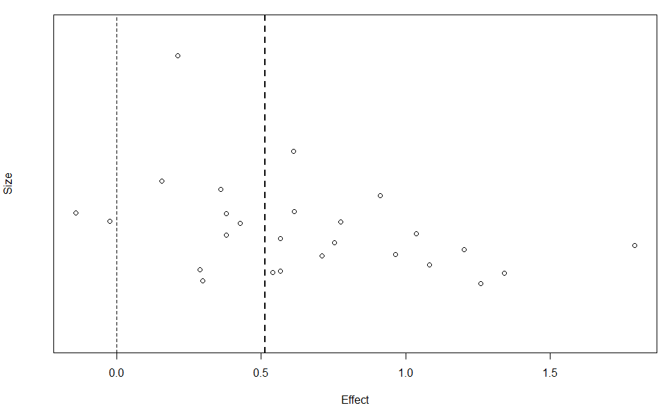

According to this plot there doesn’t appear to be a publication bias. For more information on funnel plots and their interpretation use the following link

<http://handbook.cochrane.org/chapter_10/10_4_1_funnel_plots.htm>

BCG Vaccine in the Treatment of Tuberculosis

In the above example we did not detect heterogeneity among the effect sizes in the studies used in the meta-analysis. This is typically a rare occurrence. There can be multiple sources of heterogeneity and estimating how these various factors affect the reported effect size in the studies included in a meta-analysis is of interest and importance. In the following example we will illustrate how to go about this process using the BCG (Bacillus Calmette–Guérin) vaccine data in R.

For more information on heterogeneity in meta-analyses

<http://handbook.cochrane.org/chapter_9/9_5_heterogeneity.htm>

The BCG vaccine data set contains data for a meta-analysis on the efficacy of the BCG vaccination against tuberculosis (TB). It contains the results of 13 studies and has information for seven variables. For more information about the data set see the help page in R.

data("BCG", package = "HSAUR")

?BCG

The following code will run a fixed effects model like the one used in the nicotine gum example.

BCG_OR <- meta.MH(BCG[["BCGVacc"]], BCG[["NoVacc"]],BCG[["BCGTB"]], BCG[["NoVaccTB"]],names = BCG$Study)

Once again you can use the summary function to examine the results of the analysis.

summary(BCG_OR)

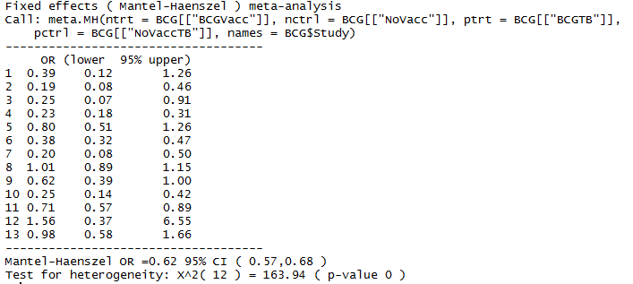

As you can tell from the test for heterogeneity we have detected significant differences among the effect sizes reported among the studies used in this meta-analysis. This means a fixed effects model is not the best analysis in this case. To proceed the authors run a random effects model on the same data set with the following code. To run a random effects model we will now use a different function in R (**meta.DSL)**.

?meta.DSL

*A further note on fixed versus random effects:* a fixed effects model is a description of all the studies included in the meta-analysis. A random effects model regards the studies in the meta-analysis as a sub-sample of a larger group of studies. The random effects model can be used to infer what would happen if a new study were performed, while the fixed effects model cannot.

BCG_DSL <- meta.DSL(BCG[["BCGVacc"]], BCG[["NoVacc"]],BCG[["BCGTB"]], BCG[["NoVaccTB"]],names = BCG$Study)

summary(BCG_DSL)

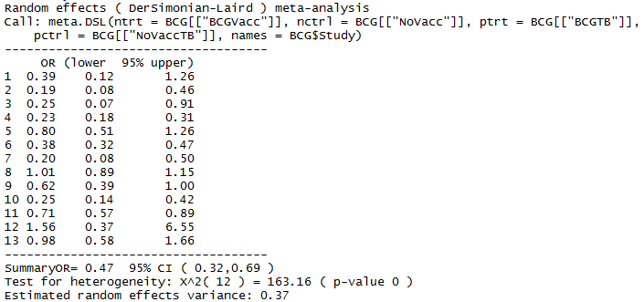

With the random effects model we have a slight change in the summary odds ratio, the test for heterogeneity remains the same, and we have an estimated random effects variance.

In this example the authors wanted to see if two covariates measured in each of the studies (latitude and the year the study took place) had a relationship with the observed effect sizes. To do this the authors used multiple regression, but they weighted each observation according to its variance. In meta-analysis it is common to give more weight to studies that had larger sample sizes or less variance.

 

Here is the code required to fit the linear model via weighted least squares

studyweights <- 1 / (BCG_DSL$tau2 + BCG_DSL$selogs^2)

y <- BCG_DSL$logs

BCG_mod <- lm(y ~ Latitude + Year, data = BCG,weights = studyweights)

Check the results

summary(BCG_mod)

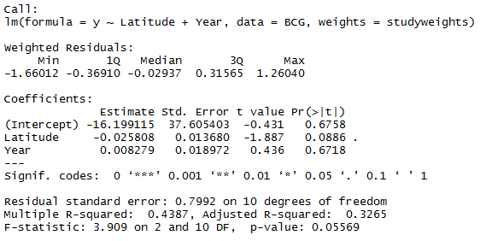

While not statistically significant, there may be a relationship between latitude and the observed effect size. To further examine the relationship between covariates and the observed effect size we can plot the log-odds ratio and the covariate in a scatter plot with the weighted regression line of fit.

plot(y ~ Latitude, data = BCG, ylab = "Estimated log-OR")

abline(lm(y ~ Latitude, data = BCG, weights = studyweights))

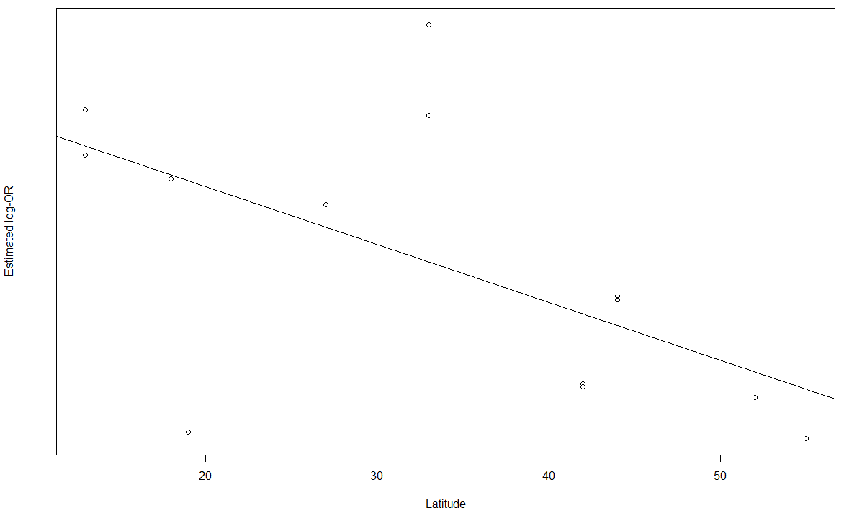

This scatter plot reveals that indeed as latitude increases, the observed effect size becomes increasingly negative suggesting that where the study took place might have impacted the observed effect size.